Modular Synthesis for ECE Education

Taylor Leblanc, Tarik Lopez, Kyle Sellers, Rafael Alvarez, Keri Grevemberg

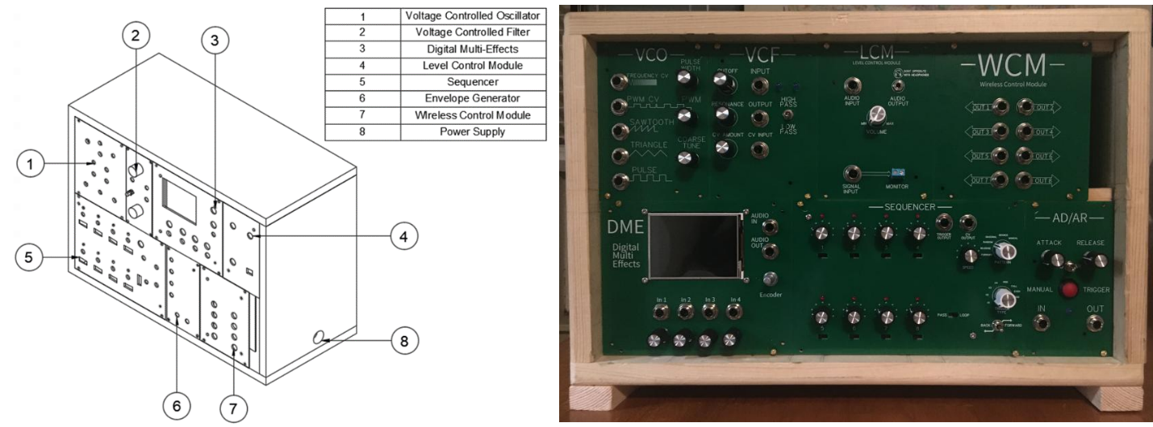

# Abstract

The motivation behind this project is to create a tool that presents complex electrical engineering topics such as frequency modulation and harmonics in a way that students can use their hands to adjust user selected settings of a signal all while seeing the results in real time. While not all modules serve as an educational purpose, our system as a whole, uses music to keep students engaged as they learn. Our team is focused on making a synthesizer that is customizable, engaging, easy to understand and easy to reconstruct. The objective that Team 80 used as an important design guide is for our system’s ability to act as a tactile learning aide to provides activities encompassing some of the various complex concepts that Electrical Engineering students at LSU are required to learn. Our team has prepared user manuals for each module which will aid in the execution of the following system objectives. Our plan is to create an instrument with the ability to control and create various signal parameters and then output those user-manipulated waveforms. The subsequent result-- a system capable of facilitating various syllabi highlighted in our EE curriculum so that students can further understand what they are studying on paper. The modular synthesizer will house six modules, including: The Voltage-Controlled Oscillator (VCO), Voltage-Controlled Filter (VCF), Envelope Generator (AD/AR), Sequencer, Multi-Effects Module, and the Wireless Controller Module (WCM). Each of the 7 modules play a unique role in fulfilling our main objectives. Our system together can produce audio signals, manipulate both frequency and amplitude, be controlled wirelessly via phone app remote control, operate within a safe temperature range, and users can create and send control voltages between compatible modules. Team made specifications such as latency, low power consumption, and sampling rate play key roles in the operation of our modular synthesizer.  Overall, through quantitative project constraints, we hope our system reflects our efforts on reducing design cost and case size, ensuring easy system transportation (i.e., lighter materials, smaller power supply), minimum power consumption, bandwidth constraint, signal to noise ratio, safe operating temperature as well as safe maximum volume levels, and finally ideal range and latency of wireless control.

Table of Contents

I. Abstract 1

II. Executive Summary 6

III. Engineering Specification 7

III.A. Objective Statement 7

III.B. Introduction 7

III.B.1. Background Information 7

III.B.2. Problem Description and Motivation for the Project 7

III.B.3. Existing/Competing Technologies 7

III.B.4. Potential Customers 7

III.C. Functional Requirements 8

III.D. Qualitative Constraints 8

III.E. Measurable Engineering Specifications 9

III.F. Deliverables 9

IV. Embodiment 10

IV.A. Functional Breakdown - Objective Tree(s) 10

IV.B. Concept/Solution Generation, Evaluation and Selection 12

IV.B.1. Concept/Solution Generation Method(s) Used 12

IV.B.2. Concept/Solution Evaluation Method(s) Used 12

IV.B.3. Concept/Solution for Function F# - Function Name 12

IV.C. System Description/Product Architecture 13

IV.C.1. Description of Sub-System SS# – Sub-Sys Name 16

V. Engineering Analysis and Materials Selection 17

V.A. Engineering Analysis for SS# - Sub-Sys Name 17

V.A.1. Types of Eng. Analysis Conducted: 17

V.A.2. Eng. Analysis & Materials Selection for SS#-P# - Part Name 17

VI. Manufacturing & Assembly 18

VI.A. Manufacturing 18

VI.B. Assembly 18

VII. Safety Considerations 20

VII.A. Operational Safety 20

VII.B. Safety During Manufacturing, Assembly and Testing 20

VIII. Environmental Impact Assessment 20

VIII.A. Manufacturing Related Environmental Impact 20

VIII.B. Operation/Usage Related Environmental Impact 20

VIII.C. End-Of-Life (Disposal) Related Environmental Impact 20

IX. Design-Phase Testing 20

IX.A. Design-Phase Testing Objectives, Rationale & Brief Description 21

IX.B. Design-Phase Testing Outcomes & Conclusions 21

X. Testing, Validation, and/or Implementation 21

X.A. Testing & Validation of Function F# - Function Name 21

X.A.1. Objective, Rationale & Brief Description - F# 21

X.A.2. Testing & Validation Summary of Results & Conclusions – F# 22

X.B. Testing & Validation of Function F# - Function Name 22

X.B.1. Objective, Rationale & Brief Description - F# 22

X.B.2. Testing & Validation Summary of Results & Conclusions – F# 22

X.C. Testing & Validation of Qualitative Constraint Q# - QC Name 23

X.C.1. Objective, Rationale & Brief Description - Q# 23

X.C.2. Testing & Validation Summary of Results & Conclusions – Q# 23

X.D. Testing & Validation of Qualita,Valitive Constraint Q# - QC Name 24

X.D.1. Objective, Rationale & Brief Description - Q# 24

X.D.2. Testing & Validation Summary of Results & Conclusions – Q# 24

X.E. Testing & Validation of Quantitative Constraint M# - MC Name 25

X.E.1. Objective, Rationale & Brief Description - M# 25

X.E.2. Testing & Validation Summary of Results & Conclusions – M# 25

X.F. Testing & Validation of Quantitative Constraint M# - MC Name 26

X.F.1. Objective, Rationale & Brief Description - M# 26

X.F.2. Testing & Validation Summary of Results & Conclusions – M# 26

XI. Project Management 27

XI.A. Schedule and Milestones 27

XI.B. Budget 29

XII. Summary and Conclusions 29

XIII. Appendix 30

XIII.A. Quality Function Deployment (QFD) - HoQ 30

XIII.B. Concept/Solution Evaluation and Selection Supplement 32

XIII.B.1. Concept/Solution for Function F# - Details 32

XIII.C. System Description/Product Architecture Supplement 33

XIII.C.1. Sub-System SS# - Sub-Sys Name 33

XIII.D. Engineering Analysis and Materials Selection Supplement 38

XIII.D.1. Eng. Analysis Details for SS# - Sub-Sys Name 38

XIII.E. Manufacturing & Assembly Supplement 39

XIII.E.1. Manufacturing Processes 39

XIII.E.2. Assembly Processes 40

XIII.F. Design Phase Testing Supplement 41

XIII.F.1. Design Phase Testing Methods and Details 41

XIII.F.2. Design Phase Testing Results 41

XIII.G. Testing & Validation Supplement 41

XIII.G.1. Testing & Validation of Function F# - Function Name 41

XIII.G.2. Testing & Validation of Function F# - Function Name 42

XIII.G.3. Testing & Validation of Qualitative Constraint Q# - QC Name 43

XIII.G.4. Testing & Validation of Qualitative Constraint Q# - QC Name 44

XIII.G.5. Testing & Validation of Quantitative Constraint M# - MC Name 45

XIII.G.6. Testing & Validation of Quantitative Constraint M# - MC Name 46

XIII.H. Project Management Supplement 48

XIII.H.1. Schedule and Milestones Details 48

XIII.H.2. Budget Details 50

XIII.I. Reference Materials 52

XIII.I.1. Codes and Standards 52

XIII.I.2. References and Bibliography 52

# Executive Summary

Objectives and Problem Definition:

Many, if not most, undergraduate Electrical Engineering students at LSU miss out on an important step in the education of fundamental theories and principles. This could be due to the lack of hands-on activities for subjects such as Signals and Systems, and Digital Signal Processing. Team 80 offers a guided experience through team selected EE curriculum by controlling a musical, university safe, and engaging system.

Key Engineering Specifications:

The main functions of our system are to Assist Course Syllabi (e.g., Electronics II, Signals and Systems, and Digital Signal Processing), Generate and Output Audio Signals, Manipulate Signal Frequency and Amplitude, Generate Control Voltages, Produce Signals Digitally, Allow Users to Reroute Signal Path, and Operate via Remote Control all while operating within a safe temperature range.

Our most important Quantitative Constraints are to keep costs under $600, limit power consumption to minimize ambient temperature, and output signals with no attenuation in the 20-22kHz audio spectrum.

Product/System Description:

Team 80 selected 7 modules for our modular synthesizer to embody the concepts selected above. A Voltage Controlled Oscillator (VCO) can generate audio waveforms via oscillator. Using the Level Control Module, users can also manipulate the amplitude of these signals via volume control, and the frequency via pitch control. A Voltage Control Filter (VCF) can manipulate signal frequency by providing filtering options (e.g., low-pass filter, high-pass filter) for inputted signals. A Sequencer Module can produce a sequence of Unipolar control voltages. The Envelope Generator Module can manipulate signal amplitude as well as produce unipolar control voltages. A Digital Multi-Effects module can process signals digitally. A Wireless Control Module allows users to control the system remotely, as well as produce bipolar control voltages. Finally, a Level Control Module reduces the output to a level appropriate for listening or analysis.



Exploded View Solid Model and Physical Prototype Picture

Engineering Analysis Result Summary: All simulations of analog modules, and analog components of digital modules, behave as expected, with the exception of the Level Control Module. This Module was redesigned in the second semester, and now behaves as expected, providing variable volume output as well as fixed output for MyDAQ analysis.

Manufacturing/Assembly Summary: The full assembly process for our system can be categorized into PCB assembly, Faceplate assembly, and case assembly. The faceplates and PCBs are first designed using EasyEDA, a free online schematic program. After obtaining Gerber files of the seven module schematics, JLC PCB manufactured our PCBs and faceplates. Soldering the components to the PCB and attaching the faceplates concludes the assembly process for the electronic side of our project. System case assembly came last. The dimensions of the faceplates together dictated the dimensions of the box which were used to cut the wood to size. Finally, by using a nail gun and drill the system case was fully assembled and the faceplates were attached on.

Safety Considerations: OSHA recommended guidelines were followed during our time in the ERAD lab while also adhering to CDC regulations. While soldering, fume ventilation fans were powered on as well as goggles for solder backsplash protection. All students wore masks and practiced social distancing during in-person work sessions. Safety considerations for the modular synthesizer were also shown. All audio jacks featured on the system are TRS ¼’ jacks. This prevents system users plugging in a personal aux cord or headphones to the system. This could result in damage to the system. All featured integrated circuit components are paired with a heat sink and holes drilled into the back of the case promote a decrease in case ambient temperature.

Design-Phase Testing Results: Most of the modules could be tested using an oscilloscope. An oscilloscope probe can be connected to the output and the input of a module and display the readings onto the screen. Using oscilloscopes throughout the testing period allowed for quicker redesign of modules that were not operating correctly. Multimeters were used to test continuity of each PCB before soldering as well as value checks for circuit components as they were received. This also aided in quicker redesign efforts.

Validation Test Plan & Results Summary: All functions, qualitative constraints, and measurable specifications are met or are close to being met, with the exception of power consumption and signal to noise ratio. For power consumption, power draw assumptions were made based upon dual DC +/- 12 V rails, and not on 120 V AC, so actual power consumption is much greater than expected. For measuring Signal to Noise Ratio, the team did not have access to the RF spectrum analyzers needed to take this measurement.

Statement of Prototype Performance: Overall, most of the system is behaving as designed. The only exceptions to this are the Voltage Controlled Filter Module experiencing pops and clicks when adjusting the cutoff, and the Digital Multi-Effects display. The Voltage Control Filter’s problems are likely due to either PCB design or manufacturing errors. Despite this, the team has a working iteration of this module on Vero Board to fall back on. As for the Digital Multi-Effects display, this issue is addressed in the appendix.

# Engineering Specification

## Objective Statement

To create a musical instrument, known as a Modular Synthesizer, to aide in the education process of Electrical Engineering concepts.

## Introduction

### Background Information

Synthesizers are musical instruments that use a variety of circuits working in tandem to create different sounds. In a modular synthesizer, each of these circuits are packaged individually. These standalone circuits are known as modules. Each module is typically designed to perform one or more specific functions that have some effect on the instrument’s final sound. Therefore, as you add more modules you also add on to the number of ways your synthesizer can shape sound.

With all the modules being physically separate, there needs to be a way to control the path of the signal from one module to another. To accomplish this, either 1/8” or ¼" audio cables known as patch cables are used. By plugging one end of a patch cable into the output of a module and plugging the other end into the input of a different module a connection is made between the two. This connection allows the signal from the first module to pass into the second module. These connections can be used to route audio signals or to route control voltage (CV) signals.

Control voltage is the term used to describe any DC or AC signals that are used to modulate one or more parameters on a separate module. The advantage to using control signals are the following:

1. Using control voltage signals allows the user to adjust module parameters smoother and quicker than what could be achieved by physically changing a parameter with a knob by hand.

2. It allows for changes with better precision.

Any module with parameters that can be adjusted using control voltage signals is typically prefaced with the title of “Voltage controlled”. For example, an oscillator, which serves as the sound source of a synth, is referred to as a Voltage controlled oscillator (VCO) if one or more parameters such as the oscillator’s frequency or pulse width can be adjusted by a CV signal. Likewise, when talking about a module whose cutoff can be adjusted via a control voltage, the module would be more accurately described as a Voltage controlled filter.

### Problem Description and Motivation for the Project

As students within an electrical engineering curriculum, we find that in some of our most important classes, such as Signals and Systems, Electronics, and Digital Signal Processing, we learn a lot of theory, but do not have many concrete and tactile examples of the concepts being taught. Due to this, many of these concepts remain purely theoretical to students. Modular synthesizers bring to life many of the concepts learned within these classes in a fun and musical way.

### Existing/Competing Technologies

**LittleBits Synth Kit**

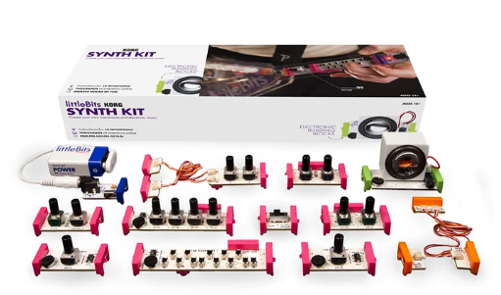

*Figure 1.a*

The little bits synth Kit is a compact, modular, digital synth kit marketed towards beginners to synthesizers. While low in price and excellent for younger audiences to get involved in music and signal manipulation, the amount of customizability is limited, and it does not offer many in depth learning opportunities for electrical engineers. [1]

**BASTL Instruments DIY**

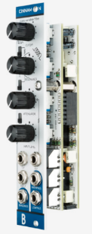

*Figure 2.a*

BASTL Instruments offers several DIY synth modules that allow customers to assemble their own modules for a reduction in cost over simply buying them. This allows for customers to have a bit more intimate knowledge of the inner workings of their modules; however, these inner workings are not explained, especially not in a rigorous way that an electrical engineer would need for full understanding of a module. While on track with one of our deliverables, we would like to offer more. [2]

**All About Circuits DIY Synth Series**

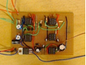

*Figure 3.a*

All About Circuits offers a free, full breakdown of the theory and design of a VCO, one of the modules our system will have, as well as a bill of materials and CAD files for PCB production. This is very similar to the deliverables that we would like to offer, however, All About Circuits only includes a VCO, while our system will contain 5 more modules done this way. [3]

**Moog Werkstatt**

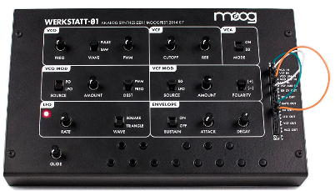

*Figure 4.a*

The Moog Werkstatt is a compact synth that contains some of the analog functions that our system will include. Its small form factor and low cost make it attractive for hobbyists and musicians wanting to enter the world of synths. Despite this, the system is not expandable, and does not offer much educational value to undergraduate electrical engineers. [4]

**Pittsburgh Modular Microvolt:**

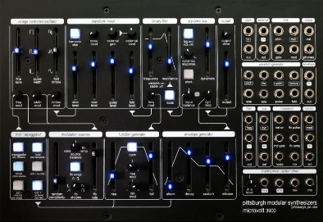

*Figure 5.a*

Like the Moog Werkstatt, the Microvolt is a premium analog synthesizer presented in a small form factor This synth is also not modular; however, it does contain more control options than the Moog Werkstatt. Again, it is gap in the market is educational value, which our product is trying to fill. [5]

### Potential Customers

Primary:

* University Electrical Engineering Students
* These students will use our system as a concrete example of concepts from Signals and Systems, Digital Signal Processing, and Electronics
* Musicians
* Modular synthesizers are primarily a musical instrument, so musicians will be able to either purchase our assembled modules or build them themselves utilizing provided PCB files and bill of materials.

Secondary: The secondary customers are the university's electrical engineering departments. A goal of the team is to make these modules available for EE professors to use as teaching aids, however the university will need to supply the professors with the modules. Since the university is purchasing the product but not using it directly, they should be considered a secondary customer.

## Functional Requirements

Table III‑1: Required Functions

| # | Function | Explanation | Type(s) of Validation Test(s) |
| --- | --- | --- | --- |
| F1 | Assist Course Syllabi | A guided learning experience through a musical instrument that aligns with concepts taught in ECE. | Faculty approval |
| F2 | Generate Audio Signals | A Voltage Controlled Oscillator designed to produce audio signals through various waveforms. | Oscilloscope readings to verify stability of sawtooth, pulse, and triangle waveforms. |
| F3 | Output Audio Signals | For this system to function as a musical instrument, its output needs to be able to be passed to speakers | An active speaker can be connected to the volume control output of the Level Control Module |
| F4 | Generate Control Voltages | An Envelope Generator and Sequencer can control the outputs of compatible modules using a control voltage. | Oscilloscope readings and system compatibility verification to validate utility of the Envelope and Sequencer to safely control the other modules. |
| F5 | Manipulate Signal Frequency | The Voltage Controlled Filter offers signal frequency manipulation through various filtering. | Spectrum analyzer and oscilloscope readings to validate the functions of lowpass and high pass filtering. |
| F6 | Manipulate Signal Amplitude | The Envelope Generator and Level Control Module offer user ability to adjust the volume, or amplitude of a signal. | By using a decibel meter application, amplitude manipulation was validated. |
| F7 | Process Signals Digitally | Digital implementations of effects are often cheaper and more versatile than analog ones, giving musicians a greater range of musical textures available to them. This also adds DSP as a class which this system can help educate. | Oscilloscope used to measure Digital Effects that directly shape wave forms (Bitcrusher & Distortion Effects).  A Digital Audio Workstation will be used to test and verify time-based effects (Delay and Reverb). |
| F8 | Operate Via Remote Control | Having remote control options allows musicians to move to other instruments or around a stage while performing. | Connected mobile device to Wireless control. Analog outputs connected to an oscilloscope to compare anticipated voltage values to actual DAC outputs. |

## Qualitative Constraints

Table III‑2: Required Qualitative Constraints

| # | Qualitative Constraint | Explanation | Type(s) of Validation Test(s) |
| --- | --- | --- | --- |
| Q1 | Customizable | System user can customize our system by easy removal/addition of modules. | Ensured each module can interact with the rest of the system, as well as behave as intended independently. |
| Q2 | Engaging/Fun to use | Clear faceplate font | The plan was to allow students and professors to test the system and give constructive feedback. Due to time constraints this was not able to be performed. |
| Q3 | Good Sound Quality | The system needs to produce low noise signals. | Oscilloscope readings of our module should be clear and stable, as well as subjectively tested by listening to system output. |
| Q4 | Easy to DIY | Approachable to hobbyist | Schematics and board files provided open source. |
| Q5 | Easy to use | Layout of the system should be straightforward so musicians without an engineering background can still operate it. | User manuals included for each module to explain functionality |
| Q6 | Stable Waveform |  | Oscilloscope readings taken of audio producing modules. |

## Measurable Engineering Specifications

Table III‑3: Required Measurable Engineering Specifications

| # | Name | Symbol | Units | Value(s) | Explanation | Type(s) of Validation Test(s) |
| --- | --- | --- | --- | --- | --- | --- |
| M1 | Cost | $ | USD | < 600 | This was a budget amount set forth by the project sponsors. | Keeping track of expenses for parts and manufacturing. |
| M2 | Size of Case | Ft^3 | Cubic feet | ~ 4 | Exceeding these dimensions would make the case uncomfortable to transport. | A tape measure was used to measure the final dimensions of the case. |
| M3 | Weight | lbs | pounds | < 20 | This was a weight set forth by the project sponsors. Exceeding this weight would make the system uncomfortable to carry. | The final system was placed on a scale. |
| M4 | Power Consumption | W | Watts | < 24 W / Rail | The power supply used is capable of delivering 24W/rail. The power consumption of the system had to be lower, or an additional PSU would be needed. | The system was plugged into a Kill-A-Watt digital power meter. |
| M5 | Bandwidth | Hz | Hertz | = 20-22k | The hearing range of the average person is between 20-2kHz. This range was extended to 22kHz as it has been argued signals in this range still affect the sound. | Signals from the synthesizer were measured with an oscilloscope set to take Fast Fourier Transform (FFT) readings. |
| M6 | Signal to Noise Ratio | dB | Decibels | > 48 | Noise levels in our system should be low enough to not affect student’s ability to analyze signals and have audio output be clear. | Subjective tests were performed by observing shape of waveform and listening to audio output to determine if noise was too high |
| M7 | Operating Temperature | °C | Degrees Celsius | < 80 | The op-amps used in the modules get damaged at temperatures above 80°C | A temperature gun was used to measure the heat of the case after the system had been left running for two hours. |
| M8 | Latency of wireless control | ms | Milliseconds | < 100 | Latency from the wireless control app to the wireless control module should be low enough so that using it does not feel clunky | Time difference between changing parameter and change in system output measured in audio editing software |
| M9 | Range of wireless control | ft | feet | > 10 | Range of the wireless control app should be enough to allow musicians to back away from the system to do other tasks on stage, while still maintaining connection | Wireless Control Module attached to oscilloscope, and user backs up with values changed until oscilloscope stopped changing or connection was lost |
| M10 | Latency of Digital module | ms | Milliseconds | < 25 | The Digital Multi-Effects Module should not add more than 25 ms of latency, to make parameters passed through it update in relatively real time. | Periodic noise passed through the module, with time difference between input and output measured. |
| M11 | Sample Rate | Hz | Hertz | >= 44100 | Sample rate should be at least 44100 to meet bandwidth requirement of 22.5 kHz according to Nyquist Theorem | Electrosmith Daisy Seed has built in function that tells user the sample rate |
| M12 | Instructional Material | # | Number of labs | >= 1 / Course | One or more mock labs needed to be made for DSP, Signals and Systems, and Electronics. This was to demonstrate to professors of these courses how the system could tie into the course. | The plan was to allow students and professors to test the system and give constructive feedback. Due to time constraints this was not able to be performed. |
| M13 | Degree of Loudness | dB | Decibels | < 90 | According to OSHA, workers can be exposed to this level for 2 hours without receiving hearing damage. | The National Institute for Occupational Safety and Health (NIOSH) sound level meter was used to measure the dB level of the system run through active speakers. |

## Deliverables:

* Seven Modules.
  + Voltage Controlled Oscillator
  + Voltage Controlled Filter
  + Sequencer
  + AD/AR Envelope Generator
  + Wireless Control/ phone application
  + Digital Multi Effect
  + Level Control
* Microbus Dual Power Supply.
* Six Mock Lab Manuals.
  + Signals and Systems (2)
  + Electronics I & II (2)
  + Digital Signal Processing (2)
* Comprehensive User Guide for included Modules.

# Embodiment

## Functional Breakdown - Objective Tree(s)

**Generate Signals**

As a musical instrument, in order to produce sounds, the synth needs to be able to generate control voltages, generate audio signals, and output these audio signals. Modules including the sequencer and wireless controller are tasked with supplying a control voltage (CV), which are used to add sound altering effects to the audio output. The oscillator is the only module that can generate audio signals and is the first module in the modular synth’s signal path.

**Manipulate Signals**

To vary the signals and noises that the modular synth produces, the product must be able to manipulate signal frequency, amplitude, and process signals in a digital domain. The filter and oscillator module manipulate the frequency of the generated signal by controlling the frequency content and pitch, respectively. The filter resonance control manipulates signal amplitude, along with the volume control, and the Envelope Generator. The multi-effects module processes generated signals digitally and produces a wider variety of sounds.

**Accept User Input**

As a modular synthesizer, there are multiple ways to operate the system in order to produce an audio output, with one being operating certain aspects of the synth via wireless control module. This expands musical applications and sound variety since the user will be able to adjust system parameters with ease. Another operating feature is to reroute the signal path, which consists of wiring and rewiring connection cables from module to module in order to connect different subsystems to produce different audio outputs.

**Supplement Education**

As a supplemental learning device, one goal of completing this project is to assist the classroom syllabi for classes such as DSP, Electronics, and Signals & Systems. This is a staple function is important for making the modular synthesizer more than just a standard electronic musical instrument, but a tool for learning as well. This is the main function that separates our device in the market.

**Operate Safely**

In order to operate safely we determined the most important thing to consider for both user and system safety is to regulate operating temperature, which consists of considering ventilation options for casing design and providing open airways and cooling systems for each module.

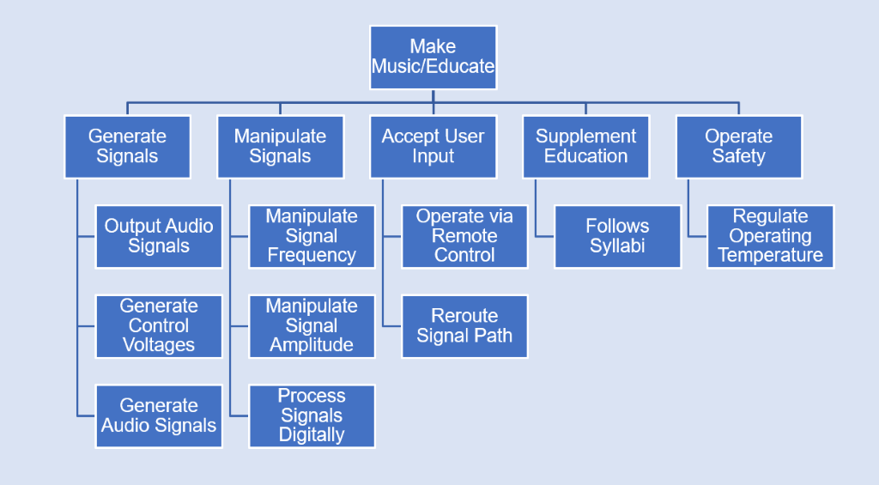

Figure IV‑1: Project Objective Tree

## Concept/Solution Generation, Evaluation and Selection

### Concept/Solution Generation Method(s) Used

In Team 80’s efforts to generate main system concepts, all of the ten functions were placed into a list. 5-10 minutes per function per team member were taken to focus on system constraints, as well as discussing the validity of these ideas. After giving each team created function 5-10 minutes of the team selected the most relevant of these concepts to be evaluated.

In future meetings after this concept generation session, team members would present additional ideas for the fulfillment of functions. These concepts would then be discussed, and if deemed a valuable consideration, they were added to the list to be evaluated.

### Concept/Solution Evaluation Method(s) Used

For this stage of the project, pros & cons tables were used to decide solutions to select. This is due to a lack of quantifiable data present for most concepts, which led to most decisions being subjective.

For each concept, the team discussed the pros and cons for selecting or including this concept in the system. After all concepts for a given function were considered, the team then voted on which they wanted included in the system, often referencing our qualitative and quantitative constraints.

### Concept/Solution for Function F1 – Assist Course Syllabi

#### Original Concept/Solution Selected for Function F1

Concept design for our system involved reviewing previously learned topics in Signals and Systems, Electronics I and II, and Digital Signal Processing. By using lab manuals and LSU course syllabi, the system’s educational ability is formatted around concepts we know students will be learning.

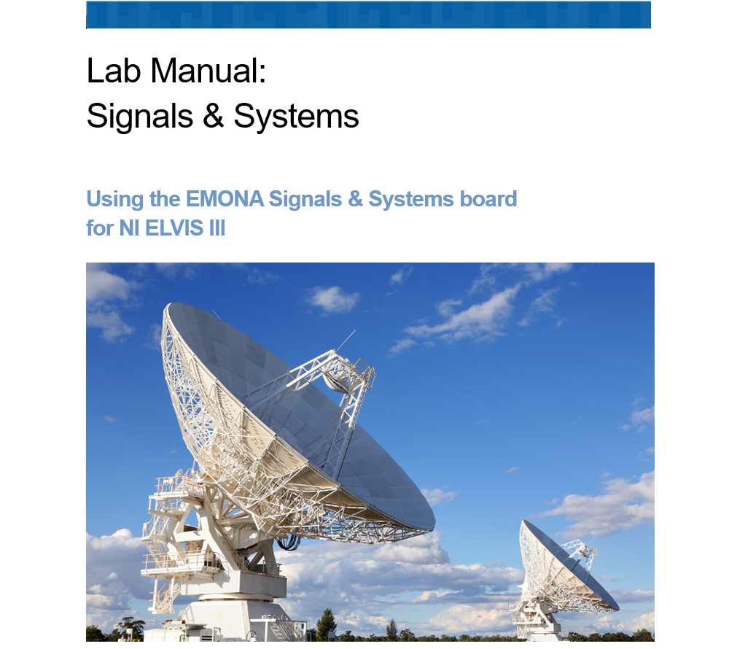

Figure IV‑2: Illustration of Original Concept for Function F1

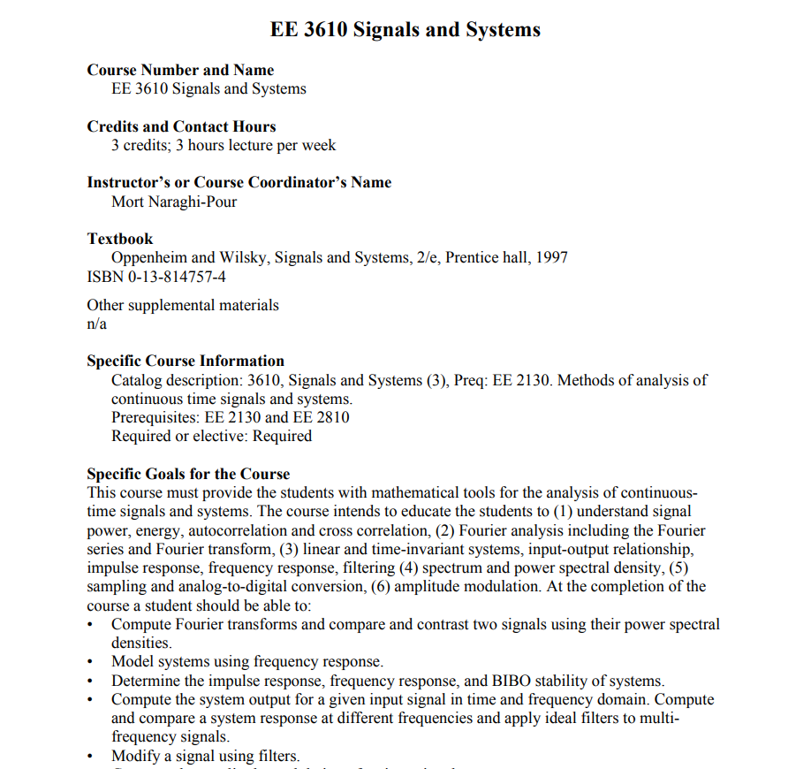

#### Re-design Concept/Solution for Function F1

The formatting of the mock lab manuals followed a conventional layout seen in most engineering labs. The main goal was to have these be comprehensive and easy to follow while learning the complexity of a modular synthesizer. Below is one example of a lab manual written for this project on the Fundamental Frequency of periodic waveforms.

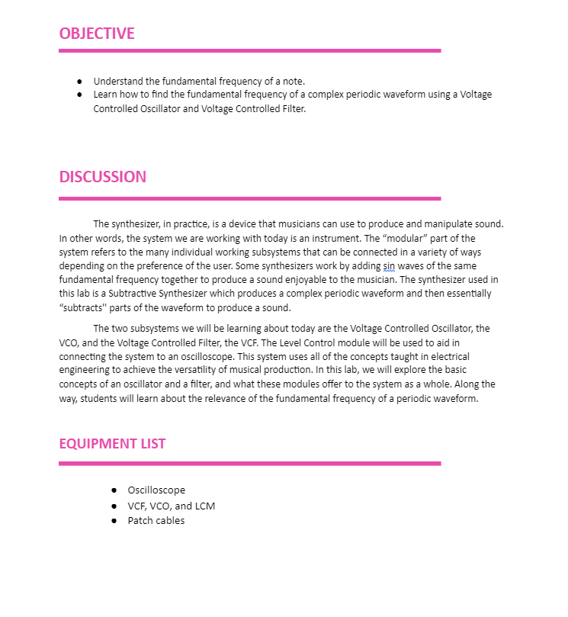

Figure IV‑3: Illustration of New Concept for Function F1

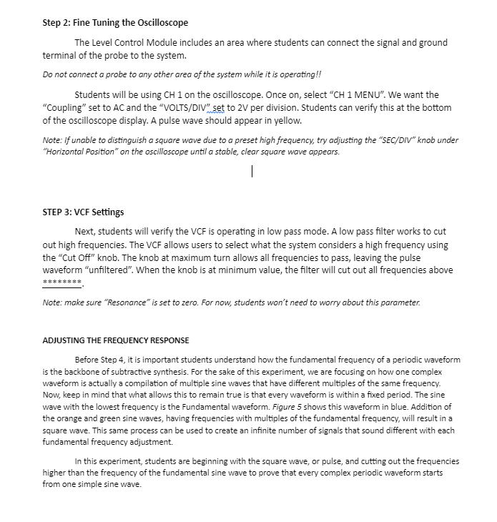

### Concept/Solution for Function F2 – Generate Audio Signals

#### Original Concept/Solution Selected for Function F2

For generating audio signals, the main signals, we wanted to output were the sawtooth triangle and pulse wave form being not only the best sounding waveforms, but the ones that the consumer we are targeting has been exposed to the most students and educators. The original design below was a schematic using a simple vco ic chip it works super well when arranged with surrounding circuitry. The original design planned for an octave control. It caused many problems and was thought to be the reason for the first design to not work.

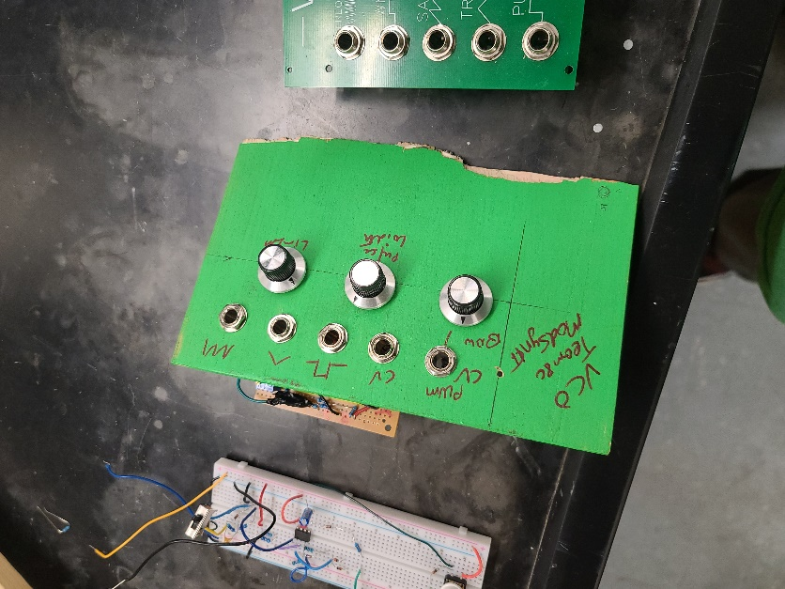

Figure IV‑2: Illustration of Original Concept for Function F2

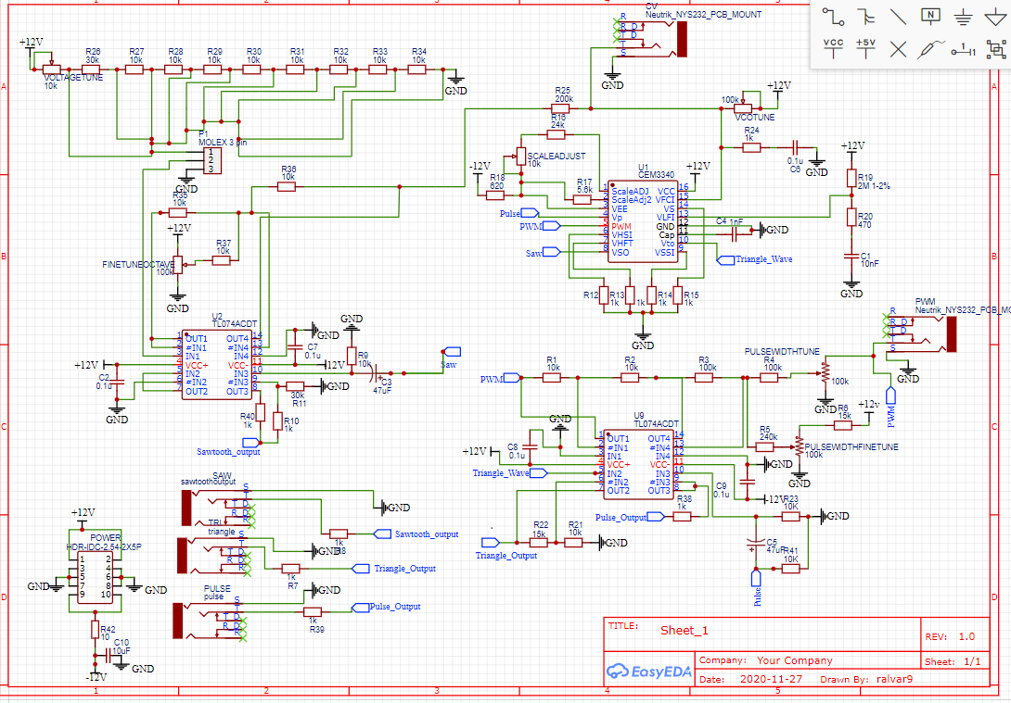

Figure IV‑3: Illustration of Original Concept for Function F2

#### Re-design Concept/Solution for Function F2

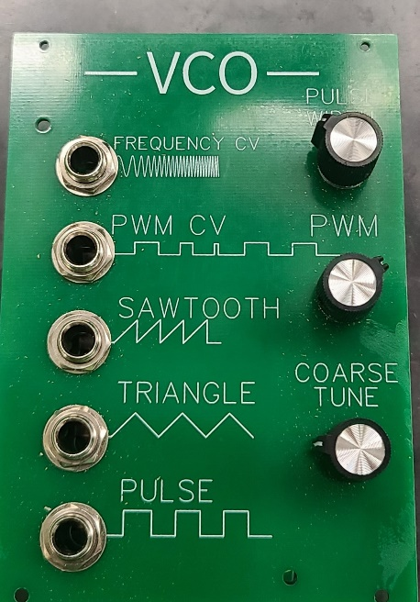

Figure IV‑4: Illustration of New Concept for Function F2

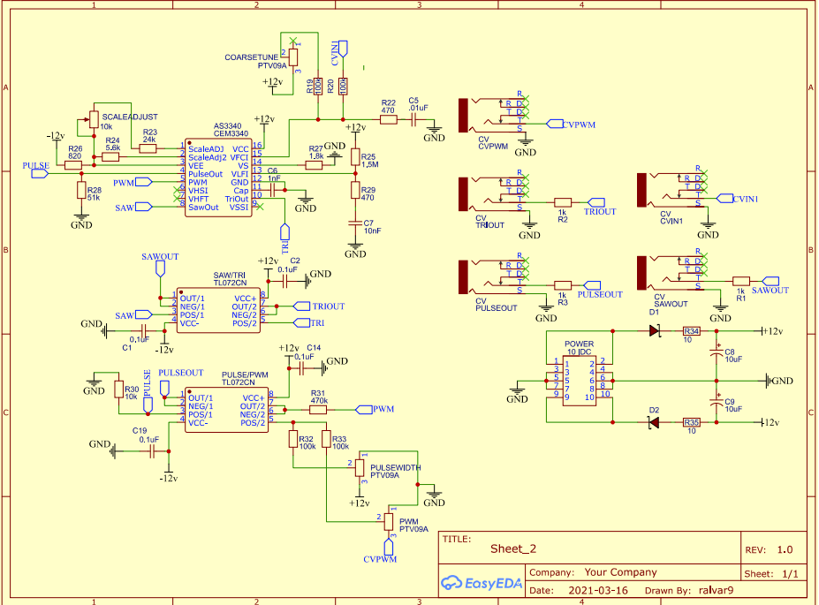

Figure IV‑5: Illustration of New Concept for Function F2

### Enter any content that you want to repeat, including other content controls. You can also insert this control around table rows in order to repeat parts of a table.

### Concept/Solution for Function F3 – Output Audio Signals

#### Original Concept/Solution Selected for Function F3

A user needs to plug the system into speakers in order to hear the signals it produces, however not all speakers offer volume control. To combat this the Level control was designed to include a volume control circuit. This would ideally allow the user to output audio to either active speakers or headphones. The circuit shown in Figure IV-2 is the circuit diagram for the original volume control circuit.

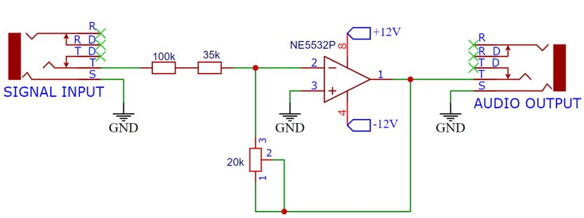

Figure IV‑2: Illustration of Original Concept for Function F3

#### Re-design Concept/Solution for Function F3

After testing the original design, it was found that too much interference and noise was disrupting the signal. It was later discovered that the 20kΩ potentiometer shown in the feedback loop was the source of the issue. After making a variety of changes to the original design on breadboard the sub circuit was scrapped for the one shown in Figure IV-3. This was a simplified version of a sub circuit found in the Befaco Out V3 module.

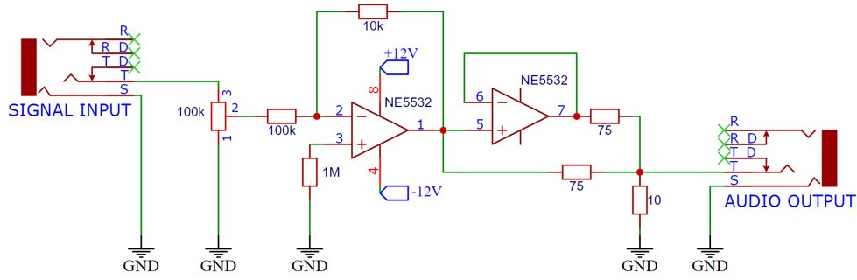

Figure IV‑3: Illustration of New Concept for Function F3

### Concept/Solution for Function F4 – Generate Control Voltages

#### Original Concept/Solution Selected for Function F4

For the types of control voltages to be used in the system, both Unipolar, or 0-5V signals, and Bipolar, or -5V to 5V CV, are selected. Unipolar is easier to implement, especially for analog modules, so they will be used in the Envelope Generator, Sequencer, and Wireless Control Module. The Envelope Generator will be able to control four-time parameters within the outputted control voltage. The Envelope Generator will focus on the timing settings of a 555 timer. Bipolar CV signals will be generated by the wireless control module.

Unipolar and bipolar CV are the only 2 types of control voltages, and both are used in the system.

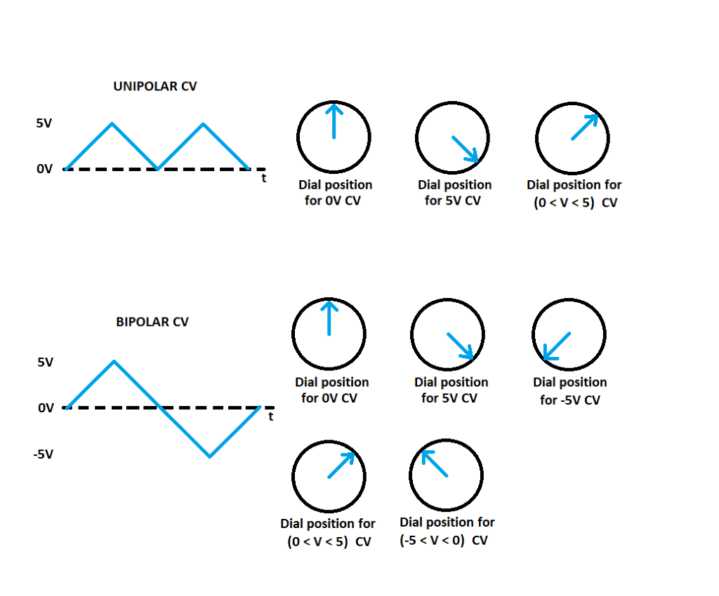

Figure IV‑2: Illustration of Original Concept for Function F4

#### Re-design Concept/Solution for Function F4

Three modules in the system were designed to create control voltages, the Envelope Generator, the Sequencer, and the Wireless Control Module. The Envelope Generator can output a zero-to-5-volt control voltage that is shaped by adjusting amplitude of the waveform at two separate time parameters of a note, the attack and the decay. Essentially, the Envelope Generator using a waveform of varying amplitude to automate the function of the module it is outputting to. The second module to create control voltages is the Sequencer. The Sequencer outputs a control voltage between 0-5V from the CV output. The voltage level this module produces is determined by the position of the potentiometer at a step when that step is triggered. Additionally, this module produces a 5V signal from the Trigger Output each time a step is triggered. The Wireless Control Module can output a control voltage from any of its eight outputs with the voltage level determined by values selected in the WCM phone application.

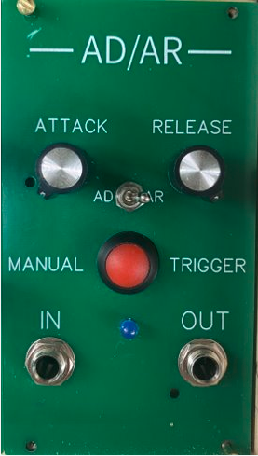

Figure IV‑3: Illustration of New Concept for Function F4

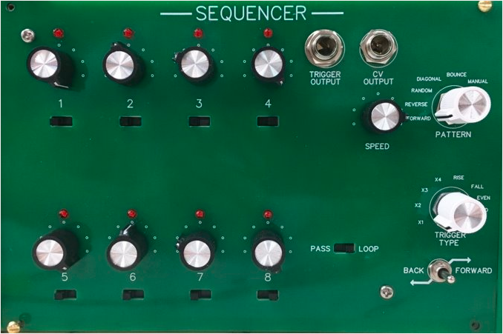

Figure IV‑3: Illustration of New Concept for Function F4

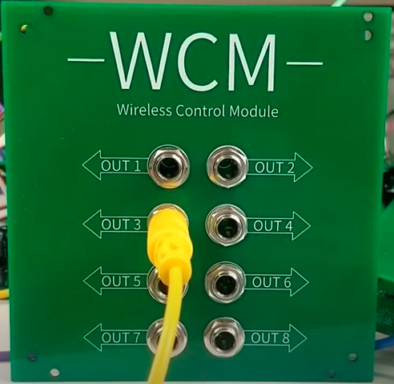

Figure IV‑3: Illustration of New Concept for Function F4

### Concept/Solution for Function F5 – Manipulate Signal Frequency

#### Original Concept/Solution Selected for Function F5

After considering a handful of concepts and processes for the manipulation of signal frequencies, we ultimately decided to include pitch and filtering controls which are present in the Voltage Controlled Oscillator, Voltage Controlled Filter, Sequencer, Envelope Generator, and Wireless Control modules.

Pitch control is a standard function for most modular synthesizers. As a musical instrument, it is important to be able to control the pitch in order to simulate the 12 notes that make up the musical scale and allow the user to create melodies. Specifically, Pitch control allows the user to raise or lower the frequency of an audio signal. Lowering the pitch is the same as lowering the fundamental frequency (or increasing the fundamental wavelength). Raising the pitch is the same as raising the fundamental frequency (or decreasing the fundamental wavelength).

Just as pitch control simulates musical notes, the filtering function of a modular synthesizer controls the tone of the output signal. In short, filtering involves manipulating signals by selectively removing (filtering) specific frequency components of a signal and passing others. Filtering different frequencies allows the user to customize the tone of an audio signal. In Team 80’s modular synthesizer, the Voltage Controlled Filter module consists of both a high-pass and low-pass filter.

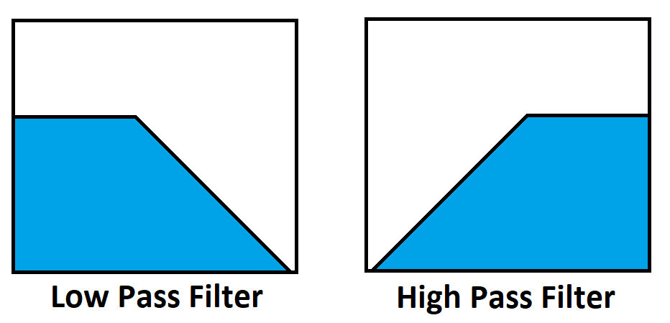

Figure IV‑2: Illustration of Original Concept for Function F5

#### Re-design Concept/Solution for Function F5

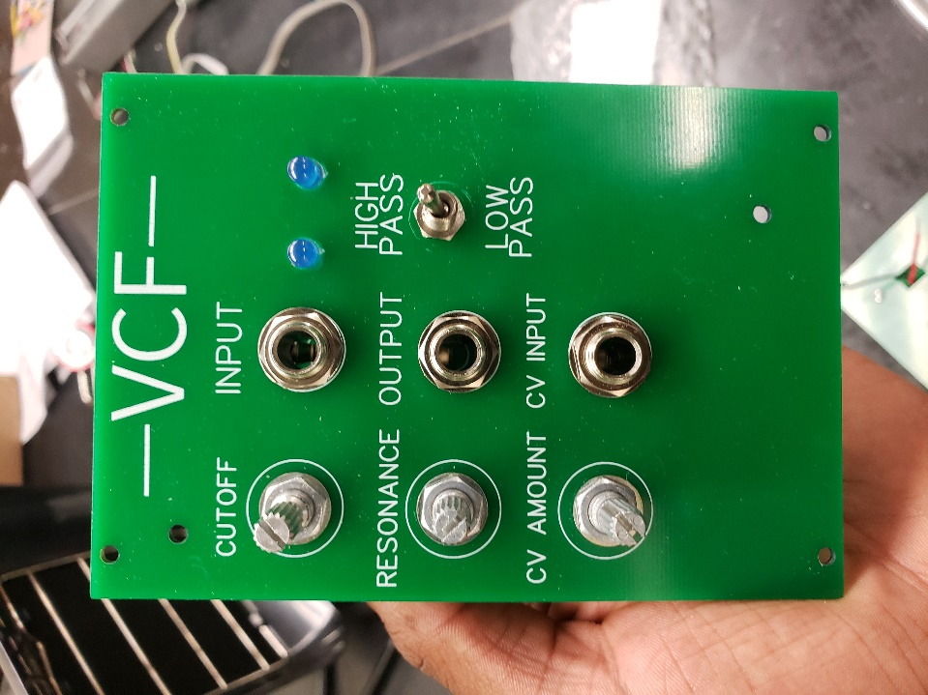

Figure IV‑3: Illustration of Voltage Controlled Filter module for Function F5

### Concept/Solution for Function F6 – Manipulate Signal Amplitude

#### Original Concept/Solution Selected for Function F6

Both the Level Control Module’s Volume Control and MyDAQ Converter subcircuits were designed to control the amplitude of the signals of the system. For an explanation of the Volume Control Circuit refer to **I.A.1. Concept/Solution for Function F3 – Output Audio Signals.**

In order to monitor signals from the system with a National Instruments MyDAQ, the signal must be attenuated to a voltage lower than +/-10V. The MyDAQ converter implemented an inverting op-amp attenuator to lower the possible +/-12V signal produced by the synthesizer by a gain factor of about 0.69. Figure IV-2 includes a circuit diagram of the original MyDAQ converter along with an example of an inverting op-amp attenuator.

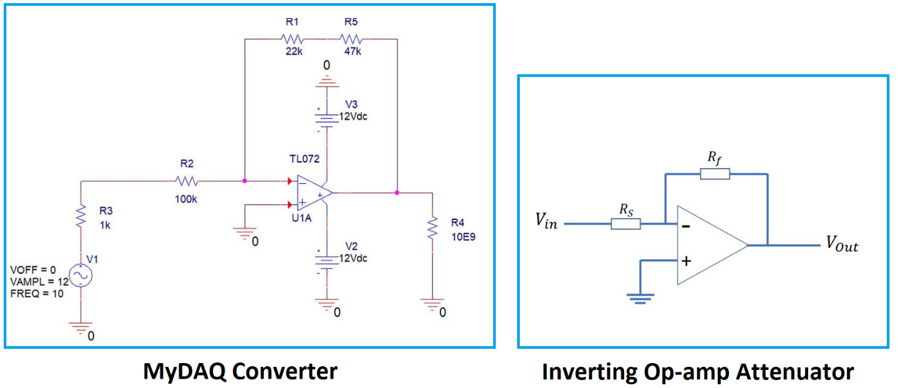

Figure IV‑2: Illustration of Original Concept for Function F6

#### Re-design Concept/Solution for Function F6

The only issue with the original design is that the signal was inverted which makes it less than ideal if the purpose of the circuit is to monitor signals. To remedy this the extra op-amp on the IC used in the original design was used to create a second inverting op-amp, but this time with unity gain. Doing this inverted the original input signal a second time so that it maintained the same polarity at the output as the input without attenuating the signal any further. Figure IV-3 shows the circuit diagram for the final design of this circuit.

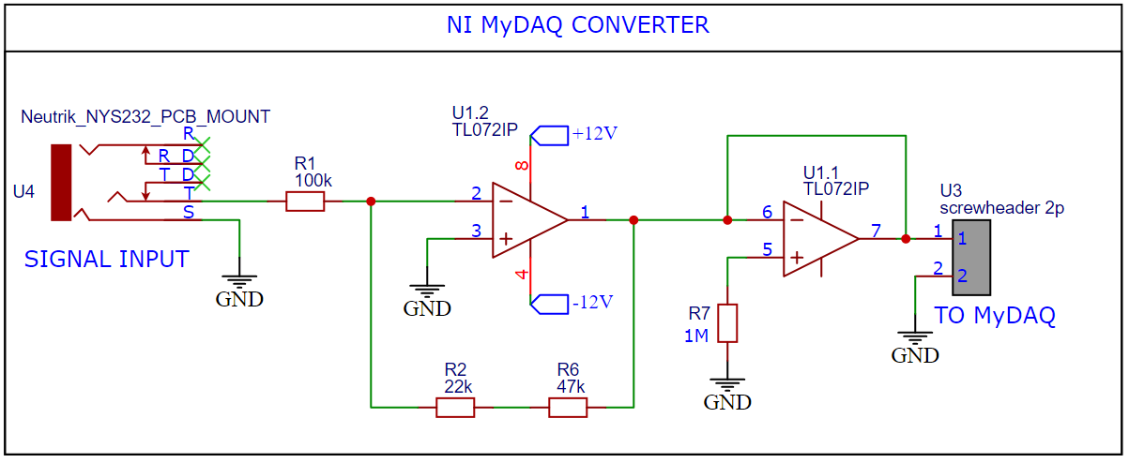

Figure IV‑3: Illustration of New Concept for Function F6

### Concept/Solution for Function F7 – Process Signals Digitally

#### Original Concept/Solution Selected for Function F7

For the digital processing of signals, a programmable DSP Microcontroller was selected. With the main function that separates our system from our competitors, it makes sense to select the option with the greatest educational value in terms of tailoring DSP programs & display, as well as allowing students to upload their own code to experiment with. It also is easy to integrate into a module form, fitting well with our system.

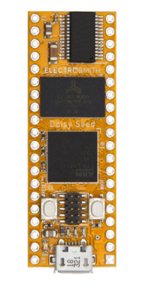

Figure IV‑2: Illustration of Original Concept for Function F7

#### Re-design Concept/Solution for Function F7

A programmable microcontroller, the Electrosmith Daisy Seed, was kept as the solution for this function. Below shows the fully assembled Digital Multi-Effects Module, which was used to fulfill the functions of Digital Signal Processing.

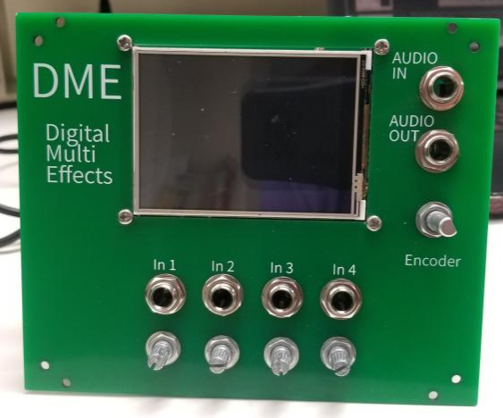

Figure IV‑3: Illustration of New Concept for Function F7

This module contains 4 effects for processing signals digitally:

1. Distortion
2. Bitcrusher
3. Delay
4. Reverb

### Concept/Solution for Function F8 – Regulate Operating Temperature

#### Original Concept/Solution Selected for Function F8

Heatsinks are attached to the circuit components with the highest power draw, such as power regulators. This regulates temperature per module basis. Heatsinks will also be placed on the power supply. Ambient case temperature will be regulated through holes located on the back side of the system case, allowing for convection cooling.

#### Re-design Concept/Solution for Function F8

These same solutions were included on the product, shown below.

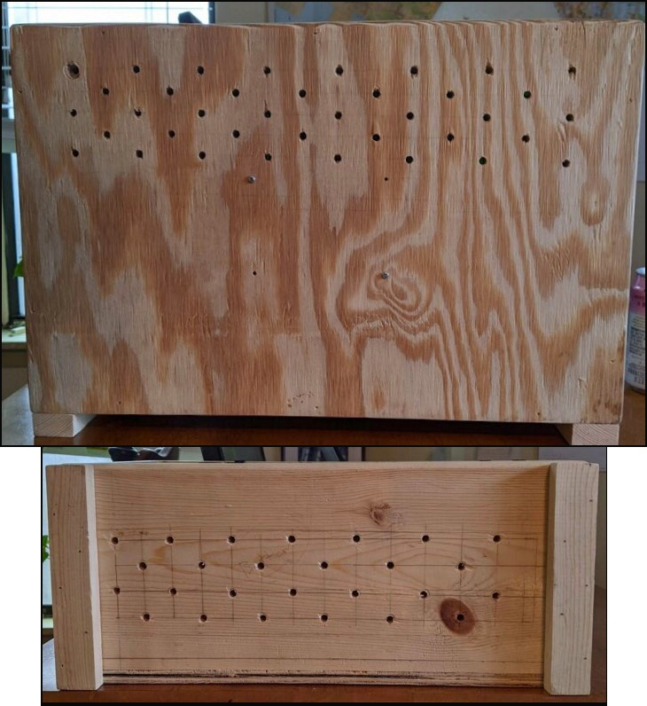

Figure IV‑2: Illustration of case system heat ventilation: Temperature Regulation F8

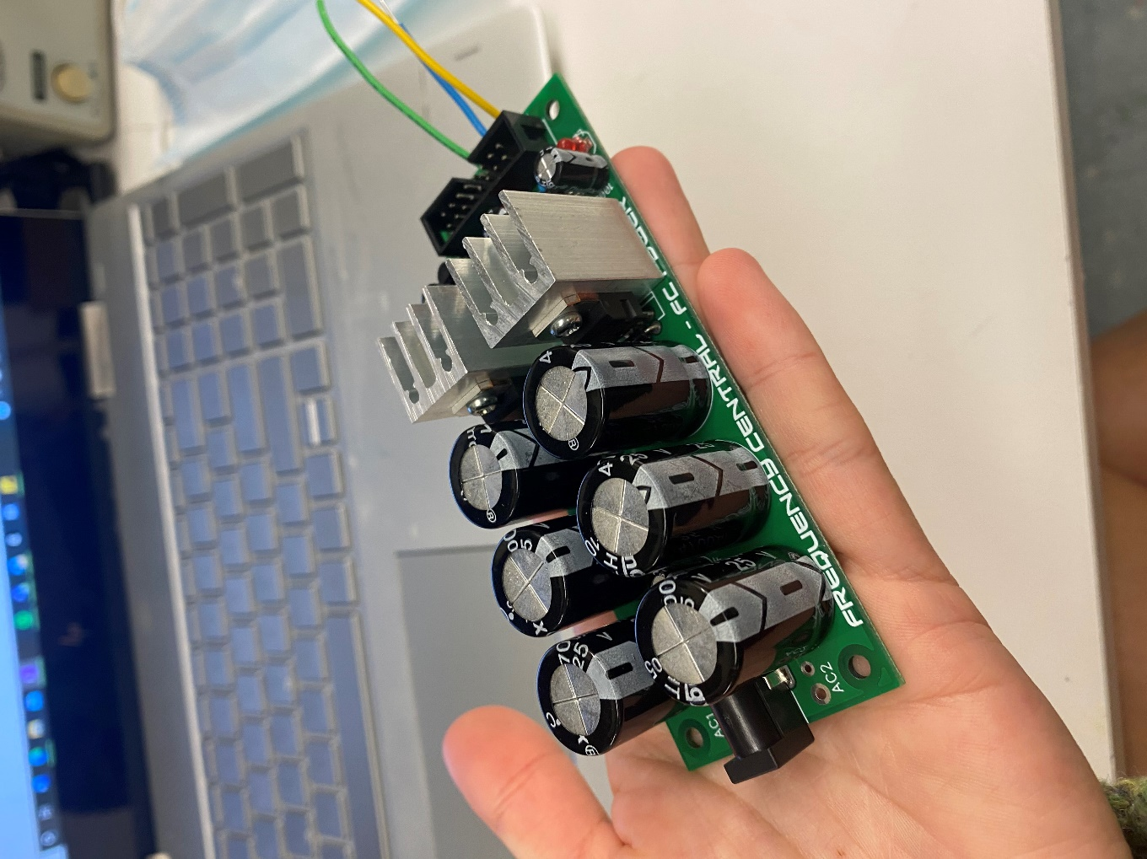

Figure IV‑3: Illustration of power supply sink: Temperature Regulation F8

### Concept/Solution for Function F9 – Reroute Signal Path

#### Original Concept/Solution Selected for Function F9

To fulfill the function of rerouting signal paths, the team opted to use patch cables, and include audio and CV I/O connections on each module. While this makes it more likely that students can make wrong or useless connections, patch cables are necessary to use modular synths, and with proper manuals explaining the modules, this problem can be mitigated.

#### Re-design Concept/Solution for Function F9

Our system uses input and output audio jacks on each module that are compatible with TS patch cables. Our faceplate offers clear labels of where patch cables should be connected from module to module.

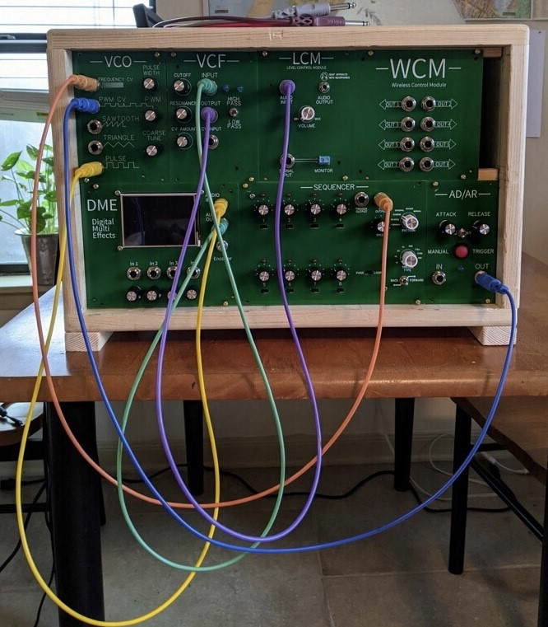

Figure IV‑3: Illustration of New Concept for Function F9

### Concept/Solution for Function F10 – Operate via Remote Control

#### Original Concept/Solution Selected for Function F10

For remote control capabilities, mobile application for remote control was selected, as it seemed the most accessible, cheapest to create, and offers many controlling options.

A laptop/computer controller was selected as well, as it is possible to create both the phone and computer app together, offering 2 options for the price of one, especially if a student does not own a smart phone, or a musician is performing using a laptop computer.

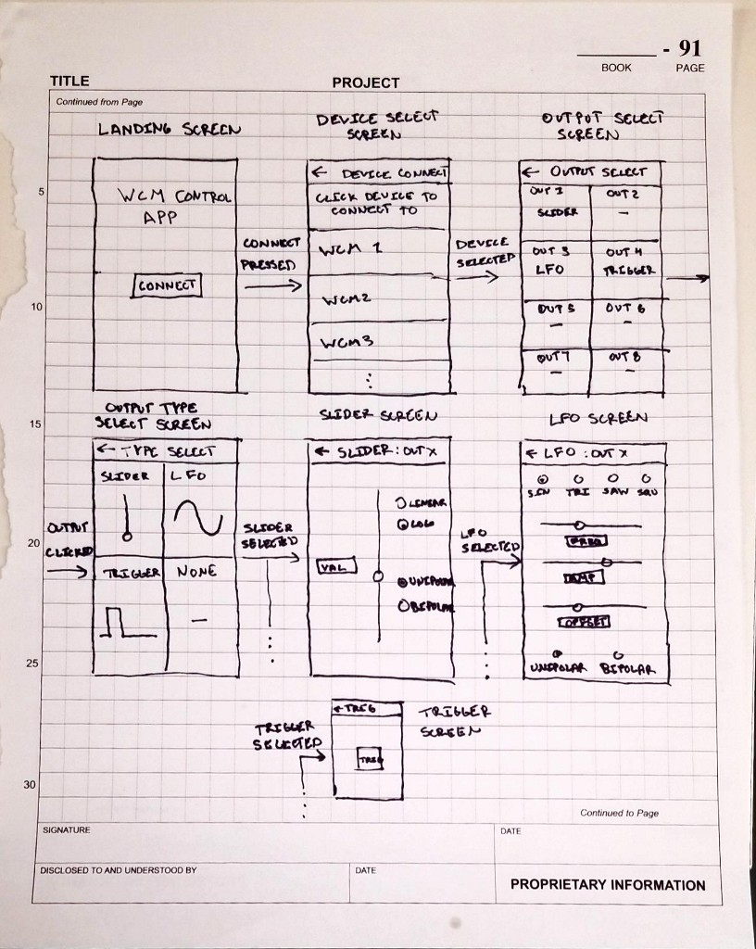

Figure IV‑2: Illustration of Original Concept for Function F10

#### Re-design Concept/Solution for Function F10

In the end, only an Android phone application was created for remote control of our system. The platform used to create this app, React Native, can be used to create iPhone and web applications, but that part of the framework was not explored for this project.

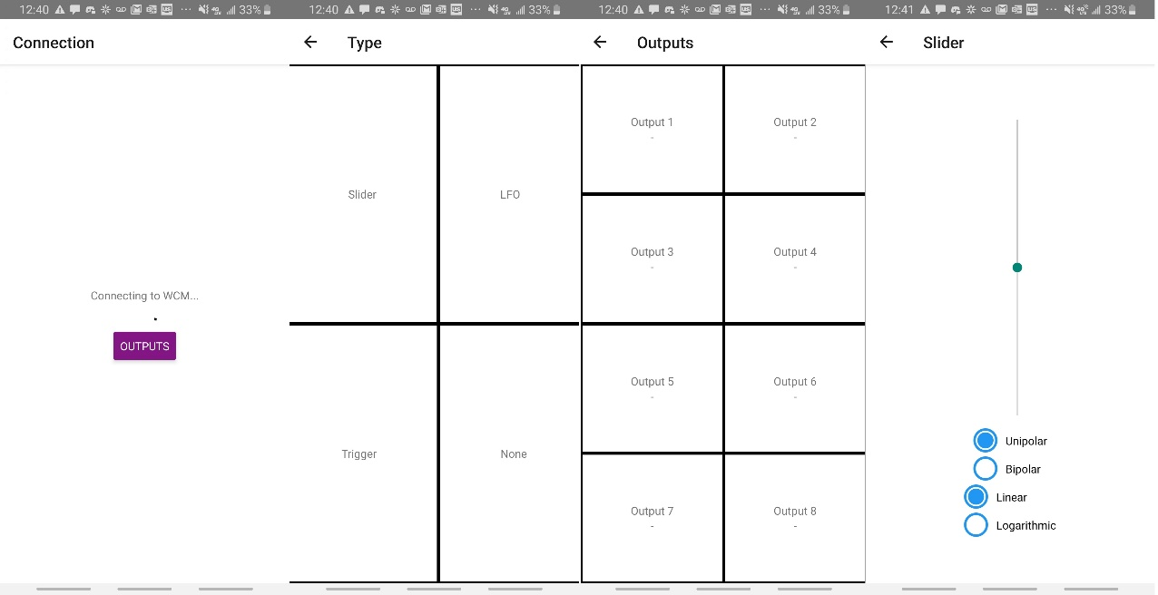

Figure IV‑3: Illustration of New Concept for Function F10

## System Description/Product Architecture

Below each module architecture is depicted within the case.

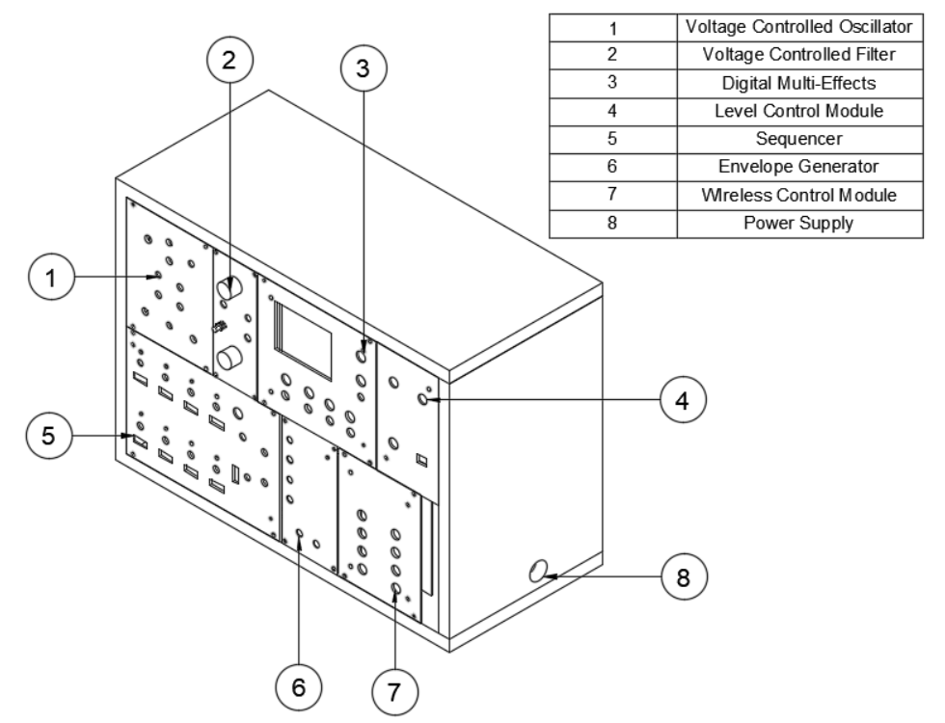

Figure IV‑4: Assembled Prototype Drawing

|  |  |  |
| --- | --- | --- |
| # | Name | Brief Description of Sub-System Functionality |
| SS1 | Voltage Controlled Oscillator | * Generate Waveforms such as Square, ramp, and triangle wave form. * Accepts user input to control voltages to change parts of the signal   Allows changes to pulse width, octaves, pitch |
| SS2 | Voltage Controlled Filter | * Filter frequency content to attenuate low or high frequency signals, or a combination of the two with a switch.   Adjust cutoff frequency and resonance for each filter type |
| SS3 | Digital Multi-Effects | * Contains several digital effects that can be applied to an input signal * Offers 5 controls to manipulate software parameters to affect DSP applied. * Displays visual feedback to user via LCD display   Contains USB connection for user to upload own effects |
| SS4 | Level Control Module | * Offers volume control so the synthesizer can be outputted to headphones or active speakers.   Steps the signal from the synthesizer down to a level that can be read by a NI MyDAQ device. |
| SS5 | Sequencer | * Produces a voltage at each step that can be used to control other modules. * The voltage at each step is adjustable. * Steps in the sequence can be triggered manually or cycled through by an internal clock.   Allows musicians to make rhythms, melodies, and analog presets. |
| SS6 | Envelope Generator | * Produces a 5-volt control voltage that automates the function of other modules. * Two user modes: Attack-Decay and Attack-release * AD is a trigger input. AR is a gate input. * Attack and Release knobs featured to adjust the rate of increase or decrease in both modes. |
| SS7 | Wireless Control Module | * Accepts commands from a wirelessly controlled application   Outputs Control Voltage signals based on these wireless signals |
| SS8 | Power Supply | Converts 120V AC into a +12V and -12V Rail for powering modules |

Table IV‑1: List of Sub-Systems

### Description of Sub-System SS1 – Voltage Controlled Oscillator

The voltage-controlled oscillator is a module of the system that can either produce waveforms or adjust the signal frequency of its own waveforms. It can produce saw, tri, and pulse waves. With knobs to change the frequency of all waveforms. The pulse width is the only one that can be changing the pulse duty cycle. The VCO like most modules is powered by +/-12v rails with Schottky diodes and filtering caps on the rails. What you see below is the cem3340IC or as3340 IC with two tlo72 chips.

These two op amps help attenuate and buffer the outputs for the output waveforms. The IC circuit resistor ratios and setups are by datasheet with only a couple of resistors changing to match. There are potentiometers to help change the outputs 3 knobs to change the PWM, pulse width fine tune, and frequency control. There is also a scale adjust above R24 that lets you tune the VCO to an instrument.

All outputs are followed with 1ks and inputs have 100k ohm resistors.



Figure IV‑5: Drawing of Sub-System SS1

### Description of Sub-System SS2– Voltage Controlled Filter

The Voltage Controlled Filter is the primary module whose purpose is to manipulate the frequency content of an input audio signal by attenuating the amplitude of either the high or low ends of a signal’s frequency, but the module also functions as a physical representation of concepts such as filtering and active components learned in Electronics II. The Filter module that we have decided to construct consists of a high-pass and low-pass filter, as well as a resonance, cutoff, and CV control.

The cutoff control knob allows the user to choose at what frequency the audio signal will attenuate and drop off, while the resonance control knob allows the user to control the amplitude boost that occurs right before the cutoff. The CV control knob is used to manipulate the cutoff frequency as well but does so using the control voltage sent through the respective CV input.

The VCF is powered by the -+12V power rails that connect the rest of the modules to the synths power source. Other than the power rails that connect to the LM13700 op-amp IC that makes up the high-pass and low-pass sub-circuits, and the TL074 IC that makes up the resonance control and current control sub-circuits, the VCF consists of a control voltage input (CV) and input audio signal that normally originates from the Voltage Controlled Oscillator Module (VCO).

The current control sub-circuit consists of a CV input and a pitch control that comes from the audio input, both of which flow into two mirroring PNP transistors that make up the exponential converter. The CV is manipulated with a potentiometer to manipulate the cutoff of the frequency response. All together alongside the TL074 op-amp that feeds into the exponential converter, these components form the control current sub-circuit which generates a current that influences parameters such as the resonance and cutoff controls in the output audio signal.

The high-pass and low-pass filter are composed of two LM13700 Operational Transconductance Amplifiers (OTA) connected in series with two transistor buffer circuits. The OTAs are configured as integrators-with-negative-feedback, which creates the same transfer function as a single RC filter. When the capacitor connected to the second OTA is grounded and the signal is fed through the first op-amp, the VCF is in its low-pass filter configuration. To switch the module to its high-pass configuration, the VCF consists of a toggle switch that grounds the first OTAs input and connects the input audio signal to the capacitor that was previously grounded under the second OTA.

​Lastly, the VCF house a clipping sub-circuit that consists of another TL074 op-amp that connects to two LEDs and a potentiometer that together form the resonance control for the module.

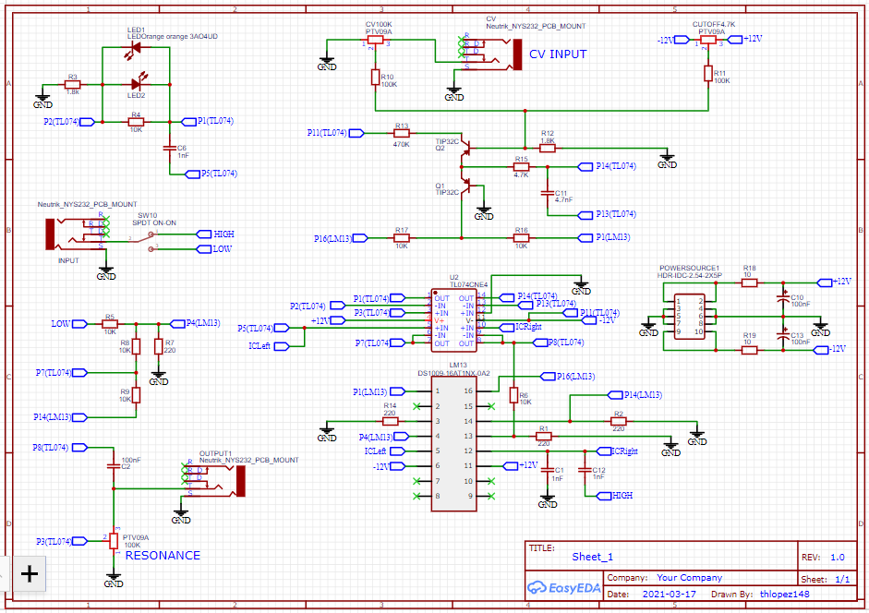

Figure IV‑5: Drawing of Sub-System SS2

### Description of Sub-System SS3– Digital Multi-Effects

The Digital Multi-Effects Module is included in the system to teach DSP concepts to its users. It takes in an analog signal from another module, converts this into a digital stream of bits, performs a specified DSP function on this digital signal, then converts it back into an analog signal for routing to another module.

The hardware for this module consists of 6 subcomponents. An audio input attenuator & filters reduces the incoming audio signal’s amplitude and filters out high frequency noise to prevent aliasing. A DSP Microcontroller, the Electrosmith Daisy, takes audio input and control values and outputs audio and LCD control data. A control parameter input amplifier and summing circuit take in knob and CV control values, adds the signals togethers, and outputs it to the DSP microcontroller for controlling program parameters. A power regulator conditions the power rails and powers all other sub circuits at varying voltages. The LCD display displays information about the applied effects and control parameters.

The code for the DSP micro controller consists of a main function in an infinite loop, calling 3 subfunctions, the analog input controller, an LCD Display Driver, and a DSP process block. The analog input controller is called when there is a change to any of the analog input pins, which updates the internal values of program select, control select, and ADC values, which represent control values. The values are then passed to the LCD display driver, which outputs commands via the SPI Bus Protocol to the display. The DSP process block is called whenever the incoming audio buffer is full, taking in the buffer and applying the algorithm specified by program select, and modified by values in ADC values. It then spits out a modified audio buffer to the output for the on board digital to analog converter.

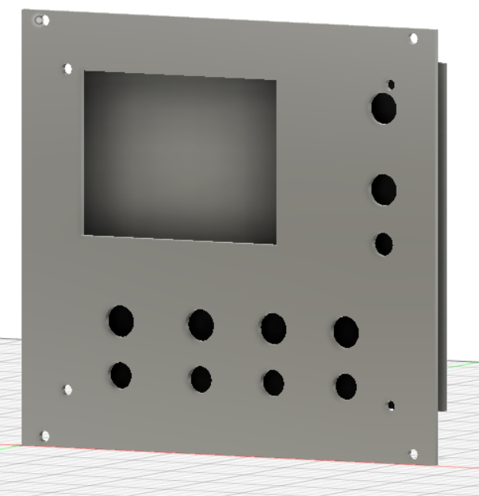

Figure IV‑5: Drawing of Sub-System SS3

### Description of Sub-System SS4– Level Control Module

The Level Control module contains a volume control circuit and a MyDAQ converter circuit on a single PCB.  The MyDAQ converter was included in the system to aid in education. It accepts a maximum +/-12V input and attenuates it to a maximum +/-8V output. By attenuating the signal from the synth to this range it is possible for students to measure signals from the synthesizer using the MyDAQ’s analog input channels. The MyDAQ offers onboard oscilloscope, spectrum analyzer, bode analyzer, and multimeter software which students can use to take measurements of the synthesizer.

​ The volume control was included in the system as a safety measure to prevent hearing damage to the user. The volume control accepts a maximum +/-12V input and attenuates it to a maximum +/-2V signal that can be outputted to headphones rated for 32Ω headphones or active speakers. The amount of attenuation can be controlled via an audio tapered potentiometer.

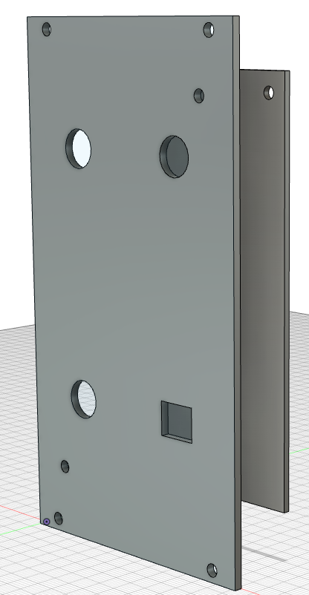

Figure IV‑5: Drawing of Sub-System SS4

### Description of Sub-System SS5– Sequencer

The Sequencer is one of three modules that outputs a control voltage. This module’s output offers the system a way to create complex rhythms and melodies.

This module includes 8 steps. A sequence refers to the pattern of when each step (or channel) is triggered by the user. Only a single channel is on at a given time. Essentially, these “steps” are 8 configurable notes that make up the CV output.

Using potentiometers, users can control the number of times a step is triggered before moving to the next step (The Trigger Count potentiometer). Trigger Count options include (Manual, 1x, 2x, 3x, 4x, 5x, 6x, 7x, and 8x). The amplitude of the Sequencer’s output can be altered by adjusting a potentiometer at each step.

An Arduino Nano is used at the core of this module’s input signal and timing function. The rate at which the Arduino changes steps (aka Sequence Rate) can be user adjusted via the “Clock Rate” potentiometer. A Loop/Through toggle switch allows users to change how the Arduino reads an “off” step. The Loop option means once the Arduino senses a step that is off, it loops back to the beginning of the sequence. The Through option includes the off steps in the sequence as a time delay.

The module’s default functionality is an 8-step sequence where all 8 steps are triggered before the pattern repeats. Limiting the sequence to 4 steps for example means only 4 steps will be triggered before the pattern repeats.  In Manuel mode, a SPDT switch labeled “Forward/Backward” allows users to manually cycle between different steps. This is possible because the Arduino is programmed to stop automatically switching steps. For instance, the “Forward” pattern triggers steps 1 through 8 in the following order(1-2-3-4-5-6-7-8-1-2-3…). There are five unique patterns available (Forward, Backward, Random, Convex, and Concave).

The output of each step channel passes through a non-inverting op-amp buffer before being sent to another module. This op-amp buffer is used to isolate the module’s circuitry from any modules it may be connected to ensuring system safety from overcurrent draw. This TL072 is powered by the +/- 12V rails directly.

We are using a voltage regulator (L78L05AC) to step down the +12V before inputting to the Arduino. The Arduino’s maximum input voltage of +5V​

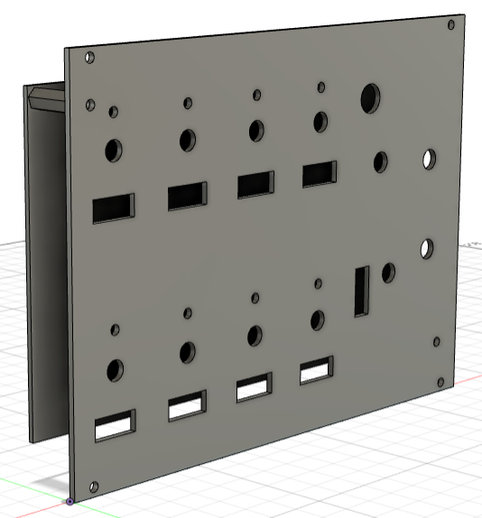

Figure IV‑5: Drawing of Sub-System SS5

### Description of Sub-System SS6– Envelope Generator

The Envelope Generator is of the Attack-Decay/Attack-Release type. This refers to the two modes that the Envelope Generator can function in.

A: “Attack” potentiometer. This knob allows system users to change the rate at which the envelope reaches the maximum set control voltage of 5 volts.

B: “Release” potentiometer. This knob allows system users to change the rate at which the envelope decreases from the maximum voltage to zero.

C: AD/AR toggle switch. When envelope is in Attack-Decay , the switch is in trigger mode. In this mode, once the attack mod is over, the control voltage decays to zero. There is no function of voltage sustain.

When the envelope is in Attack-Release, the switch is in gate mode. In this mode, the maximum voltage begins to fade out at the falling edge of a gate signal. The input acts as a comparator. When the gate input goes high, the comparator output goes high, and the capacitor is charged through D7 and the Attack pot; when the gate goes low, the comparator goes low, and the capacitor discharges through the Release pot and D8.

D: Manual trigger button. Triggers the start of the attack phase when pressed. During AR mode, the button can be held down and the maximum 5 voltages will sustain until the button is released.

E: Input audio jack. The Envelope Generator can accept positive 5-volt gate signals from the Digital Effects Module, Voltage Controlled Oscillator, and the Sequencer.

F: Output audio jack. Output of this module can supply a control voltage to the Voltage Controlled Filter and Sequencer.

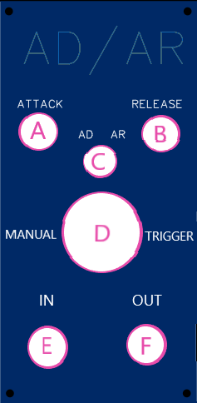 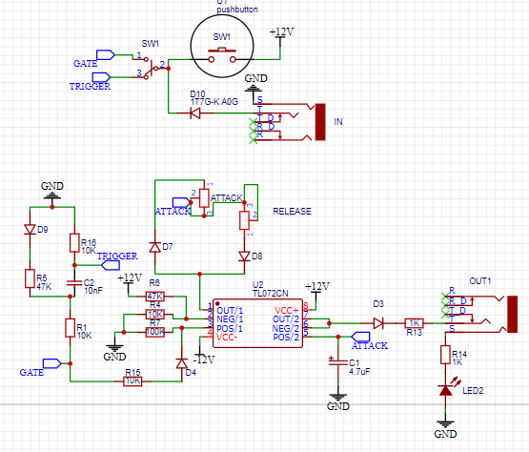

Figure IV‑5: Drawing of Sub-System SS6

### Description of Sub-System SS7– Wireless Control Module

The wireless control module is an array of 8 Control Voltage outputs that can each be independently controlled via the remote wireless application. Types of control voltage outputs include linear and logarithmic sliders, low frequency oscillators, and digital keyboard control, among others.

The hardware of this module consists of 4 main subsystems. A wireless microcontroller, the ESP32, accepts wireless commands from the remote application. It then sends a PWM signal in SPI bus protocol to 8 digitals to analog converters. Amplifier and voltage shift circuits accept the analog signal from the DAC and convert it to acceptable CV range, +/- 5V. A power regulator conditions the power rails and supplies power to all other subcircuits.

The software of this module is split into 2 halves, the application and module side. On the application side, a user will select an output number and CV type via the user interface. When they change its value, a packet will be generated on the application side and sent wirelessly to the module’s microcontroller. The microcontroller will interpret this packet and update the appropriate output, outputting appropriate commands via SPI Bus Protocol.

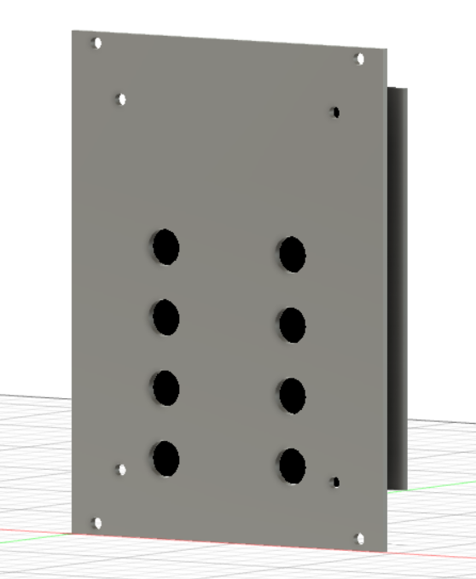

Figure IV‑5: Drawing of Sub-System SS7

### Description of Sub-System SS8– Power Supply

The power supply is the Microbus, purchased from Frequency Central. This is a dual linear power supply meaning it has a +12V and -12V linear power rail. Each of these rails is capable of delivering 500mA individually. This supply was chosen due to its current capabilities and the fact that all of the op-amps in the system require a +/-12V supply. Additionally, the Microbus includes male header 16pin IDC connectors making it simple for all of the modules to be connected. Figure IV-5 shows the Microbus and how it connects to a module.

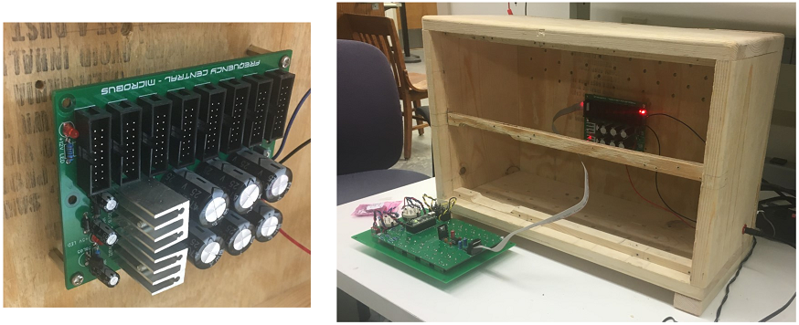

Figure IV‑5: Drawing of Sub-System SS7

# Engineering Analysis and Materials Selection

## Engineering Analysis for SS1- Voltage Controlled Oscillator

### Types of Eng. Analysis Conducted:

Brief description the circuit covering the oscillator has two parts. The PWM and the outputs (Saw wave, pulse, and triangle.

Current draw was conducted on the circuit indirectly by being part of the total system power draw.

* Simple Circuit Analysis using PSPICE simulations
  + Before implementing the circuit, we ran PSPICE simulations on the outputs to see if the circuit would perform close to the datasheet specifications.

The saw the triangle and pulse outputted on the PSPICE schematics at 10v,8.4v,10, respectively.

With outcomes on datasheet for the ic project the outputs being at 8.4v, 10v, and 11v.

Even though the schematics were off I was confident that it was just some proprietary IP on the IC that was not being simulated.

* Live Oscilloscope Readings of the outputs
* Temperature Readings of IC’s
  + Conducted using heat gun
  + With temperature readings taken while powered and outputting over 5min intervals. The readings were taken over an average.
  + So, the readings didn’t even come close to 30degrees Celsius so no heat sink or redesign was needed for moving parts on the board.
  + But the expected max outcomes were 50degrees Celsius, but we didn’t even get close at 26-30degrees Celsius over the testing interval.

### 

### Eng. Analysis & Materials Selection for SS#-P# - Part Name

Click or tap here to enter text.

## Engineering Analysis for SS2- Voltage Controlled Filter

### Types of Eng. Analysis Conducted:

* DC Analysis
* The chosen Op-Amps that increase the amplitude of the signal require rail voltages between +12V and -12V, and a gain low enough that keeps the amplified signal within a +/-12V output voltage. To test this, a DC sweep ran through PSPICE with voltage measurement nodes through the individual Op-Amps to measure the gain of each, and make sure that a cascading voltage gain is present.
* AC/Frequency Response Analysis
* The filter module needs to be able to handle frequencies ranging from 1 Hz – 40kHz.
* In between the 20Hz-20kHz range, each filter circuit needs to be able to attenuate the signal at different frequency levels.
* · Low-Pass Filter: Able to filter out signals over 20KHz
* · High-Pass Filter: Able to filter out signals under 20Hz
* The PSPICE frequency response analysis can assess the output frequency content from each of the three filters, as well as the effect of the resonance and cutoff controls.

* Power Analysis
* The module should be able to take in and output +-12V. Like the DC analysis, a PSPICE DC sweep can measure the module’s input/output voltage by placing voltage nodes at the input and output of the module to measure the total voltage output of the system. From the information given we can derive the total power output of the module, as well as the power produced by each Op-Amp in the circuit.
* Sensitivity Analysis
* PSPICE advanced analysis can measure the sensitivity of each circuit component in the filter design to determine the needed sensitivity ranges.
* Temperature Analysis
* A temperature sweep done in PSPICE can determine the temperature variation given off by each circuit component in the filter module, and the parameters of the simulation temperature can be altered and tested.

### Eng. Analysis & Materials Selection for SS2-P1–LM13/700 OTA

Tarik Lopez

Since the filter module’s low-pass and high-pass functions operate with two operational transconductance amplifiers connected in series with two transistor buffers, deciding to use the LM13/700 op-amp was based on the desired parameters and circuit layout that the IC promised.

### Click or tap here to enter text.

## Engineering Analysis for SS3- Digital Multi-Effects

### Types of Eng. Analysis Conducted:

* DC Sweep
  + Ensure input audio signals of +/-10V translate to +/-1V for the Electrosmith Daisy
  + Ensure output audio signals from the Daisy of +/-1V translate to +/-10V
  + Ensure knob input of 0-3.3V summed with CV input of +/-5V translate to 0-3.3V analog input to the Daisy for control parameters
* AC Analysis
  + Ensure no attenuation of frequencies under 20kHz but filter out high frequency noise at audio input and output.
  + Ensure filtering out of frequencies of over 1kHz for the parameter input summing circuit
* Sensitivity Analysis
  + Identify most crucial components for audio I/O and parameter control sub circuits in terms of altering output voltages.
* Transient Analysis
  + Ensure slew rate of audio I/O is capable of handling 7kHz, the highest frequency of the VCO
  + Ensure slew rate of parameter input circuit can handle 100 Hz, the highest frequency of the LFO of the Wireless Control Module
* Temperature Analysis
  + Ensure minimal alteration of voltage levels at temperatures between 0 °C and 120 °C, the minimum and maximum expected temperatures of components
* Power Analysis
  + Discover power draw for the circuit from the +12V and -12V rail to determine total power draw of all modules, and therefore power supply needs.

### Eng. Analysis & Materials Selection for SS3-P1- DSP Microcontroller

Kyle Sellers (EEC)

The 2 most common chips for digital signal processing are the Electrosmith Daisy and SPIN FV-1, which were weighed in terms of cost, ease of programming, size, audio fidelity, I/O, and memory in a decision matrix. The Electrosmith Daisy was selected primarily due to its wildly superior ease of programming and memory specs, as the device should be easy to code by electrical engineering students who have only taken one programming course and be able to hold multiple programs. The decision matrix for this can be found in the corresponding appendix section.

### Eng. Analysis & Materials Selection for SS3-P2- Audio Input Attenuator / Filter

Kyle Sellers (EEC)

**DC Sweep:**

The input of this sub circuit was swept from -10V to +10V, with anticipated values at the output being +1V to -1V, respectively, as this sub circuit is in the inverting attenuator Op-Amp configuration with a calculated gain of 0.1.

Results of SPICE analysis aligns with calculated values, as seen in the appendix.

**AC Sweep:**

The audio input needs to pass all frequencies from 20-22kHz without attenuation but filter out frequencies above 22kHz to prevent aliasing.

The RC cutoff frequency was calculated to be 28kHz. Looking at the output Bode plot, the SPICE simulated -3dB frequency aligns with this.

Transient, sensitivity, temperature, and power analysis were also conducted, with results available in the appendix.

### Eng. Analysis & Materials Selection for SS3-P4- CV / Knob Sum Kyle Sellers (EEC)

**DC Sweep:**

Since both CV and Knob inputs should be able to independently generate a 0-3.3V sweep at the output, 3 DC Sweeps were run, with the knob at the minimum, maximum, and middle position, respectively.

Since the Op-Amp is in inverting configuration, the minimum position should produce 3.3V at the output. Sweeping the CV from -5V to +5V , the -5V to 0V range should not affect the output, and the 0V to +5V range should sweep the output from 3.3V to 0V. SPICE simulations show the output remains at 3.3V from -5V to about 120 mV. Then, it sweeps linearly from 3.3V to 8 mV (essentially 0) when CV is 5V.

At the knob minimum position, the output should produce 0V. .Sweeping the CV from -5V to +5V , the 0V to 5V range should not affect the output, and the -5V to 0V range should sweep the output from 3.3V to 0V. SPICE simulations follow this exact assumption.

At the knob middle position, the output should be at 1.67V, half the output range. .Sweeping the CV from -5V to +5V , the -5V to -2.5V range and +2.5V to 5V range should not affect the output. The -2.5V to 2.5V range should sweep the output from 3.3V to 0V. SPICE simulations show this range is actually -2.26V to +2.6V, but this is close enough for our uses.

**AC Analysis:**

The cutoff frequency for the RC low pass filter in this circuit is 1kHz, which is high enough to account for a 100Hz square wave LFO’s 9th harmonic at 900Hz.

Running an AC analysis at the CV input, the -6dB frequency was verified to be 1kHz, which is half signal strength.

Transient, temperature, and power analysis were also conducted, which can be found in the corresponding appendix section.

### Eng. Analysis & Materials Selection for SS3-P5- LCD Display Kyle Sellers (ECE)

The LCD Display is used for giving the user feedback about internal program values, so it needs to be large enough to display the program selected and 4 parameter names and their values. Discussing size with the sponsor, a minimum of 3 inches was a constraint.

Looking at display options, OLED and LCD displays were considered. LCD was selected due to having lower cost and higher resolution.

A 3.2” TFT LCD was selected, with specifications included in the appendix.

### Eng. Analysis & Materials Selection for SS3-P6- Power Regulator Kyle Sellers (EEC)

The power regulator needs to filter the +/-12V power rails, provide 5V power to the DSP Microcontroller and LCD Display, and provide a -10V reference voltage to the CV/ Knob Sum circuit.

The +/- 12V rails are filtered via a 10uF capacitor near the input, and 0.1uF capacitors near each Op-Amps power input. Ferrite beads were considered but were ultimately not included in the design.

For providing 5V power, the LM7805 linear power supply was selected, since the Electrosmith Daisy Seed can be powered from 5-12V, and the LCD Display can be powered from 3.3V-5V. Since 5 V is on the fringe values of both, the 5V power needs to be stable, so linear power was selected. Input and output capacitors are included as well to account for current spikes and other ripples in voltage values. A heatsink will be mounted to the LM7805, as there is a large voltage drop across the power supply.

The -10V reference voltage is provided by a 10V LM4040 from the -12 V rail. This is sufficient, as 0.1 mA is the maximum current draw for this application, so a voltage regulator is not needed.

## Engineering Analysis for SS4- Level Control Module

### Types of Eng. Analysis Conducted:

* Transient Analysis
* Power Analysis
  + Discover power draw for the circuit from the +12V and -12V rail to determine total power draw of all modules, and therefore power supply needs.

### Eng. Analysis & Materials Selection for SS4-P1 – MyDAQ Converter

Taylor LeBlanc(EE)

The converter needs to attenuate a +/- 12V signal to +/-8V (20% less than the max input voltage of the MyDAQ). To accomplish this, an inverting op-amp configuration was needed. A TL072 op-amp was chosen for this task because of its low power consumption, low noise production, and low price.

**Transient Analysis:**

PSPICE analysis was performed to monitor how the output voltage changed in relation to changes in the input voltage. The circuit was shown to have a fixed gain of about 0.69. This was determined by the gain equation of an inverting op-amp: $A= - \frac{R_{f}}{R_{s}}$  .

**Power Analysis:**

  The TL072 drew about 4.7mA from the +12V rail and 4.7mA from the -12V rail. Due to the large input impedance of the MyDAQ (10GΩ), the current draw of the load was negligible. Therefore, the MyDAQ draws 5mA from the +/-12V rails.

### Eng. Analysis & Materials Selection for SS4-P2 – Volume Control

Taylor LeBlanc (EE)

The volume control circuit uses an inverting op-amp configuration to attenuate a signal sent to a 35Ω impedance rating. The NE5532 op-amp was selected due to its high output-drive capability and low distortion.

**Transient Analysis**

PSPICE was used to verify that adjustments made to the potentiometer used as the amplifier’s feedback resistor could vary the circuit’s gain. When the potentiometer was all the way down the gain was 0. With the potentiometer all the way up, the gain was approximately 0.15 resulting in an output of about -1.6V when the input was 12V.

**Power Analysis**

​It was determined through PSPICE analysis that the circuit draws approximately 85mA of RMS current from the +12V supply rail, and about 82mA of RMS current from the negative supply rail.

## Engineering Analysis for SS5- Sequencer

### Types of Eng. Analysis Conducted:

* Transient Analysis
  + Ensure the CV Output ranges from 0V to approximately 5V, and changes depending on the position of the potentiometer at the step which is currently active.
* Power Analysis
  + Discover power draw for the circuit from the +12V and -12V rail to determine total power draw of all modules, and therefore power supply needs.
* Temperature Analysis
  + Ensure minimal alteration of voltage levels at temperatures between 0 °C and 120 °C, the minimum and maximum expected temperatures of components

### Eng. Analysis & Materials Selection for SS5-P1 – Arduino Nano

Taylor LeBlanc (EE)

The Arduino Nano was weighed against the Arduino Uno and the CD4017 counter IC. The Nano was chosen over the Uno due to its smaller size. The Nano was chosen over the CD4017 due to its ability to create complex patterns which the CD4017 was not capable of.

According to the datasheet each of the Arduino’s digital pins are capable of outputting a 5V DC signal and constrained to delivering a recommended 20mA to a load. These constraints were considered when running PSPICE simulations for the digital outputs.

Power draw: approximately 6.1mA from the +12V rail of the power supply.

### Eng. Analysis & Materials Selection for SS5-P2 – Analog Inputs

Taylor LeBlanc (EE)

Taylor LeBlanc (EE) Each of the analog inputs are powered from the +12V rail of the power supply after being stepped down to a voltage of about 5V by a larger resistor (typically 100kΩ). The voltage read by each of the corresponding analog pins of the Arduino influences how the Arduino’s outputs behave. The input impedance of the Arduino’s analog inputs is rated as 100MΩ in the datasheet.

**Power Analysis:**

PSPICE analysis was performed to determine the power draw of all of the analog inputs combined. This turned out to be approximately 1mA.

### Eng. Analysis & Materials Selection for SS5-P3 – Digital Outputs

Taylor LeBlanc (EE)

**Transient Analysis:**

The sequencer needs to be capable of outputting a voltage ranging from 0V to 5V to other modules in the synthesizer. Transient analysis was conducted in PSPICE to measure how the output changed as the potentiometer at each step in the sequencer was adjusted. When the step potentiometer was set to its max value the output was about 4.7V (the 0.3V drop resulted from the signal passing through a diode). When the step potentiometer was set to 50% of its resistance the output was about 2.2V. When the step potentiometer was set to 0.25% of its resistance the output was about 0.9V. From these measurements it is clear that a change in a step’s potentiometer causes a direct linear change in the output voltage.

**Power Analysis:**

PSPICE analysis was performed to determine the power draw of the digital outputs. Only a single step is ON at a time, so the Arduino only needs to be able to supply enough current to power a signal LED and supply a reference voltage via the step potentiometer. As a result, the Digital Output Stage of the sequencer only draws about 3.2mA from the Arduino. The Arduino Nano’s datasheets recommend to only allow it to supply up to 19mA of current per pin. Therefore, the Arduino is more than capable of supplying enough current to the digital outputs.

### Eng. Analysis & Materials Selection for SS5-P4 – Output Buffer

Taylor LeBlanc (EE)

**Transient Analysis:**

The output buffer was intended to act as a unity gain amplifier. This means the signal coming out of the op-amp should be the same as the signal going into the op-amp. Transient analysis was performed on the op-amp to measure the input and output of the op-amp configuration with a pulse wave as the source voltage to simulate the signal generated by the Arduino. The analysis showed that the output voltage matched the input voltage in both amplitude and phase. This verified that the op-amp design was indeed acting as a buffer.

**Power Analysis:**

The output buffer uses a single op-amp on a TL072 IC to form a non-inverting unity gain buffer.

The gain of the buffer is based determined by the gain equation for a non-inverting amplifier:

$$A_{v}=\frac{V_{out}}{V_{in}}$$

$$A_{v}=1+ \frac{R_{f}}{R_{s}}$$

Where $R_{f}$ is the feedback resistor, and $R_{s}$ is the source resistor? A wire was placed in the feedback loop instead of a resistor in order to bring the gain equation to $A_{v}$ = 1(aka unity gain).

Power draw of the output buffer: about 4.7mA from the +12V rail, and about 4.7mA from the -12V rail.

### Eng. Analysis & Materials Selection for SS5-P5 - Power Regulator

Taylor LeBlanc (EE)

**Power Analysis:**

The L78L5AC regulator used to supply power to the Arduino Nano is documented in the datasheets to be capable of delivering 100mA of current. Analysis was run in PSPICE to measure how much current the regulator was drawing from the power supply. It was determined from the simulation that the regulator draws about 6mA from the +12V rail of the power supply.

**Thermal(Smoke Point):**

​A L78L05AC regulator is connected to the +12V rail of the power supply line on the sequencer, and outputs a regulated 5V signal. This 5V signal is used to power the Arduino via its +5V supply pin. Since the regulator is stepping down a 12V signal to 5V there was a concern that a heat sink would be needed to cool down the regulator. Smoke point analysis was simulated in PSPICE to determine how hot the regulator would potentially get. The L78L05AC is rated at a max operating junction temperature of 125 ®C. The simulation returned an expected junction temperature of about 113 ®C. While this is technically below the max operating junction temperature, it is close enough (within 10% of the max temperature) that a heatsink should be included.

Click or tap here to enter text.

## Engineering Analysis for SS6- Envelope Generator

### Types of Eng. Analysis Conducted:

* Transient analysi
  + To verify the overall correct functionality of the envelope’s timed control voltage output, running a voltage analysis over the length of the input pulse was necessary.
* Power analysis
  + All system modules need to draw less than 500mA to be compatible with our power supply. Due to the max collector current specifications of the BJT at the envelope’s input, all signals need to supply less than 200mA to the envelope’s input.
* Temperature analysis
  + Ensuring temperature ranges do not stray beyond 0-120 °C, which is the temperature parameters of most common electronic components.
* Sensitivity analysis

### Eng. Analysis & Materials Selection for SS6-P1 – TL072

The TL072 is a dual operational amplifier. It offers low noise and low power consumption ideal for a modular synthesizer.

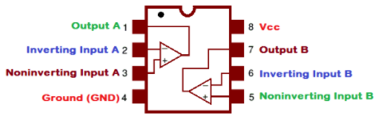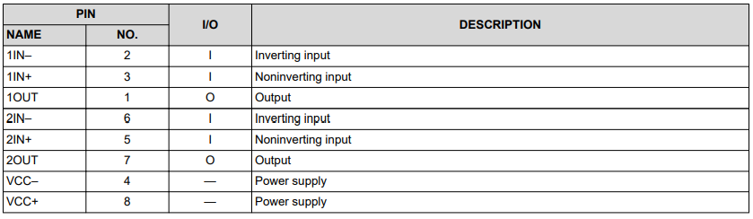

### Eng. Analysis & Materials Selection for SS6-P2– Attack Time

Click or tap here to enter text.

### Eng. Analysis & Materials Selection for SS6-P3– Release Time

Click or tap here to enter text.

## Engineering Analysis for SS7- Wireless Control Module

### Types of Eng. Analysis Conducted:

* DC Sweep
  + Ensure output of the digital analog converter, 0-3.3V, is converted to +/-5V at the output by the amplifier and voltage shift circuit.
* AC Analysis
  + Ensure no filtering of frequencies by the amplifier and voltage shift circuit, due to no inclusion of capacitors in the circuit.
* Sensitivity Analysis
  + Identify most crucial components for in terms of altering output voltages of the amplifier and voltage shift subcircuit.
* Transient Analysis
  + Ensure no slew rate of an incoming square wave LFO output, due to no capacitors being included in the amplifier and voltage shift subcircuit.
* Temperature Analysis
  + Ensure minimal alteration of voltage levels at temperatures between 0 °C and 120 °C, the minimum and maximum expected temperatures of components
* Power Analysis
  + Discover power draw for the circuit from the +12V and -12V rail to determine total power draw of all modules, and therefore power supply needs.

### Eng. Analysis & Materials Selection for SS7-P1- Wireless Microcontroller

Kyle Sellers (EEC)

Before selecting a Wireless microcontroller, a protocol for wireless control needed to be selected. Wi-fi, Bluetooth, and Zigbee were weighed in a decision matrix on multiple device support, latency, documentation, range, power consumption, and security. Details can be found in the appendix.

Both Wi-Fi and Bluetooth scored significantly higher than Zigbee, and while researching microcontrollers, a device with both Wi-Fi and Bluetooth capabilities was found, the ESP32. It was selected for use in the system since we can test both protocols and use the one that performs best in terms of latency, range, and reliability.

Power Draw: 80 mA average, according to datasheet.

### Eng. Analysis & Materials Selection for SS7-P2- DAC

Kyle Sellers (EEC)

Two options were tested for taking output from the Wireless Microcontroller and converting it to an output voltage : PWM integration and DACs.

A PWM integrator circuit would take a PWM signal from the microcontroller and pass it through a low pass filter to obtain a relatively DC voltage. After simulating this design, it was found that ripple was too high using an RC lowpass filter, and obscure values were needed using an RLC filter.

Due to this, a DAC was selected. Since 8 DACs are needed, a bus protocol would be used to communicate with these devices, either I2C or SPI. SPI was selected due to it also being used to communicate with the LCD in the Digital Multi-Effects. The team decided that greater than 10-bit resolution was needed in order for this module to function as a digital keyboard.

Taking in these considerations, the MCP4922 was selected, as it operates on SPI bus protocol, has 12-bit resolution, and has 2 DACs per chip, reducing board space.

### Eng. Analysis & Materials Selection for SS7-P3- Output Amplifier / Voltage Shift

Kyle Sellers (EEC)

**DC Sweep:**

The output of the DACs only ranges from 0-3.3V, but the output of the module needs to be -5V to +5V. Due to this, an amplification of 3x is needed, and a DC offset of -5V. This is performed via an inverting summing amplifier, with inputs for the DAC output and a -5V reference voltage. Since the configuration is inverting, the input range of 0-3.3V equates to +5V to -5V, respectively, with a linear transition between these values.

Results of the DC sweep verify our assumptions, as seen in the appendix.

Sensitivity Analysis:

Sensitivity analysis was run to identify the most critical resistors and voltage inputs for this subcircuit.

Results indicate the output value changes by 2% for every 1% change to the DAC voltage and resistance value, and 1% for every 1% change to the -5V reference voltage, input resistor, and internal resistor . Due to this 1% tolerance resistors are selected for this circuit for optimal performance.

**Power Analysis:**

Power analysis was run to discover total power draw of this subsystem, for power supply selection considerations. The TL07x series datasheet indicates a max recorded power draw of 2.5 mA per rail per Op-Amp. With 8 Op-Amps, this should total 20 mA per rail total.

Simulations in SPICE indicated that the power draw per rail per Op-Amp was 11.4 mA, much higher than anticipated. This comes out to 91 mA power draw per rail total. Inquiring on the DIY Pedals Discord server and Forum about this issue, reputable users indicated the SPICE model is likely inaccurate. However, these higher values are used in totaling power consumption, just in case.

AC and Transient Analysis were also performed, and since there are no capacitive elements, there is no noteworthy AC or phase shifts, nor slew in transients. Temperature analysis can be found in the appendix as well.

### Eng. Analysis & Materials Selection for SS7-P4- Power Regulator

Kyle Sellers (EEC)

The power regulator needs to filter the +/-12V power rails, provide 5V power to the Wireless Microcontroller and DACs, and provide a -5V reference voltage to the Output Amplifier / Voltage Shift circuit.

The +/- 12V rails are filtered via a 10uF capacitor near the input, and 0.1uF capacitors near each Op-Amps power input. Ferrite beads were considered, but were ultimately not included in the design.

For providing 5V power, the LM7805 linear power supply was selected, since the ESP32 can be powered from 5-12V, and the MCP4922 DACs can be powered from 3.3V-5V. Since 5 V is on the fringe values of both, the 5V power needs to be stable, so linear power was selected. Input and output capacitors are included as well to account for current spikes and other ripples in voltage values. A heatsink will be mounted to the LM7805, as there is a large voltage drop across the power supply.

The -5V reference voltage is provided by a 5V LM4040 from the -12 V rail. This is sufficient, as 0.1 mA is the maximum current draw for this application, so a voltage regulator is not needed.

## Engineering Analysis for SS8- Power Supply

The power supply was purchased online through Frequency Central. Due to the company’s credibility, our team did not need deep analysis of the microbus power supply. However, after power draw analysis of each module in the Fall semester, we concluded that two power supplies were needed to support all seven modules.

### Types of Eng. Analysis Conducted:

* Power draw:

### Eng. Analysis & Materials Selection for SS#-P# - Part Name

Keri Grevemberg (EE)

# Manufacturing & Assembly

The manufacturing of this project has multiple parts, such as pcb, faceplate, and case.

## Manufacturing

**Manufacturing has two parts including the case and the circuit boards.**

**Manufacturing PCB**

1st step we did was take our schematics and put them on breadboard.

2nd test to see if it works and adjust the parameters for the design and redesign the schematic until it works before moving on to Veroboard.

3rd Veroboard this is a great middle point while waiting for pcb redesigns to be finalized, but to have a more stable testing environment we had a wooden faceplate.

4th once the redesigns are finalized, we moved to pcb

5th PCB done we worked on Faceplate because they came from our schematic and made of fr-4

So, with the pcb done we need to have the mounting holes properly mounted to the pcb. Eurorack dimensions stated 3mm holes for mounting holes from face plate to pcb, knobs were measured by caliper and milled at 9mm and 6mm for phone jack input output holes.

**Manufacturing Case**

Eurorack standard dimensions

Simple Design for Case laid out

Measurements taken

Wood, screws, nails, tools, and the like acquired.

Cut wood to dimensions according to design in appendix.

## Assembly

**PCB Assembly**

PCB was relatively simple we received the boards and components and then place them through the appropriate matching silkscreen then solder the components to the board and clip the leads of the components.

**Case Assembly**

Once the sides were cut and the rails cut the sides were assembled into a box shape, by drilling pilot holes for guiding the screws into the box and not damaging. With the rail mounted in the middle. Depth of the rail decided by how far the pcb is from the faceplate. Once sides are done then bevels were done on the corners of the case with a router and

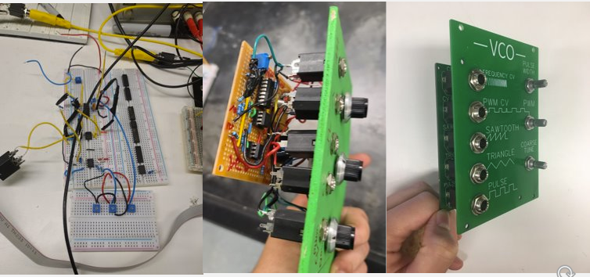

Figure VI‑1: Exploded View Assembly Drawing of Prototype – Sub-System Level

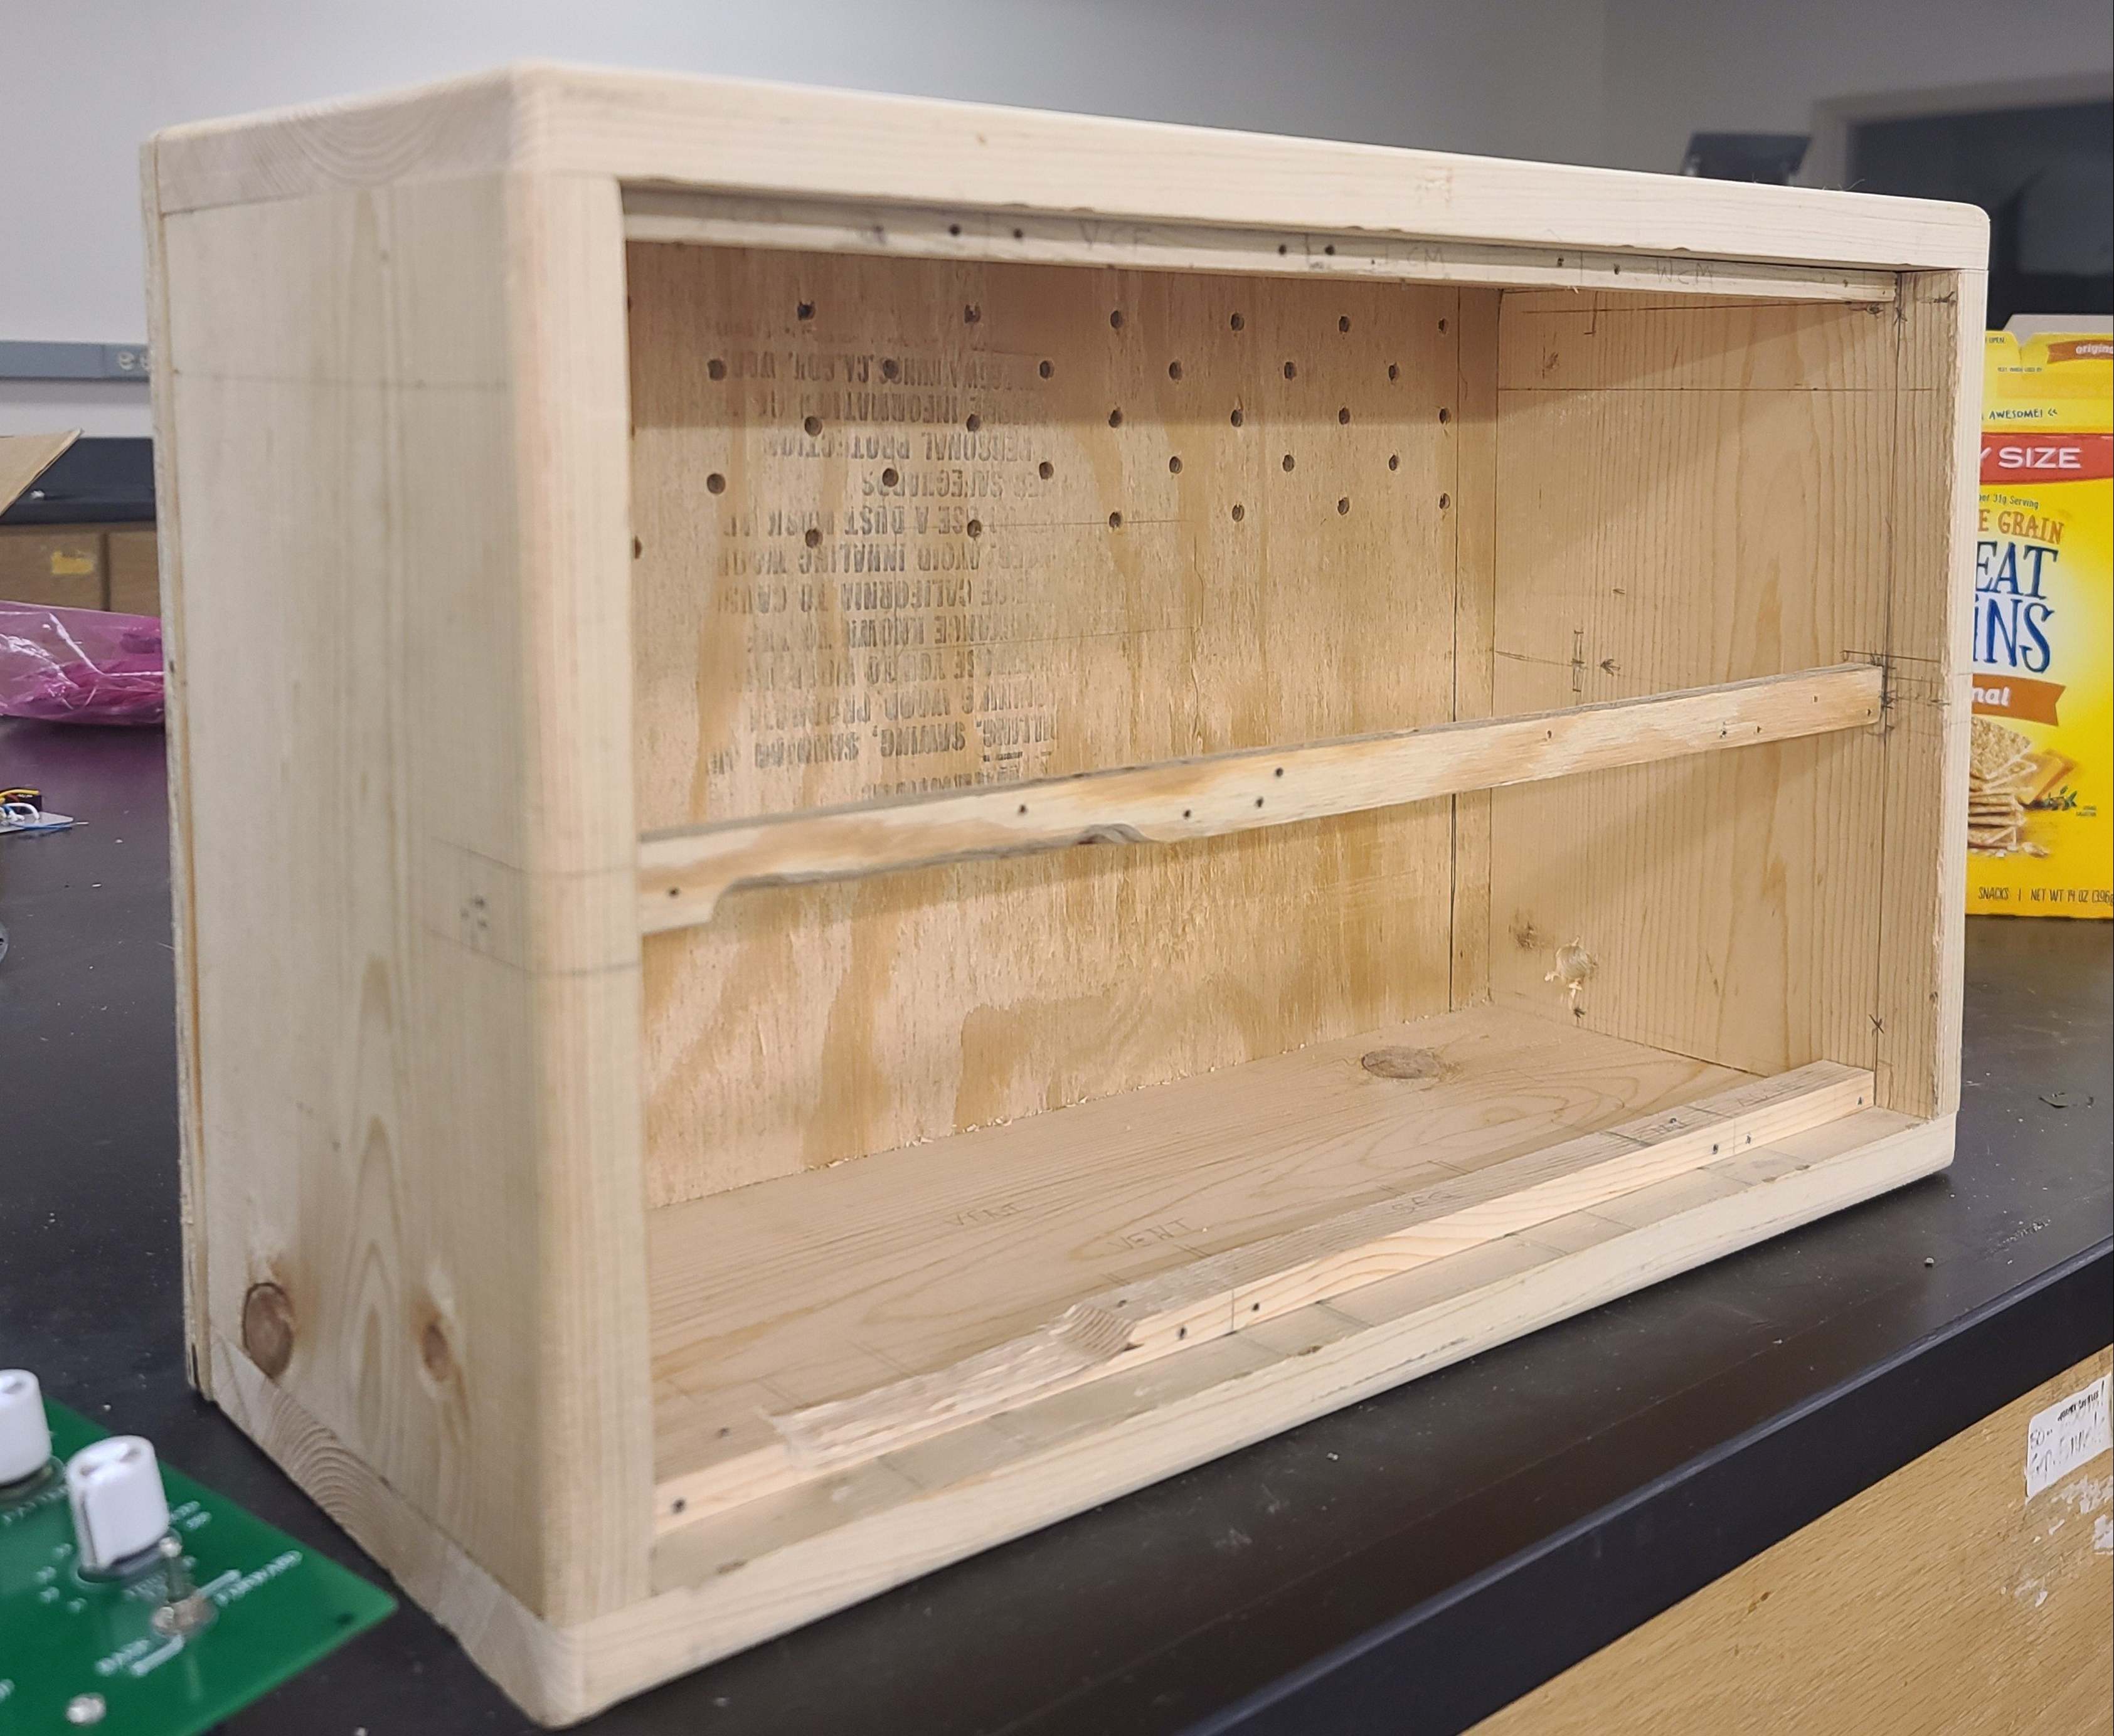

Figure VI‑1: Exploded View Assembly Drawing of Prototype – Sub-System Level

# Safety Considerations

## Operational Safety

Due to our system being an instrument that can be used for education, safe operation is top priority. Temperature regulation required the use of heat sinks on the PCBs with the highest power consumption as well as heat releasing holes found on the back of the wooden enclosure. Our Level Control Module allows system users to connect their earphones or data acquisition device (e.g., National Instruments MyDAQ) within a safe volume range.

## Safety During Manufacturing, Assembly and Testing

OSHA recommended safety measures were taken while manufacturing, assembling, and testing the system. During soldering and resoldering, fume fans remained on to prevent toxic consumption of solder fumes. Continuity tests were performed on the PCBS before components were placed on to ensure proper trace functionality. This is essential to the protection of overheating and component blowout.

# Environmental Impact Assessment

## Manufacturing Related Environmental Impact

Most raw materials used to create the components in electronics are derived from natural resources. The manufacturing steps for electronics involves processes that rely on massive amounts of water and electricity with significant carbon footprints. Chemicals commonly used in industrial cleaning such as Benzene (known carcinogen) and Fluorine can have major environmental impacts to the soil and water near if leaked as well as cause health complications with those who are in contact.

## Operation/Usage Related Environmental Impact

Noise pollution is any unwanted or disturbing sound that affects the health and well-being of humans and other organisms. Our system has little potential environmental impacts associated with operation and usage of the product. The US Environmental Protection Agency deems noise levels of 85 dB or higher to be dangerous with long term exposure. Our system has a maximum degree of loudness of 80 dB to prevent long term effects.

## End-Of-Life (Disposal) Related Environmental Impact

Our PCBs will be made of FR4, a thermoset plastic composed of woven fiberglass cloth with an epoxy resin binder that is flame resistant. This material commonly used in PCB production is then laminated with a copper foil that can bleed into the environment which is proven to be damaging and extremely wasteful if not disposed of properly or recycled. The process of stripping down printed circuit boards for recycling includes recovering a lot of metals such as copper, tin, mercury, and gold used in the production process. This can be time-consuming but many companies such as LEI- Recycling Made Easy and B.W. Recycling Inc offer industrial recycling services for those looking to responsibly dispose of their electronics.

# Design-Phase Testing

**Voltage Controlled Oscillator:**

The maximum frequency that the VCO can generate is necessary knowledge for conducting transient analysis on other module’s audio inputs.

To find a working value, our sponsor Taylor LeBlanc tested the maximum frequency on the prototype’s VCO. This was done by turning the frequency control knob to its maximum position, routing audio to a speaker, then measuring the fundamental frequency using a spectrum analyzer smart phone application.

The highest fundamental frequency found was 7kHz. This is acceptable, as the highest fundamental frequency on a grand piano is C8, or 4168 Hz, so our system can produce about an octave above this. 7kHz is used as the highest frequency in transient analyses of other modules.

**Voltage Controlled Filter:**

Testing the Voltage Controlled filter module mainly consisted of observing spectrum analyzer readings to discern whether the input audio signal is being properly attenuated by the VCF’s control knobs. Part of these observations include measuring the frequency range, or bandwidth in order to interpret the module’s ability to attenuate a broad range of frequencies. Other aspects of the Voltage Controlled Filter that were tested include the amount of rise when the module is set to full resonance, and voltage output, which will be elaborated on later in the section.

**Digital Multi-Effects:**

After selecting the Electrosmith Daisy Seed as our DSP microcontroller, the team wanted to verify that development on this microcontroller would be simple enough for EE students.

To test this, our sponsor Kyle Sellers ordered one to test setting up the development environment and wrote a simple program to test passing audio through the microcontroller. This test was performed by routing one ¼” TS jack to the input with a guitar audio signal coming in and routing another ¼” TS jack to the output which connected to an active amplifier.

As a result, audio was passed successfully without distortion or attenuation, so proper functionality was verified.

**Sequencer:**

After selecting an Arduino Nano as the sequencer microcontroller, the team wanted to verify that it was capable of producing the sequence patterns we needed.

To test this, our sponsor Taylor LeBlanc ordered an Arduino Nano. LEDs were used in place of each output stage to signal when the microcontroller was triggering a step channel.

The Forwards pattern, Backwards pattern, and 2x trigger count pattern were successfully verified, which validates the Arduino Nano as an appropriate microcontroller.

**Wireless Control Module:**

After selecting the ESP32 as our wireless microcontroller, the team wanted to verify that connectivity to mobile phones was possible.

To test this, our sponsor Kyle Sellers ordered one to test connection via Bluetooth. To do so, the Bluetooth connectivity test example program was uploaded to the microcontroller and connected to an Android phone via the LightBlue application.

Connectivity, reading packets, and writing packets to the phone application were successfully verified, which validates the ESP32 as an appropriate microcontroller.

**Envelope Generator:**

The timing parameters of the attack and release knobs was calculated on paper through an RC time constant equation, but we weren’t able to verify the numbers through PSCIPCE. After circuit assembly, an oscilloscope was used to test the maximum and minimum time of the attack and release times.

The first envelope generator design was not outputting a waveform that could be manipulated by the knobs but after a second redesign we were able to acquire maximum times that matched the previous analysis.

# Testing, Validation, and/or Implementation

## Testing & Validation of Function F1 – Assist Course Syllabi

Keri Grevemberg (EE)

### Objective, Rationale & Brief Description – F1

Student comprehension tests before and after using the system would be useful for proving the system’s educational value. Ideally, a human subject takes a pretest of lab manual concepts. After using one of the team written lab manuals paired with the system, the student would take a post test to test how much they learned.

### Testing & Validation Summary of Results & Conclusions – F1

Unfortunately, due to COVID-19 restrictions and time limitations, student subject studies were not performed for testing and validation. However, the six lab manuals have been reviewed by multiple Electrical Engineering advisors to at least verify the legitimacy and potential of the system to assist Electrical Engineering course syllabi.

Table X‑1: Test Result Data Table

|  |  |  |  |  |
| --- | --- | --- | --- | --- |
| Column 1 Title | Column 2 Title |  |  |  |
|  |  |  |  |  |
|  |  |  |  |  |



Figure X‑1: Test Results

## Testing & Validation of Function F2 – Generate Audio Signals

Rafael Alvarez (EE), Tarik Lopez (EE)

### Objective, Rationale & Brief Description – F2

Our object is to produce waveforms that the other modules on the system can change and manipulate and then produce audio.

### Testing & Validation Summary of Results & Conclusions – F2

The test was simple first make sure that the VCO can generate the waveform and then check if the output will drive a speaker.

Table X‑2: Test Result Data Table

|  |  |
| --- | --- |
| Data ​ | Voltage ​ |
| Square​ | 11V​ |
| Triangle​ | 4.2v​ |

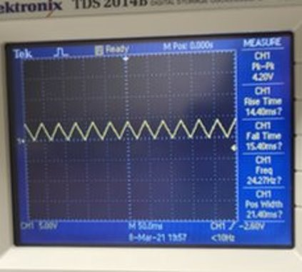

Figure X‑2: Test Results

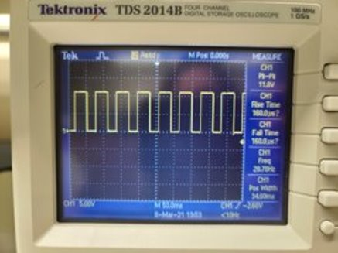

Figure X‑3: Test Results

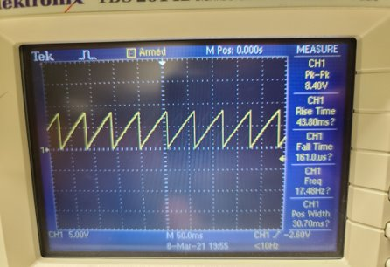

Figure X‑4: Test Results

## Testing & Validation of Function F3 – Output Audio Signals

Taylor LeBlanc (EE)

### Objective, Rationale & Brief Description – F3

The synthesizer is an instrument, and therefore it needs to be capable of outputting audio signals.

### Testing & Validation Summary of Results & Conclusions – F3

To test and validate that it was capable of outputting audio signals the square wave of the Voltage Controlled Oscillator was connected to the Level Control Module’s volume controller. The output of the volume controller was then connected to an active speaker. Upon connecting it to the speaker the system began producing a sound, verifying the system is capable of outputting audio signals. Figure X-2 shows the speaker that was connected to the system during this testing.

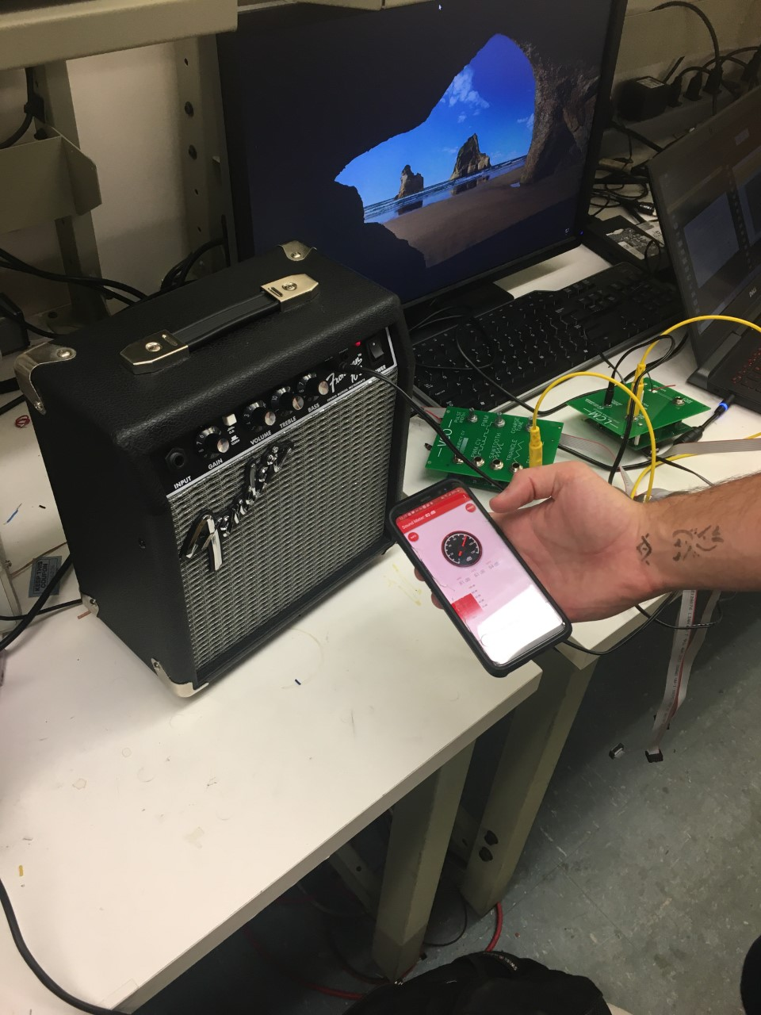

Figure X‑2: Test Results

## Testing & Validation of Function F4 – Generate Control Voltages

Keri Grevemberg (EE), Taylor LeBlanc (EE)

Oscilloscope readings will be used to verify control voltage generation. The Sequencer, the Envelope Generator, and the Wireless Control Voltage should only be able to provide a control voltage with maximum 5 volts. This is a constraint vital to module compatibility throughout the system.

### Objective, Rationale & Brief Description – F4

A control voltage is a DC electrical signal with the ability to manipulate specified parts of an analog circuit. By design nature, some modules produce a control voltage at their output in order to affectively connect and manipulate the function of another module.

### Testing & Validation Summary of Results & Conclusions – F4

Successful testing via oscilloscope readings of the outputs of all three previously mentioned modules was completed. The Envelope Generator, Sequencer and Voltage Controlled Oscillator can output a control voltage between zero and 5 volts.

Table X‑2: Test Result Data Table

|  |  |
| --- | --- |
| **Module** | **Output Max Voltage** |
| Sequencer | 4.7V |
| Envelope Generator | 5.8V |
| WCM | 5V |

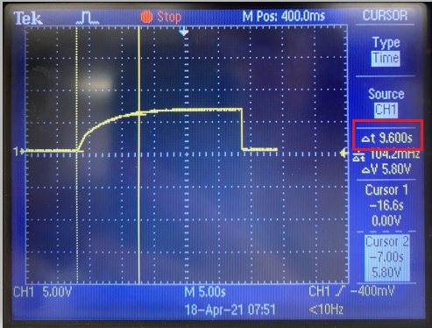

Figure X‑2: Envelope Generator Max. Output Voltage

## Testing & Validation of Function F5 – Manipulate Signal Frequency

Rafael Alvarez (EE), Tarik Lopez (EE)

### Objective, Rationale & Brief Description – F5

After determining parameters and designing the modules around certain specifications during the analysis phase, testing for the Voltage Controlled Filter and Voltage Controlled Oscillator was necessary to validate their abilities to manipulate signal frequency through signal filtering and pitch control. In short, the VCF and VCO modules needed to be tested to measure and observe the frequency content to ensure that both modules operated as intended.

To test the filtering capacity and cutoff range of the Voltage Controlled Filter, a spectrum analyzer was used to observe the frequency content of both the low-pass and high-pass setting on the module.

Listed below are the recorded values that we observed from testing the Voltage Controlled Filter module’s frequency range and resonance.

### Testing & Validation Summary of Results & Conclusions – F5

As displayed in the table and through the pictures posted below, the Voltage Controlled Filter successfully fulfills the filtering requirements, including the ability to attenuate the cutoff frequency, attenuate the resonance, and switch between the low-pass and high-pass filter settings.

Table X‑2: Test Results for VCF Module

|  |  |  |  |
| --- | --- | --- | --- |
| Filter Type | Frequency Range | Resonance | Output Voltage |
| Low-Pass | 1kHz – 24.4kHz | +3dB | 5v |
| High-Pass | 24.4kHz – 1kHz | +3dB | 4v |

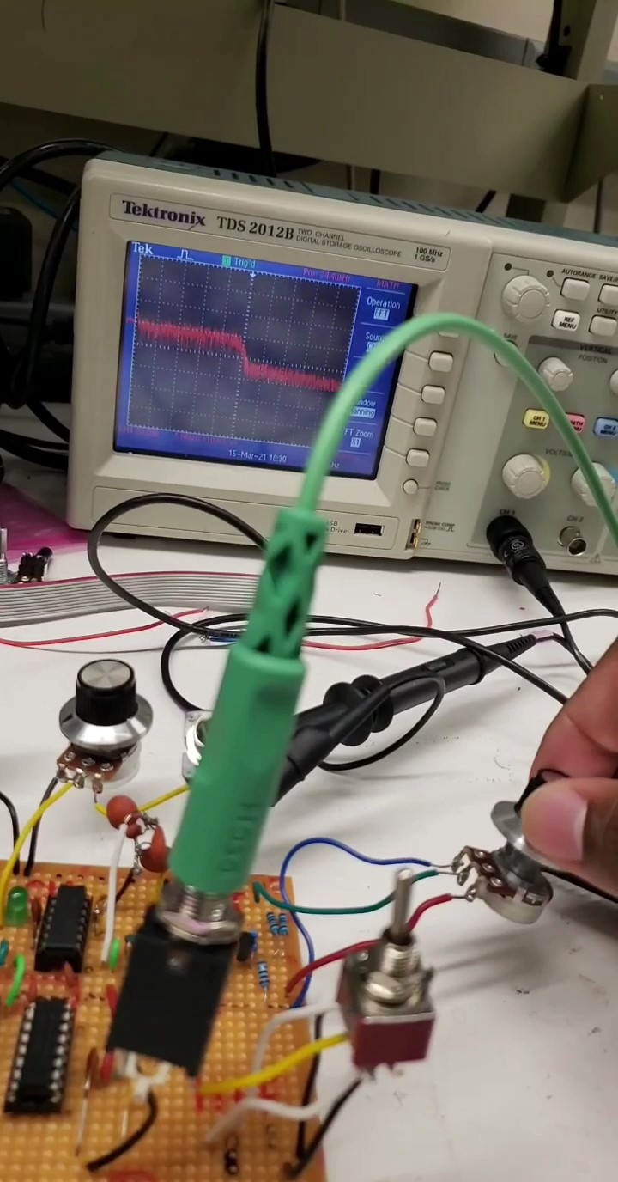 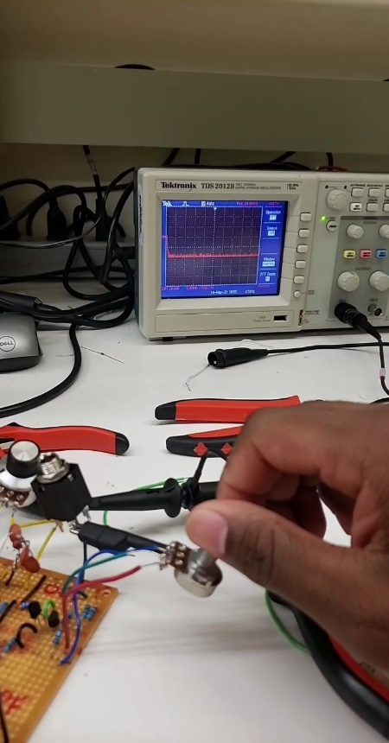 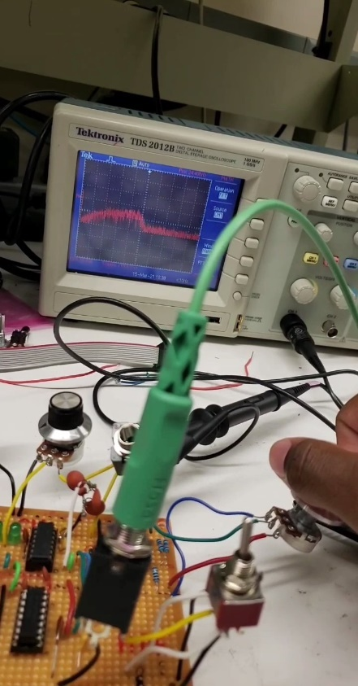

Figure X‑2: Test Results

## Testing & Validation of Function F6 – Manipulate Signal Amplitude

Taylor LeBlanc (EE)

### Objective, Rationale & Brief Description – F6

In order to connect the system to a NI MyDAQ the signal from the system needs to be attenuated appropriately. This is accomplished using the Level Control Module’s MyDAQ converter. According to the MyDAQ’s datasheet the analog inputs are rated to handle a recommended voltage range of -10V to +10V. To prevent damage to the MyDAQ, the MyDAQ converter was designed to have a fixed attenuation gain factor of 0.69. This was chosen in case the system ever shorted and began delivering a +/-12V signal (the range of the system’s linear power supply).

### Testing & Validation Summary of Results & Conclusions – F6

The gain of the MyDAQ converter was tested and validated by first measuring the voltage amplitude of the Voltage Controlled Oscillator’s square wave output. The square wave was then passed into the Level Control Module’s MyDAQ converter input. The output voltage of the MyDAQ converter was then measured both with an oscilloscope and a MyDAQ. The amplitude of the input and output signals were then compared, and the gain was calculated using the following equation:

$$A_{V}= \frac{V_{output}}{V_{input}}$$

It was found during testing that the MyDAQ converter ended up actually attenuating the signal with a gain factor of about 0.3.

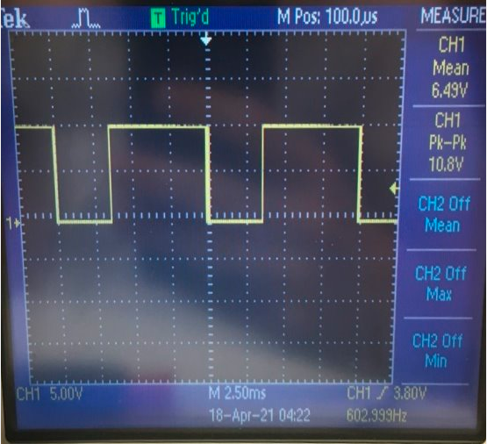

Figure X‑2: Test Results

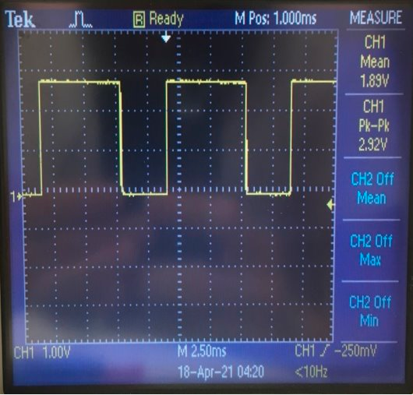

Figure X‑2: Test Results

## Testing & Validation of Function F7 – Process Signals Digitally

Kyle Sellers (EEC)

### Objective, Rationale & Brief Description – F7

To test the Digital Multi-Effects ability to process signals digitally, a basic waveform, such as a sine, triangle, sawtooth, or square wave, was passed through each effect, with results verified either visibly on an oscilloscope, or audibly by listening to the output of the system.

The distortion and Bitcrusher effects were verified using an oscilloscope. For the distortion effect, it was verified that the wave was shaped non-linearly by the arc-tangent function it was passed through and then linearly scaled with the volume knob. For the Bitcrusher, a 1 kHz sawtooth wave was passed through, and ability to add noise, reduce bit depth, and reduce sample rate were verified.

For delay and reverb effects, the sequencer was routed to the pitch Control Voltage of the Voltage Controlled Oscillator, and then that audio routed to the Digital Multi-Effects. This was done because it is easier to tell if these effects are working while pitch is changing. These 2 effects were verified subjectively, as it is difficult to verify via an oscilloscope.

### Testing & Validation Summary of Results & Conclusions – F7

Below shows the oscilloscope readings of the distortion and Bitcrusher effects.

As you can see, the output no longer looks like a sawtooth wave, but more so approaching a square wave.

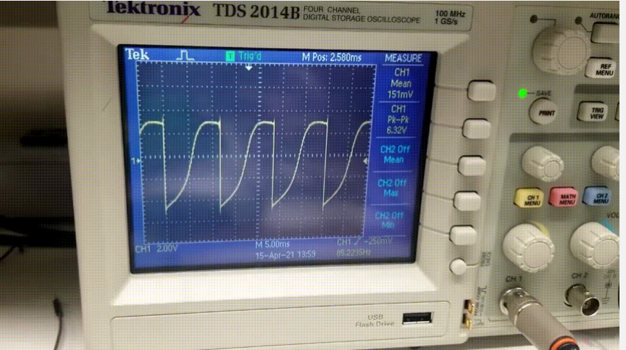

Figure X‑2: Distortion

From left to right, we see the effect of adding noise, reducing bit depth, and reducing sample rate.

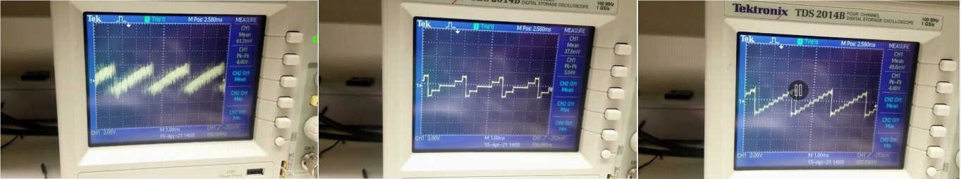

Figure X‑2: Bitcrusher

## Testing & Validation of Function F8 – Regulate Operating Temperature

Taylor LeBlanc (EE), Kyle Sellers (EEC)

### Objective, Rationale & Brief Description – F8

To reduce risk of component damage and student exposure to high temperatures, the team needed to measure the temperature of critical components that dissipate a lot of heat, as well as measure ambient case temperature.

### Testing & Validation Summary of Results & Conclusions – F8

Readings were taken with an infrared heat gun, with infrared display to identify the warmest components in the system. It was observed that the warmest components were the power regulators, which we already placed heat sinks on. Below shows measured temperatures of these components, as well as the case. As seen, the warmest component was the power supply’s heat sinks, which is at a temperature that is still safe to touch. Ambient case temperature was only 26.7 C, which is only slightly warmer than the ambient temperature of the lab that day, 23.8 C.

Table X‑2: Test Result Data Table

|  |  |
| --- | --- |
| Module | Temperature (* C) |
| Power Supply | 37.3 |
| Wireless Control Module | 32.9 |
| Digital Multi-Effects | 30 |
| Sequencer | 30.6 |
| Ambient Case | 26.7 |

## Testing & Validation of Function F9 – Reroute Signal Path

Keri Grevemberg (EE)

A modular synthesizer would not function properly without being able to reroute signal paths.

### Objective, Rationale & Brief Description – F9

By using a speaker, multiple patch cables, and an oscilloscope, we tested each module ability to accept a signal from another module while also being able to send a signal to the next.

### Testing & Validation Summary of Results & Conclusions – F9

Starting with a clean square wave from the VCO, we then sent it to the VCF and adjusted the filter until with each given parameter such as high pass and low pass filtering to verify that the modules functioned as expected when plugged into each other. This proved successful once all of our modules were assembled.

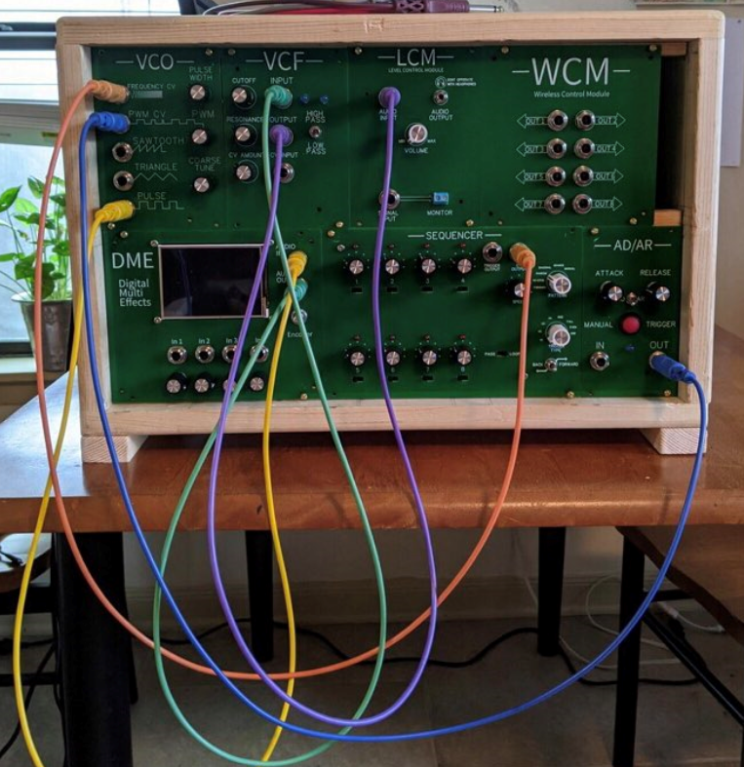

Figure X‑2: Test Results

## Testing & Validation of Function F10 – Operate via Remote Control

Kyle Sellers (EEC)

### Objective, Rationale & Brief Description – F10

The inclusion of the ability to operate via remote control was decided to allow musicians to control our modular synthesizer in an easier way during performance, and to expand the control voltage options available to users. This is manifested in the Wireless Control Module, which can be controlled via a smart phone application over Bluetooth.

To operate our system via remote control, the team needed a module that can convert Bluetooth commands into control voltages. This is achieved through the ESP32 microcontroller, which is the backbone of the Wireless Control Module. It receives Bluetooth packets and relays the data over SPI bus protocol to an array of Digital to Analog Converters (DACs), which converts that data into a measurable voltage.

### Testing & Validation Summary of Results & Conclusions – F10

Voltages from the DACs have been measured using the Tektronix TDS 2014B Oscilloscopes available in the ERAD IEEE Lab on LSUs campus.

The DACs being used are the MCP4922s, which have 12 bits of precision. This means that the DAC should provide a linear transition between Vdd (ideally 0 V in our case) and Vcc (ideally 3.3V in our case) in 4096 steps (between hex values 0x000 and 0xFFF).

Below is a table showing the resultant data collected over a range of test values

Table X‑2: Test Result Data Table

|  |  |  |  |  |
| --- | --- | --- | --- | --- |
| Input Value (Integer) | Input Value (Hex) | Expected Output (V) | Actual Output (V) | Input Value (Integer) |
| ​0 | ​0x000 | ​0 | ​0.09 | ​0 |
| ​1365 | ​0x555 | ​1.1 | ​1.1 | ​1365 |
| ​2184 | ​0x888 | ​1.76 | ​1.76 | ​2184 |
| ​2730 | ​0xAAA | ​2.2 | ​2.19 | ​2730 |
| ​4095 | ​0xFFF | ​3.3 | ​3.29 | ​4095 |

## Testing & Validation of Qualitative Constraint Q1 - Customizable

Taylor LeBlanc (EE)

### Objective, Rational & Brief Description – Q1

A large part of the appeal of using a modular synthesizer is that it is a highly customizable instrument. Here customizability implies a user can add or take away from their system as many modules as they see fit. To properly verify the system is customizable it must meet two criteria. First each module must be capable of operating on its own without any other module in the system. Second it must be able to either interact with every other module in the system, or at the very least not damage any module in the system.

### Testing & Validation Summary of Results & Conclusions – Q1

Testing the customizability of the system involved running two pass/fail tests for each module in the system. The first was an isolated test of each module which involved powering the module in question and noting whether or not the module turned on and was operational on its own. Every module passed the isolated test. The second test involved powering each module simultaneously and creating different connections between each in order to make sure they were capable of interacting with one another. An example of this would be outputting a square wave from the VCO to the input of the VCF and then passing the filtered signal to the LCM. In this case confirming the signal was passed to the final module in the chain (in this example the LCM) confirms the integrated test was successful. After extensive testing between each module, it was found that each module passed the system integrated test.

Table X‑3: Test Result Data Table

|  |  |  |  |
| --- | --- | --- | --- |
| Sub System (SS#) | Module | Isolated Test (Pass/Fail) | Integrated Test (Pass/Fail) |
| SS1 | Voltage Controlled Oscillator | Passed | Passed |
| SS2 | Voltage Controlled Filter | Passed | Passed |
| SS3 | Digital Multi-Effects | Passed | Passed |
| SS4 | Level Control Module | Passed | Passed |
| SS5 | Sequencer | Passed | Passed |
| SS6 | Envelope Generator | Passed | Passed |
| SS7 | Wireless Control Module | Passed | Passed |

## Testing & Validation of Qualitative Constraint Q2 – Engaging / Fun to Use

Tarik Lopez (EE)

### Objective, Rationale & Brief Description – Q2

Part of constructing an instrument that can also serve as an educational supplement is making the learning process something that the students can actively enjoy engaging with. Therefore, when designing the overall system, our team was tasked with determining how much to include within the system. The number of modules, the number of functions each module consists of, and how students and faculty can interact with the system in a fun, but also digestible manner where the user is not too overwhelmed by all the facilities housed within the wooden casing are all situations that the team considered when proceeding with construction of the modular synthesizer.

### Testing & Validation Summary of Results & Conclusions – Q2

In order to test how effectively the modular synthesizer fulfills its engaging constraint, the team previously planned to let focus groups interact with the system after putting together a survey questioning users on their experience. However, time constraints presented scheduling conflicts that skewed any future plans of having the system tested. As such, we decided to test engaging and “fun to use” functionalities on ourselves and our peers who had time to experiment with our system. The feedback that we have gotten from test subjects have been extremely positive, with users stating that the system is “hard to stay away from” and “engrossing”. Testing the synthesizer ourselves proved the same result, with team meetups ending with us spending hours experimenting with the multitude of sounds and effects that the system produces.

## Testing & Validation of Qualitative Constraint Q3 – Good Sound Quality

Rafael Alvarez (EE)

### Objective, Rationale & Brief Description – Q3

The objective is to output good sound quality and that is too see if there is much noise in the signal or distortion cause while having noise is what make music feel more natural and crisp would be better to do add it in. The test is just to see on an oscilloscope how much noise is on a signal deviating from its specifications. Here the sawtooth needs to be 8.4v pk-pk. With the human eye there was little to no noise or interference.

### Testing & Validation Summary of Results & Conclusions – Q3

Table X‑4: Test Result Data Table

T

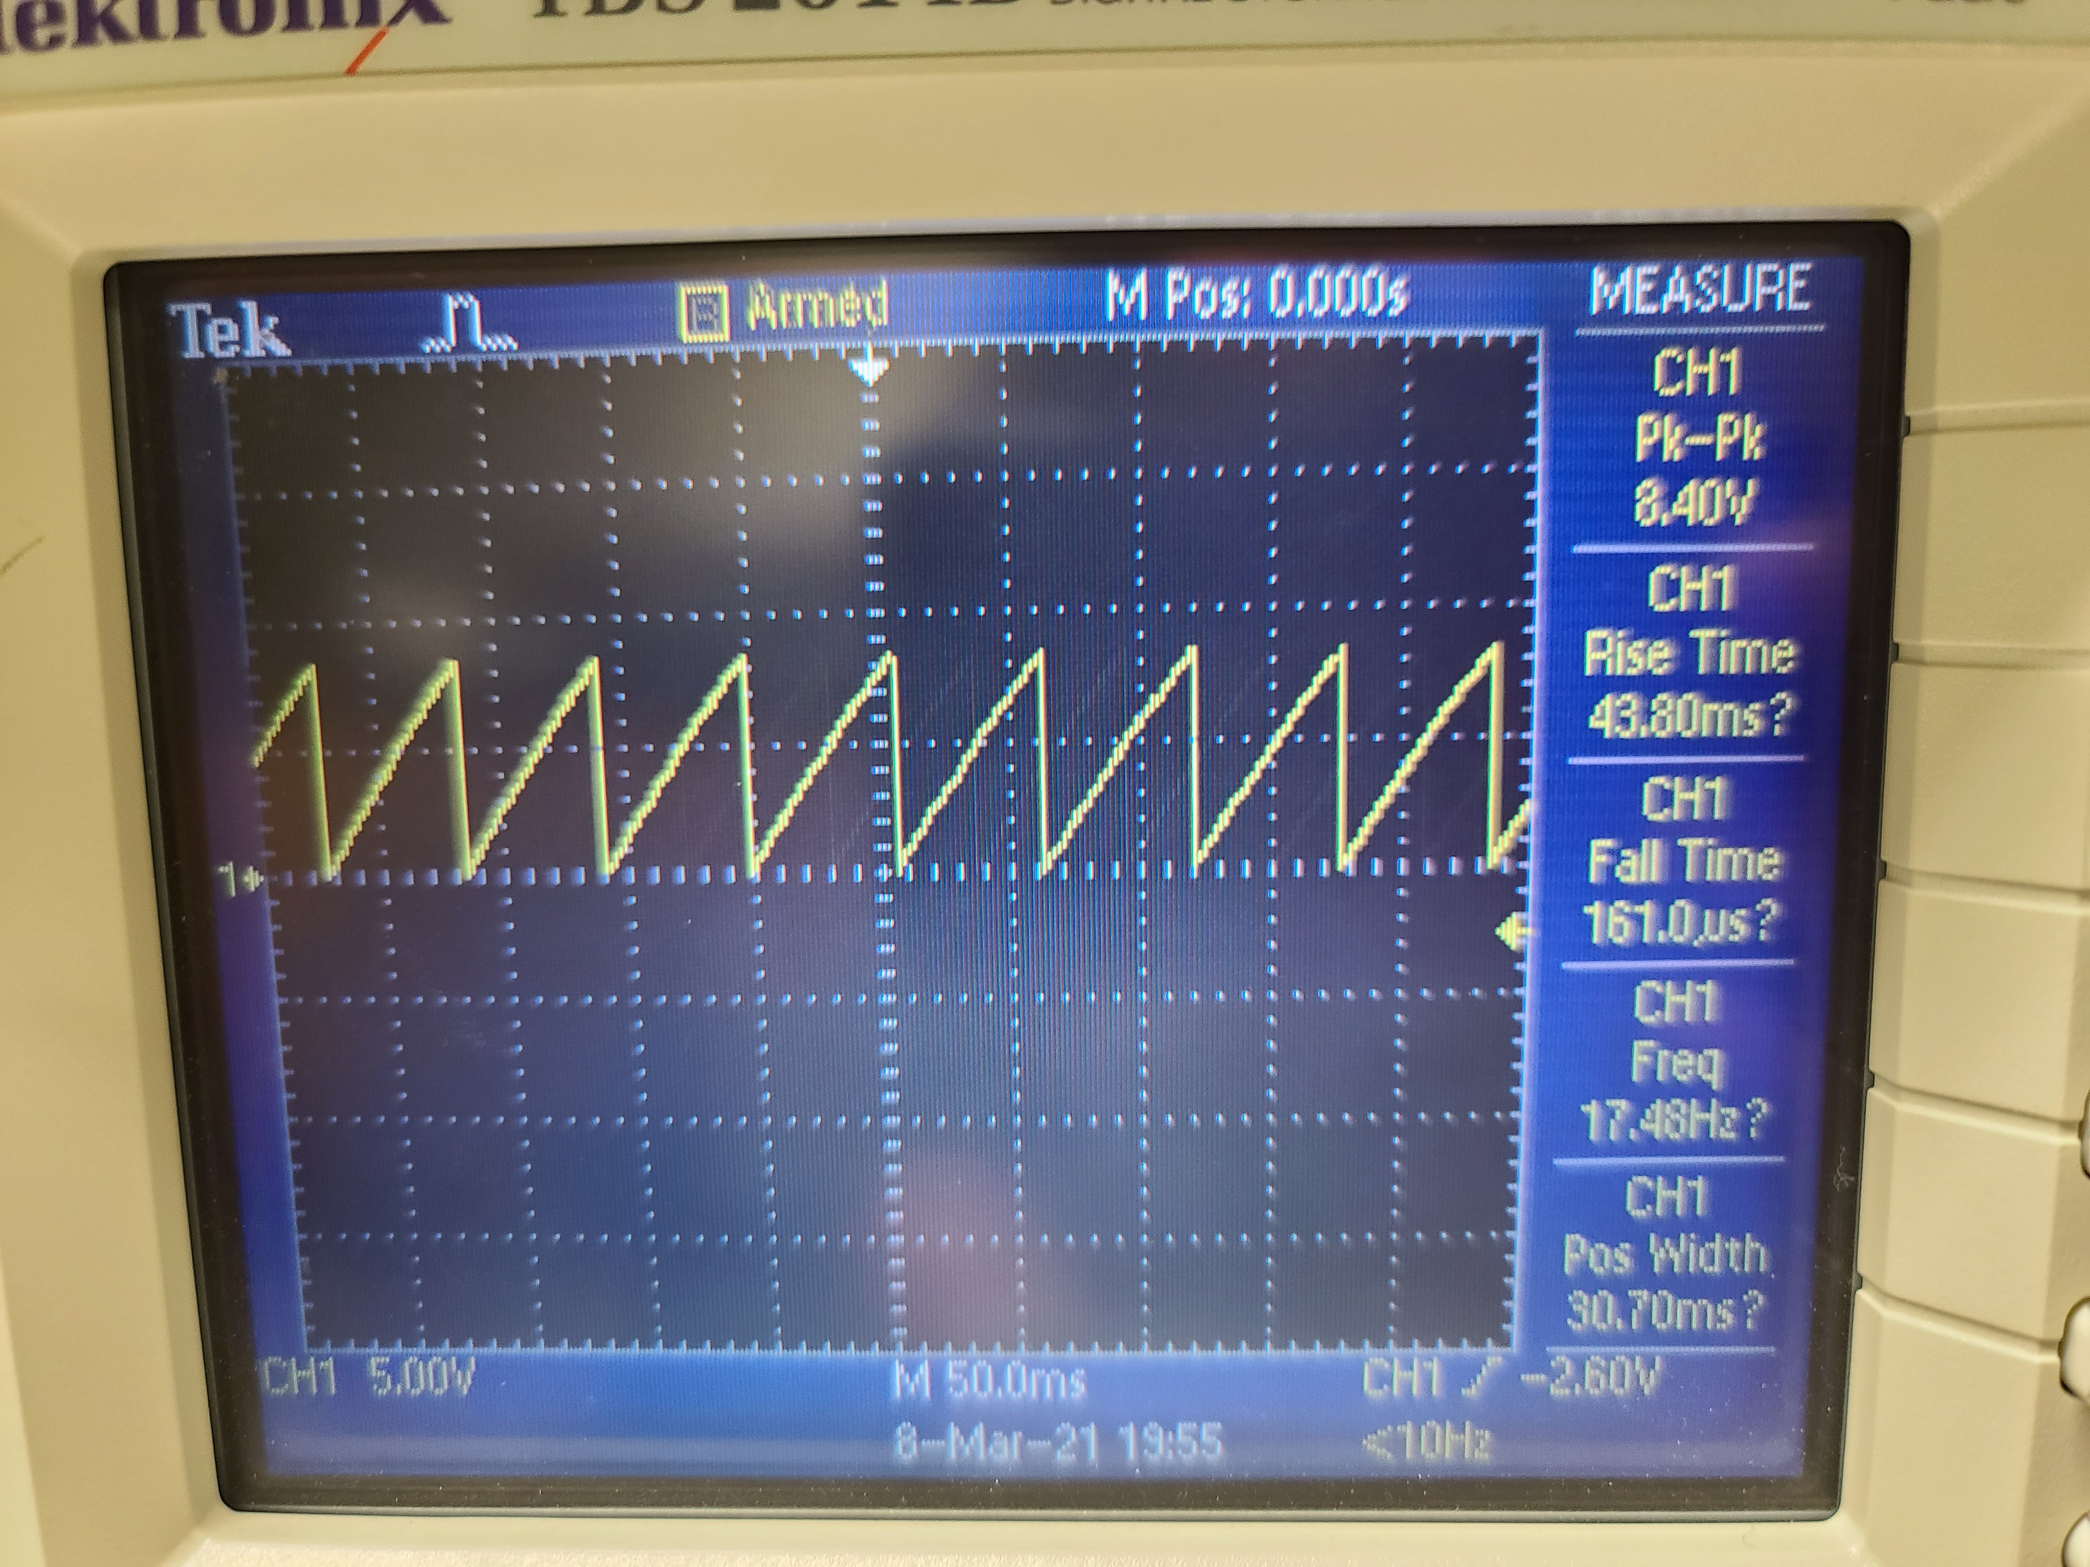

Figure X‑4: Test Results

## Testing & Validation of Qualitative Constraint Q4 – Easy to DIY

Taylor LeBlanc (EE)

### Objective, Rationale & Brief Description – Q4

To make the synthesizer modules more accessible to hobbyest it’s important that schematics, gerber files, and accompanying BOM are publicly available.

### Testing & Validation Summary of Results & Conclusions – Q4

This constraint was validated by the schematics, gerber files, and accompanying BOM that the team has written over the course of the project. After the project is finished they will be made publicly available. There is no further testing and validation that could be done for this constraint that would actually make sense. Likewise there is no need for any accompanying tables or figures.

## Testing & Validation of Qualitative Constraint Q5 – Easy to Use

Tarik Lopez (EE)

### Objective, Rationale & Brief Description – Q5

As an instrument used to assist learning, users should have no problem operating and understanding how to navigate the various modules that make up the modular synthesizer. As such, our team has provided some features to aid students with just that.

### Testing & Validation Summary of Results & Conclusions – Q5

Included with each module is a lab manual that covers what the module is and what it contributes to the overall system. The faceplates for each module are labeled and are simple enough for any junior level electrical engineering student to understand. Along with the simple faceplate designs and the lab manuals, the synthesizer comes with mock labs that engage the user in interacting with the module in ways they might not have considered, emerging them deeper into the system as a result.

## Testing & Validation of Qualitative Constraint Q6 – Stable Waveform

Rafael Alvarez (EE)

### Objective, Rationale & Brief Description – Q6

Stability of waveform there is a good reason why this is important there needs to be signal stability, without it signals will be off shifted and out of phase. How I tested this was to run a sawtooth wave through a sinshaper circuit. And then use the sawtooth from the vco to see how out of phase the sinwave would be.

### Testing & Validation Summary of Results & Conclusions – Q6

Table X‑4: Test Result Data Table

The sin wave was perfect it was just a hair out of phase.

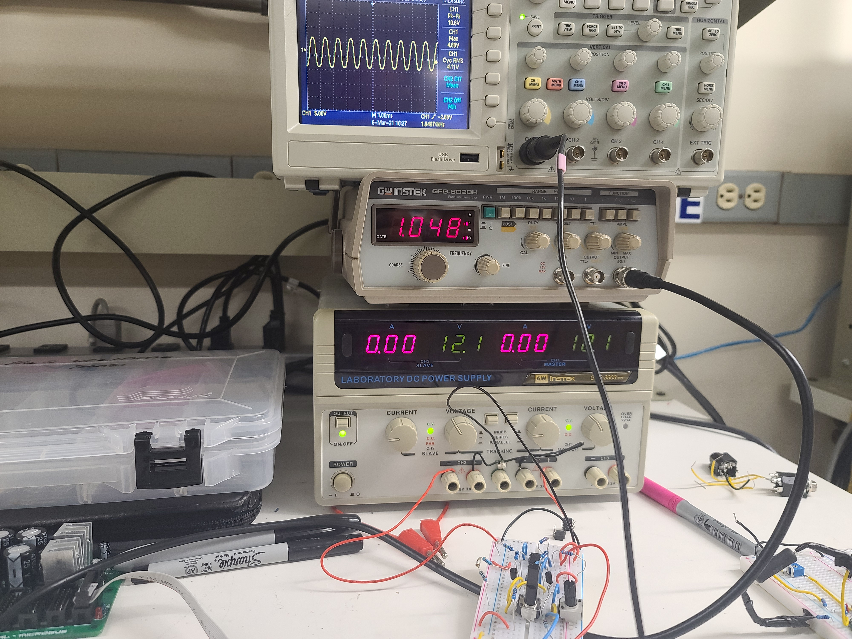

Figure X‑4: Test Results

## Testing & Validation of Quantitative Constraint M1 - Cost

Rafael Alvarez (EE)

### Objective, Rationale & Brief Description - M1

The cost test is a simple cost analysis to see where we stack up module to module to other companies and per system basis.

### Testing & Validation Summary of Results & Conclusions – M1

Table X‑5: Test Result Data Table

|  |  |
| --- | --- |
| Final Spent​ | Per System Cost ​ |
| $647.96​ | $414.09​  ​ |
| $91.46​ | $13.07​ |
| $124.91​ | $17.85​ |
| $35.00​ | $35.00​ |
| $899.33​ | $479.85​ |

Here are the results of our endeavor without any testing issues and having all materials in hand it would cost you 479.85 to make a system like this.

Most systems are within the thousands and module kits alone cost around $135 to $400 dollars.

So for example the vco is around 30dollars of parts and 30 dollars in faceplate and pcb. Totaling around 60 dollars for a kit diy. But without pcb or faceplate it would cost you around $30 dollars for a simple module.

## Testing & Validation of Quantitative Constraint M2 – Size of Case

Taylor LeBlanc (EE)

### Objective, Rationale & Brief Description – M2

The size of the case needs to be small enough that it can be easily transported by professors or students moving between classrooms. A tape measure was used to validate the final dimensions of the case. The targeted case size was under height/width/depth of 17.25 in/33 in/ 8.25 in. After getting the final measurements of the case, it was found that the original constraints were satisfied.

### Testing & Validation Summary of Results & Conclusions – M2

Using a tape measure, the final dimensions of the case were found to be a height of 12.5 in. a width of 18 in. and a depth of 7.75 in. Therefore, the original constraints we set were satisfied.

Table X‑6: Test Result Data Table

|  |  |  |
| --- | --- | --- |
| Dimension | Original Constraint (in) | Final Measurement (in) |
| Height | 17.25 | 12.5 |
| Width | 33 | 18 | |
| Depth | 8.25 | 7.75 |

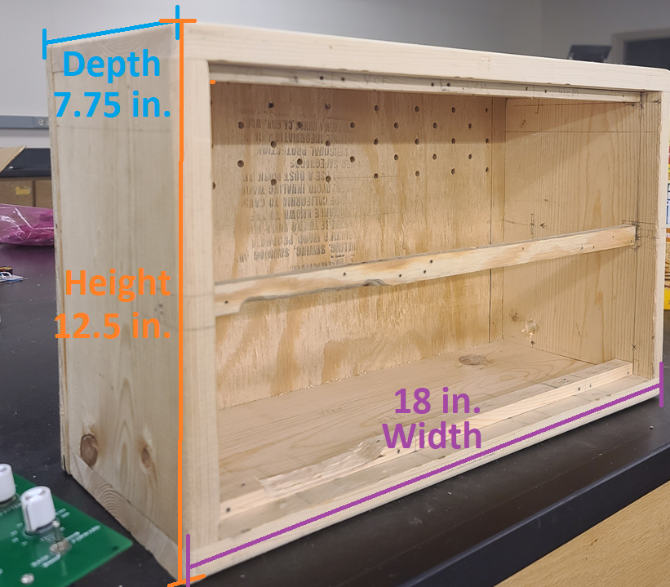

Figure X‑6: Test Results

## Testing & Validation of Quantitative Constraint M3 – Weight

Kyle Sellers (EEC)

### Objective, Rationale & Brief Description – M3

Weight is important for maintenance and transportation of the system. The case and all seven modules should be light enough for one user to handle. A scale can validate that the system weight stays below the team’s set limit of 20 lbs.

### Testing & Validation Summary of Results & Conclusions – M3

Weighing the full system with all modules mounted, the final weight came out to be 12.6 lbs, well under spec.

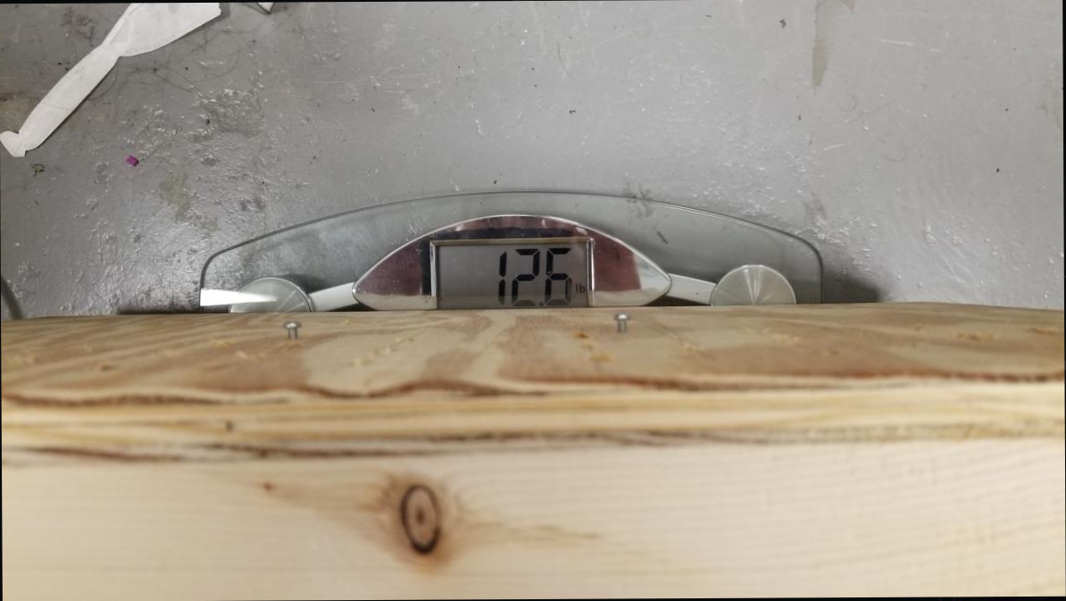

Figure X‑6: Test Results

## Testing & Validation of Quantitative Constraint M4 – Power Consumption

Taylor LeBlanc (EE)

### Objective, Rationale & Brief Description – M4

The Frequency Central Microbus Power Supply being used to power the system is capable of supplying 500mA on the +12V rail and 500mA on the -12V rail. Because of this limitation it is important to know how much power the system draws to make sure it does not exceed the power supply’s capacity.

### Testing & Validation Summary of Results & Conclusions – M4

To determine the power draw of the complete system a Kill-A-Watt electric wall monitor was used. Modules were first connected to the power supply. The wall monitor was then plugged into an outlet, and the power supply wall wart was plugged into the wall monitor. The system was then powered on and power readings were measured for the system. Measuring the full power draw of the system revealed it consumed approximately 11.7 W, which is significantly higher than the targeted spec of 2.5W.

The figure below verifies the power draw readings for the complete system using the Kill-A-Watt meter.

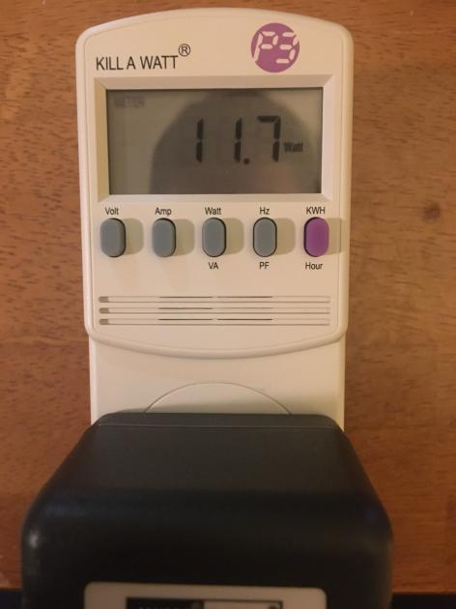

Figure X‑6: Test Results

## Testing & Validation of Quantitative Constraint M5 – Bandwidth

Rafael Alvarez (EE), Tarik Lopez (EE)

Rafael Alvarez (EE), Tarik Lopez (EE)

### Objective, Rationale & Brief Description – M5

Since the human hearing range stretches between 20 to 20kHz, our system should be able to produce frequencies close to this range. Also, Bandwidth is a concept taught in courses such as Circuits 2, so it is important to have sufficient bandwidth for analysis. The bandwidth for the Voltage Controlled Filter module can be seen in Section IX - Manipulate Signal Frequencies.

### Testing & Validation Summary of Results & Conclusions – M5

Below are the bandwidth values that were found during the testing phase of the Voltage Controlled Filter

Table X‑6: Test Result Data Table

|  |  |  |  |  |
| --- | --- | --- | --- | --- |
| Filter Type | Frequency Range |  |  |  |
| Low-Pass | 1kHz – 24.4kHz |  |  |  |
| High-Pass | 24.4kHz – 1kHz |  |  |  |



Figure X‑6: Test Results

## Testing & Validation of Quantitative Constraint M6 – Signal to Noise Ratio

Kyle Sellers (EEC)

Kyle Sellers (EEC)

### Objective, Rationale & Brief Description – M6

Signal to noise ratio should be low enough so that students cannot see noise interference when analyzing signals on lab equipment, as well as musicians should not be able to hear unwanted noise when building sounds to use in performances.

### Testing & Validation Summary of Results & Conclusions – M6

The team was unable to successfully measure the signal to noise ratio of the system. It was attempted to be measured via oscilloscopes available in the IEEE Lab in the ERAD, however, the FFT function on those oscilloscopes are not fit for accurately measuring signal to noise ratio. There is a possibility that these measurements could have been taken using better spectrum analyzers available in the RF Lab, however, we anticipate that our bandwidth requirements (20 Hz to 22kHz) are too low for this specialized equipment.

Subjectively monitoring signals all semester in the time domain on oscilloscopes, noise was never high enough to alter signal shape. Due to this, we anticipate that signal to noise ratio is plenty low enough for students to analyze on the NI MyDAQ device.

## Testing & Validation of Quantitative Constraint M7 – Operating Temperature

Taylor LeBlanc (EE) & Kyle Sellers (EEC)

**See Section IX.H. F8 – Regulate Operating Temperature**

## Testing & Validation of Quantitative Constraint M8 – Latency of Wireless Control

Kyle Sellers (EEC)

### Objective, Rationale & Brief Description – M8

Since the Wireless Control Module is controlled via Bluetooth, there is inherent delay from when a packet is sent from the controller app to when it is received by the wireless microcontroller. This time should be less than 100 ms to ensure that changing values via the Wireless Control Module is not frustratingly slow.

One of the outputs of the Wireless Control Module will be attached to the pitch input of the voltage-controlled oscillator. The wave output of the VCO will then be routed through the level control module to a set of speakers. The tester will connect to the WCM via the controller app. A microphone will be placed halfway between the system and the tester, which is recording audio. They will then change the value of the pitch output, and snap at the same time. The output of the audio through the speakers will then change. The recording will be stopped and uploaded to audio processing software, where the time difference between the snap and the change in pitch is measured and recorded.

### Testing & Validation Summary of Results & Conclusions – M8

This test was run 4 times, with results of each test shown below.

Table X‑6: Test Result Data Table

|  |  |
| --- | --- |
| Test # | Latency |
| 1 | 49 ms |
| 2 | 44 ms |
| 3 | 54 ms |
| 4 | 43 ms |

Average wireless latency was found to be around 50 ms.

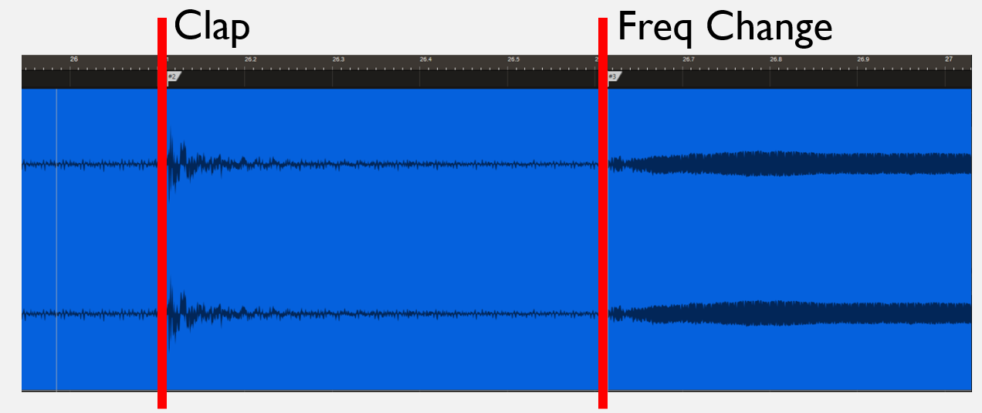

Figure X‑6: Test Visualization

## Testing & Validation of Quantitative Constraint M9 – Range of Wireless Control

Kyle Sellers (EEC)

### Objective, Rationale & Brief Description – M9

The system should be able to be controlled via the Wireless Control Module from anywhere within a room with the system. The team decided that about 10 feet is all the range that the Wireless Control App needs to be able to consistently communicate with the system, without data drops.

The Wireless Control Module will be attached to the case to ensure that the physical obstruction of the case does not reduce the range past 10 feet. The Wireless Control App will be connected to the WCM, and the output of the WCM connected to an oscilloscope. The value of the output will be changed on the Wireless Control App, and the oscilloscope will be read to ensure the voltage value changed. The tester will then back up 3 feet and repeat this process, until the connection is dropped, or data is lost.

### Testing & Validation Summary of Results & Conclusions – M9

Below shows a visual of the range the Wireless Control Application was able to achieve. First, the tested backed up while changing the pitch of the VCO wirelessly, until a wall was reached at 50 feet. Since connection was still available, the tested walked to the left until connection was lost. This gave a total range of around 58 feet through 2 walls.

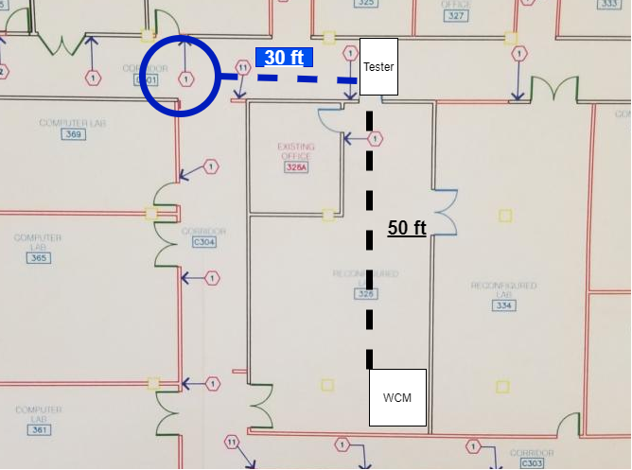

Figure X‑6: Test Results

## Testing & Validation of Quantitative Constraint M10 – Latency of Digital Module

Kyle Sellers (EEC)

### Objective, Rationale & Brief Description – M10

One downside of processing signals digitally is that some amount of delay is added to the signal. Digital signal processing occurs on buffers of samples, so there is inherent delay in filling these buffers, processing the sound, and then output from these audio buffers. Ideally this delay is small enough that it is not noticeable to the user, and if noticeable, it isn’t frustrating to try to work with. The team decided that 25 milliseconds would be short enough that the user should not notice a delay.

A buffer program will be loaded into the Digital Multi-Effects, with a low frequency square wave passed through. The input signal and output signal will both be fed into an oscilloscope, and the difference in the rising edges will be measured.

### Testing & Validation Summary of Results & Conclusions – M10

With the Electrosmith Daisy Seed having a known sample rate of 48 kHz and buffer size of 48 samples, the expected delay can be calculated as 48 / 48,000 = 1 ms.

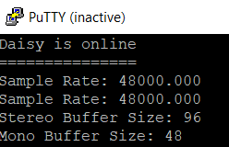

Figure X‑6: Output of Daisy Seed

The Daisy Seed offers stereo (2 channel) audio, so by dividing this value by 2, we find the monophonic buffer size.

In actually testing the latency on an oscilloscope, the latency was found to be 2.6 ms, seen at the top right of the image below.

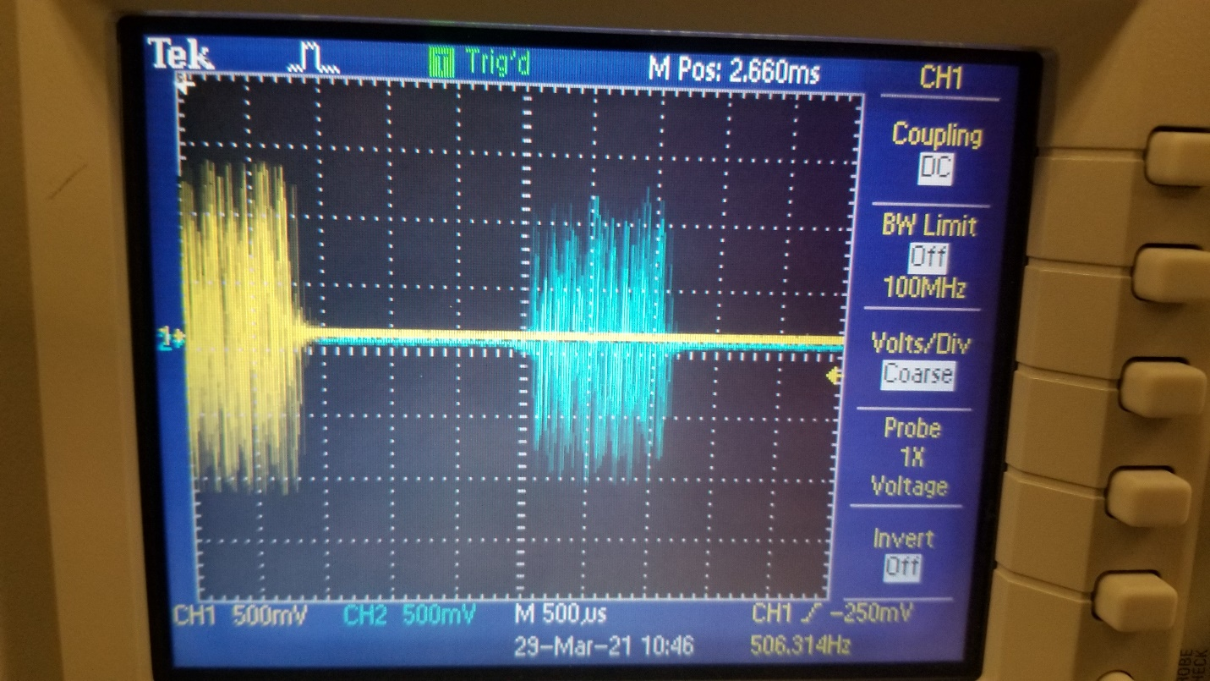

Figure X‑6: Test Results

## Testing & Validation of Quantitative Constraint M11 – Sample Rate

Kyle Sellers (EEC)

### Objective, Rationale & Brief Description – M11

For the Digital Multi-Effects Module, the sample rate of the microcontroller being used (the Electrosmith Daisy Seed) needs to be high enough to represent all frequencies in the audible spectrum for humans (20-22k). According to the Nyquist-Shannon sampling theorem, the sample rate should be greater than or equal to 2x the highest frequency one wants to represent. Therefore, 44kHz is the minimum sampling rate that we want for this project.

The Electrosmith Daisy Seed has a getAudioSampleRate() function, which tells the sample rate that the microcontroller is using. In debug mode, this will be printed to the console to verify it is above 44kHz.

### Testing & Validation Summary of Results & Conclusions – M11

Results from debugging the sample rate from the Daisy microcontroller showed that it runs at 48kHz for the audio sample rate, which is higher than 44kHz. Therefore, our system meets our sample rate constraint.

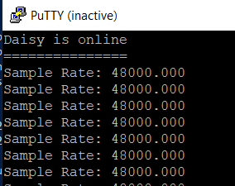

Figure X‑6: Test Results

## Testing & Validation of Quantitative Constraint M12 – Instructional Material

Keri Grevemberg (EE)

### Objective, Rationale & Brief Description – M12

### Testing & Validation Summary of Results & Conclusions – M12

Table X‑6: Test Result Data Table

|  |  |  |  |  |
| --- | --- | --- | --- | --- |
| Column 1 Title | Column 2 Title |  |  |  |
|  |  |  |  |  |
|  |  |  |  |  |



Figure X‑6: Test Results

## Testing & Validation of Quantitative Constraint M13 – Degree of Loudness

Taylor LeBlanc (EE)

### Objective, Rationale & Brief Description – M13

Since professors and students will be listening to the system it is crucial to keep the degree of loudness below a certain threshold to prevent hearing damage. A threshold of 90 dB was selected based on OSHA’s claims that workers could be exposed to this sound level for two hours before experiencing hearing damage.

### Testing & Validation Summary of Results & Conclusions – M13

The NIOSH sound level meter phone application was used to measure the output from active speakers. Measurements were taken with the meter placed directly next to the speaker. This was done to simulate the worst case scenario of an individual listening with their head next to the speaker. Along with testing the synthesizer’s max output level, a phone was used to output audio at two different levels; one at the phone’s recommended volume and the second at the phone’s max volume. This was done as a reference of what the appropriate output of the speaker should be. The reason for this is due to the degree of loudness being largely dependent upon the size of the speaker being used. The table below gives the values measured for each test using the same speaker in all three trials.

Table X‑6: Test Result Data Table

|  |  |
| --- | --- |
| Test | Degree of Loudness Measured (dB) |
| Synthesizer Max Output | 98.8 |
| Phone Recommended Volume Level | 84.5 | |
| Phone Max Volume Level | 104.1 |

The readings shown in Figure X-6 verify the findings included in Table X-6.

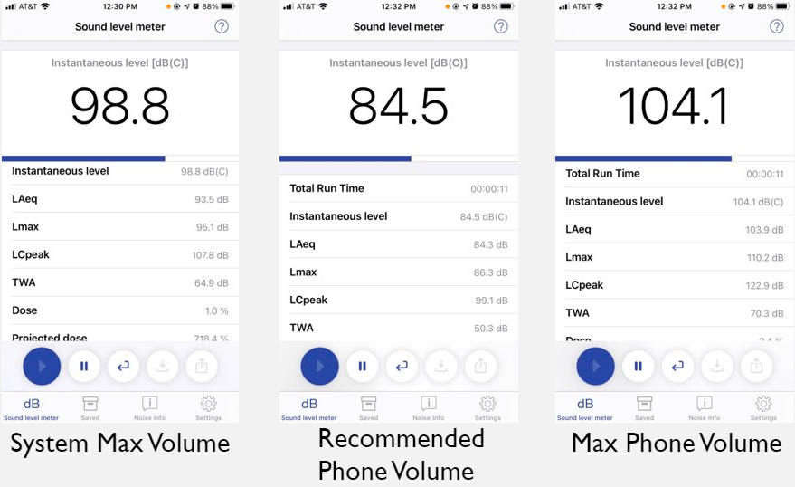

Figure X‑6: Test Results

# Project Management

## Schedule and Milestones

We have our theoretical and actual timeline of events that we proposed.

On the first figure is our proposed timeline with timelines and milestones.

They are color coded with roadblocks to preventing the achievement of other parts of the project.

More detailed explanation of phases will be found in the appendix.

**Here I will elaborate on the figures below and underlined the actual dates with what happened to change that.**

**Procurement Phase**

BOM Started Jan 11 and turned in the 22nd

Parts and PCB ordered Jan 22nd

These are huge bottlenecks that if not met will set us behind because the next part is testing and manufacturing

Roadblocks: BOM for budget and ordering, and PCB and Component ordering

Actual not much changed we had a pretty good start to the semester so no major differences.

**Manufacturing Phase**

Board testing to start in Jan 25 and finish Feb 1

PCB redesign also to start alongside testing Feb 1 and end Feb 9th

Roadblocks if boards do not arrive, we won’t be able to assemble or test them.

Actual: Took the most amount of time and differed much from what we predicted. We projected to be done by February but in actuality we finished around March 28th. This occurred because of issues with soldering, parts being dead on arrival or missing, and the fact that we had 7 modules to assemble and test.

**Assembly Phase**

PCB V2 to be ordered at the end of march the 5th

And case design to start while we wait for pcbs to arrive.

Major roadblocks are the pcb redesign to finish by Feb 17th

**Main Testing Phase**

This phase will cover the majority of the testing of the project but most testing will occur throughout the semester, but we find that this testing is the most impactful for our qualitative and quantitative constraints. Once 2nd PCB round shows up we assemble and test to see if our results change or are consistent and then with case assembled integration testing and temperature testing to be done the on March 19th and March 15th respectively.

While research of educational material and mock labs to be done over the course of the semester.

Critical path. Bill of materials > Parts ordered , Boards ordered> Receive Parts and boards> Board testing and pcb redesign> PCB v2> final testing and adjustments> Case built> full assembly.

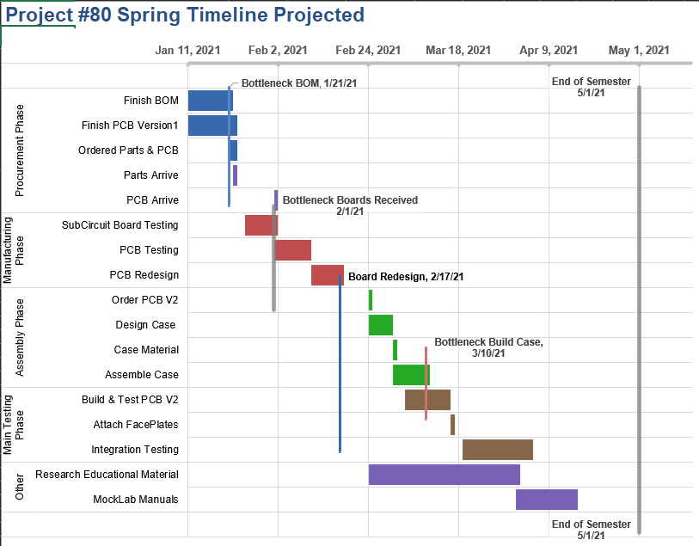

Figure XI‑1: Gantt Chart with Project Time-Line

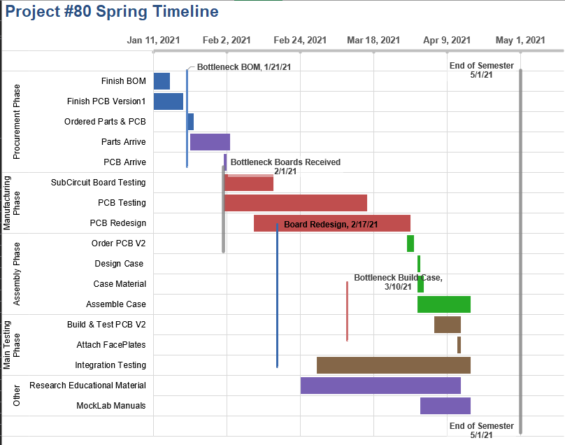

Figure XI‑1: Gantt Chart with Project Time-Line

## Budget

# 

|  |  |  |  |
| --- | --- | --- | --- |
| Expense Type​ | Ideal Budget ​ | Final Spent​ | Per System Cost ​ |
| Circuit Components​ | $400.00​ | $647.96​ | $414.09​  ​ |
| PCBs​ | $75.00​ | $91.46​ | $13.07​ |
| Faceplates​ | $75.00​ | $124.91​ | $17.85​ |
| Case Material​ | $50.00​ | $35.00​ | $35.00​ |
| **TOTAL**​ | $600​ | $899.33​ | $479.85​ |

Circuit Components Final spent was $899.33.

Components totaled to be the majority of that at 647 with two orders of components being made one primary and one secondary that added most miscellaneous items such as mounting screws, knobs, and aesthetics.

Pcbs cost us around $40 for first round and $60 on second round with faceplate milling being $124.

Case Material at lows with screws and nails was around $35.

Our projected was for $600 but with issues ordering we had wrong parts ordered, led screen broken ,some parts lost or broken. The replacements took more than expected cause not expecting so much component loss and breaking. PCBs were also ordered twice.

So, the discrepancy for components was huge.

# Summary and Conclusions

# Appendix

## Quality Function Deployment (QFD) - HoQ

**Relationships/Interdependence (Roof)**

Cost relates to the size of the case positively. A larger case costs more money in materials.

Costs relation to the power-consumption is strongly negative. The more efficient we make our system, the more it will cost.

Cost relates to the bandwidth positively. The more money we put into the product the better the bandwidth.

Cost relates to signal to noise ratio positively. The more money we put in the more the signal to noise ratio will be in the favor of signal, minimizing noise, and raising signal.

Cost relates to operating temperature negatively. As we decrease the operating temperature the cost will go up. Using heat sinks takes up surface area and expensive metals.

Cost relates to latency negatively. The more money put into the project the more resources are available to use in lowering the latency of the wireless controller.

Cost relates to range positively. The more range we need for the wireless controller the more expensive an antenna we will need, increasing cost.

Size of Case strongly positively relates to weight. The size of the case will increase the weight.

Size of Case relates negatively to operating temperature. The larger the case, the more airflow is allowed, reducing operating temperature.

Power consumption relates positively to bandwidth. Higher power consumption in our Op-Amps will lead to a higher potential bandwidth.

Power consumption relates positively to signal to noise ratio. The more power we provide our circuits, the more powerful the signal will be, increasing the signal to noise ratio.

Power consumption relates strongly positively to operating temperature. The more power our system consumes, the more heat it will generate.

Power consumption related positively to Degree of Loudness. A greater output volume requires a greater power draw.

Signal to noise ratio relates positively to Degree of Loudness. A larger signal to noise ratio means greater signal strength, thus a louder signal.

**Weights**

**(9) Assist Course Syllabi:** Being the main function that separates our product from competitors, this gets the maximum possible rating

**(9) Generate Audio Signals:** Generating periodic waveforms is the primary function of our product. These are the cornerstones in basic signal education.

**(9) Output Audio Signals:** Without a way to output the signals at the end of the signal chain, our system is useless.

**(9) Generate Control Voltages:** Control voltages allow for dynamic manipulation of signals, and are a cornerstone of modular synthesizers, thus rating so high.

**(8) Manipulate Signal Frequency:** Manipulating Signal Frequency also scores high because without manipulating the signal frequency, users will not have many ways to change the sounds that they are producing. Filtering is a very important concept in electrical engineering, and it fits nicely in a musical context

**(8) Manipulate Signal Amplitude:** Manipulating signal amplitude is only an 8, because we need to be able to change volume levels to keep below a threshold of loudness.

**(6) Process Signals Digitally:**  Many competing systems offer digital signal manipulation, so it is a priority that we do as well. This also serves to help educate in Digital Signal Processing. This, however, is not a necessity for the system to operate at a bare level.

**(6) Regulate Operating Temperature:** For the stability of waveforms as well as the safety of our system, our system should not overhear. This should not be a problem most of the time, but it should be kept in mind.

**(8) Reroute Signal Path:** At the end of the day, we are designing a modular synthesizer, so the ability to change the signal path is a very important function.

**(6) Operate via Remote Control:** Wireless control is another high priority item. This is a novel module that not many other systems have, so its marketability past an educational use is high.

**(5) Easy to Use:** We want the project to be as approachable as it can be and easy to engage with. However, simplicity is not an extremely vital qualitative constraint.

**(6) Stability of Waveform:** The stability of a waveform is crucial. Students will be measuring and analyzing the waveforms produced by our system, so their stability in both frequency and shape is important.

**(5) Engaging/Fun to Use.** Our device will be an educational tool, so we aim to make our synthesis engaging for students. A fun to use system will break down the barrier of education in signals and to make it more approachable.

**(7) Customizable**. It is important that our project is made customizable so that when it is to be used at differing educational levels, students can use a tailored device that is specific to their academics.

**(5) Good Sound Quality**. Since our device is a musical instrument, good sound quality is important, but it is not a top priority for our system. We should strive to have good sound quality but understand that it is not as important as, Customizable, for example.

**(5) Easy to DIY**. The easier our system is to build from provided files and material, the easier it is to get students involved and learning. This, however, is not vital for the function for the system.

**What’s vs. How’s**

**Assist Course Syllabi**

|  |  |  |
| --- | --- | --- |
| Quantitative Constraint | Correlation | Explanation |
| Bandwidth | M | Bandwidth is a concept taught in courses such as Circuits 2, so it is important to have sufficient bandwidth for analysis. |
| Signal to Noise Ratio | W | SN Ratio is also a concept taught in EE courses, but signals can still be analyzing with a decently low SN ratio. |
| Instructional Material | S | This is the most important metric for measuring how much material there is assisting syllabi. |
| Degree of Loudness | W | If a signal is too low that it can’t be analyzed, it is useless. |

**Generate Audio Signals**

|  |  |  |
| --- | --- | --- |
| Quantitative Constraint | Correlation | Explanation |
| Power Consumption | M | The greater the amplitude of the signal generated, the more power the system will draw |
| Bandwidth | M | The frequency range of signals that we should produce is limited to the human hearing range |
| Signal to Noise Ratio | W | The audio signals we generate will have inherent noise, since we are generating analog signals. |
| Operating Temperature | W | Similar to power consumption, larger signals will produce more heat. |

**Output Audio Signals**

|  |  |  |
| --- | --- | --- |
| Quantitative Constraint | Correlation | Explanation |
| Output Audio Signals | S | Our method of outputting audio signals should be able to produce all frequencies of the human hearing spectrum without attenuation or distortion. |
| Signal to Noise Ratio | M | Our method of output may add in unwanted noise, so our team should attempt to minimize this. |
| Operating Temperature | M | The type of device our system will drive for audio output will draw more or less power, creating heat. |
| Degree of Loudness | S | Our outputting of audio signals is directly correlated to the degree of loudness measured from it. |

**Generate Control Voltages**

|  |  |  |
| --- | --- | --- |
| Quantitative Constraint | Correlation | Explanation |
| Power Consumption | S | The strength and quantity of control voltages created relates directly to power consumption. |
| Operating Temperature | M | The strength and quantity of control voltages created relates directly to power consumption, and therefore heat output. |

**Manipulate Signal Frequency**

|  |  |  |
| --- | --- | --- |
| Quantitative Constraint | Correlation | Explanation |
| Bandwidth | S | The frequencies that we can affect is directly affected by system bandwidth. |
| Sampling Rate | M | To manipulate signal frequency digitally, the sampling rate directly affects the range of frequencies that are represented. |

**Manipulate Signal Amplitude**

|  |  |  |
| --- | --- | --- |
| Quantitative Constraint | Correlation | Explanation |
| Power Consumption | S | Amplifying signals requires power. |
| Signal to Noise Ratio | M | Amplifiers can introduce unwanted noise, and then amplify that noise, increasing SN ratio. |
| Operating Temperature | M | Amplifying signals requires power, generating heat. |

**Process Signals Digitally**

|  |  |  |
| --- | --- | --- |
| Quantitative Constraint | Correlation | Explanation |
| Cost | M | Better DSP microchips come at a higher cost. |
| Bandwidth | W | Strong signals above the Nyquist frequency of our Digital processor causes aliasing. |
| Latency of Digital Module | S | Our processing of signals digitally directly add latency to the system. |
| Sample Rate | S | The sample rate of our digital module determines sampling rate. |

**Regulate Operating Temperature**

|  |  |  |
| --- | --- | --- |
| Quantitative Constraint | Correlation | Explanation |
| Power Consumption | S | The more power our system draws, the more heat components will output. |
| Operating Temperature | S | Our regulation of operating temperature is directly measured by operating temperature. |

**Reroute Signal Path**

|  |  |  |
| --- | --- | --- |
| Quantitative Constraint | Correlation | Explanation |
| Size of Case | S | Our choice of how we reroute signals directly impacts the size of faceplates and circuits, thus influencing the size of the case. |

**Operate via Remote Control**

|  |  |  |
| --- | --- | --- |
| Quantitative Constraint | Correlation | Explanation |
| Cost | M | Faster and further range wireless control microcontrollers cost more money. |
| Latency of Wireless Control | S | This metric directly measures the performance of Remote-Control access. |
| Range | S | This metric directly measures the performance of Remote-Control access. |

**Easy to Use**

|  |  |  |
| --- | --- | --- |
| Quantitative Constraint | Correlation | Explanation |
| Size of Case | M | If the system is too large are too small, it will be either too cumbersome or too intricate to use. |
| Instructional Material | M | Including more instructional material can help explain how to operate the system. |

**Stable Waveforms**

|  |  |  |
| --- | --- | --- |
| Quantitative Constraint | Correlation | Explanation |
| Cost | W | More expensive signal producers create a marginal increase in waveform stability. |
| Operating Temperature | M | Higher operating temperature increases resistance, altering the waveform as it increases |

**Engaging/Fun to Use**

|  |  |  |
| --- | --- | --- |
| Quantitative Constraint | Correlation | Explanation |
| Size of Case | M | If the system is too cumbersome or intricate to use, users will lose interest |
| Latency of Wireless Control | M | If the system has too much latency, users will get frustrated. |
| Range of Wireless Control | W | If users are trying to operate the system remotely, they will get frustrated if connection drops out due to range issues. |
| Latency of Digital Module | W | If the system has too much latency, users will get frustrated. This latency, however, is much smaller than that of wireless control. |

**Customizable**

|  |  |  |
| --- | --- | --- |
| Quantitative Constraint | Correlation | Explanation |
| Cost | M | Creating more routing options via patch cables or a switching matrix costs more money. |
| Size of Case | S | Creating more routing options via patch cables or a switching matrix requires more space. |
| Weight | M | Creating more modules for more customization option increases the weight of the system. |
| Power Consumption | M | Including more modules for increased customizability would require higher power draw. |
| Instructional Material | W | Including more modules for increased customizability would require more instructional material to explain them. |

**Good Sound Quality**

|  |  |  |
| --- | --- | --- |
| Quantitative Constraint | Correlation | Explanation |
| Bandwidth | S | Being able to produce all frequencies of the human hearing spectrum, especially near 20 Hz and 20kHz, is very important for perception of sound quality. |
| Signal to Noise Ratio | S | Having too much noise in a signal deteriorates sound quality perception. |
| Sample Rate | M | Sampling rate directly affects the bandwidth of digital processing. It should be above 44.1kHz to include all audible frequencies |
| Degree of Loudness | S | Louder sounds are perceived better, however, it should not be too loud to damage hearing. |

**Easy to DIY**

|  |  |  |
| --- | --- | --- |
| Quantitative Constraint | Correlation | Explanation |
| Cost | W | Through hole components typically cost more than SMD components but are easier to assemble. |
| Size of case | M | The system and its modules should not be so small that it takes a professional to assemble. |
| Instructional Material | S | The more instructions on how to assemble the system, the easier it will be. |

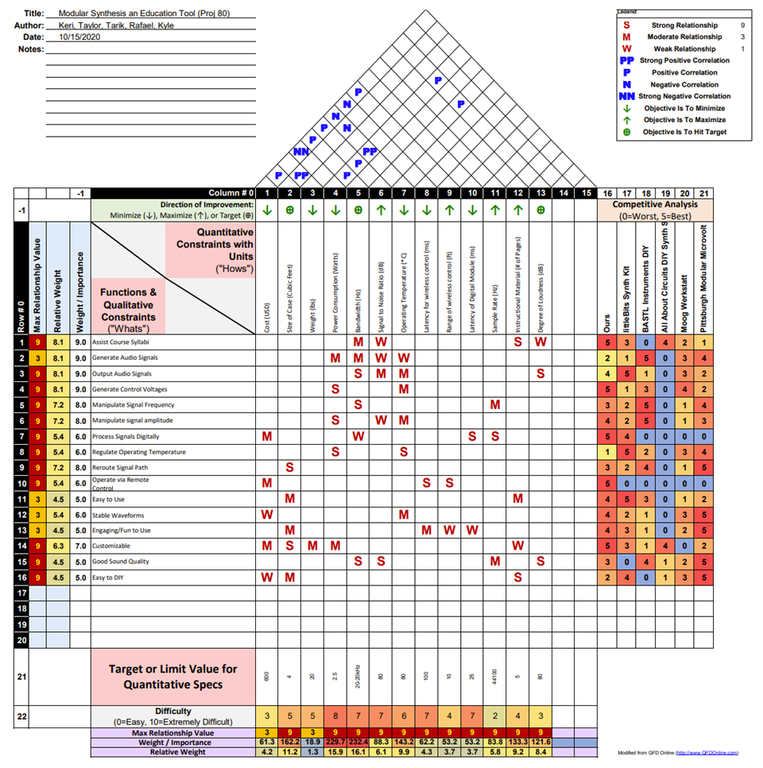

Figure XIII‑1: The House of Quality for the project.

## Concept/Solution Evaluation and Selection Supplement

### Concept/Solution for Function F1- Details

#### Original Concept Selected – Details

|  |  |  |  |
| --- | --- | --- | --- |
| **#** | **Concept** | **Selected?** | **Explanation** |
| 1 | QR code Linked to Module Theory | Yes | Addition of a QR code would allow easy access to the educational material relating to these modules without the need for the user to buy a physical copy of a manual. |
| 2 | Lab Manuals | Yes | The addition of a lab manual would provide students with examples of how the synthesizer can be used to experiment with and measure different signals. |
| 3 | Built in Oscilloscope | No | The system is intended to be used by junior and senior year engineers. These primary customers likely have access to better quality oscilloscopes in their labs. Likewise, the addition of a subpar oscilloscope would add to the overall cost of the system. |

#### Re-design Concept Selected – Details

#### Original and Re-designed Concepts Considered but not Selected.

### Concept/Solution for Function F2- Details

#### Original Concept Selected – Details

#### Re-design Concept Selected – Details

#### Original and Re-designed Concepts Considered but not Selected.

### Concept/Solution for Function F3- Details

#### Original Concept Selected – Details

|  |  |  |  |
| --- | --- | --- | --- |
| **#** | **Concept** | **Selected?** | **Explanation** |
| 1 | Programmable DSP Microcontroller | Yes | With the main function that separates our system from our competitors, it makes sense to select the option with the greatest educational value in terms of tailoring DSP programs & display, as well as allowing students to upload their own code to experiment with. |

|  |  |  |
| --- | --- | --- |
| **#** | **Concept** | **Explanation** |
| 1 | Programmable DSP Microcontroller | Programmable DSP microchips allow designers and users to upload their own code for the digital processing of signals. |

|  |  |  |  |
| --- | --- | --- | --- |
| **#** | **Concept** | **Pros** | **Cons** |
| 1 | Programmable DSP Microcontroller | •Customizable  •Allows for students to experiment with their own code | •More expensive  •Requires set up for DIY customers  •Subject to software bugs |

#### Original and Re-designed Concepts Considered but not Selected.

|  |  |  |  |
| --- | --- | --- | --- |
| **#** | **Concept** | **Selected?** | **Explanation** |
| 2 | Out of the Box Digital Effects | No | While out of the box digital effects offer analysis, there is no way for us as creators to change these programs. |
| 3 | Route Audio through Computer Program | No | While the processing power of this option (for both DSP and display) is enticing, requiring an external computer is too inconvenient. Programs like this already exist, as well. |

|  |  |  |
| --- | --- | --- |
| **#** | **Concept** | **Explanation** |
| 2 | Out of the Box Digital Effects | Out of the box digital effects accept audio input and output, and only apply non customizable digital effects to them. |
| 3 | Route Audio through Computer Program | Audio can be routed out of the system and into a computer, allowing for DSP operations to be performed there. |

|  |  |  |  |
| --- | --- | --- | --- |
| **#** | **Concept** | **Pros** | **Cons** |
| 2 | Out of the Box Digital Effects | •Cheaper  •Have been tested by creators | •Only allows for analysis of DSP (not testing own algorithms) |
| 3 | Route Audio through Computer Program | •Does not require its own dedicated module  •More processing power | •Not easy route into and out of computer  •Requires external computer (possibly requires an audio interface as well) |

### Concept/Solution for Function F4- Details

#### Original Concept Selected – Details

#### Re-design Concept Selected – Details

#### Original and Re-designed Concepts Considered but not Selected.

### Concept/Solution for Function F4- Details

#### Original Concept Selected – Details

#### Re-design Concept Selected – Details

#### Original and Re-designed Concepts Considered but not Selected.

### Concept/Solution for Function F5- Details

#### Original Concept Selected – Details

#### Re-design Concept Selected – Details

#### Original and Re-designed Concepts Considered but not Selected.

### Concept/Solution for Function F6- Details

#### Original Concept Selected – Details

#### Re-design Concept Selected – Details

#### Original and Re-designed Concepts Considered but not Selected.

### Concept/Solution for Function F7- Details

#### Original Concept Selected – Details

#### Re-design Concept Selected – Details

#### Original and Re-designed Concepts Considered but not Selected.

### Concept/Solution for Function F8- Details

#### Original Concept Selected – Details

Heat sinks were placed on the following modules and following components:

Digital Multi-Effects: LM7805 5 V Power Regulator

Sequencer: LM7805 5 V Power Regulator

Wireless Control Module: LM7805 5 V Power Regulator

Power Supply: Heat Sinks on Power Regulators included

#### Original and Re-designed Concepts Considered but not Selected.

A fan was also considered to include in the case to lower ambient temperature. This was decided against, as it would add ambient noise to the environment and affect how the student perceives audio from the system.

### Concept/Solution for Function F9- Details

#### Original Concept Selected – Details

#### Re-design Concept Selected – Details

#### Original and Re-designed Concepts Considered but not Selected.

### Concept/Solution for Function F10- Details

#### Original Concept Selected – Details

|  |  |  |  |
| --- | --- | --- | --- |
| **#** | **Concept** | **Selected?** | **Explanation** |
| 2 | Phone App | Yes | A mobile application for remote control makes the most sense, as it is the most accessible, cheapest to create, and offers many controlling options. |
| 3 | Laptop/Computer App | Yes | The computer controller is selected as well, as it is likely possible to create both the phone and computer app together, offering 2 options for the price of one. |
| **#** | **Concept** | **Explanation** | |
| 2 | Phone App | An application for iOS and android that sends wireless signals to module. Controlled via touch. All phones come with wireless capabilities via Wi-Fi or Bluetooth. | |
| 3 | Laptop/Computer App | A computer application that connects to a wireless control module. Controlled via keyboard and mouse. Laptops and computers can connect to Wi-Fi and Bluetooth, allowing for wireless control. | |

|  |  |  |  |
| --- | --- | --- | --- |
| **#** | **Concept** | **Pros** | **Cons** |
| 2 | Phone App | •Mobile  •Most people have phones  •Virtually infinite control possibilities | •Small form factor  Only allows few controls on screen at once  •Requires cumbersome menus |
| 3 | Laptop/Computer App | •Large display  •Convenient for lab use  •Virtually infinite control possibilities | •Requires laptop / computer which some students may not have  •Can be bulky |

#### Re-design Concept Selected – Details

After development began, only the phone app was selected to be used, as making a web app for laptop/computer was not as easy as anticipated.

#### Original and Re-designed Concepts Considered but not Selected.

|  |  |  |  |
| --- | --- | --- | --- |
| **#** | **Concept** | **Selected?** | **Explanation** |
| 1 | Physical Remote | No | A physical remote would take a lot of engineering effort to create, as well as be expensive & difficult to DIY. |

|  |  |  |
| --- | --- | --- |
| **#** | **Concept** | **Explanation** |
| 1 | Physical Remote | Many types of remote controllers exist (e.g., infrared and radio). A physical remote would include knobs and sliders, like those found connected to our system, and communicates with the system wirelessly. |

|  |  |  |  |
| --- | --- | --- | --- |
| **#** | **Concept** | **Pros** | **Cons** |
| 1 | Physical Remote | •Intuitive, as controls are similar to those existing on system  •Physical controls are more engaging than digital | •Requires building hardware  •Limited on number of controls based on controller size |

## System Description/Product Architecture Supplement

### Sub-System SS1- Voltage Controlled Oscillator

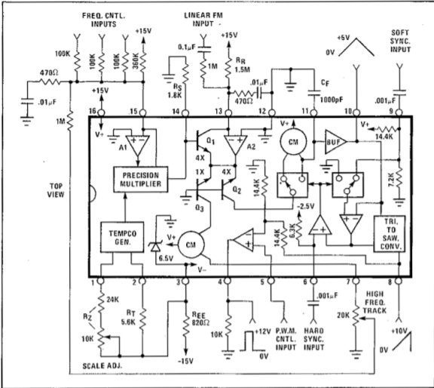

The design for the module starts at what functions we need satisfied, generate audio signals, they aren’t worth much if they aren’t read so output also, then manipulate signal frequencies, and assist course syllabi (this is a bit of icing on the cake since it satisfies other functions, and all of our modules satisfy education to a degree.

So, we need to output waveforms for the generate audio signals this chip and datasheet barebones factory stock settings will accommodate all of your signal needs and it has the basics that are widely used in engineering and in electronic music.

You can see on the datasheet that it has pulse, saw, triangle and PWM control input. Since those are the functions covered I will be going over those.

The datasheet design uses pretty much all the features of the chip and shows one or two of its quirks too. The CEM3340 is extremely unusual in that it offers both Hard and Soft Sync inputs (pin 6 and pin 9), and neither of them work the way you might expect. As we’ll see, this led to them being widely ignored.

One of the quirks of the CEM3340 is the waveform outputs. For a start, these are all different levels. The Ramp is 2/3rds of the positive supply. The Triangle is 1/3rd of the positive supply. The Pulse/Square is the positive supply level minus 1.3V.

For a typical +12V supply, this gives levels of 0→10V, 0→4.8V, and 0→11V respectively. Another quirk is that the Pulse is an open emitter output, so it needs a pull-down resistor to set the lower level.

Typical supplies for synth circuits would be +/-15V or +/-12V, but the CEM3340/AS3340 cannot stand more than 24V between its supply pins, so even +/-12V is right at the limit.

Starting numerically at Pins 1 and 2, this is the temperature compensation circuit. This temperature compensation circuit helps produce a highly accurate result when it comes to temperature drift and outputting.

Pins 4, 5, and 6 are inputs and outputs all labelled above, so no need to discuss those.

Pin 11 is the next important one. It’s the VCO’s timing capacitor. Use a good quality capacitor here, with low leakage and low tempco. Polystyrene film used to be the best regarded.

Pin 15 is the Frequency CV input. Modules can manipulate the signal frequency by applying up to a -5 to 5v. Kyles WCM outputs into the CV allowing a less 10 Hz and a max 33khz.

I have basically followed the manufacturing schematic to the T and added some op-amps to help buffer or amplify the signal as needed. The pulse width control is tricky and has some quirks suck as reaching full pulse width at certain levels this must be a chip bug because some chips just do not have the same quirk and it is solved by swapping to another chip. The outputs just go through followers and have some resistors for gain. Then the outputs go through 1k resistors to their output to limit their amperage as to not damage components.

Following the schematic may seem similar but this design is based on a chip that is fairly difficult to acquire, and have resorted to using similar chips that have same design specifications, this schematic is also from the 60s or 70s, so we have a lot changes to make.

For once the pull down the resistor at the pulse pin 4 needs to be 51k ohms and not one ohm shorter.

Or the pulse wave will not output at all. This was figured out with some research a lot of guess work.

Ree at pin 3 needs to be either 820 or 620 ohms. You will find out which when you turn it on, and it does not

do anything. Apparently, there is a current that must match the inner workings of the chip and there is a range that’s from 620 ohm to 820 to find that sweet spot.

But that was a rare exception.



Figure XIII‑2: Exploded View Assembly Drawing of Sub-System SS1 - VCO

#### Comprehensive Parts List for SS1- Voltage Controlled Oscillator

Table XIII‑1: List of Parts for Sub-System SS1

|  |  |  |  |
| --- | --- | --- | --- |
| Part # | Quantity | Type | Name |
| SS1-P1 | 1 | IC | Cem3340/as3340 |
| SS1-P2 | 2 | IC | Tl072 |
| SS1-P3 | 2 | .01uf | Capacitor |
| SS1-P4 | 1 | 1nF | Capacitor |
| SS1-P5 | 2 | 10uF | Bipolar Cap |
| SS1-P6 | 4 | .1uF | Capacitor |
| SS1-P7 | 1 | 1.5Mohm | Resistor |
| SS1-P8 | 1 | 470kohm | Resistor |
| SS1-P9 | 4 | 100k | Resistor |
| SS1-P10 | 1 | 51kohm | Resistor |
| SS1-P11 | 1 | 24k | Resistor |
| SS1-P11 | 1 | 10k | Resistor |
| SS1-P11 | 1 | 5.6k | Resistor |
| SS1-P11 | 1 | 1.8k | Resistor |
| SS1-P11 | 4 | 1k | Resistor |
| SS1-P11 | 2 | 470ohm | Resistor |
| SS1-P11 | 2 | 10ohm | Resistor |
| SS1-P11 | 5 | Output | Phone jack |
| SS1-P11 | 1 | 10kohm | Potentiometer cermet trimmer |
| SS1-P11 | 3 | 100kohm | potentiometer |
| SS1-P11 | 2 | Schottky Diode | Diode |
| SS1-P11 | 1 | Header | 10pin IDC |

#### Off-The-Shelf Parts and Component Specifications for SS# - Sub-Sys Name



Figure XIII‑3: Specifications for part SS1-P1 – Cem3340 Pinout/Datasheet

#### Engineering (Manufacturing) Drawings of All Parts of SS# - Sub-Sys Name



Figure XIII‑4: Manufacturing Drawing of part SS#-P# - Part name

### Sub-System SS2- Voltage Controlled Filter

Below are the links to the Mock Lab and Lab Manual:

Mock Lab: <https://docs.google.com/document/d/1hAaE2zSHt2OmR_1zOxF_C5R1qC0kocSc--IPfkO2wJY/edit?usp=sharing>

Lab Manual: <https://docs.google.com/document/d/1flxD_q9zZXkrHP92lTx2Hou0zQVlUOIwcoD-iHMTSX4/edit?usp=sharing>

Also, her is a link for any information involving the filter that needs to be addressed in



Figure XIII‑2: Exploded View Assembly Drawing of Sub-System SS# - VCF

#### Comprehensive Parts List for SS# - Sub-Sys Name

Table XIII‑1: List of Parts for Sub-System SS#

|  |  |  |  |
| --- | --- | --- | --- |
| Part # | Quantity | Material | Name |
| SS#-P1 | 3 | N/A | Stepper Motor |
| SS#-P2 | 3 | Aluminum | Motor Bracket |
| SS#-P3 |  |  |  |
| SS#-P4 |  |  |  |
| SS#-P5 |  |  |  |
| SS#-P6 |  |  |  |
| SS#-P7 |  |  |  |
| SS#-P8 |  |  |  |
| SS#-P9 |  |  |  |
| SS#-P10 |  |  |  |

#### Off-The-Shelf Parts and Component Specifications for SS# - Sub-Sys Name

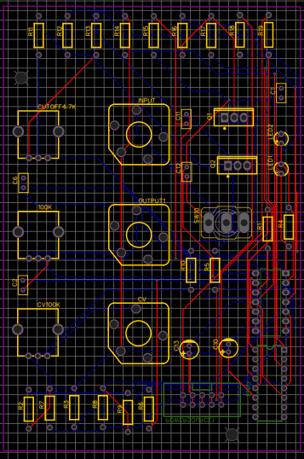

Figure XIII‑3: Specifications for part SS#-P# - Part Name

#### Engineering (Manufacturing) Drawings of All Parts of SS# - Sub-Sys Name



Figure XIII‑4: Manufacturing Drawing of part SS#-P# - Part name

### Sub-System SS3- Digital Multi-Effects

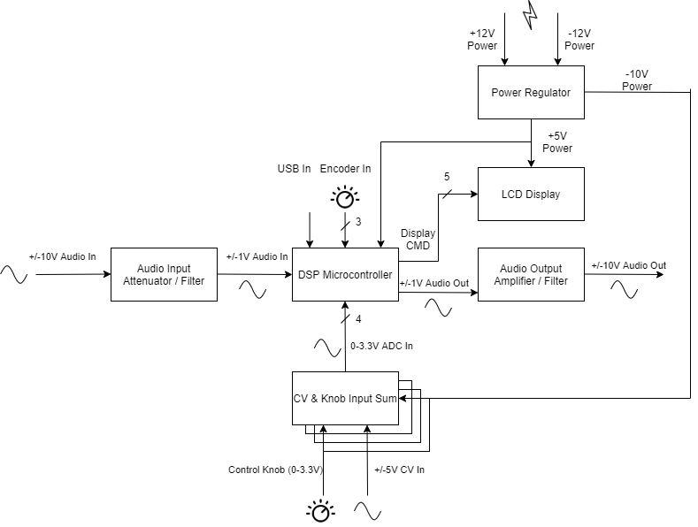

Figure XI‑2: Level 1 Hardware Drawing of Sub-System SS3 – Digital Multi-Effects

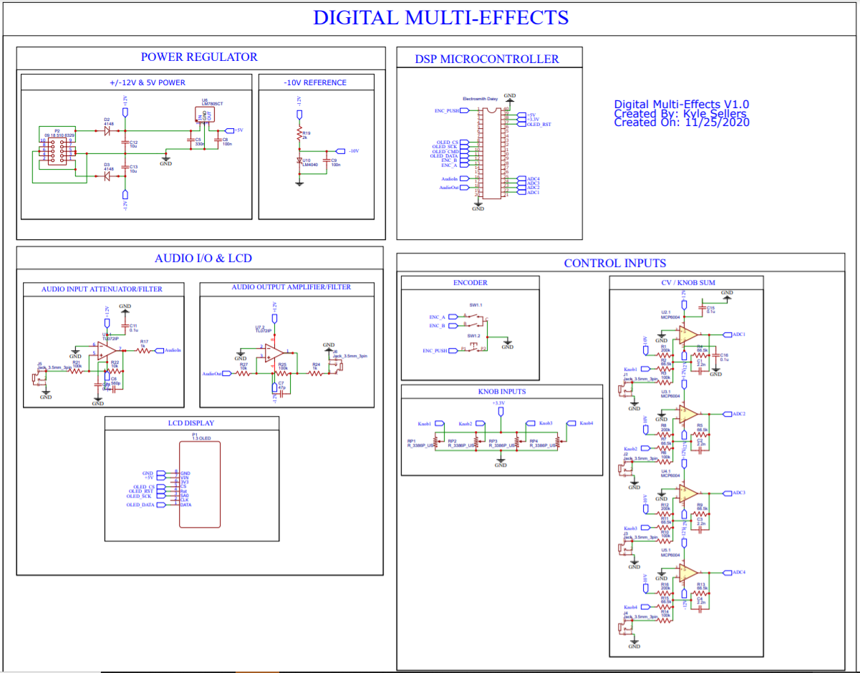

Figure XI‑2: Circuit Drawing of Sub-System SS3 – Digital Multi-Effects



Figure XI‑2: 3D Model of Sub-System SS3 – Digital Multi-Effects

Faceplate is 128.5 x 137 x 2 mm.

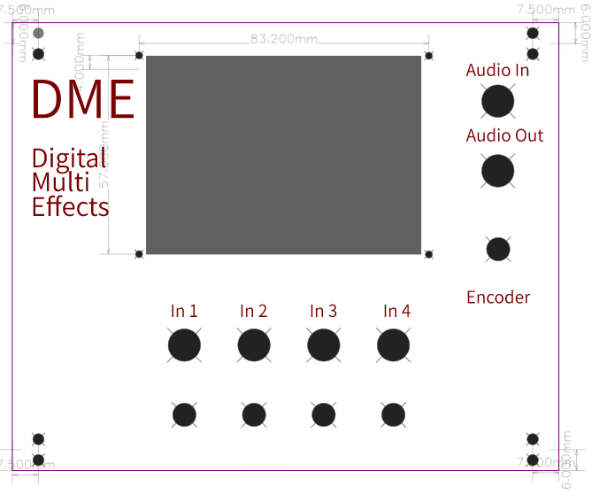

Figure XIII‑2: Faceplate Design and Dimensions

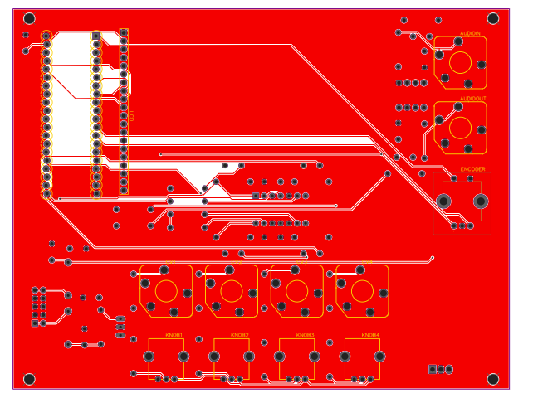

Figure XIII‑2: PCB Top Layer

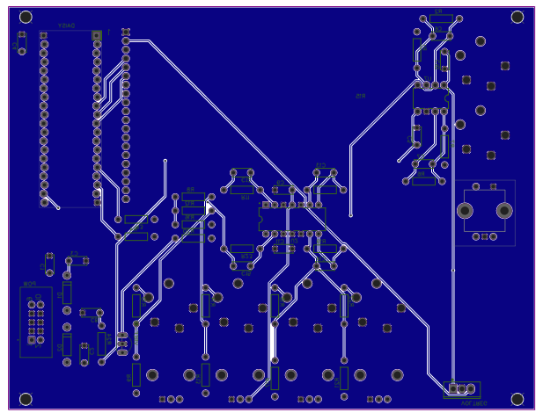

Figure XIII‑2: PCB Bottom Layer

#### Comprehensive Parts List for SS3- Digital Multi-Effects

Table XIII‑1: List of Parts for Sub-System SS#

|  |  |  |  |
| --- | --- | --- | --- |
| Part # | Quantity | Material | Name |
| SS3-P1 | 1 | DSP Microcontroller | SS3-P1 |
| SS3-P2 | 1 | Audio Input Attenuator / Filter | SS3-P2 |
| SS3-P3 | 1 | Audio Output Amplifier / Filter | SS3-P3 |
| SS3-P4 | 1 | CV / Knob Sum | SS3-P4 |
| SS3-P5 | 1 | LCD Display | SS3-P5 |
| SS3-P6 | 1 | Power Regulator | SS3-P6 |

#### Off-The-Shelf Parts and Component Specifications for SS3- Digital Multi-Effects

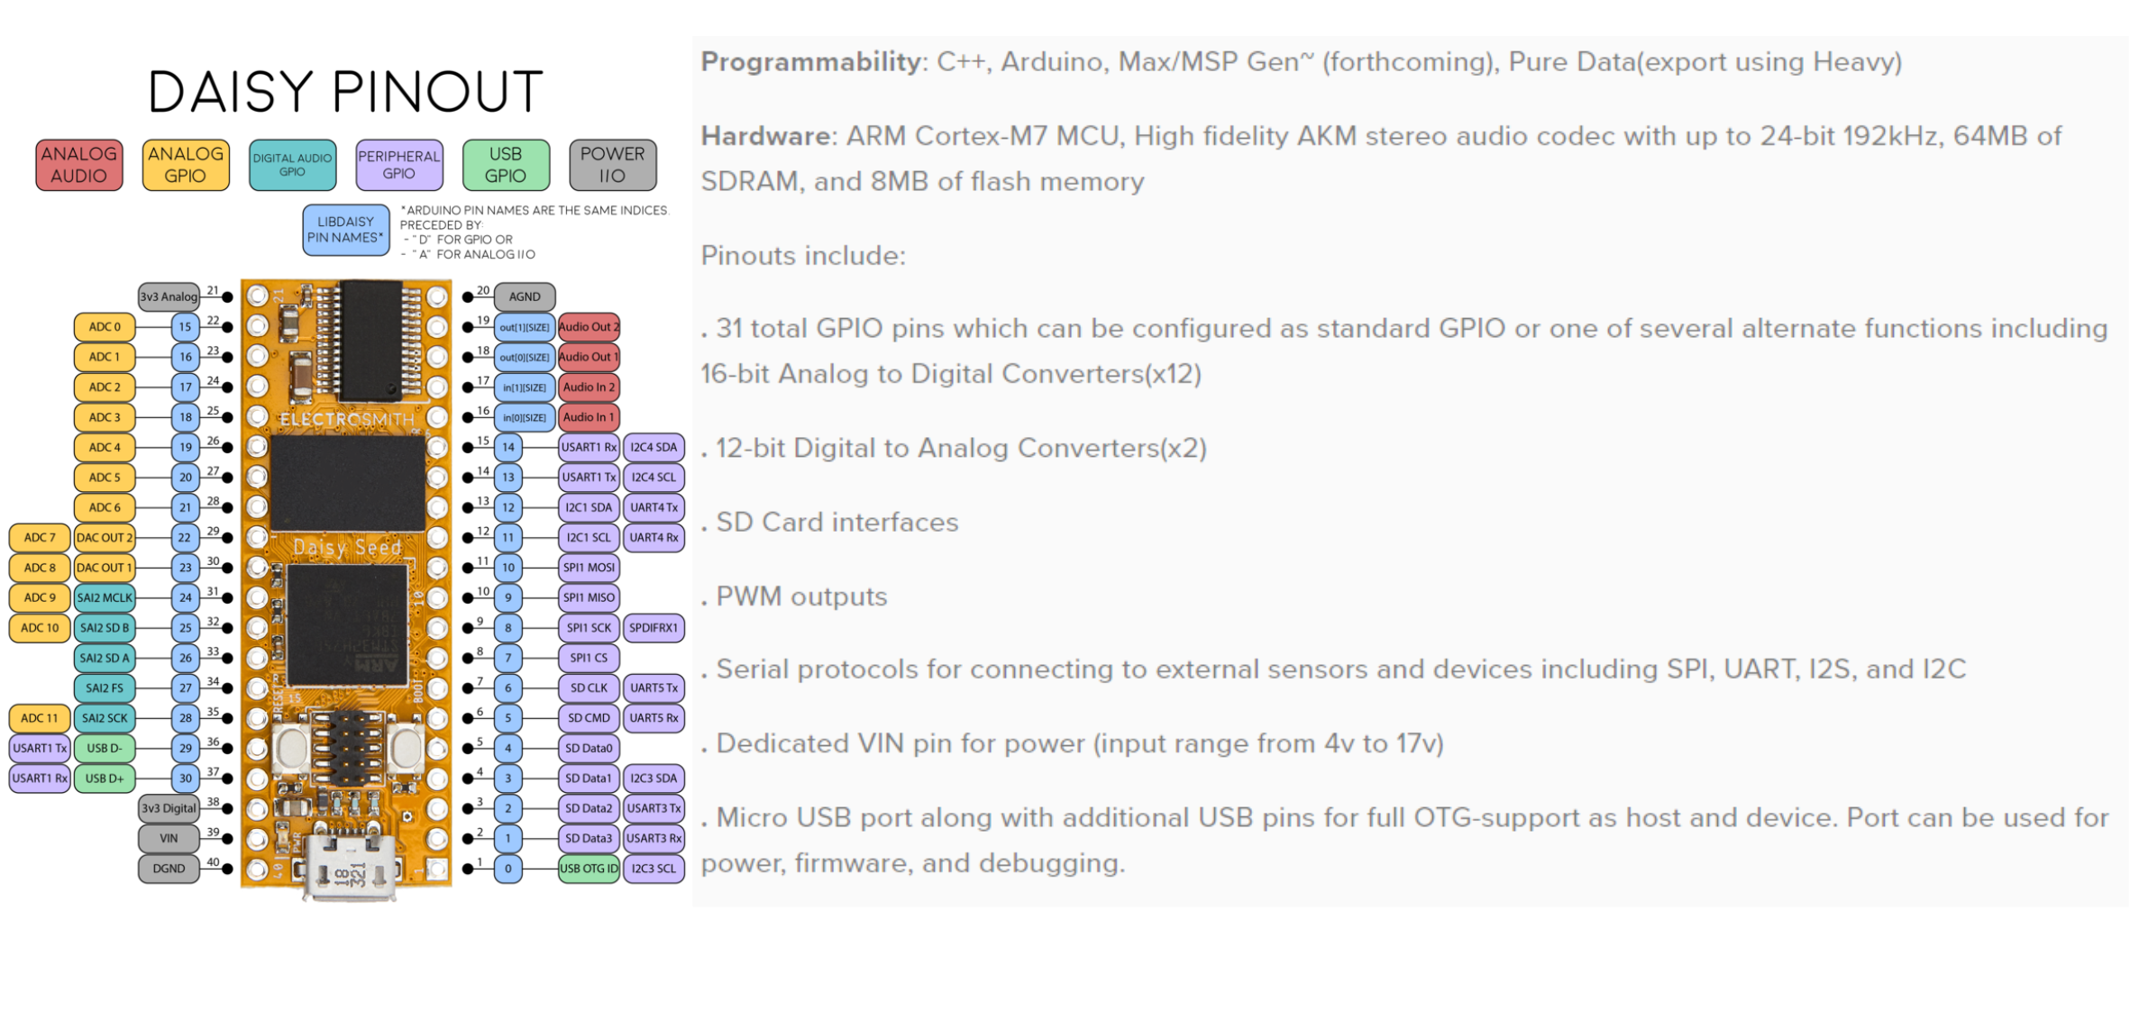

Figure XI‑3: Specifications for part SS3-P1 – DSP Microcontroller

Below shows specifications for the LCD screen originally selected for use in the DME:



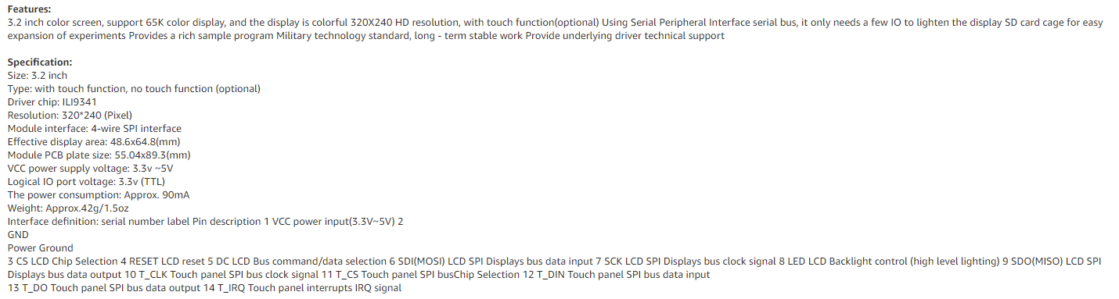

Figure XI‑3: Original Specifications for part SS3-P5 – LCD Display

However, after ordering 2 of these and them not working, the team decided to go with a more reputable manufacturer, adafruit.

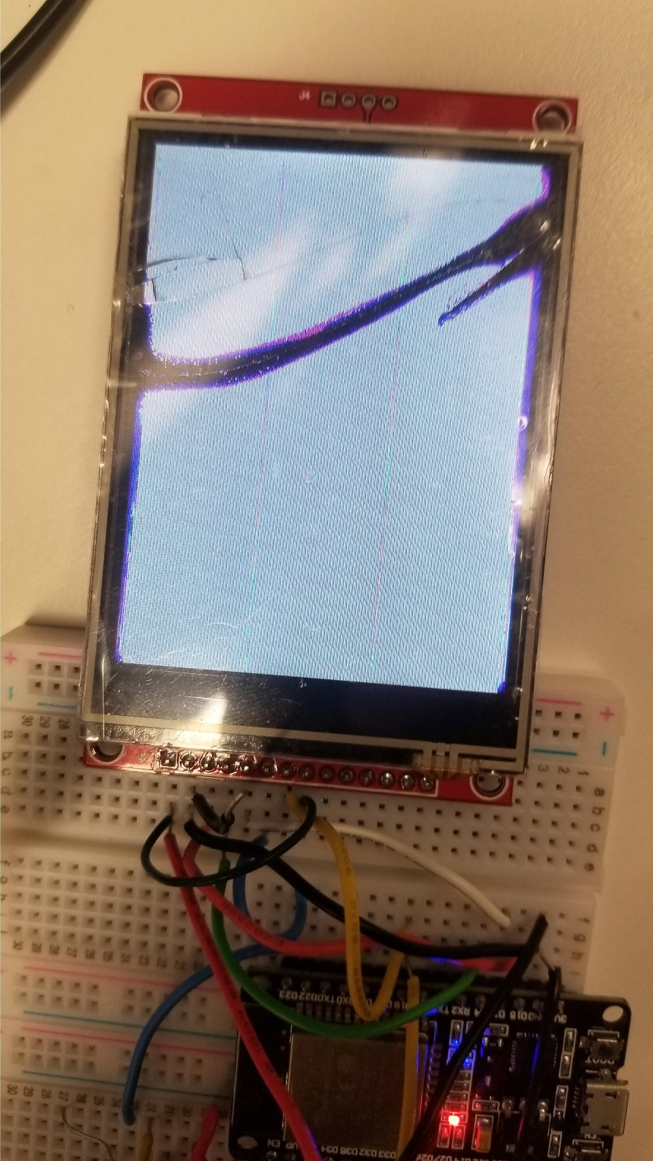

Figure XIII‑3: Broken Display

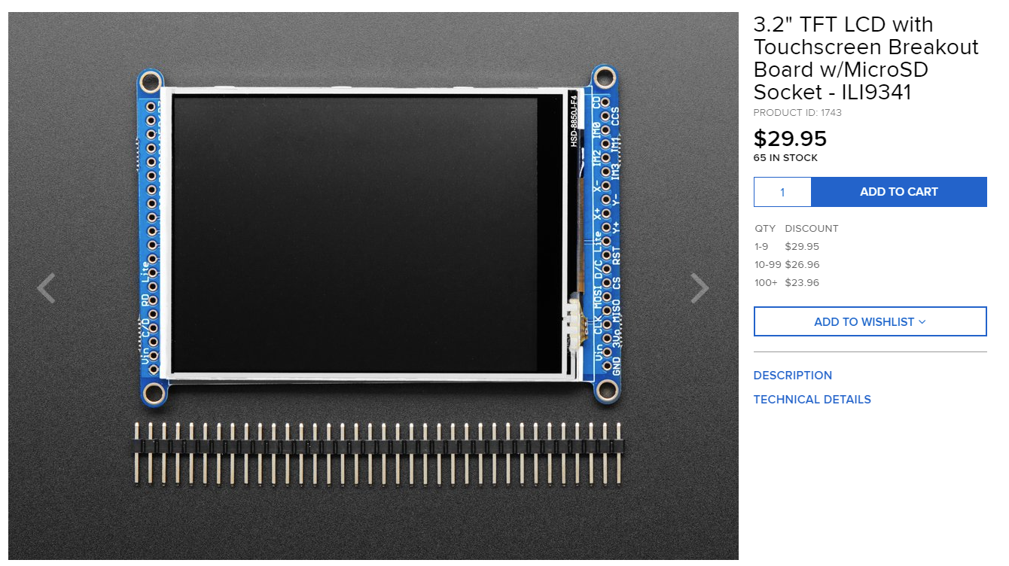

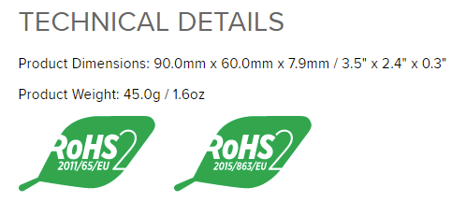

Figure XI‑3: Actual Specifications for part SS3-P5 – LCD Display

Although the above display is $10 (50%) more expensive, the team felt increased reliability trumped this price increase.

At the time of writing this report, the LCD display is not working on the Digital Multi-Effects. The biggest reasons for this are

* 1. Lack of support for this display type by Electrosmith Daisy Seed Creators
  2. Lack of memory space on the Electrosmith Daisy Seed

When messaging Daisy Seed creator Stephen Hensley about support for our display, the following was stated.

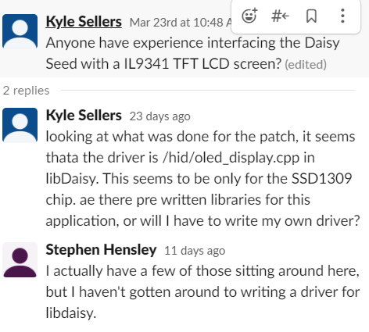

Figure XI‑3: Daisy Seed Creator on Display Support

This SSD1309 chip is for OLED displays, which typically have lower resolution, smaller size, less color options, and higher cost than the ILI9341 driven LCD displays. For a display to be included with the Digital Multi-Effects, either one of our team members needs to write a driver, or the module needs to be redesigned to include an SSD1309 display.

We do know the display works with correct drivers. Below shows a test program with the display connected to an Arduino Uno.

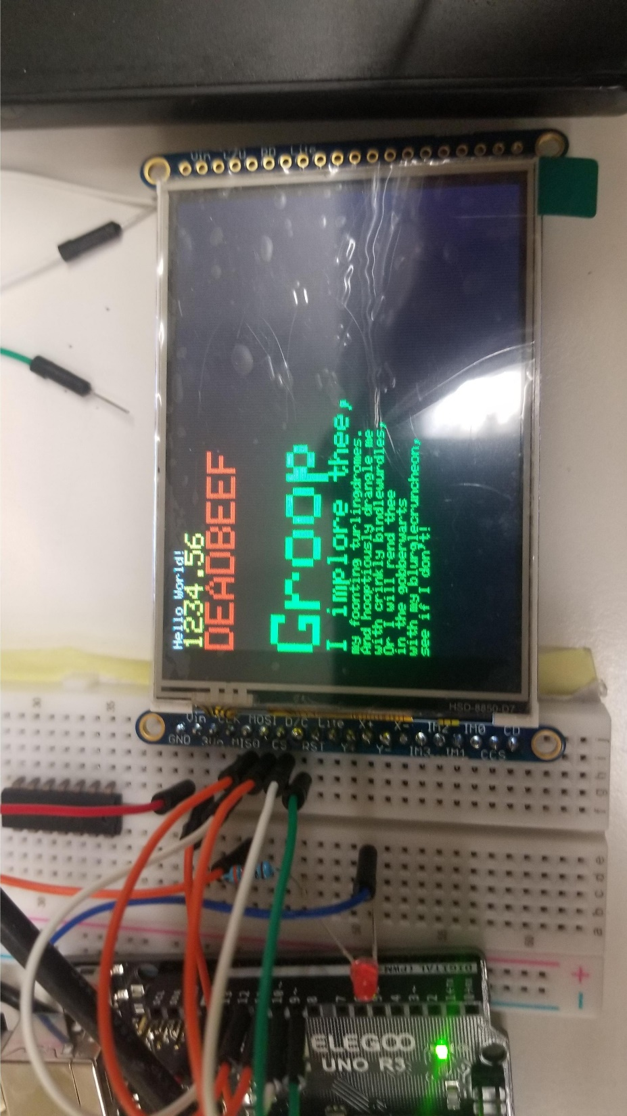

Figure XI‑3: Working Adafruit Display

The other issue ran into with adding display driver code was lack of space on the Electrosmith Daisy Seed after flashing our 4 programs to it.

The Daisy Seed claims to have 64 MB of SDRAM, as seen above in the Daisy Seed Specs.

Below shows a screenshot of the error message when trying to load all effects with the max delay on the delay effect being 1 second.

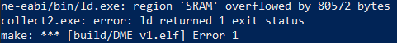

Figure XI‑3: Upload Error Message

As seen above this fails. However, reducing the delay to 0.5 s (reducing memory used by 4-byte float * 24000 samples = 96 kB), the program compiles and uploads.



Figure XI‑3: Upload Success Message

Due to these memory constraints, it is likely best to limit the number of effects on the device to 2-3, depending how memory intensive they are.



#### Engineering (Manufacturing) Drawings of All Parts of SS3- Digital Multi-Effects

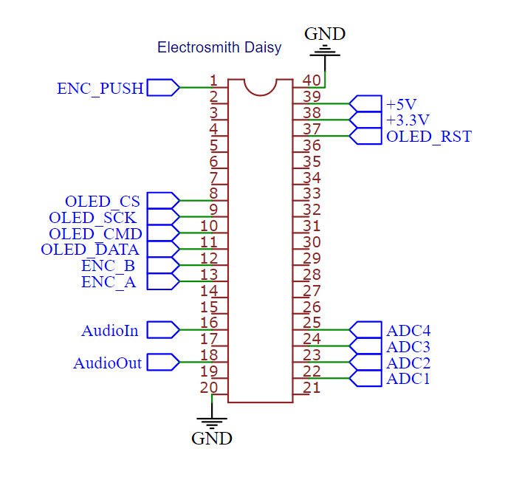

Figure XI‑3: Our Pinout for part SS3-P1 – DSP Microcontroller

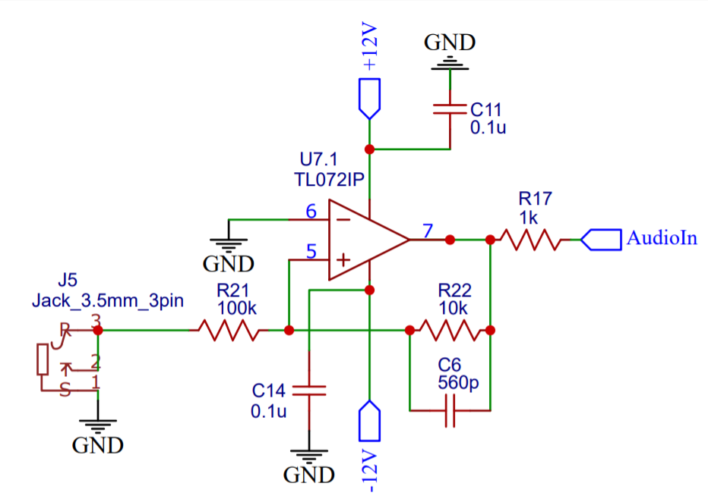

Figure XI‑4: Circuit Drawing of part SS3-P2 – Audio Input Attenuator/Filter

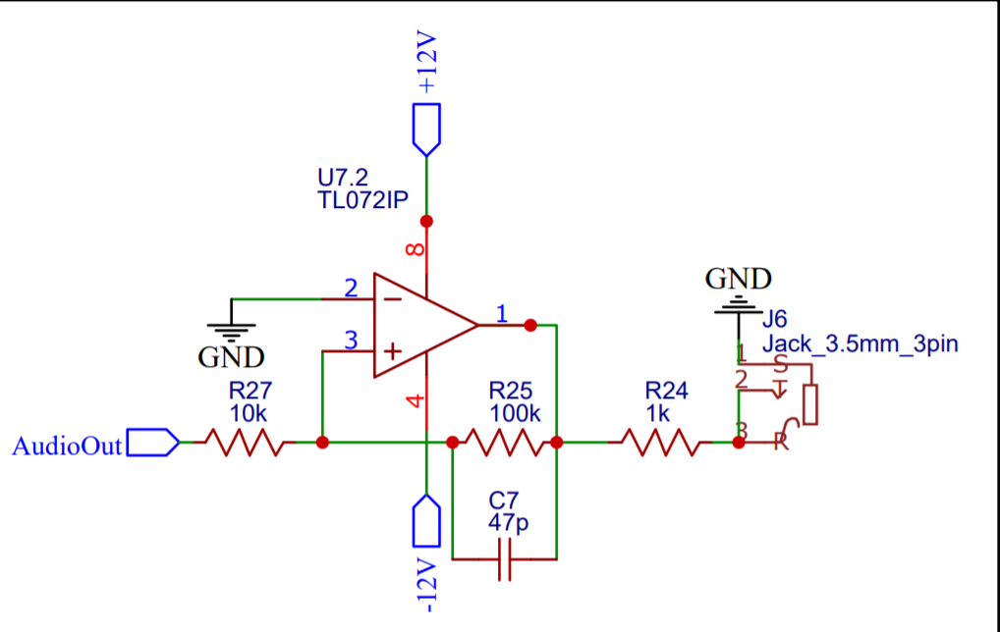Figure XI‑4: Circuit Drawing of part SS3-P3– Audio Output Amplifier/Filter

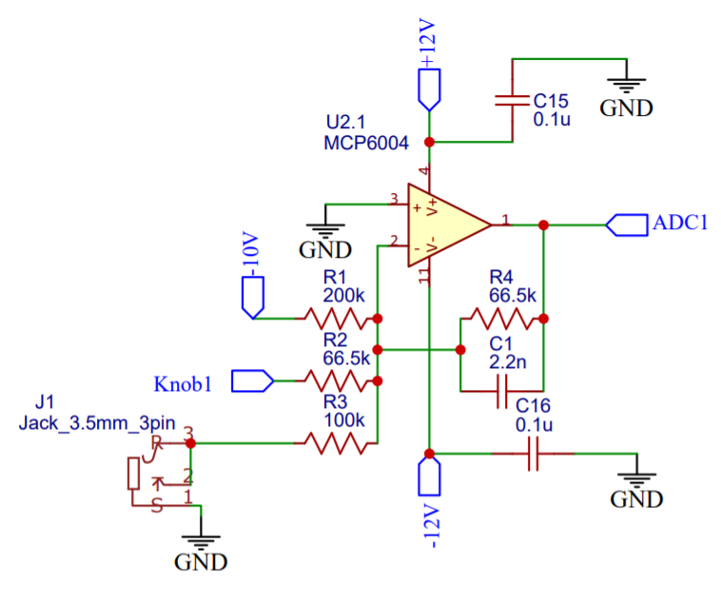

Figure XI‑4: Circuit Drawing of part SS3-P4– CV / Knob Sum

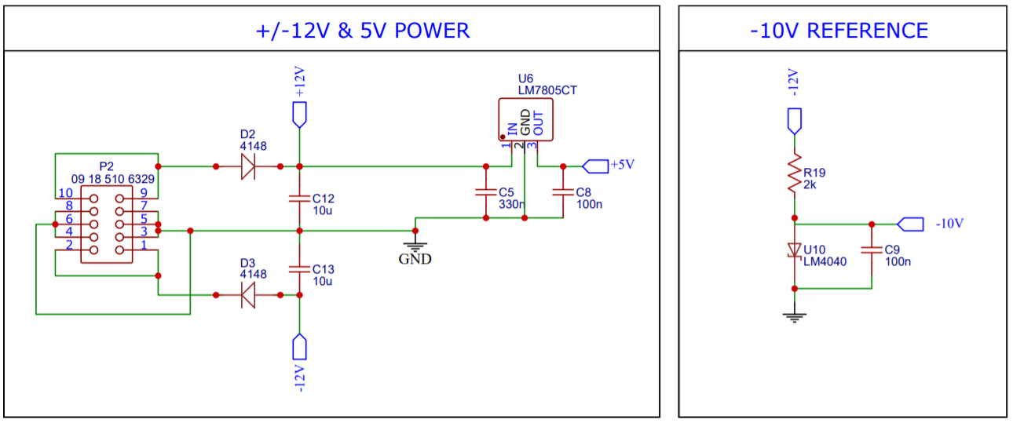

Figure XI‑4: Circuit Drawing of part SS3-P6– Power Regulator



### Sub-System SS4- Level Control Module

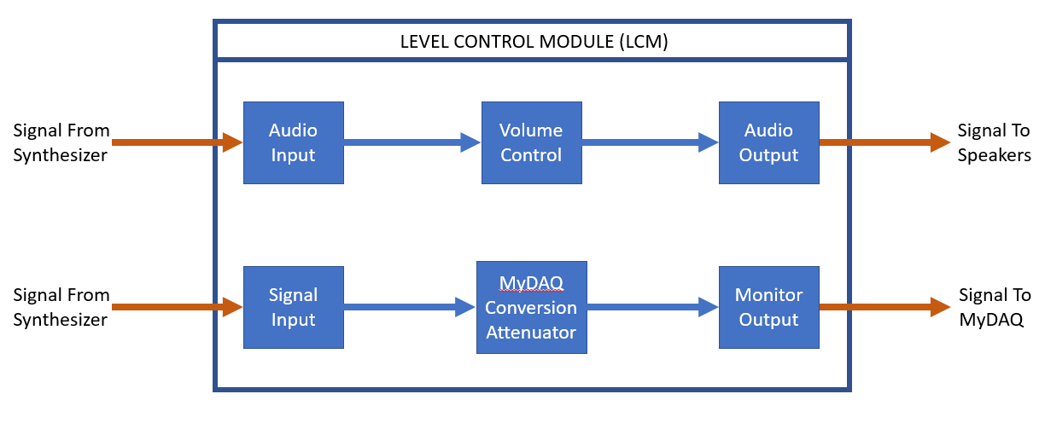Figure

XIII‑2: Level 1 Drawing of Sub-System SS4 – Level Control Module

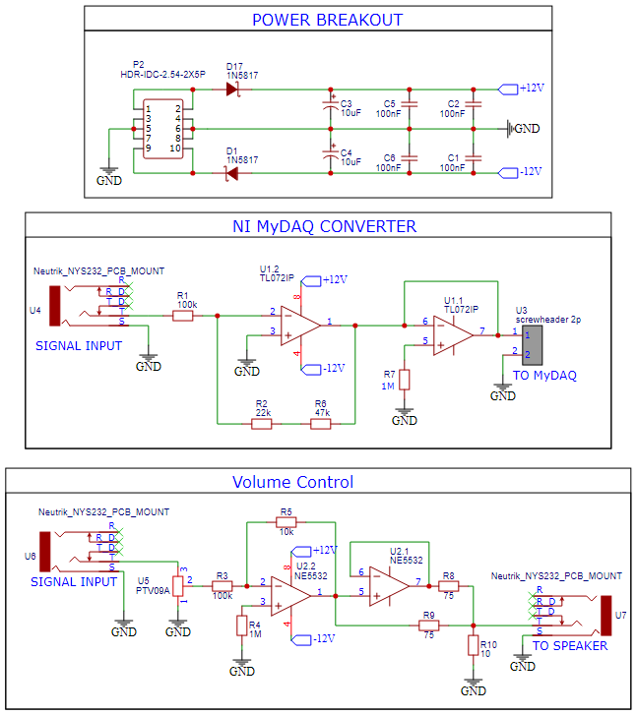

Figure XIII‑2: Circuit Drawing of Sub-System SS4 – Level Control Module



Figure XIII‑2: 3D Model of Sub-System SS4 – Level Control Module

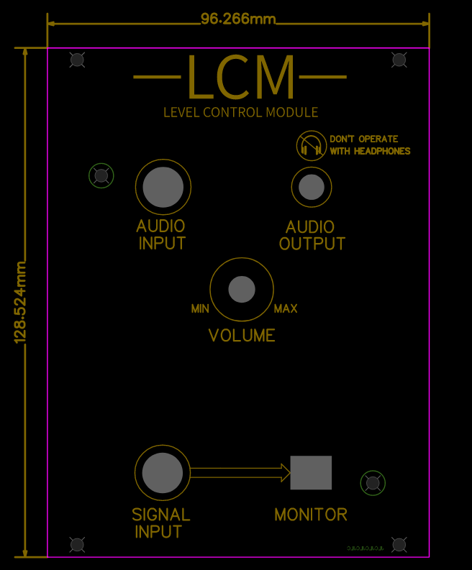

Figure XIII‑2: Faceplate Design and Dimensions of Sub-System SS4 – Level Control Module

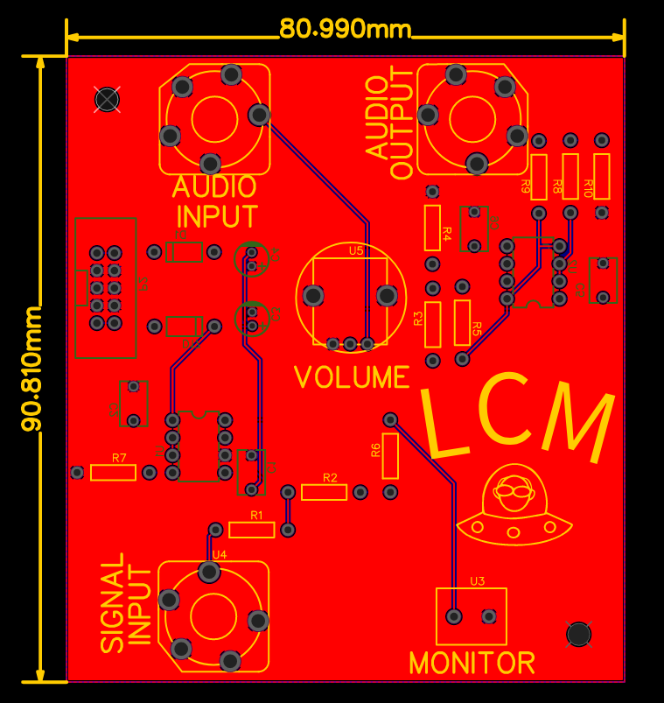

Figure XIII‑2: PCB Top Layer of Sub-System SS4 – Level Control Module

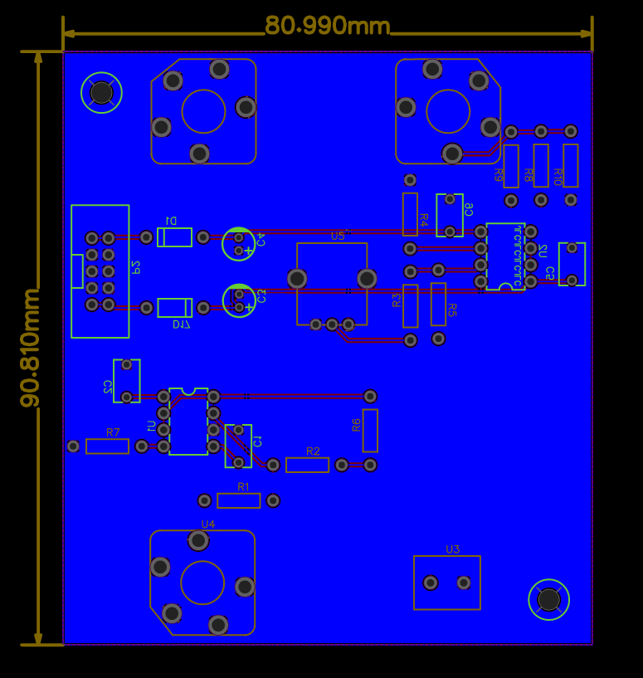

Figure XIII‑2: PCB Bottom Layer of Sub-System SS4 – Level Control Module

#### Comprehensive Parts List for SS# - Sub-Sys Name

Table XIII‑1: List of Parts for Sub-System SS4

|  |  |  |  |
| --- | --- | --- | --- |
| Part # | Quantity | Material | Name |
| SS4-P1 | 1 | MyDAQ Converter | SS4-P1 |
| SS4-P2 | 1 | Volume Control | SS4-P2 |

#### Off-The-Shelf Parts and Component Specifications for SS# - Sub-Sys Name



Figure XIII‑3: Specifications for part SS#-P# - Part Name

#### Engineering (Manufacturing) Drawings of All Parts of SS# - Sub-Sys Name



Figure XIII‑4: Manufacturing Drawing of part SS#-P# - Part name

### Sub-System SS5- Sequencer

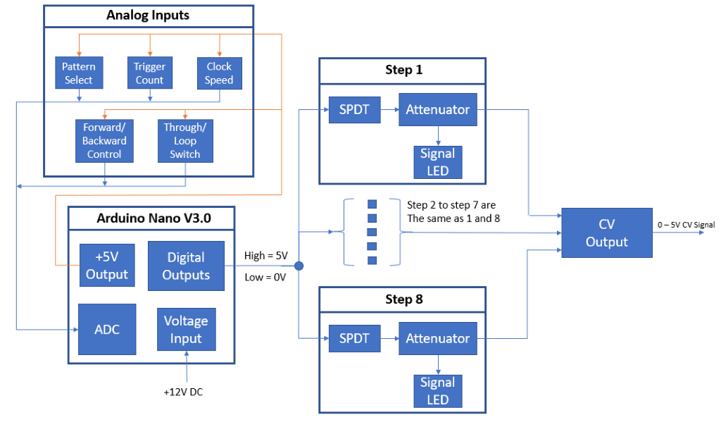Figure

XIII‑2: Level 1 Hardware Drawing of Sub-System SS5 - Sequencer

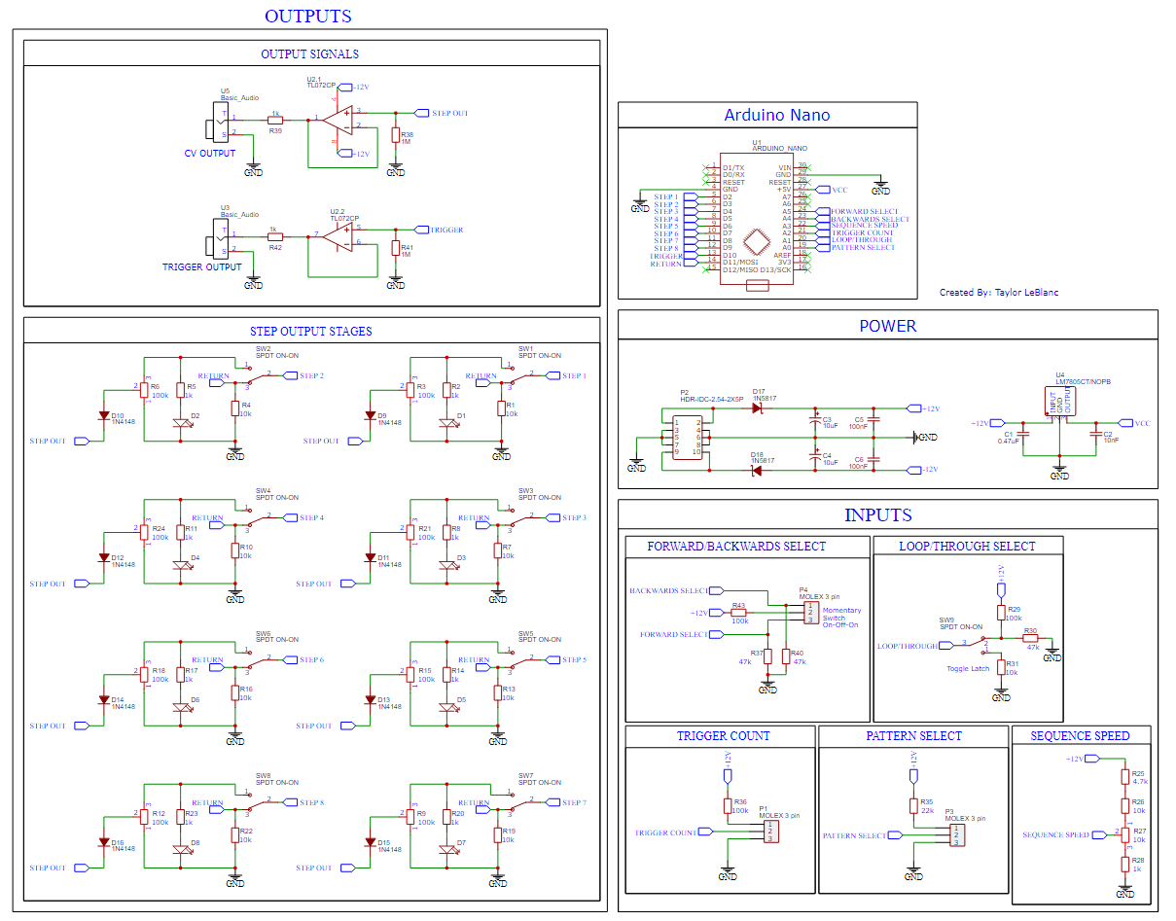 Figure XIII‑2: Circuit Drawing of Sub-System SS5 - Sequencer



Figure XIII‑2: 3D Model of Sub-System SS5 - Sequencer

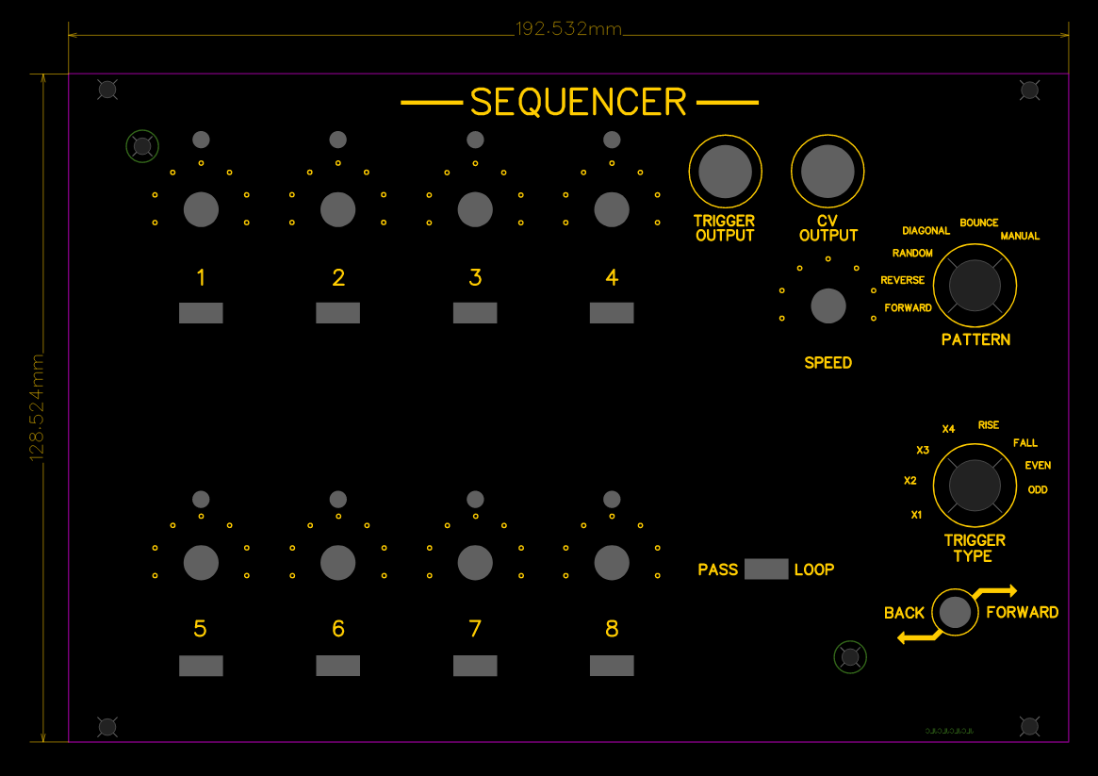

Figure XIII‑2: Faceplate Design and Dimensions of Sub-System SS5 - Sequencer

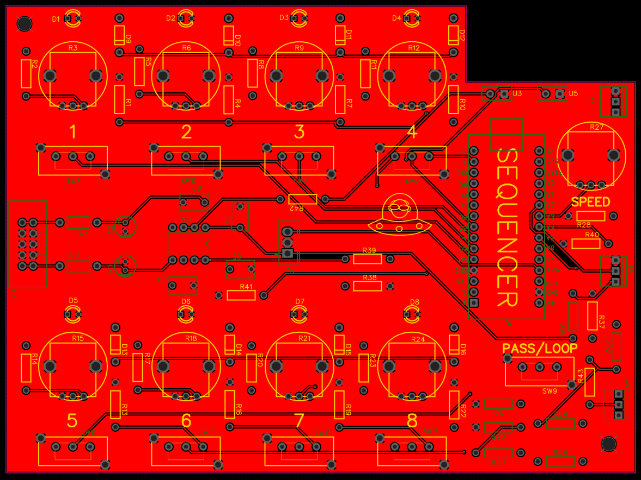

Figure XIII‑2: PCB Top Layer of Sub-System SS5 - Sequencer

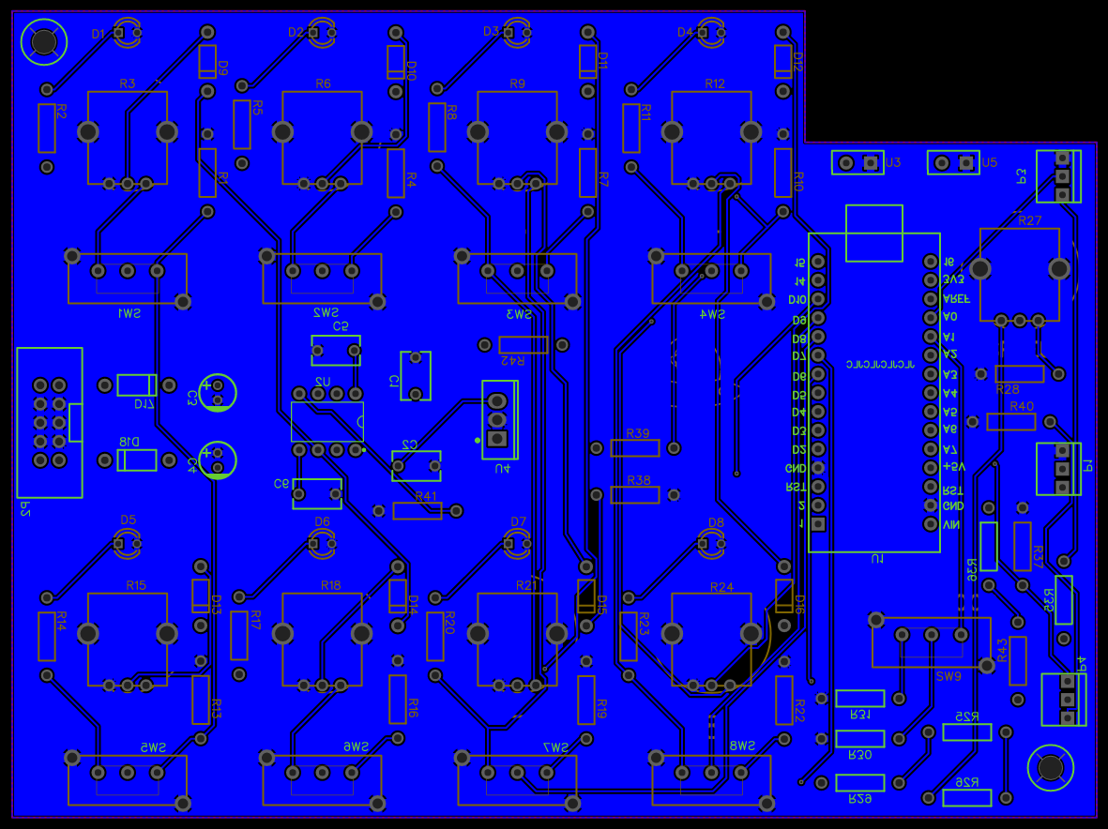

Figure XIII‑2: PCB Bottom Layer of Sub-System SS5 - Sequencer

#### Comprehensive Parts List for SS5 - Sequencer

Table XIII‑1: List of Parts for Sub-System SS5

|  |  |  |  |
| --- | --- | --- | --- |
| Part # | Quantity | Material | Name |
| SS#-P1 | 1 | Arduino Nano | SS5-P1 |
| SS#-P2 | 5 | Analog Inputs | SS5-P2 |
| SS#-P3 | 8 | Digital Outputs | SS5-P3 |
| SS#-P4 | 2 | Output Buffer | SS5-P4 |
| SS#-P5 | 1 | Power Regulator | SS5-P5 |

#### Off-The-Shelf Parts and Component Specifications for SS5 - Sequencer

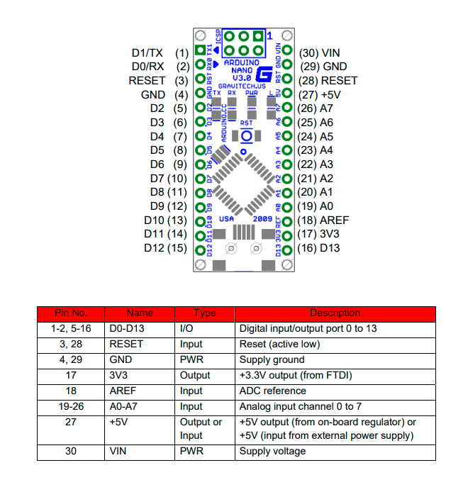 Figure XIII‑3: Specifications for part SS5-P1 – Arduino Nano

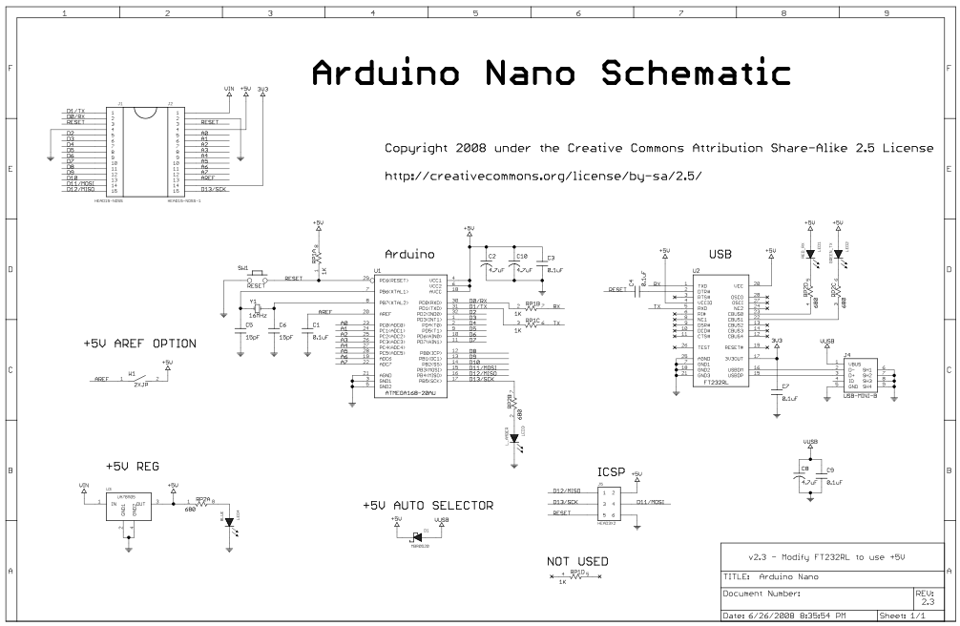

Figure XIII‑3: Specifications for part SS5-P1 - Arduino Nano

#### Engineering (Manufacturing) Drawings of All Parts of SS5 – Arduino Nano

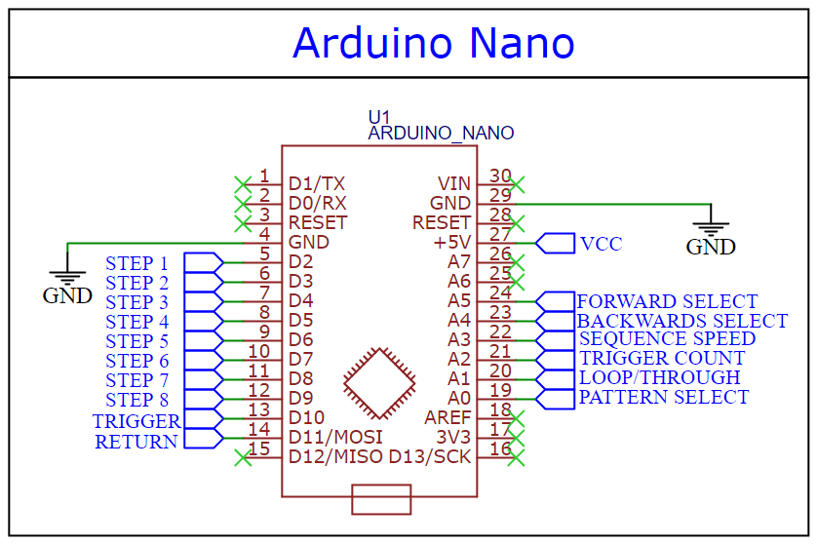

Figure XIII‑4: Manufacturing Drawing of part SS5-P1 – Arduino Nano

#### Engineering (Manufacturing) Drawings of All Parts of SS5 – Analog Inputs

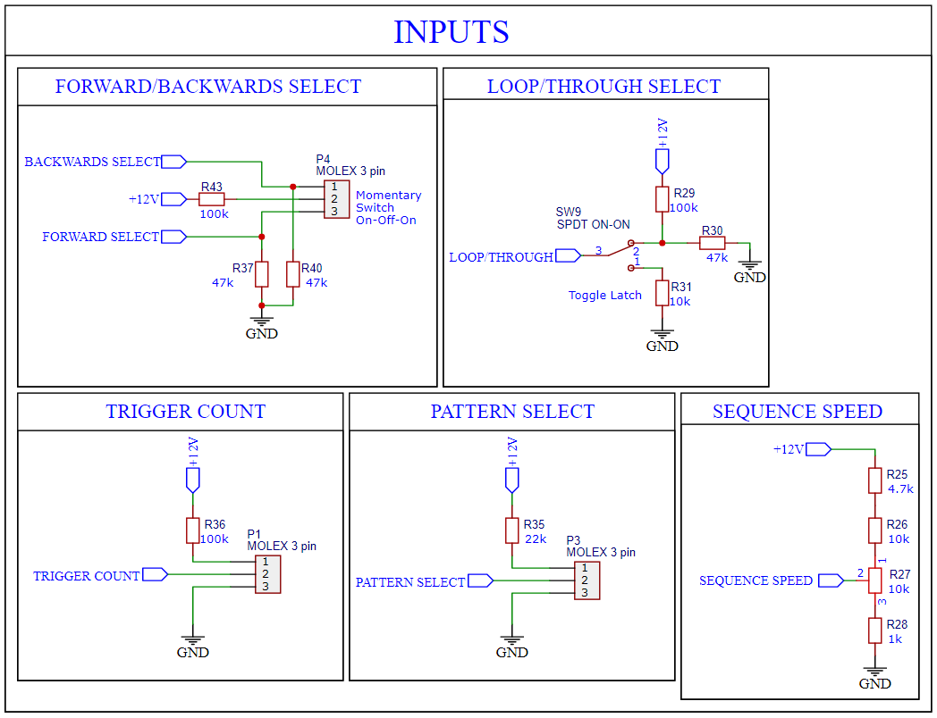

Figure XIII‑4: Manufacturing Drawing of part SS5-P2 – Analog Inputs

#### Engineering (Manufacturing) Drawings of All Parts of SS5 – Digital Outputs

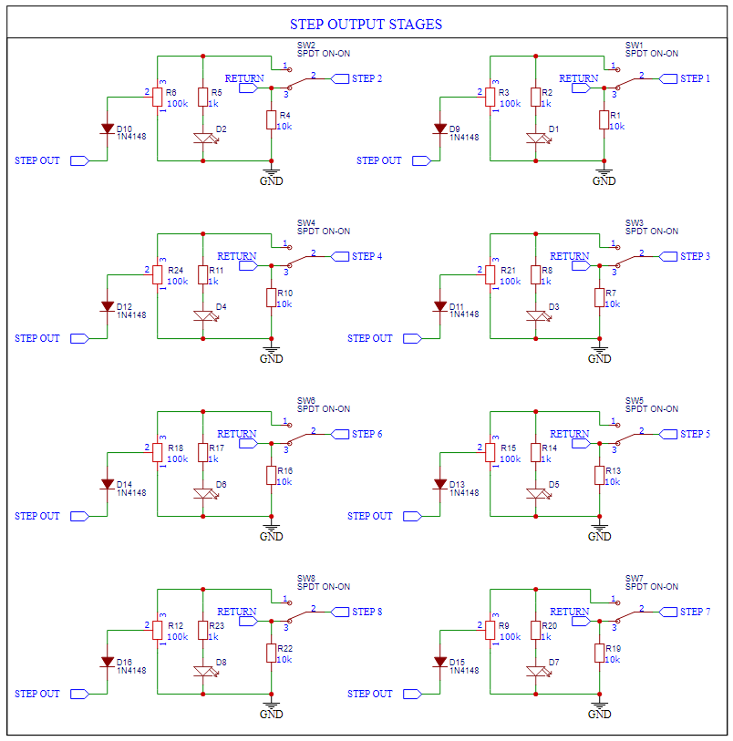

Figure XIII‑4: Manufacturing Drawing of part SS5-P3 – Digital Outputs

#### Engineering (Manufacturing) Drawings of All Parts of SS5 – Output Buffers

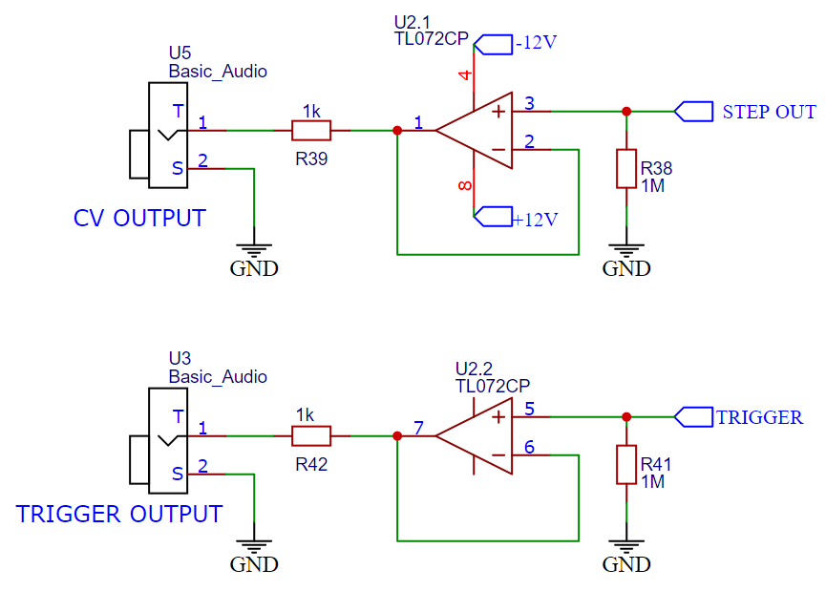

Figure XIII‑4: Manufacturing Drawing of part SS5-P4 – Output Buffers

#### Engineering (Manufacturing) Drawings of All Parts of SS5 – Power Regulator

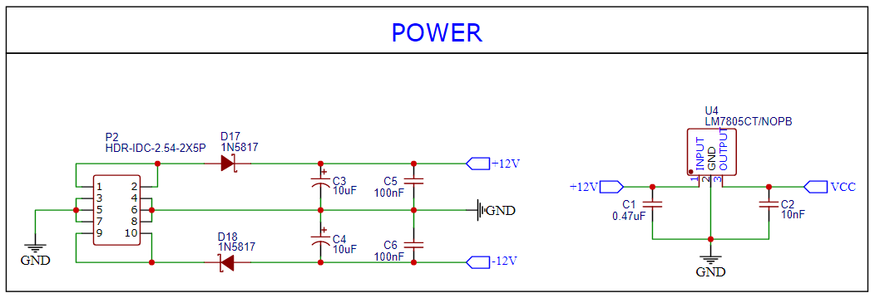

Figure XIII‑4: Manufacturing Drawing of part SS5-P5 – Power Regulator

### Sub-System SS6- Envelope Generator



Figure XIII‑2: Exploded View Assembly Drawing of Sub-System SS# - Sub-Sys Name

#### Comprehensive Parts List for SS# - Sub-Sys Name

Table XIII‑1: List of Parts for Sub-System SS#

|  |  |  |  |
| --- | --- | --- | --- |
| Part # | Quantity | Material | Name |
| SS#-P1 | 3 | N/A | Stepper Motor |
| SS#-P2 | 3 | Aluminum | Motor Bracket |
| SS#-P3 |  |  |  |
| SS#-P4 |  |  |  |
| SS#-P5 |  |  |  |
| SS#-P6 |  |  |  |
| SS#-P7 |  |  |  |
| SS#-P8 |  |  |  |
| SS#-P9 |  |  |  |
| SS#-P10 |  |  |  |

#### Off-The-Shelf Parts and Component Specifications for SS# - Sub-Sys Name



Figure XIII‑3: Specifications for part SS#-P# - Part Name

#### Engineering (Manufacturing) Drawings of All Parts of SS# - Sub-Sys Name



Figure XIII‑4: Manufacturing Drawing of part SS#-P# - Part name

### Sub-System SS7- Wireless Control Module

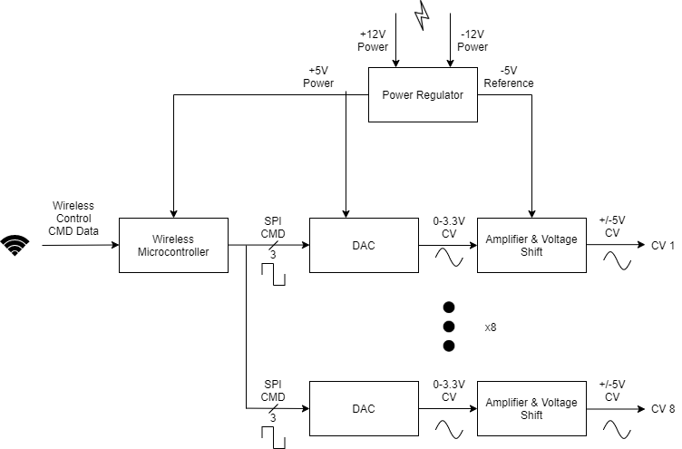

Figure XI‑2: Level 1 Hardware Diagram of Sub-System SS7- Wireless Control Module

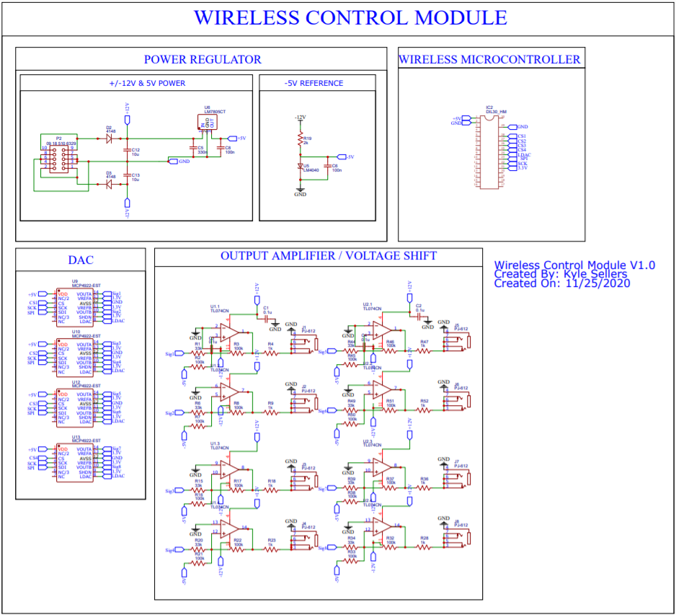

Figure XI‑2: Circuit Drawing of Sub-System SS7- Wireless Control Module



Figure XI‑2: 3D CAD Model of Sub-System SS7- Wireless Control Module

Faceplate 128.5 x 95.9 x 2 mm.

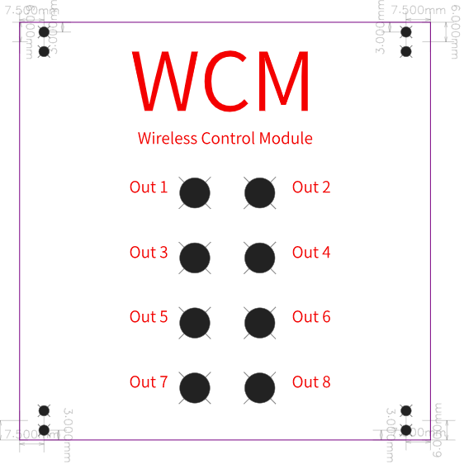

Faceplate of Wireless Control Module

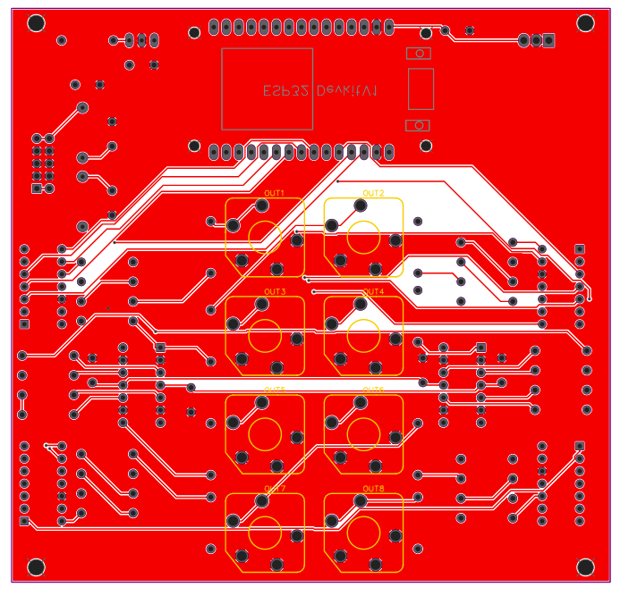

Figure XI‑2: Front of PCB, Wireless Control Module

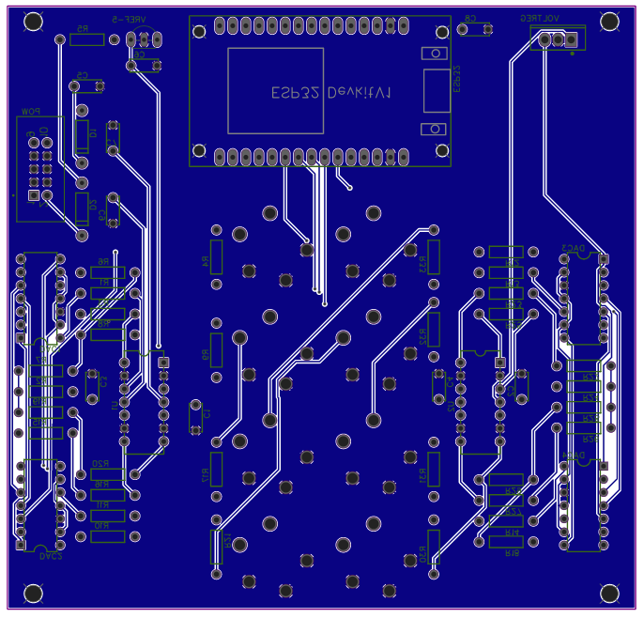

Figure XI‑2: Back of PCB, Wireless Control Module

#### Comprehensive Parts List for SS7- Wireless Control Module

Table XIII‑1: List of Parts for Sub-System SS7

|  |  |  |  |
| --- | --- | --- | --- |
| Part # | Quantity | Material | Name |
| SS#-P1 | 1 | Wireless Microcontroller | SS#-P1 |
| SS#-P2 | 8 | DAC | SS#-P2 |
| SS#-P3 | 8 | Output Amplifier / Voltage Shift | SS#-P3 |
| SS#-P4 | 1 | Power Regulator | SS#-P4 |

#### Off-The-Shelf Parts and Component Specifications for SS# - Sub-Sys Name

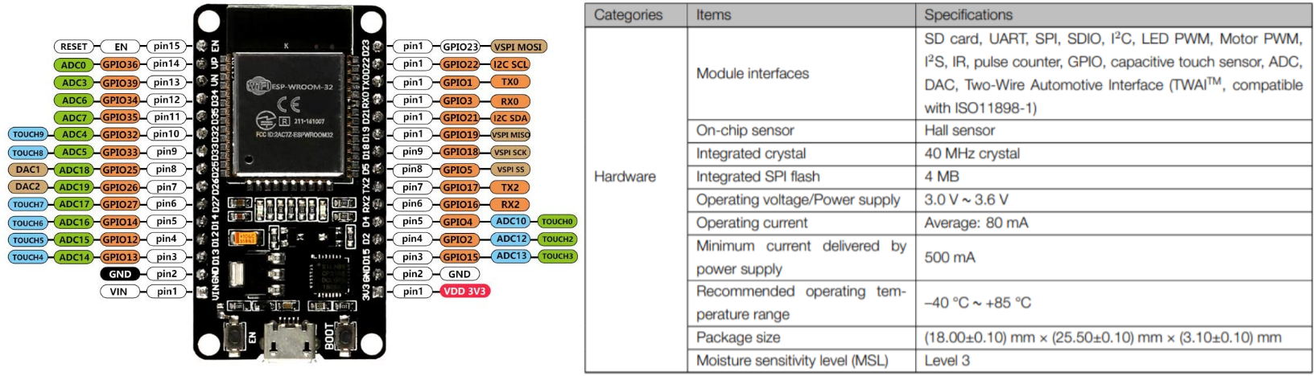

Figure XI‑3: Specifications for part SS7-P1 – Wireless Microcontroller

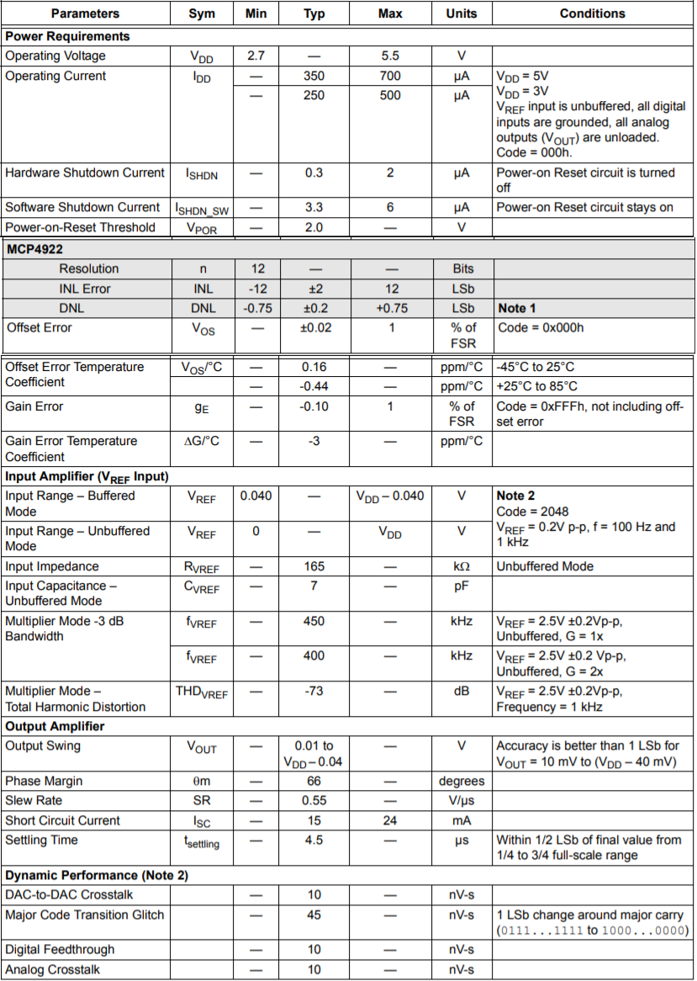

Figure XI‑3: Specifications for part SS7-P2 – DAC



#### Engineering (Manufacturing) Drawings of All Parts of SS7- Wireless Control Module

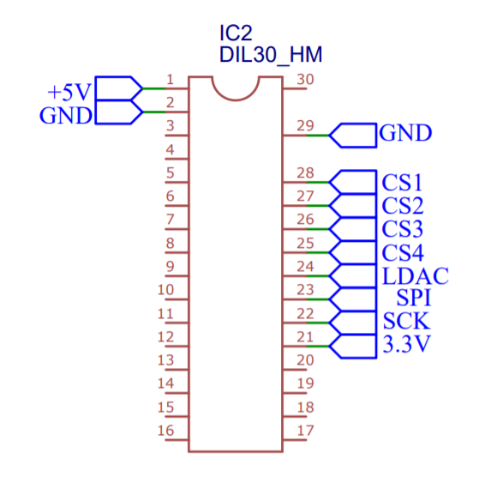

Figure XI‑4: Pinout of part SS7-P1 – Wireless Microcontroller

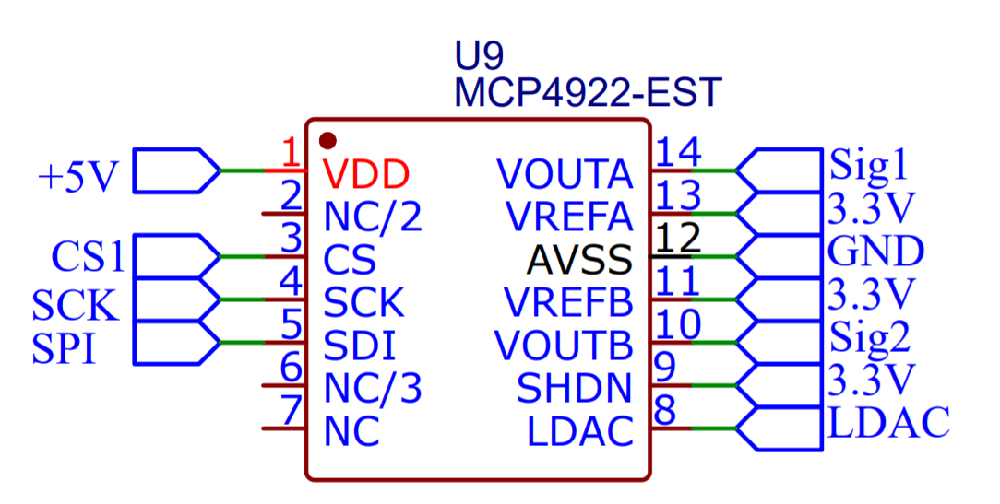

Figure XI‑4: Pinout of part SS7-P2– DAC

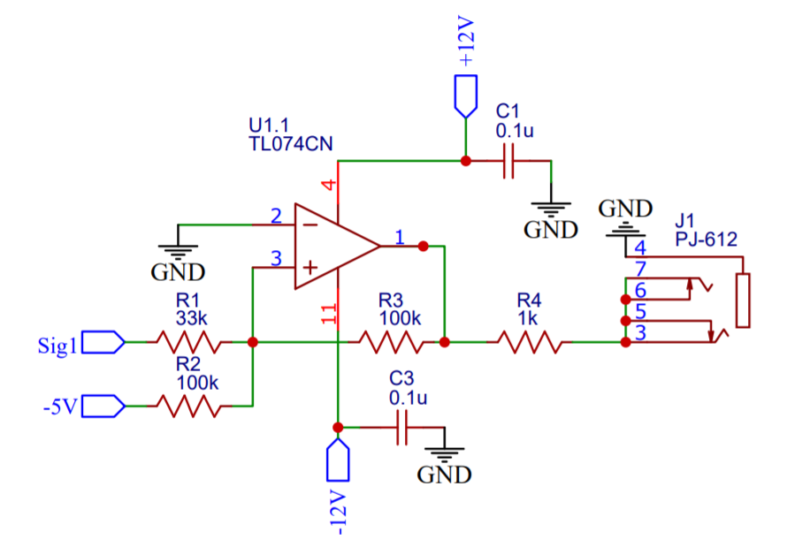

Figure XI‑4: Circuit Drawing of part SS7-P3 – Output Amplifier/Voltage Shift

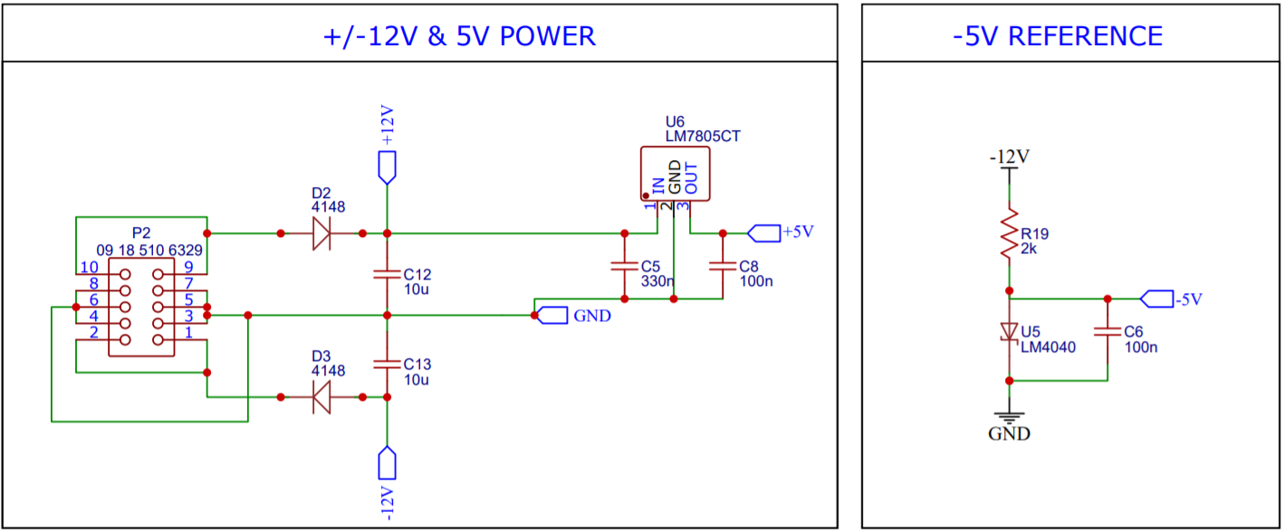

Figure XI‑4: Circuit Drawing of part SS7-P4– Power Regulator

Code for this module is broken into 2 parts: microcontroller code and application code.

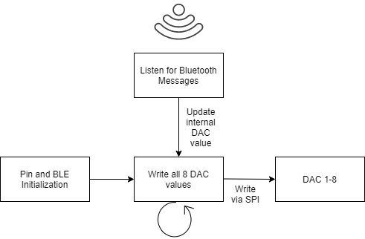

Figure XI‑4: ESP32 Code Diagram

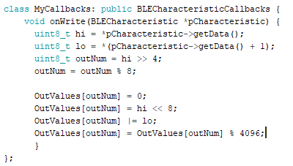

Figure XI‑4: ESP32 Bluetooth Callback

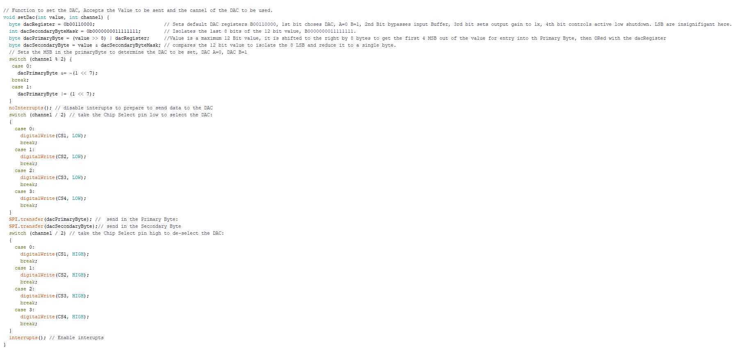

Figure XI‑4: ESP32 Write to DAC

All ESP32 functions execute in O(1) time.

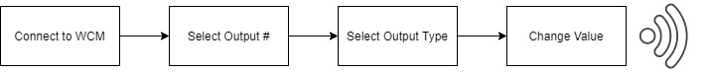

Figure XI‑4: Control App Flow Diagram

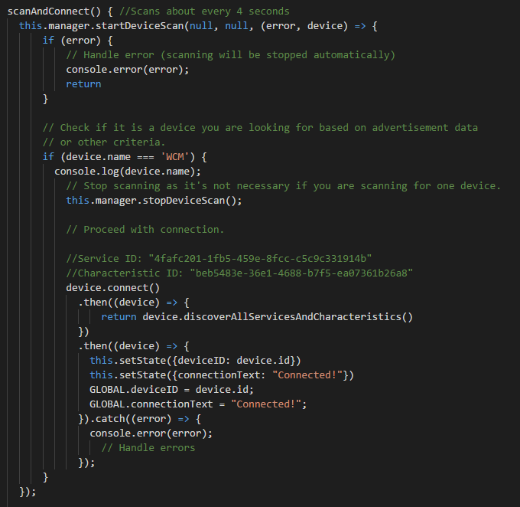

Figure XI‑4: Control App Connecting to ESP32

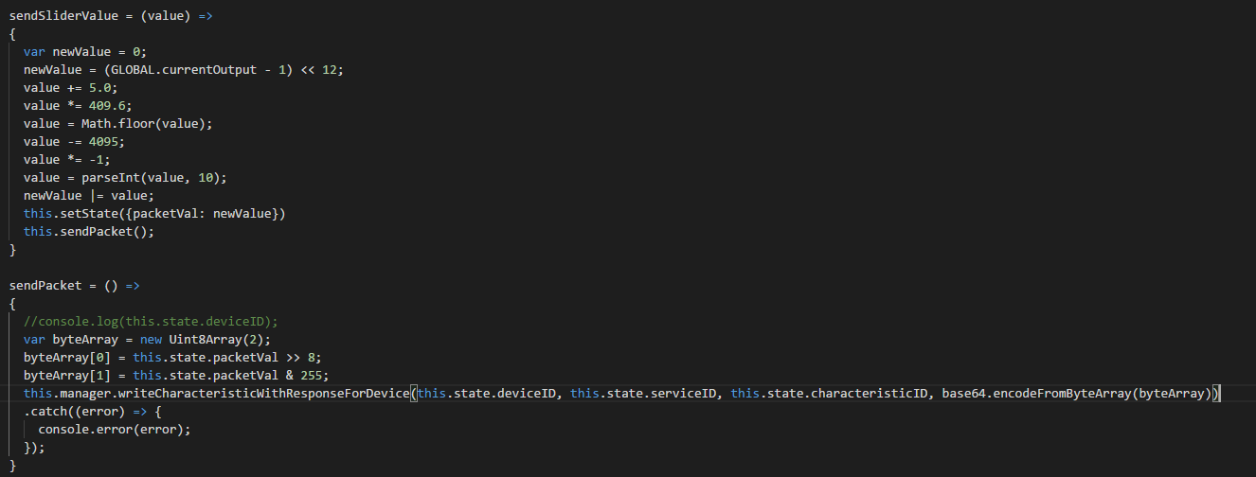

Figure XI‑4: Control App Sending Packet

ScanAndConnect function will execute until the WCM ESP32 is found. All other functions in the control app execute in O(1) time.

Code for both is placed in Team 80s shared folder, under WCM folder, titled CODE.

The ESP32 code is under folder WCM_ESP32_v1.

Majority of Control app code is in App.js



### Sub-System SS8- Power Supply

Powered by a 12V AC wall wart and provides ~500mA at +/-12V, ~100mA at 5V (optional). The power supply outputs +/-12VDC @ 500mA per rail.

The power supply can provide as much as 500mA of current per rail and the voltage will be at least +/-12VDC up to that maximum current level.

Just a simple full bridge rectifier circuit from microbus.

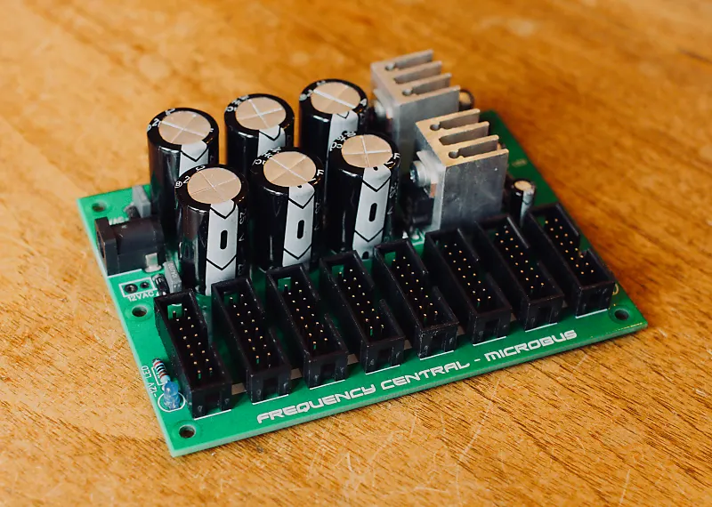

Figure XIII‑2: Exploded View Assembly Drawing of Sub-System SS8 – Power supply

https://www.google.com/url?sa=i&url=https%3A%2F%2Fwww.electronics-tutorials.ws%2Fdiode%2Fdiode_6.html&psig=AOvVaw0NhodO8erhu980S_FtXsdM&ust=1619748104906000&source=images&cd=vfe&ved=0CAMQjB1qFwoTCIjgz4SuovACFQAAAAAdAAAAABAI



Figure XIII‑2: Exploded View Assembly Drawing of Sub-System SS# - Sub-Sys Name

#### Comprehensive Parts List for SS8- Power Supply

Table XIII‑1: List of Parts for Sub-System SS#

|  |  |  |  |
| --- | --- | --- | --- |
| Part # | Quantity | Type | Name |
| SS8-P1 | 3 | 1k | Resistor |
| SS8-P2 | 2 | 100nF | Capacitor |
| SS8-P3 | 3 | 100uF @35v | Capacitor |
| SS8-P4 | 6 | 4700uF@25v | Capacitor |
| SS8-P5 | 1 | 7812 Regulator | Voltage Regulator |
| SS8-P6 | 1 | 7912 Regulator | Voltage Regulator |
| SS8-P7 | 1 | 78l05 | Voltage Regulator |
| SS8-P8 | 6 | 1n4004 | Diode |
| SS8-P9 | 3 | 3mm Red LED | Diode |
| SS8-P10 | 2 | Heatsink | Heatsink |
| SS8-P11 | 2 | Header | Power header |
| SS8-P12 | 2 | Inputs | Power Input Sockets |
| SS8-P13 | 2 | M3 | Bolts |

#### Off-The-Shelf Parts and Component Specifications for SS# - Sub-Sys Name



Figure XIII‑3: Specifications for part SS#-P# - Part Name

#### Engineering (Manufacturing) Drawings of All Parts of SS# - Sub-Sys Name

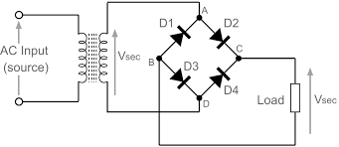

Figure XIII‑4: Manufacturing Drawing of part SS8-P1 Power SupplySS#-P# - Part name

## Engineering Analysis and Materials Selection Supplement

### Eng. Analysis Details for SS1- Voltage Controlled Oscillator

#### Eng. Analysis and Materials Selection Details for SS1-P1 – Cem3340/As3340

**EE Rafael A Alvarez-Santiago**

|  |  |  |  |  |
| --- | --- | --- | --- | --- |
|  | weights | Transistor Circuit | Op-Amp Circuit | Integrated Circuit VCO |
| Features | 0.475821214 | 2 | 3 | 5 |
| Cost | 0.296119233 | 5 | 5 | 1 |
| Ease of Use | 0.168228203 | 2 | 1 | 4 |
| Size | 0.05983135 | 5 | 4 | 2 |
| Totals | deviation | 1.71508027 | 1.707825128 | 1.825741858 |

|  |  |  |  |  |  |
| --- | --- | --- | --- | --- | --- |
| Features | cost | Ease of use | size | geometric mean | weights |
| 1 | 2 | 4 | 5 | 2.514866859 | 0.475821 |
| 0.50 | 1 | 3 | 4 | 1.56508458 | 0.296119 |
| 0.25 | 0.5 | 1 | 5 | 0.889139705 | 0.168228 |
| 0.2 | 0.25 | 0.2 | 1 | 0.316227766 | 0.059831 |

Here is the math for finding the weights. These are their scores and geometric mean used to find their respective weights.

Features came out on top .47

with cost being 2nd at .3

Ease of use 3rd .16

Size being last at .05

|  |  |  |
| --- | --- | --- |
| 0.25 | 0.5 | 1 |
| 1 | 1 | 0 |
| 0.25 | 0 | 0.75 |
| 1 | 0.75 | 0.25 |
|  |  |  |
| 3.067851748 | 3.315613408 | 3.467800816 |
| 0.766962937 | 0.828903352 | 0.866950204 |

The scores highlighted in yellow are multiplied by the above weights of .47,.3,.16,.05.

And this is the results

|  |  |  |
| --- | --- | --- |
| Transistor Circuit | Transistor Circuit | Transistor Circuit |
| 3.067851748 | 3.315613408 | 3.467800816 |

The VCO IC won at 3.46

After normalizing

|  |  |  |
| --- | --- | --- |
| Transistor Circuit | Transistor Circuit | Transistor Circuit |
| 0.766962937 | 0.828903352 | 0.866950204 |

Outcome: What design choice for our circuit, our winner is the ICVCO.

#### Eng. Analysis and Materials Selection Details for SS1-P2– Outputs

**EE Rafael A Alvarez-Santiago**

**Outputs on simulation of the frequency response of the waveforms and their schematics.** So, I ran a sawtooth wave through the circuit shown below at 8v. And took the magnitude response of the circuit.

We need the frequency response to have no loss in amplitude and low phase noise to make sure our audio is close to 1:1.

So, as you can see on the left. For the frequencies of 100-22khz normal human hearing the bode is flat for the voltage being output.

The current draw for the circuit was done interactively and shown to be negligible at the input and tremendous at the op-amp supply voltages being 11mA. This will need to be recorded so that we will know the total draw of the system.

Outcome: Frequency response was stable and current draw was only 22mA.

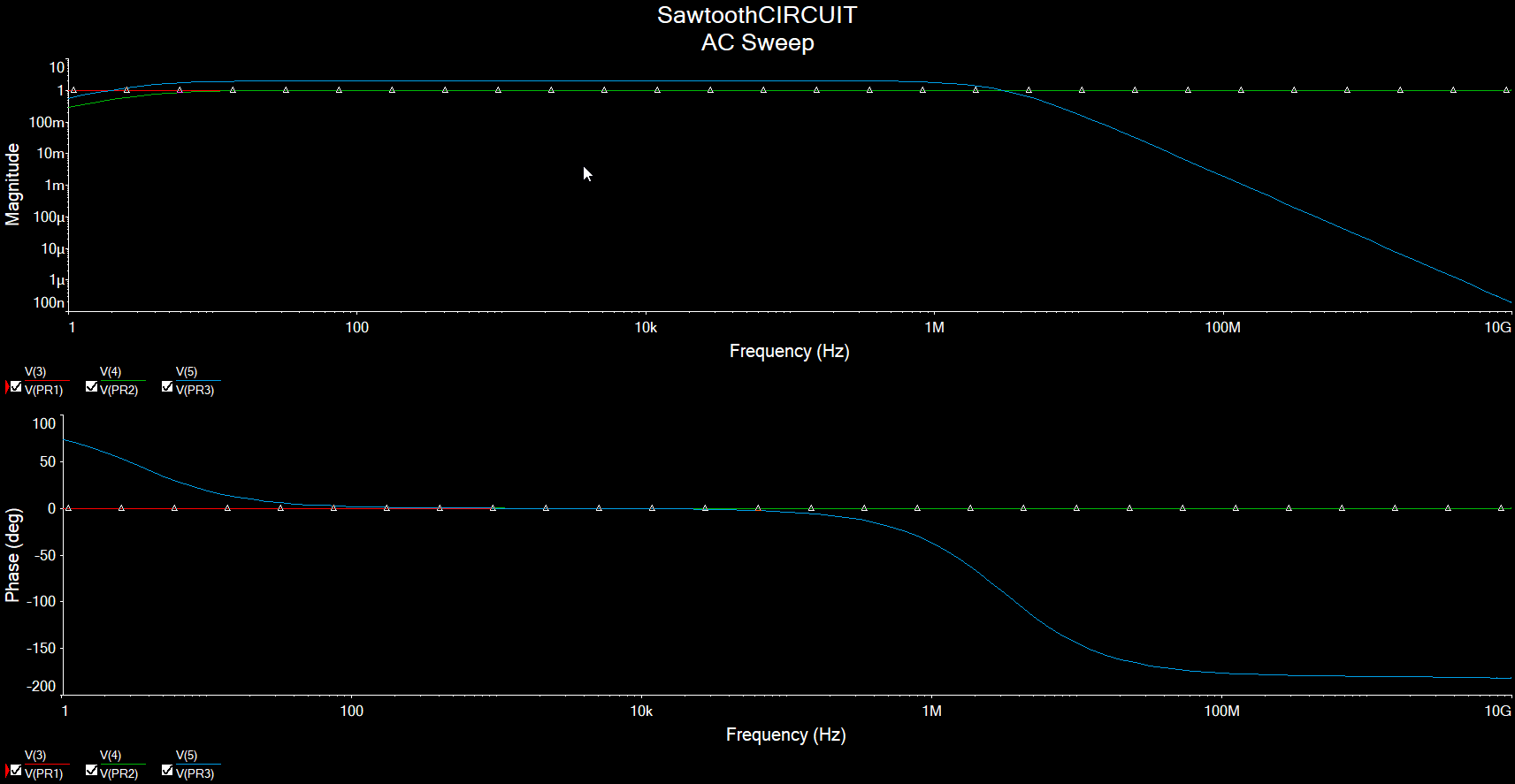

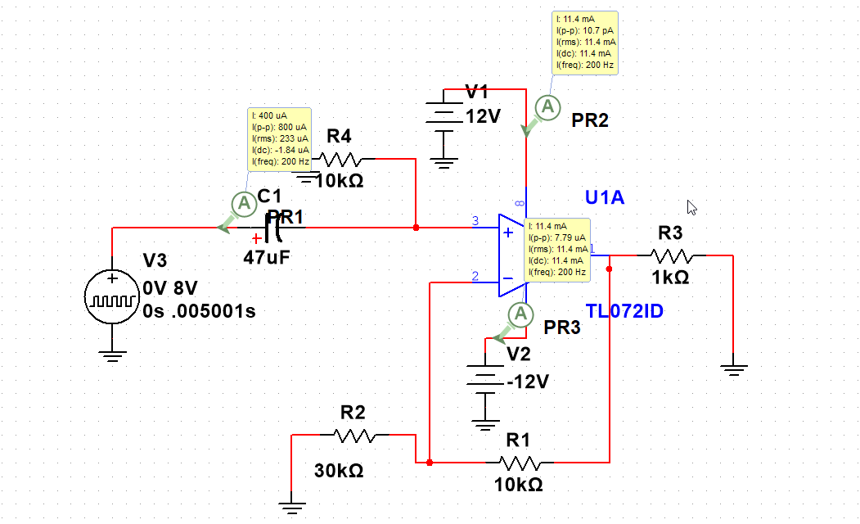

#### 15 10 -10 -15 0.0 VIPRII 0.2 triagnlewaveout input Waveform 04 0.6 08 1.0

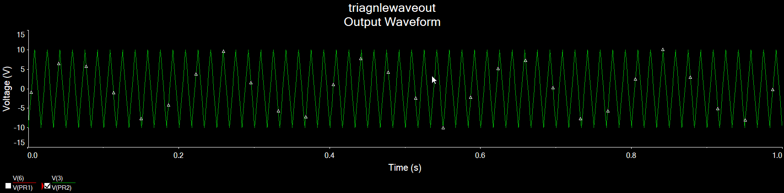

|  |  |  |  |  |
| --- | --- | --- | --- | --- |
|  | weights | Transistor Circuit | Op-Amp Circuit | Integrated Circuit VCO |
| Features | 0.475821214 | 2 | 3 | 5 |
| Cost | 0.296119233 | 5 | 5 | 1 |
| Ease of Use | 0.168228203 | 2 | 1 | 4 |
| Size | 0.05983135 | 5 | 4 | 2 |
| Totals | deviation | 1.71508027 | 1.707825128 | 1.825741858 |

|  |  |  |  |  |  |
| --- | --- | --- | --- | --- | --- |
| Features | cost | Ease of use | size | geometric mean | weights |
| 1 | 2 | 4 | 5 | 2.514866859 | 0.475821 |
| 0.50 | 1 | 3 | 4 | 1.56508458 | 0.296119 |
| 0.25 | 0.5 | 1 | 5 | 0.889139705 | 0.168228 |
| 0.2 | 0.25 | 0.2 | 1 | 0.316227766 | 0.059831 |

Here is the math for finding the weights. These are their scores and geometric mean used to find their respective weights.

Features came out on top .47

with cost being 2nd at .3

Ease of use 3rd .16

Size being last at .05

|  |  |  |
| --- | --- | --- |
| 0.25 | 0.5 | 1 |
| 1 | 1 | 0 |
| 0.25 | 0 | 0.75 |
| 1 | 0.75 | 0.25 |
|  |  |  |
| 3.067851748 | 3.315613408 | 3.467800816 |
| 0.766962937 | 0.828903352 | 0.866950204 |

The scores highlighted in yellow are multiplied by the above weights of .47,.3,.16,.05.

And this is the results

|  |  |  |
| --- | --- | --- |
| Transistor Circuit | Transistor Circuit | Transistor Circuit |
| 3.067851748 | 3.315613408 | 3.467800816 |

The VCO IC won at 3.46

After normalizing

|  |  |  |
| --- | --- | --- |
| Transistor Circuit | Transistor Circuit | Transistor Circuit |
| 0.766962937 | 0.828903352 | 0.866950204 |

Outcome: What design choice for our circuit, our winner is the ICVCO.

#### Eng. Analysis and Materials Selection Details for SS1-P2– Outputs

**EE Rafael A Alvarez-Santiago**

**Outputs on simulation of the frequency response of the waveforms and their schematics.** So, I ran a sawtooth wave through the circuit shown below at 8v. And took the magnitude response of the circuit.

We need the frequency response to have no loss in amplitude and low phase noise to make sure our audio is close to 1:1.

So, as you can see on the left. For the frequencies of 100-22khz normal human hearing the bode is flat for the voltage being output.

The current draw for the circuit was done interactively and shown to be negligible at the input and tremendous at the op-amp supply voltages being 11mA. This will need to be recorded so that we will know the total draw of the system.

Outcome: Frequency response was stable and current draw was only 22mA.

|  |  |  |  |  |
| --- | --- | --- | --- | --- |
|  | weights | Transistor Circuit | Op-Amp Circuit | Integrated Circuit VCO |
| Features | 0.475821214 | 2 | 3 | 5 |
| Cost | 0.296119233 | 5 | 5 | 1 |
| Ease of Use | 0.168228203 | 2 | 1 | 4 |
| Size | 0.05983135 | 5 | 4 | 2 |
| Totals | deviation | 1.71508027 | 1.707825128 | 1.825741858 |

|  |  |  |  |  |  |
| --- | --- | --- | --- | --- | --- |
| Features | cost | Ease of use | size | geometric mean | weights |
| 1 | 2 | 4 | 5 | 2.514866859 | 0.475821 |
| 0.50 | 1 | 3 | 4 | 1.56508458 | 0.296119 |
| 0.25 | 0.5 | 1 | 5 | 0.889139705 | 0.168228 |
| 0.2 | 0.25 | 0.2 | 1 | 0.316227766 | 0.059831 |

Here is the math for finding the weights. These are their scores and geometric mean used to find their respective weights.

Features came out on top .47

with cost being 2nd at .3

Ease of use 3rd .16

Size being last at .05

|  |  |  |
| --- | --- | --- |
| 0.25 | 0.5 | 1 |
| 1 | 1 | 0 |
| 0.25 | 0 | 0.75 |
| 1 | 0.75 | 0.25 |
|  |  |  |
| 3.067851748 | 3.315613408 | 3.467800816 |
| 0.766962937 | 0.828903352 | 0.866950204 |

The scores highlighted in yellow are multiplied by the above weights of .47,.3,.16,.05.

And this is the results

|  |  |  |
| --- | --- | --- |
| Transistor Circuit | Transistor Circuit | Transistor Circuit |
| 3.067851748 | 3.315613408 | 3.467800816 |

The VCO IC won at 3.46

After normalizing

|  |  |  |
| --- | --- | --- |
| Transistor Circuit | Transistor Circuit | Transistor Circuit |
| 0.766962937 | 0.828903352 | 0.866950204 |

Outcome: What design choice for our circuit, our winner is the ICVCO.

#### Eng. Analysis and Materials Selection Details for SS1-P2– Outputs

**EE Rafael A Alvarez-Santiago**

**Outputs on simulation of the frequency response of the waveforms and their schematics.** So, I ran a sawtooth wave through the circuit shown below at 8v. And took the magnitude response of the circuit.

We need the frequency response to have no loss in amplitude and low phase noise to make sure our audio is close to 1:1.

So, as you can see on the left. For the frequencies of 100-22khz normal human hearing the bode is flat for the voltage being output.

The current draw for the circuit was done interactively and shown to be negligible at the input and tremendous at the op-amp supply voltages being 11mA. This will need to be recorded so that we will know the total draw of the system.

Outcome: Frequency response was stable and current draw was only 22mA.

|  |  |  |  |  |
| --- | --- | --- | --- | --- |
|  | weights | Transistor Circuit | Op-Amp Circuit | Integrated Circuit VCO |
| Features | 0.475821214 | 2 | 3 | 5 |
| Cost | 0.296119233 | 5 | 5 | 1 |
| Ease of Use | 0.168228203 | 2 | 1 | 4 |
| Size | 0.05983135 | 5 | 4 | 2 |
| Totals | deviation | 1.71508027 | 1.707825128 | 1.825741858 |

|  |  |  |  |  |  |
| --- | --- | --- | --- | --- | --- |
| Features | cost | Ease of use | size | geometric mean | weights |
| 1 | 2 | 4 | 5 | 2.514866859 | 0.475821 |
| 0.50 | 1 | 3 | 4 | 1.56508458 | 0.296119 |
| 0.25 | 0.5 | 1 | 5 | 0.889139705 | 0.168228 |
| 0.2 | 0.25 | 0.2 | 1 | 0.316227766 | 0.059831 |

Here is the math for finding the weights. These are their scores and geometric mean used to find their respective weights.

Features came out on top .47

with cost being 2nd at .3

Ease of use 3rd .16

Size being last at .05

|  |  |  |
| --- | --- | --- |
| 0.25 | 0.5 | 1 |
| 1 | 1 | 0 |
| 0.25 | 0 | 0.75 |
| 1 | 0.75 | 0.25 |
|  |  |  |
| 3.067851748 | 3.315613408 | 3.467800816 |
| 0.766962937 | 0.828903352 | 0.866950204 |

The scores highlighted in yellow are multiplied by the above weights of .47,.3,.16,.05.

And this is the results

|  |  |  |
| --- | --- | --- |
| Transistor Circuit | Transistor Circuit | Transistor Circuit |
| 3.067851748 | 3.315613408 | 3.467800816 |

The VCO IC won at 3.46

After normalizing

|  |  |  |
| --- | --- | --- |
| Transistor Circuit | Transistor Circuit | Transistor Circuit |
| 0.766962937 | 0.828903352 | 0.866950204 |

Outcome: What design choice for our circuit, our winner is the ICVCO.

#### Eng. Analysis and Materials Selection Details for SS1-P2– Outputs

**EE Rafael A Alvarez-Santiago**

**Outputs on simulation of the frequency response of the waveforms and their schematics.** So, I ran a sawtooth wave through the circuit shown below at 8v. And took the magnitude response of the circuit.

We need the frequency response to have no loss in amplitude and low phase noise to make sure our audio is close to 1:1.

So, as you can see on the left. For the frequencies of 100-22khz normal human hearing the bode is flat for the voltage being output.

The current draw for the circuit was done interactively and shown to be negligible at the input and tremendous at the op-amp supply voltages being 11mA. This will need to be recorded so that we will know the total draw of the system.

Outcome: Frequency response was stable and current draw was only 22mA.

|  |  |  |  |  |
| --- | --- | --- | --- | --- |
|  | weights | Transistor Circuit | Op-Amp Circuit | Integrated Circuit VCO |
| Features | 0.475821214 | 2 | 3 | 5 |
| Cost | 0.296119233 | 5 | 5 | 1 |
| Ease of Use | 0.168228203 | 2 | 1 | 4 |
| Size | 0.05983135 | 5 | 4 | 2 |
| Totals | deviation | 1.71508027 | 1.707825128 | 1.825741858 |

|  |  |  |  |  |  |
| --- | --- | --- | --- | --- | --- |
| Features | cost | Ease of use | size | geometric mean | weights |
| 1 | 2 | 4 | 5 | 2.514866859 | 0.475821 |
| 0.50 | 1 | 3 | 4 | 1.56508458 | 0.296119 |
| 0.25 | 0.5 | 1 | 5 | 0.889139705 | 0.168228 |
| 0.2 | 0.25 | 0.2 | 1 | 0.316227766 | 0.059831 |

Here is the math for finding the weights. These are their scores and geometric mean used to find their respective weights.

Features came out on top .47

with cost being 2nd at .3

Ease of use 3rd .16

Size being last at .05

|  |  |  |
| --- | --- | --- |
| 0.25 | 0.5 | 1 |
| 1 | 1 | 0 |
| 0.25 | 0 | 0.75 |
| 1 | 0.75 | 0.25 |
|  |  |  |
| 3.067851748 | 3.315613408 | 3.467800816 |
| 0.766962937 | 0.828903352 | 0.866950204 |

The scores highlighted in yellow are multiplied by the above weights of .47,.3,.16,.05.

And this is the results

|  |  |  |
| --- | --- | --- |
| Transistor Circuit | Transistor Circuit | Transistor Circuit |
| 3.067851748 | 3.315613408 | 3.467800816 |

The VCO IC won at 3.46

After normalizing

|  |  |  |
| --- | --- | --- |
| Transistor Circuit | Transistor Circuit | Transistor Circuit |
| 0.766962937 | 0.828903352 | 0.866950204 |

Outcome: What design choice for our circuit, our winner is the ICVCO.

#### Eng. Analysis and Materials Selection Details for SS1-P2– Outputs

**EE Rafael A Alvarez-Santiago**

**Outputs on simulation of the frequency response of the waveforms and their schematics.** So, I ran a sawtooth wave through the circuit shown below at 8v. And took the magnitude response of the circuit.

We need the frequency response to have no loss in amplitude and low phase noise to make sure our audio is close to 1:1.

So, as you can see on the left. For the frequencies of 100-22khz normal human hearing the bode is flat for the voltage being output.

The current draw for the circuit was done interactively and shown to be negligible at the input and tremendous at the op-amp supply voltages being 11mA. This will need to be recorded so that we will know the total draw of the system.

Outcome: Frequency response was stable and current draw was only 22mA.

|  |  |  |  |  |
| --- | --- | --- | --- | --- |
|  | weights | Transistor Circuit | Op-Amp Circuit | Integrated Circuit VCO |
| Features | 0.475821214 | 2 | 3 | 5 |
| Cost | 0.296119233 | 5 | 5 | 1 |
| Ease of Use | 0.168228203 | 2 | 1 | 4 |
| Size | 0.05983135 | 5 | 4 | 2 |
| Totals | deviation | 1.71508027 | 1.707825128 | 1.825741858 |

|  |  |  |  |  |  |
| --- | --- | --- | --- | --- | --- |
| Features | cost | Ease of use | size | geometric mean | weights |
| 1 | 2 | 4 | 5 | 2.514866859 | 0.475821 |
| 0.50 | 1 | 3 | 4 | 1.56508458 | 0.296119 |
| 0.25 | 0.5 | 1 | 5 | 0.889139705 | 0.168228 |
| 0.2 | 0.25 | 0.2 | 1 | 0.316227766 | 0.059831 |

Here is the math for finding the weights. These are their scores and geometric mean used to find their respective weights.

Features came out on top .47

with cost being 2nd at .3

Ease of use 3rd .16

Size being last at .05

|  |  |  |
| --- | --- | --- |
| 0.25 | 0.5 | 1 |
| 1 | 1 | 0 |
| 0.25 | 0 | 0.75 |
| 1 | 0.75 | 0.25 |
|  |  |  |
| 3.067851748 | 3.315613408 | 3.467800816 |
| 0.766962937 | 0.828903352 | 0.866950204 |

The scores highlighted in yellow are multiplied by the above weights of .47,.3,.16,.05.

And this is the results

|  |  |  |
| --- | --- | --- |
| Transistor Circuit | Transistor Circuit | Transistor Circuit |
| 3.067851748 | 3.315613408 | 3.467800816 |

The VCO IC won at 3.46

After normalizing

|  |  |  |
| --- | --- | --- |
| Transistor Circuit | Transistor Circuit | Transistor Circuit |
| 0.766962937 | 0.828903352 | 0.866950204 |

Outcome: What design choice for our circuit, our winner is the ICVCO.

#### Eng. Analysis and Materials Selection Details for SS1-P2– Outputs

**EE Rafael A Alvarez-Santiago**

**Outputs on simulation of the frequency response of the waveforms and their schematics.** So, I ran a sawtooth wave through the circuit shown below at 8v. And took the magnitude response of the circuit.

We need the frequency response to have no loss in amplitude and low phase noise to make sure our audio is close to 1:1.

So, as you can see on the left. For the frequencies of 100-22khz normal human hearing the bode is flat for the voltage being output.

The current draw for the circuit was done interactively and shown to be negligible at the input and tremendous at the op-amp supply voltages being 11mA. This will need to be recorded so that we will know the total draw of the system.

Outcome: Frequency response was stable and current draw was only 22mA.

|  |  |  |  |  |
| --- | --- | --- | --- | --- |
|  | weights | Transistor Circuit | Op-Amp Circuit | Integrated Circuit VCO |
| Features | 0.475821214 | 2 | 3 | 5 |
| Cost | 0.296119233 | 5 | 5 | 1 |
| Ease of Use | 0.168228203 | 2 | 1 | 4 |
| Size | 0.05983135 | 5 | 4 | 2 |
| Totals | deviation | 1.71508027 | 1.707825128 | 1.825741858 |

|  |  |  |  |  |  |
| --- | --- | --- | --- | --- | --- |
| Features | cost | Ease of use | size | geometric mean | weights |
| 1 | 2 | 4 | 5 | 2.514866859 | 0.475821 |
| 0.50 | 1 | 3 | 4 | 1.56508458 | 0.296119 |
| 0.25 | 0.5 | 1 | 5 | 0.889139705 | 0.168228 |
| 0.2 | 0.25 | 0.2 | 1 | 0.316227766 | 0.059831 |

Here is the math for finding the weights. These are their scores and geometric mean used to find their respective weights.

Features came out on top .47

with cost being 2nd at .3

Ease of use 3rd .16

Size being last at .05

|  |  |  |
| --- | --- | --- |
| 0.25 | 0.5 | 1 |
| 1 | 1 | 0 |
| 0.25 | 0 | 0.75 |
| 1 | 0.75 | 0.25 |
|  |  |  |
| 3.067851748 | 3.315613408 | 3.467800816 |
| 0.766962937 | 0.828903352 | 0.866950204 |

The scores highlighted in yellow are multiplied by the above weights of .47,.3,.16,.05.

And this is the results

|  |  |  |
| --- | --- | --- |
| Transistor Circuit | Transistor Circuit | Transistor Circuit |
| 3.067851748 | 3.315613408 | 3.467800816 |

The VCO IC won at 3.46

After normalizing

|  |  |  |
| --- | --- | --- |
| Transistor Circuit | Transistor Circuit | Transistor Circuit |
| 0.766962937 | 0.828903352 | 0.866950204 |

Outcome: What design choice for our circuit, our winner is the ICVCO.

#### Eng. Analysis and Materials Selection Details for SS1-P2– Outputs

**EE Rafael A Alvarez-Santiago**

**Outputs on simulation of the frequency response of the waveforms and their schematics.** So, I ran a sawtooth wave through the circuit shown below at 8v. And took the magnitude response of the circuit.

We need the frequency response to have no loss in amplitude and low phase noise to make sure our audio is close to 1:1.

So, as you can see on the left. For the frequencies of 100-22khz normal human hearing the bode is flat for the voltage being output.

The current draw for the circuit was done interactively and shown to be negligible at the input and tremendous at the op-amp supply voltages being 11mA. This will need to be recorded so that we will know the total draw of the system.

Outcome: Frequency response was stable and current draw was only 22mA.

|  |  |  |  |  |
| --- | --- | --- | --- | --- |
|  | weights | Transistor Circuit | Op-Amp Circuit | Integrated Circuit VCO |
| Features | 0.475821214 | 2 | 3 | 5 |
| Cost | 0.296119233 | 5 | 5 | 1 |
| Ease of Use | 0.168228203 | 2 | 1 | 4 |
| Size | 0.05983135 | 5 | 4 | 2 |
| Totals | deviation | 1.71508027 | 1.707825128 | 1.825741858 |

|  |  |  |  |  |  |
| --- | --- | --- | --- | --- | --- |
| Features | cost | Ease of use | size | geometric mean | weights |
| 1 | 2 | 4 | 5 | 2.514866859 | 0.475821 |
| 0.50 | 1 | 3 | 4 | 1.56508458 | 0.296119 |
| 0.25 | 0.5 | 1 | 5 | 0.889139705 | 0.168228 |
| 0.2 | 0.25 | 0.2 | 1 | 0.316227766 | 0.059831 |

Here is the math for finding the weights. These are their scores and geometric mean used to find their respective weights.

Features came out on top .47

with cost being 2nd at .3

Ease of use 3rd .16

Size being last at .05

|  |  |  |
| --- | --- | --- |
| 0.25 | 0.5 | 1 |
| 1 | 1 | 0 |
| 0.25 | 0 | 0.75 |
| 1 | 0.75 | 0.25 |
|  |  |  |
| 3.067851748 | 3.315613408 | 3.467800816 |
| 0.766962937 | 0.828903352 | 0.866950204 |

The scores highlighted in yellow are multiplied by the above weights of .47,.3,.16,.05.

And this is the results

|  |  |  |
| --- | --- | --- |
| Transistor Circuit | Transistor Circuit | Transistor Circuit |
| 3.067851748 | 3.315613408 | 3.467800816 |

The VCO IC won at 3.46

After normalizing

|  |  |  |
| --- | --- | --- |
| Transistor Circuit | Transistor Circuit | Transistor Circuit |
| 0.766962937 | 0.828903352 | 0.866950204 |

Outcome: What design choice for our circuit, our winner is the ICVCO.

#### Eng. Analysis and Materials Selection Details for SS1-P2– Outputs

**EE Rafael A Alvarez-Santiago**

**Outputs on simulation of the frequency response of the waveforms and their schematics.** So, I ran a sawtooth wave through the circuit shown below at 8v. And took the magnitude response of the circuit.

We need the frequency response to have no loss in amplitude and low phase noise to make sure our audio is close to 1:1.

So, as you can see on the left. For the frequencies of 100-22khz normal human hearing the bode is flat for the voltage being output.

The current draw for the circuit was done interactively and shown to be negligible at the input and tremendous at the op-amp supply voltages being 11mA. This will need to be recorded so that we will know the total draw of the system.

Outcome: Frequency response was stable and current draw was only 22mA.

|  |  |  |  |  |
| --- | --- | --- | --- | --- |
|  | weights | Transistor Circuit | Op-Amp Circuit | Integrated Circuit VCO |
| Features | 0.475821214 | 2 | 3 | 5 |
| Cost | 0.296119233 | 5 | 5 | 1 |
| Ease of Use | 0.168228203 | 2 | 1 | 4 |
| Size | 0.05983135 | 5 | 4 | 2 |
| Totals | deviation | 1.71508027 | 1.707825128 | 1.825741858 |

|  |  |  |  |  |  |
| --- | --- | --- | --- | --- | --- |
| Features | cost | Ease of use | size | geometric mean | weights |
| 1 | 2 | 4 | 5 | 2.514866859 | 0.475821 |
| 0.50 | 1 | 3 | 4 | 1.56508458 | 0.296119 |
| 0.25 | 0.5 | 1 | 5 | 0.889139705 | 0.168228 |
| 0.2 | 0.25 | 0.2 | 1 | 0.316227766 | 0.059831 |

Here is the math for finding the weights. These are their scores and geometric mean used to find their respective weights.

Features came out on top .47

with cost being 2nd at .3

Ease of use 3rd .16

Size being last at .05

|  |  |  |
| --- | --- | --- |
| 0.25 | 0.5 | 1 |
| 1 | 1 | 0 |
| 0.25 | 0 | 0.75 |
| 1 | 0.75 | 0.25 |
|  |  |  |
| 3.067851748 | 3.315613408 | 3.467800816 |
| 0.766962937 | 0.828903352 | 0.866950204 |

The scores highlighted in yellow are multiplied by the above weights of .47,.3,.16,.05.

And this is the results

|  |  |  |
| --- | --- | --- |
| Transistor Circuit | Transistor Circuit | Transistor Circuit |
| 3.067851748 | 3.315613408 | 3.467800816 |

The VCO IC won at 3.46

After normalizing

|  |  |  |
| --- | --- | --- |
| Transistor Circuit | Transistor Circuit | Transistor Circuit |
| 0.766962937 | 0.828903352 | 0.866950204 |

Outcome: What design choice for our circuit, our winner is the ICVCO.

#### Eng. Analysis and Materials Selection Details for SS1-P2– Outputs

**EE Rafael A Alvarez-Santiago**

**Outputs on simulation of the frequency response of the waveforms and their schematics.** So, I ran a sawtooth wave through the circuit shown below at 8v. And took the magnitude response of the circuit.

We need the frequency response to have no loss in amplitude and low phase noise to make sure our audio is close to 1:1.

So, as you can see on the left. For the frequencies of 100-22khz normal human hearing the bode is flat for the voltage being output.

The current draw for the circuit was done interactively and shown to be negligible at the input and tremendous at the op-amp supply voltages being 11mA. This will need to be recorded so that we will know the total draw of the system.

Outcome: Frequency response was stable and current draw was only 22mA.

|  |  |  |  |  |
| --- | --- | --- | --- | --- |
|  | weights | Transistor Circuit | Op-Amp Circuit | Integrated Circuit VCO |
| Features | 0.475821214 | 2 | 3 | 5 |
| Cost | 0.296119233 | 5 | 5 | 1 |
| Ease of Use | 0.168228203 | 2 | 1 | 4 |
| Size | 0.05983135 | 5 | 4 | 2 |
| Totals | deviation | 1.71508027 | 1.707825128 | 1.825741858 |

|  |  |  |  |  |  |
| --- | --- | --- | --- | --- | --- |
| Features | cost | Ease of use | size | geometric mean | weights |
| 1 | 2 | 4 | 5 | 2.514866859 | 0.475821 |
| 0.50 | 1 | 3 | 4 | 1.56508458 | 0.296119 |
| 0.25 | 0.5 | 1 | 5 | 0.889139705 | 0.168228 |
| 0.2 | 0.25 | 0.2 | 1 | 0.316227766 | 0.059831 |

Here is the math for finding the weights. These are their scores and geometric mean used to find their respective weights.

Features came out on top .47

with cost being 2nd at .3

Ease of use 3rd .16

Size being last at .05

|  |  |  |
| --- | --- | --- |
| 0.25 | 0.5 | 1 |
| 1 | 1 | 0 |
| 0.25 | 0 | 0.75 |
| 1 | 0.75 | 0.25 |
|  |  |  |
| 3.067851748 | 3.315613408 | 3.467800816 |
| 0.766962937 | 0.828903352 | 0.866950204 |

The scores highlighted in yellow are multiplied by the above weights of .47,.3,.16,.05.

And this is the results

|  |  |  |
| --- | --- | --- |
| Transistor Circuit | Transistor Circuit | Transistor Circuit |
| 3.067851748 | 3.315613408 | 3.467800816 |

The VCO IC won at 3.46

After normalizing

|  |  |  |
| --- | --- | --- |
| Transistor Circuit | Transistor Circuit | Transistor Circuit |
| 0.766962937 | 0.828903352 | 0.866950204 |

Outcome: What design choice for our circuit, our winner is the ICVCO.

#### Eng. Analysis and Materials Selection Details for SS1-P2– Outputs

**EE Rafael A Alvarez-Santiago**

**Outputs on simulation of the frequency response of the waveforms and their schematics.** So, I ran a sawtooth wave through the circuit shown below at 8v. And took the magnitude response of the circuit.

We need the frequency response to have no loss in amplitude and low phase noise to make sure our audio is close to 1:1.

So, as you can see on the left. For the frequencies of 100-22khz normal human hearing the bode is flat for the voltage being output.

The current draw for the circuit was done interactively and shown to be negligible at the input and tremendous at the op-amp supply voltages being 11mA. This will need to be recorded so that we will know the total draw of the system.

Outcome: Frequency response was stable and current draw was only 22mA.

|  |  |  |  |  |
| --- | --- | --- | --- | --- |
|  | weights | Transistor Circuit | Op-Amp Circuit | Integrated Circuit VCO |
| Features | 0.475821214 | 2 | 3 | 5 |
| Cost | 0.296119233 | 5 | 5 | 1 |
| Ease of Use | 0.168228203 | 2 | 1 | 4 |
| Size | 0.05983135 | 5 | 4 | 2 |
| Totals | deviation | 1.71508027 | 1.707825128 | 1.825741858 |

|  |  |  |  |  |  |
| --- | --- | --- | --- | --- | --- |
| Features | cost | Ease of use | size | geometric mean | weights |
| 1 | 2 | 4 | 5 | 2.514866859 | 0.475821 |
| 0.50 | 1 | 3 | 4 | 1.56508458 | 0.296119 |
| 0.25 | 0.5 | 1 | 5 | 0.889139705 | 0.168228 |
| 0.2 | 0.25 | 0.2 | 1 | 0.316227766 | 0.059831 |

Here is the math for finding the weights. These are their scores and geometric mean used to find their respective weights.

Features came out on top .47

with cost being 2nd at .3

Ease of use 3rd .16

Size being last at .05

|  |  |  |
| --- | --- | --- |
| 0.25 | 0.5 | 1 |
| 1 | 1 | 0 |
| 0.25 | 0 | 0.75 |
| 1 | 0.75 | 0.25 |
|  |  |  |
| 3.067851748 | 3.315613408 | 3.467800816 |
| 0.766962937 | 0.828903352 | 0.866950204 |

The scores highlighted in yellow are multiplied by the above weights of .47,.3,.16,.05.

And this is the results

|  |  |  |
| --- | --- | --- |
| Transistor Circuit | Transistor Circuit | Transistor Circuit |
| 3.067851748 | 3.315613408 | 3.467800816 |

The VCO IC won at 3.46

After normalizing

|  |  |  |
| --- | --- | --- |
| Transistor Circuit | Transistor Circuit | Transistor Circuit |
| 0.766962937 | 0.828903352 | 0.866950204 |

Outcome: What design choice for our circuit, our winner is the ICVCO.

#### Eng. Analysis and Materials Selection Details for SS1-P2– Outputs

**EE Rafael A Alvarez-Santiago**

**Outputs on simulation of the frequency response of the waveforms and their schematics.** So, I ran a sawtooth wave through the circuit shown below at 8v. And took the magnitude response of the circuit.

We need the frequency response to have no loss in amplitude and low phase noise to make sure our audio is close to 1:1.

So, as you can see on the left. For the frequencies of 100-22khz normal human hearing the bode is flat for the voltage being output.

The current draw for the circuit was done interactively and shown to be negligible at the input and tremendous at the op-amp supply voltages being 11mA. This will need to be recorded so that we will know the total draw of the system.

Outcome: Frequency response was stable and current draw was only 22mA.

|  |  |  |  |  |
| --- | --- | --- | --- | --- |
|  | weights | Transistor Circuit | Op-Amp Circuit | Integrated Circuit VCO |
| Features | 0.475821214 | 2 | 3 | 5 |
| Cost | 0.296119233 | 5 | 5 | 1 |
| Ease of Use | 0.168228203 | 2 | 1 | 4 |
| Size | 0.05983135 | 5 | 4 | 2 |
| Totals | deviation | 1.71508027 | 1.707825128 | 1.825741858 |

|  |  |  |  |  |  |
| --- | --- | --- | --- | --- | --- |
| Features | cost | Ease of use | size | geometric mean | weights |
| 1 | 2 | 4 | 5 | 2.514866859 | 0.475821 |
| 0.50 | 1 | 3 | 4 | 1.56508458 | 0.296119 |
| 0.25 | 0.5 | 1 | 5 | 0.889139705 | 0.168228 |
| 0.2 | 0.25 | 0.2 | 1 | 0.316227766 | 0.059831 |

Here is the math for finding the weights. These are their scores and geometric mean used to find their respective weights.

Features came out on top .47

with cost being 2nd at .3

Ease of use 3rd .16

Size being last at .05

|  |  |  |
| --- | --- | --- |
| 0.25 | 0.5 | 1 |
| 1 | 1 | 0 |
| 0.25 | 0 | 0.75 |
| 1 | 0.75 | 0.25 |
|  |  |  |
| 3.067851748 | 3.315613408 | 3.467800816 |
| 0.766962937 | 0.828903352 | 0.866950204 |

The scores highlighted in yellow are multiplied by the above weights of .47,.3,.16,.05.

And this is the results

|  |  |  |
| --- | --- | --- |
| Transistor Circuit | Transistor Circuit | Transistor Circuit |
| 3.067851748 | 3.315613408 | 3.467800816 |

The VCO IC won at 3.46

After normalizing

|  |  |  |
| --- | --- | --- |
| Transistor Circuit | Transistor Circuit | Transistor Circuit |
| 0.766962937 | 0.828903352 | 0.866950204 |

Outcome: What design choice for our circuit, our winner is the ICVCO.

#### Eng. Analysis and Materials Selection Details for SS1-P2– Outputs

**EE Rafael A Alvarez-Santiago**

**Outputs on simulation of the frequency response of the waveforms and their schematics.** So, I ran a sawtooth wave through the circuit shown below at 8v. And took the magnitude response of the circuit.

We need the frequency response to have no loss in amplitude and low phase noise to make sure our audio is close to 1:1.

So, as you can see on the left. For the frequencies of 100-22khz normal human hearing the bode is flat for the voltage being output.

The current draw for the circuit was done interactively and shown to be negligible at the input and tremendous at the op-amp supply voltages being 11mA. This will need to be recorded so that we will know the total draw of the system.

Outcome: Frequency response was stable and current draw was only 22mA.

|  |  |  |  |  |
| --- | --- | --- | --- | --- |
|  | weights | Transistor Circuit | Op-Amp Circuit | Integrated Circuit VCO |
| Features | 0.475821214 | 2 | 3 | 5 |
| Cost | 0.296119233 | 5 | 5 | 1 |
| Ease of Use | 0.168228203 | 2 | 1 | 4 |
| Size | 0.05983135 | 5 | 4 | 2 |
| Totals | deviation | 1.71508027 | 1.707825128 | 1.825741858 |

|  |  |  |  |  |  |
| --- | --- | --- | --- | --- | --- |
| Features | cost | Ease of use | size | geometric mean | weights |
| 1 | 2 | 4 | 5 | 2.514866859 | 0.475821 |
| 0.50 | 1 | 3 | 4 | 1.56508458 | 0.296119 |
| 0.25 | 0.5 | 1 | 5 | 0.889139705 | 0.168228 |
| 0.2 | 0.25 | 0.2 | 1 | 0.316227766 | 0.059831 |

Here is the math for finding the weights. These are their scores and geometric mean used to find their respective weights.

Features came out on top .47

with cost being 2nd at .3

Ease of use 3rd .16

Size being last at .05

|  |  |  |
| --- | --- | --- |
| 0.25 | 0.5 | 1 |
| 1 | 1 | 0 |
| 0.25 | 0 | 0.75 |
| 1 | 0.75 | 0.25 |
|  |  |  |
| 3.067851748 | 3.315613408 | 3.467800816 |
| 0.766962937 | 0.828903352 | 0.866950204 |

The scores highlighted in yellow are multiplied by the above weights of .47,.3,.16,.05.

And this is the results

|  |  |  |
| --- | --- | --- |
| Transistor Circuit | Transistor Circuit | Transistor Circuit |
| 3.067851748 | 3.315613408 | 3.467800816 |

The VCO IC won at 3.46

After normalizing

|  |  |  |
| --- | --- | --- |
| Transistor Circuit | Transistor Circuit | Transistor Circuit |
| 0.766962937 | 0.828903352 | 0.866950204 |

Outcome: What design choice for our circuit, our winner is the ICVCO.

#### Eng. Analysis and Materials Selection Details for SS1-P2– Outputs

**EE Rafael A Alvarez-Santiago**

**Outputs on simulation of the frequency response of the waveforms and their schematics.** So, I ran a sawtooth wave through the circuit shown below at 8v. And took the magnitude response of the circuit.

We need the frequency response to have no loss in amplitude and low phase noise to make sure our audio is close to 1:1.

So, as you can see on the left. For the frequencies of 100-22khz normal human hearing the bode is flat for the voltage being output.

The current draw for the circuit was done interactively and shown to be negligible at the input and tremendous at the op-amp supply voltages being 11mA. This will need to be recorded so that we will know the total draw of the system.

Outcome: Frequency response was stable and current draw was only 22mA.

|  |  |  |  |  |
| --- | --- | --- | --- | --- |
|  | weights | Transistor Circuit | Op-Amp Circuit | Integrated Circuit VCO |
| Features | 0.475821214 | 2 | 3 | 5 |
| Cost | 0.296119233 | 5 | 5 | 1 |
| Ease of Use | 0.168228203 | 2 | 1 | 4 |
| Size | 0.05983135 | 5 | 4 | 2 |
| Totals | deviation | 1.71508027 | 1.707825128 | 1.825741858 |

|  |  |  |  |  |  |
| --- | --- | --- | --- | --- | --- |
| Features | cost | Ease of use | size | geometric mean | weights |
| 1 | 2 | 4 | 5 | 2.514866859 | 0.475821 |
| 0.50 | 1 | 3 | 4 | 1.56508458 | 0.296119 |
| 0.25 | 0.5 | 1 | 5 | 0.889139705 | 0.168228 |
| 0.2 | 0.25 | 0.2 | 1 | 0.316227766 | 0.059831 |

Here is the math for finding the weights. These are their scores and geometric mean used to find their respective weights.

Features came out on top .47

with cost being 2nd at .3

Ease of use 3rd .16

Size being last at .05

|  |  |  |
| --- | --- | --- |
| 0.25 | 0.5 | 1 |
| 1 | 1 | 0 |
| 0.25 | 0 | 0.75 |
| 1 | 0.75 | 0.25 |
|  |  |  |
| 3.067851748 | 3.315613408 | 3.467800816 |
| 0.766962937 | 0.828903352 | 0.866950204 |

The scores highlighted in yellow are multiplied by the above weights of .47,.3,.16,.05.

And this is the results

|  |  |  |
| --- | --- | --- |
| Transistor Circuit | Transistor Circuit | Transistor Circuit |
| 3.067851748 | 3.315613408 | 3.467800816 |

The VCO IC won at 3.46

After normalizing

|  |  |  |
| --- | --- | --- |
| Transistor Circuit | Transistor Circuit | Transistor Circuit |
| 0.766962937 | 0.828903352 | 0.866950204 |

Outcome: What design choice for our circuit, our winner is the ICVCO.

#### Eng. Analysis and Materials Selection Details for SS1-P2– Outputs

**EE Rafael A Alvarez-Santiago**

**Outputs on simulation of the frequency response of the waveforms and their schematics.** So, I ran a sawtooth wave through the circuit shown below at 8v. And took the magnitude response of the circuit.

We need the frequency response to have no loss in amplitude and low phase noise to make sure our audio is close to 1:1.

So, as you can see on the left. For the frequencies of 100-22khz normal human hearing the bode is flat for the voltage being output.

The current draw for the circuit was done interactively and shown to be negligible at the input and tremendous at the op-amp supply voltages being 11mA. This will need to be recorded so that we will know the total draw of the system.

Outcome: Frequency response was stable and current draw was only 22mA.

|  |  |  |  |  |
| --- | --- | --- | --- | --- |
|  | weights | Transistor Circuit | Op-Amp Circuit | Integrated Circuit VCO |
| Features | 0.475821214 | 2 | 3 | 5 |
| Cost | 0.296119233 | 5 | 5 | 1 |
| Ease of Use | 0.168228203 | 2 | 1 | 4 |
| Size | 0.05983135 | 5 | 4 | 2 |
| Totals | deviation | 1.71508027 | 1.707825128 | 1.825741858 |

|  |  |  |  |  |  |
| --- | --- | --- | --- | --- | --- |
| Features | cost | Ease of use | size | geometric mean | weights |
| 1 | 2 | 4 | 5 | 2.514866859 | 0.475821 |
| 0.50 | 1 | 3 | 4 | 1.56508458 | 0.296119 |
| 0.25 | 0.5 | 1 | 5 | 0.889139705 | 0.168228 |
| 0.2 | 0.25 | 0.2 | 1 | 0.316227766 | 0.059831 |

Here is the math for finding the weights. These are there scores and geometric mean used to find their respective weights.

Features came out on top .47

with cost being 2nd at .3

Ease of use 3rd .16

Size being last at .05

|  |  |  |
| --- | --- | --- |
| 0.25 | 0.5 | 1 |
| 1 | 1 | 0 |
| 0.25 | 0 | 0.75 |
| 1 | 0.75 | 0.25 |
|  |  |  |
| 3.067851748 | 3.315613408 | 3.467800816 |
| 0.766962937 | 0.828903352 | 0.866950204 |

The scores highlighted in yellow are multiplied by the above weights of .47,.3,.16,.05.

And this is the results

|  |  |  |
| --- | --- | --- |
| Transistor Circuit | Transistor Circuit | Transistor Circuit |
| 3.067851748 | 3.315613408 | 3.467800816 |

The VCO IC won at 3.46

After normalizing

|  |  |  |
| --- | --- | --- |
| Transistor Circuit | Transistor Circuit | Transistor Circuit |
| 0.766962937 | 0.828903352 | 0.866950204 |

Outcome: What design choice for our circuit, our winner is the ICVCO.

#### Eng. Analysis and Materials Selection Details for SS1-P2– Outputs

**EE Rafael A Alvarez-Santiago**

**Outputs on simulation of the frequency response of the waveforms and there schematics.** So I ran a sawtooth wave through the circuit shown below at 8v. And took the magnitude response of the circuit.

We need the frequency response to have no loss in amplitude and low phase noise to make sure our audio is close to 1:1.

So as you can see on the left. For the frequencies of 100-22khz normal human hearing the bode is flat for the voltage being output.

The current draw for the circuit was done interactively and shown to be negligible at the input and tremendous at the opamp supply voltages being 11mA. This will need to be recorded so that we will know the total draw of the system.

Outcome: Frequency response was stable and current draw was only 22mA.

|  |  |  |  |  |
| --- | --- | --- | --- | --- |
|  | weights | Transistor Circuit | Op-Amp Circuit | Integrated Circuit VCO |
| Features | 0.475821214 | 2 | 3 | 5 |
| Cost | 0.296119233 | 5 | 5 | 1 |
| Ease of Use | 0.168228203 | 2 | 1 | 4 |
| Size | 0.05983135 | 5 | 4 | 2 |
| Totals | deviation | 1.71508027 | 1.707825128 | 1.825741858 |

|  |  |  |  |  |  |
| --- | --- | --- | --- | --- | --- |
| Features | cost | Ease of use | size | geometric mean | weights |
| 1 | 2 | 4 | 5 | 2.514866859 | 0.475821 |
| 0.50 | 1 | 3 | 4 | 1.56508458 | 0.296119 |
| 0.25 | 0.5 | 1 | 5 | 0.889139705 | 0.168228 |
| 0.2 | 0.25 | 0.2 | 1 | 0.316227766 | 0.059831 |

Here is the math for finding the weights. These are there scores and geometric mean used to find their respective weights.

Features came out on top .47

with cost being 2nd at .3

Ease of use 3rd .16

Size being last at .05

|  |  |  |
| --- | --- | --- |
| 0.25 | 0.5 | 1 |
| 1 | 1 | 0 |
| 0.25 | 0 | 0.75 |
| 1 | 0.75 | 0.25 |
|  |  |  |
| 3.067851748 | 3.315613408 | 3.467800816 |
| 0.766962937 | 0.828903352 | 0.866950204 |

The scores highlighted in yellow are multiplied by the above weights of .47,.3,.16,.05.

And this is the results

|  |  |  |
| --- | --- | --- |
| Transistor Circuit | Transistor Circuit | Transistor Circuit |
| 3.067851748 | 3.315613408 | 3.467800816 |

The VCO IC won at 3.46

After normalizing

|  |  |  |
| --- | --- | --- |
| Transistor Circuit | Transistor Circuit | Transistor Circuit |
| 0.766962937 | 0.828903352 | 0.866950204 |

Outcome: What design choice for our circuit, our winner is the ICVCO.

#### Eng. Analysis and Materials Selection Details for SS1-P2– Outputs

**EE Rafael A Alvarez-Santiago**

**Outputs on simulation of the frequency response of the waveforms and there schematics.** So I ran a sawtooth wave through the circuit shown below at 8v. And took the magnitude response of the circuit.

We need the frequency response to have no loss in amplitude and low phase noise to make sure our audio is close to 1:1.

So as you can see on the left. For the frequencies of 100-22khz normal human hearing the bode is flat for the voltage being output.

The current draw for the circuit was done interactively and shown to be negligible at the input and tremendous at the opamp supply voltages being 11mA. This will need to be recorded so that we will know the total draw of the system.

Outcome: Frequency response was stable and current draw was only 22mA.

|  |  |  |  |  |
| --- | --- | --- | --- | --- |
|  | weights | Transistor Circuit | Op-Amp Circuit | Integrated Circuit VCO |
| Features | 0.475821214 | 2 | 3 | 5 |
| Cost | 0.296119233 | 5 | 5 | 1 |
| Ease of Use | 0.168228203 | 2 | 1 | 4 |
| Size | 0.05983135 | 5 | 4 | 2 |
| Totals | deviation | 1.71508027 | 1.707825128 | 1.825741858 |

|  |  |  |  |  |  |
| --- | --- | --- | --- | --- | --- |
| Features | cost | Ease of use | size | geometric mean | weights |
| 1 | 2 | 4 | 5 | 2.514866859 | 0.475821 |
| 0.50 | 1 | 3 | 4 | 1.56508458 | 0.296119 |
| 0.25 | 0.5 | 1 | 5 | 0.889139705 | 0.168228 |
| 0.2 | 0.25 | 0.2 | 1 | 0.316227766 | 0.059831 |

Here is the math for finding the weights. These are there scores and geometric mean used to find their respective weights.

Features came out on top .47

with cost being 2nd at .3

Ease of use 3rd .16

Size being last at .05

|  |  |  |
| --- | --- | --- |
| 0.25 | 0.5 | 1 |
| 1 | 1 | 0 |
| 0.25 | 0 | 0.75 |
| 1 | 0.75 | 0.25 |
|  |  |  |
| 3.067851748 | 3.315613408 | 3.467800816 |
| 0.766962937 | 0.828903352 | 0.866950204 |

The scores highlighted in yellow are multiplied by the above weights of .47,.3,.16,.05.

And this is the results

|  |  |  |
| --- | --- | --- |
| Transistor Circuit | Transistor Circuit | Transistor Circuit |
| 3.067851748 | 3.315613408 | 3.467800816 |

The VCO IC won at 3.46

After normalizing

|  |  |  |
| --- | --- | --- |
| Transistor Circuit | Transistor Circuit | Transistor Circuit |
| 0.766962937 | 0.828903352 | 0.866950204 |

Outcome: What design choice for our circuit, our winner is the ICVCO.

#### Eng. Analysis and Materials Selection Details for SS1-P2– Outputs

**EE Rafael A Alvarez-Santiago**

**Outputs on simulation of the frequency response of the waveforms and there schematics.** So I ran a sawtooth wave through the circuit shown below at 8v. And took the magnitude response of the circuit.

We need the frequency response to have no loss in amplitude and low phase noise to make sure our audio is close to 1:1.

So as you can see on the left. For the frequencies of 100-22khz normal human hearing the bode is flat for the voltage being output.

The current draw for the circuit was done interactively and shown to be negligible at the input and tremendous at the opamp supply voltages being 11mA. This will need to be recorded so that we will know the total draw of the system.

Outcome: Frequency response was stable and current draw was only 22mA.

|  |  |  |  |  |
| --- | --- | --- | --- | --- |
|  | weights | Transistor Circuit | Op-Amp Circuit | Integrated Circuit VCO |
| Features | 0.475821214 | 2 | 3 | 5 |
| Cost | 0.296119233 | 5 | 5 | 1 |
| Ease of Use | 0.168228203 | 2 | 1 | 4 |
| Size | 0.05983135 | 5 | 4 | 2 |
| Totals | deviation | 1.71508027 | 1.707825128 | 1.825741858 |

|  |  |  |  |  |  |
| --- | --- | --- | --- | --- | --- |
| Features | cost | Ease of use | size | geometric mean | weights |
| 1 | 2 | 4 | 5 | 2.514866859 | 0.475821 |
| 0.50 | 1 | 3 | 4 | 1.56508458 | 0.296119 |
| 0.25 | 0.5 | 1 | 5 | 0.889139705 | 0.168228 |
| 0.2 | 0.25 | 0.2 | 1 | 0.316227766 | 0.059831 |

Here is the math for finding the weights. These are there scores and geometric mean used to find their respective weights.

Features came out on top .47

with cost being 2nd at .3

Ease of use 3rd .16

Size being last at .05

|  |  |  |
| --- | --- | --- |
| 0.25 | 0.5 | 1 |
| 1 | 1 | 0 |
| 0.25 | 0 | 0.75 |
| 1 | 0.75 | 0.25 |
|  |  |  |
| 3.067851748 | 3.315613408 | 3.467800816 |
| 0.766962937 | 0.828903352 | 0.866950204 |

The scores highlighted in yellow are multiplied by the above weights of .47,.3,.16,.05.

And this is the results

|  |  |  |
| --- | --- | --- |
| Transistor Circuit | Transistor Circuit | Transistor Circuit |
| 3.067851748 | 3.315613408 | 3.467800816 |

The VCO IC won at 3.46

After normalizing

|  |  |  |
| --- | --- | --- |
| Transistor Circuit | Transistor Circuit | Transistor Circuit |
| 0.766962937 | 0.828903352 | 0.866950204 |

Outcome: What design choice for our circuit, our winner is the ICVCO.

#### Eng. Analysis and Materials Selection Details for SS1-P2– Outputs

**EE Rafael A Alvarez-Santiago**

**Outputs on simulation of the frequency response of the waveforms and there schematics.** So I ran a sawtooth wave through the circuit shown below at 8v. And took the magnitude response of the circuit.

We need the frequency response to have no loss in amplitude and low phase noise to make sure our audio is close to 1:1.

So as you can see on the left. For the frequencies of 100-22khz normal human hearing the bode is flat for the voltage being output.

The current draw for the circuit was done interactively and shown to be negligible at the input and tremendous at the opamp supply voltages being 11mA. This will need to be recorded so that we will know the total draw of the system.

Outcome: Frequency response was stable and current draw was only 22mA.

|  |  |  |  |  |
| --- | --- | --- | --- | --- |
|  | weights | Transistor Circuit | Op-Amp Circuit | Integrated Circuit VCO |
| Features | 0.475821214 | 2 | 3 | 5 |
| Cost | 0.296119233 | 5 | 5 | 1 |
| Ease of Use | 0.168228203 | 2 | 1 | 4 |
| Size | 0.05983135 | 5 | 4 | 2 |
| Totals | deviation | 1.71508027 | 1.707825128 | 1.825741858 |

|  |  |  |  |  |  |
| --- | --- | --- | --- | --- | --- |
| Features | cost | Ease of use | size | geometric mean | weights |
| 1 | 2 | 4 | 5 | 2.514866859 | 0.475821 |
| 0.50 | 1 | 3 | 4 | 1.56508458 | 0.296119 |
| 0.25 | 0.5 | 1 | 5 | 0.889139705 | 0.168228 |
| 0.2 | 0.25 | 0.2 | 1 | 0.316227766 | 0.059831 |

Here is the math for finding the weights. These are there scores and geometric mean used to find their respective weights.

Features came out on top .47

with cost being 2nd at .3

Ease of use 3rd .16

Size being last at .05

|  |  |  |
| --- | --- | --- |
| 0.25 | 0.5 | 1 |
| 1 | 1 | 0 |
| 0.25 | 0 | 0.75 |
| 1 | 0.75 | 0.25 |
|  |  |  |
| 3.067851748 | 3.315613408 | 3.467800816 |
| 0.766962937 | 0.828903352 | 0.866950204 |

The scores highlighted in yellow are multiplied by the above weights of .47,.3,.16,.05.

And this is the results

|  |  |  |
| --- | --- | --- |
| Transistor Circuit | Transistor Circuit | Transistor Circuit |
| 3.067851748 | 3.315613408 | 3.467800816 |

The VCO IC won at 3.46

After normalizing

|  |  |  |
| --- | --- | --- |
| Transistor Circuit | Transistor Circuit | Transistor Circuit |
| 0.766962937 | 0.828903352 | 0.866950204 |

Outcome: What design choice for our circuit, our winner is the ICVCO.

#### Eng. Analysis and Materials Selection Details for SS1-P2– Outputs

**EE Rafael A Alvarez-Santiago**

**Outputs on simulation of the frequency response of the waveforms and there schematics.** So I ran a sawtooth wave through the circuit shown below at 8v. And took the magnitude response of the circuit.

We need the frequency response to have no loss in amplitude and low phase noise to make sure our audio is close to 1:1.

So as you can see on the left. For the frequencies of 100-22khz normal human hearing the bode is flat for the voltage being output.

The current draw for the circuit was done interactively and shown to be negligible at the input and tremendous at the opamp supply voltages being 11mA. This will need to be recorded so that we will know the total draw of the system.

Outcome: Frequency response was stable and current draw was only 22mA.

|  |  |  |  |  |
| --- | --- | --- | --- | --- |
|  | weights | Transistor Circuit | Op-Amp Circuit | Integrated Circuit VCO |
| Features | 0.475821214 | 2 | 3 | 5 |
| Cost | 0.296119233 | 5 | 5 | 1 |
| Ease of Use | 0.168228203 | 2 | 1 | 4 |
| Size | 0.05983135 | 5 | 4 | 2 |
| Totals | deviation | 1.71508027 | 1.707825128 | 1.825741858 |

|  |  |  |  |  |  |
| --- | --- | --- | --- | --- | --- |
| Features | cost | Ease of use | size | geometric mean | weights |
| 1 | 2 | 4 | 5 | 2.514866859 | 0.475821 |
| 0.50 | 1 | 3 | 4 | 1.56508458 | 0.296119 |
| 0.25 | 0.5 | 1 | 5 | 0.889139705 | 0.168228 |
| 0.2 | 0.25 | 0.2 | 1 | 0.316227766 | 0.059831 |

Here is the math for finding the weights. These are there scores and geometric mean used to find their respective weights.

Features came out on top .47

with cost being 2nd at .3

Ease of use 3rd .16

Size being last at .05

|  |  |  |
| --- | --- | --- |
| 0.25 | 0.5 | 1 |
| 1 | 1 | 0 |
| 0.25 | 0 | 0.75 |
| 1 | 0.75 | 0.25 |
|  |  |  |
| 3.067851748 | 3.315613408 | 3.467800816 |
| 0.766962937 | 0.828903352 | 0.866950204 |

The scores highlighted in yellow are multiplied by the above weights of .47,.3,.16,.05.

And this is the results

|  |  |  |
| --- | --- | --- |
| Transistor Circuit | Transistor Circuit | Transistor Circuit |
| 3.067851748 | 3.315613408 | 3.467800816 |

The VCO IC won at 3.46

After normalizing

|  |  |  |
| --- | --- | --- |
| Transistor Circuit | Transistor Circuit | Transistor Circuit |
| 0.766962937 | 0.828903352 | 0.866950204 |

Outcome: What design choice for our circuit, our winner is the ICVCO.

#### Eng. Analysis and Materials Selection Details for SS1-P2– Outputs

**EE Rafael A Alvarez-Santiago**

**Outputs on simulation of the frequency response of the waveforms and there schematics.** So I ran a sawtooth wave through the circuit shown below at 8v. And took the magnitude response of the circuit.

We need the frequency response to have no loss in amplitude and low phase noise to make sure our audio is close to 1:1.

So as you can see on the left. For the frequencies of 100-22khz normal human hearing the bode is flat for the voltage being output.

The current draw for the circuit was done interactively and shown to be negligible at the input and tremendous at the opamp supply voltages being 11mA. This will need to be recorded so that we will know the total draw of the system.

Outcome: Frequency response was stable and current draw was only 22mA.

|  |  |  |  |  |
| --- | --- | --- | --- | --- |
|  | weights | Transistor Circuit | Op-Amp Circuit | Integrated Circuit VCO |
| Features | 0.475821214 | 2 | 3 | 5 |
| Cost | 0.296119233 | 5 | 5 | 1 |
| Ease of Use | 0.168228203 | 2 | 1 | 4 |
| Size | 0.05983135 | 5 | 4 | 2 |
| Totals | deviation | 1.71508027 | 1.707825128 | 1.825741858 |

|  |  |  |  |  |  |
| --- | --- | --- | --- | --- | --- |
| Features | cost | Ease of use | size | geometric mean | weights |
| 1 | 2 | 4 | 5 | 2.514866859 | 0.475821 |
| 0.50 | 1 | 3 | 4 | 1.56508458 | 0.296119 |
| 0.25 | 0.5 | 1 | 5 | 0.889139705 | 0.168228 |
| 0.2 | 0.25 | 0.2 | 1 | 0.316227766 | 0.059831 |

Here is the math for finding the weights. These are there scores and geometric mean used to find their respective weights.

Features came out on top .47

with cost being 2nd at .3

Ease of use 3rd .16

Size being last at .05

|  |  |  |
| --- | --- | --- |
| 0.25 | 0.5 | 1 |
| 1 | 1 | 0 |
| 0.25 | 0 | 0.75 |
| 1 | 0.75 | 0.25 |
|  |  |  |
| 3.067851748 | 3.315613408 | 3.467800816 |
| 0.766962937 | 0.828903352 | 0.866950204 |

The scores highlighted in yellow are multiplied by the above weights of .47,.3,.16,.05.

And this is the results

|  |  |  |
| --- | --- | --- |
| Transistor Circuit | Transistor Circuit | Transistor Circuit |
| 3.067851748 | 3.315613408 | 3.467800816 |

The VCO IC won at 3.46

After normalizing

|  |  |  |
| --- | --- | --- |
| Transistor Circuit | Transistor Circuit | Transistor Circuit |
| 0.766962937 | 0.828903352 | 0.866950204 |

Outcome: What design choice for our circuit, our winner is the ICVCO.

#### Eng. Analysis and Materials Selection Details for SS1-P2– Outputs

**EE Rafael A Alvarez-Santiago**

**Outputs on simulation of the frequency response of the waveforms and there schematics.** So I ran a sawtooth wave through the circuit shown below at 8v. And took the magnitude response of the circuit.

We need the frequency response to have no loss in amplitude and low phase noise to make sure our audio is close to 1:1.

So as you can see on the left. For the frequencies of 100-22khz normal human hearing the bode is flat for the voltage being output.

The current draw for the circuit was done interactively and shown to be negligible at the input and tremendous at the opamp supply voltages being 11mA. This will need to be recorded so that we will know the total draw of the system.

Outcome: Frequency response was stable and current draw was only 22mA.

|  |  |  |  |  |
| --- | --- | --- | --- | --- |
|  | weights | Transistor Circuit | Op-Amp Circuit | Integrated Circuit VCO |
| Features | 0.475821214 | 2 | 3 | 5 |
| Cost | 0.296119233 | 5 | 5 | 1 |
| Ease of Use | 0.168228203 | 2 | 1 | 4 |
| Size | 0.05983135 | 5 | 4 | 2 |
| Totals | deviation | 1.71508027 | 1.707825128 | 1.825741858 |

|  |  |  |  |  |  |
| --- | --- | --- | --- | --- | --- |
| Features | cost | Ease of use | size | geometric mean | weights |
| 1 | 2 | 4 | 5 | 2.514866859 | 0.475821 |
| 0.50 | 1 | 3 | 4 | 1.56508458 | 0.296119 |
| 0.25 | 0.5 | 1 | 5 | 0.889139705 | 0.168228 |
| 0.2 | 0.25 | 0.2 | 1 | 0.316227766 | 0.059831 |

Here is the math for finding the weights. These are there scores and geometric mean used to find their respective weights.

Features came out on top .47

with cost being 2nd at .3

Ease of use 3rd .16

Size being last at .05

|  |  |  |
| --- | --- | --- |
| 0.25 | 0.5 | 1 |
| 1 | 1 | 0 |
| 0.25 | 0 | 0.75 |
| 1 | 0.75 | 0.25 |
|  |  |  |
| 3.067851748 | 3.315613408 | 3.467800816 |
| 0.766962937 | 0.828903352 | 0.866950204 |

The scores highlighted in yellow are multiplied by the above weights of .47,.3,.16,.05.

And this is the results

|  |  |  |
| --- | --- | --- |
| Transistor Circuit | Transistor Circuit | Transistor Circuit |
| 3.067851748 | 3.315613408 | 3.467800816 |

The VCO IC won at 3.46

After normalizing

|  |  |  |
| --- | --- | --- |
| Transistor Circuit | Transistor Circuit | Transistor Circuit |
| 0.766962937 | 0.828903352 | 0.866950204 |

Outcome: What design choice for our circuit, our winner is the ICVCO.

#### Eng. Analysis and Materials Selection Details for SS1-P2– Outputs

**EE Rafael A Alvarez-Santiago**

**Outputs on simulation of the frequency response of the waveforms and there schematics.** So I ran a sawtooth wave through the circuit shown below at 8v. And took the magnitude response of the circuit.

We need the frequency response to have no loss in amplitude and low phase noise to make sure our audio is close to 1:1.

So as you can see on the left. For the frequencies of 100-22khz normal human hearing the bode is flat for the voltage being output.

The current draw for the circuit was done interactively and shown to be negligible at the input and tremendous at the opamp supply voltages being 11mA. This will need to be recorded so that we will know the total draw of the system.

Outcome: Frequency response was stable and current draw was only 22mA.

|  |  |  |  |  |
| --- | --- | --- | --- | --- |
|  | weights | Transistor Circuit | Op-Amp Circuit | Integrated Circuit VCO |
| Features | 0.475821214 | 2 | 3 | 5 |
| Cost | 0.296119233 | 5 | 5 | 1 |
| Ease of Use | 0.168228203 | 2 | 1 | 4 |
| Size | 0.05983135 | 5 | 4 | 2 |
| Totals | deviation | 1.71508027 | 1.707825128 | 1.825741858 |

|  |  |  |  |  |  |
| --- | --- | --- | --- | --- | --- |
| Features | cost | Ease of use | size | geometric mean | weights |
| 1 | 2 | 4 | 5 | 2.514866859 | 0.475821 |
| 0.50 | 1 | 3 | 4 | 1.56508458 | 0.296119 |
| 0.25 | 0.5 | 1 | 5 | 0.889139705 | 0.168228 |
| 0.2 | 0.25 | 0.2 | 1 | 0.316227766 | 0.059831 |

Here is the math for finding the weights. These are there scores and geometric mean used to find their respective weights.

Features came out on top .47

with cost being 2nd at .3

Ease of use 3rd .16

Size being last at .05

|  |  |  |
| --- | --- | --- |
| 0.25 | 0.5 | 1 |
| 1 | 1 | 0 |
| 0.25 | 0 | 0.75 |
| 1 | 0.75 | 0.25 |
|  |  |  |
| 3.067851748 | 3.315613408 | 3.467800816 |
| 0.766962937 | 0.828903352 | 0.866950204 |

The scores highlighted in yellow are multiplied by the above weights of .47,.3,.16,.05.

And this is the results

|  |  |  |
| --- | --- | --- |
| Transistor Circuit | Transistor Circuit | Transistor Circuit |
| 3.067851748 | 3.315613408 | 3.467800816 |

The VCO IC won at 3.46

After normalizing

|  |  |  |
| --- | --- | --- |
| Transistor Circuit | Transistor Circuit | Transistor Circuit |
| 0.766962937 | 0.828903352 | 0.866950204 |

Outcome: What design choice for our circuit, our winner is the ICVCO.

#### Eng. Analysis and Materials Selection Details for SS1-P2– Outputs

**EE Rafael A Alvarez-Santiago**

**Outputs on simulation of the frequency response of the waveforms and there schematics.** So I ran a sawtooth wave through the circuit shown below at 8v. And took the magnitude response of the circuit.

We need the frequency response to have no loss in amplitude and low phase noise to make sure our audio is close to 1:1.

So as you can see on the left. For the frequencies of 100-22khz normal human hearing the bode is flat for the voltage being output.

The current draw for the circuit was done interactively and shown to be negligible at the input and tremendous at the opamp supply voltages being 11mA. This will need to be recorded so that we will know the total draw of the system.

Outcome: Frequency response was stable and current draw was only 22mA.

|  |  |  |  |  |
| --- | --- | --- | --- | --- |
|  | weights | Transistor Circuit | Op-Amp Circuit | Integrated Circuit VCO |
| Features | 0.475821214 | 2 | 3 | 5 |
| Cost | 0.296119233 | 5 | 5 | 1 |
| Ease of Use | 0.168228203 | 2 | 1 | 4 |
| Size | 0.05983135 | 5 | 4 | 2 |
| Totals | deviation | 1.71508027 | 1.707825128 | 1.825741858 |

|  |  |  |  |  |  |
| --- | --- | --- | --- | --- | --- |
| Features | cost | Ease of use | size | geometric mean | weights |
| 1 | 2 | 4 | 5 | 2.514866859 | 0.475821 |
| 0.50 | 1 | 3 | 4 | 1.56508458 | 0.296119 |
| 0.25 | 0.5 | 1 | 5 | 0.889139705 | 0.168228 |
| 0.2 | 0.25 | 0.2 | 1 | 0.316227766 | 0.059831 |

Here is the math for finding the weights. These are there scores and geometric mean used to find their respective weights.

Features came out on top .47

with cost being 2nd at .3

Ease of use 3rd .16

Size being last at .05

|  |  |  |
| --- | --- | --- |
| 0.25 | 0.5 | 1 |
| 1 | 1 | 0 |
| 0.25 | 0 | 0.75 |
| 1 | 0.75 | 0.25 |
|  |  |  |
| 3.067851748 | 3.315613408 | 3.467800816 |
| 0.766962937 | 0.828903352 | 0.866950204 |

The scores highlighted in yellow are multiplied by the above weights of .47,.3,.16,.05.

And this is the results

|  |  |  |
| --- | --- | --- |
| Transistor Circuit | Transistor Circuit | Transistor Circuit |
| 3.067851748 | 3.315613408 | 3.467800816 |

The VCO IC won at 3.46

After normalizing

|  |  |  |
| --- | --- | --- |
| Transistor Circuit | Transistor Circuit | Transistor Circuit |
| 0.766962937 | 0.828903352 | 0.866950204 |

Outcome: What design choice for our circuit, our winner is the ICVCO.

#### Eng. Analysis and Materials Selection Details for SS1-P2– Outputs

**EE Rafael A Alvarez-Santiago**

**Outputs on simulation of the frequency response of the waveforms and there schematics.** So I ran a sawtooth wave through the circuit shown below at 8v. And took the magnitude response of the circuit.

We need the frequency response to have no loss in amplitude and low phase noise to make sure our audio is close to 1:1.

So as you can see on the left. For the frequencies of 100-22khz normal human hearing the bode is flat for the voltage being output.

The current draw for the circuit was done interactively and shown to be negligible at the input and tremendous at the opamp supply voltages being 11mA. This will need to be recorded so that we will know the total draw of the system.

Outcome: Frequency response was stable and current draw was only 22mA.

|  |  |  |  |  |
| --- | --- | --- | --- | --- |
|  | weights | Transistor Circuit | Op-Amp Circuit | Integrated Circuit VCO |
| Features | 0.475821214 | 2 | 3 | 5 |
| Cost | 0.296119233 | 5 | 5 | 1 |
| Ease of Use | 0.168228203 | 2 | 1 | 4 |
| Size | 0.05983135 | 5 | 4 | 2 |
| Totals | deviation | 1.71508027 | 1.707825128 | 1.825741858 |

|  |  |  |  |  |  |
| --- | --- | --- | --- | --- | --- |
| Features | cost | Ease of use | size | geometric mean | weights |
| 1 | 2 | 4 | 5 | 2.514866859 | 0.475821 |
| 0.50 | 1 | 3 | 4 | 1.56508458 | 0.296119 |
| 0.25 | 0.5 | 1 | 5 | 0.889139705 | 0.168228 |
| 0.2 | 0.25 | 0.2 | 1 | 0.316227766 | 0.059831 |

Here is the math for finding the weights. These are there scores and geometric mean used to find their respective weights.

Features came out on top .47

with cost being 2nd at .3

Ease of use 3rd .16

Size being last at .05

|  |  |  |
| --- | --- | --- |
| 0.25 | 0.5 | 1 |
| 1 | 1 | 0 |
| 0.25 | 0 | 0.75 |
| 1 | 0.75 | 0.25 |
|  |  |  |
| 3.067851748 | 3.315613408 | 3.467800816 |
| 0.766962937 | 0.828903352 | 0.866950204 |

The scores highlighted in yellow are multiplied by the above weights of .47,.3,.16,.05.

And this is the results

|  |  |  |
| --- | --- | --- |
| Transistor Circuit | Transistor Circuit | Transistor Circuit |
| 3.067851748 | 3.315613408 | 3.467800816 |

The VCO IC won at 3.46

After normalizing

|  |  |  |
| --- | --- | --- |
| Transistor Circuit | Transistor Circuit | Transistor Circuit |
| 0.766962937 | 0.828903352 | 0.866950204 |

Outcome: What design choice for our circuit, our winner is the ICVCO.

#### Eng. Analysis and Materials Selection Details for SS1-P2– Outputs

**EE Rafael A Alvarez-Santiago**

**Outputs on simulation of the frequency response of the waveforms and there schematics.** So I ran a sawtooth wave through the circuit shown below at 8v. And took the magnitude response of the circuit.

We need the frequency response to have no loss in amplitude and low phase noise to make sure our audio is close to 1:1.

So as you can see on the left. For the frequencies of 100-22khz normal human hearing the bode is flat for the voltage being output.

The current draw for the circuit was done interactively and shown to be negligible at the input and tremendous at the opamp supply voltages being 11mA. This will need to be recorded so that we will know the total draw of the system.

Outcome: Frequency response was stable and current draw was only 22mA.

|  |  |  |  |  |
| --- | --- | --- | --- | --- |
|  | weights | Transistor Circuit | Op-Amp Circuit | Integrated Circuit VCO |
| Features | 0.475821214 | 2 | 3 | 5 |
| Cost | 0.296119233 | 5 | 5 | 1 |
| Ease of Use | 0.168228203 | 2 | 1 | 4 |
| Size | 0.05983135 | 5 | 4 | 2 |
| Totals | deviation | 1.71508027 | 1.707825128 | 1.825741858 |

|  |  |  |  |  |  |
| --- | --- | --- | --- | --- | --- |
| Features | cost | Ease of use | size | geometric mean | weights |
| 1 | 2 | 4 | 5 | 2.514866859 | 0.475821 |
| 0.50 | 1 | 3 | 4 | 1.56508458 | 0.296119 |
| 0.25 | 0.5 | 1 | 5 | 0.889139705 | 0.168228 |
| 0.2 | 0.25 | 0.2 | 1 | 0.316227766 | 0.059831 |

Here is the math for finding the weights. These are there scores and geometric mean used to find their respective weights.

Features came out on top .47

with cost being 2nd at .3

Ease of use 3rd .16

Size being last at .05

|  |  |  |
| --- | --- | --- |
| 0.25 | 0.5 | 1 |
| 1 | 1 | 0 |
| 0.25 | 0 | 0.75 |
| 1 | 0.75 | 0.25 |
|  |  |  |
| 3.067851748 | 3.315613408 | 3.467800816 |
| 0.766962937 | 0.828903352 | 0.866950204 |

The scores highlighted in yellow are multiplied by the above weights of .47,.3,.16,.05.

And this is the results

|  |  |  |
| --- | --- | --- |
| Transistor Circuit | Transistor Circuit | Transistor Circuit |
| 3.067851748 | 3.315613408 | 3.467800816 |

The VCO IC won at 3.46

After normalizing

|  |  |  |
| --- | --- | --- |
| Transistor Circuit | Transistor Circuit | Transistor Circuit |
| 0.766962937 | 0.828903352 | 0.866950204 |

Outcome: What design choice for our circuit, our winner is the ICVCO.

#### Eng. Analysis and Materials Selection Details for SS1-P2– Outputs

**EE Rafael A Alvarez-Santiago**

**Outputs on simulation of the frequency response of the waveforms and there schematics.** So I ran a sawtooth wave through the circuit shown below at 8v. And took the magnitude response of the circuit.

We need the frequency response to have no loss in amplitude and low phase noise to make sure our audio is close to 1:1.

So as you can see on the left. For the frequencies of 100-22khz normal human hearing the bode is flat for the voltage being output.

The current draw for the circuit was done interactively and shown to be negligible at the input and tremendous at the opamp supply voltages being 11mA. This will need to be recorded so that we will know the total draw of the system.

Outcome: Frequency response was stable and current draw was only 22mA.

|  |  |  |  |  |
| --- | --- | --- | --- | --- |
|  | weights | Transistor Circuit | Op-Amp Circuit | Integrated Circuit VCO |
| Features | 0.475821214 | 2 | 3 | 5 |
| Cost | 0.296119233 | 5 | 5 | 1 |
| Ease of Use | 0.168228203 | 2 | 1 | 4 |
| Size | 0.05983135 | 5 | 4 | 2 |
| Totals | deviation | 1.71508027 | 1.707825128 | 1.825741858 |

|  |  |  |  |  |  |
| --- | --- | --- | --- | --- | --- |
| Features | cost | Ease of use | size | geometric mean | weights |
| 1 | 2 | 4 | 5 | 2.514866859 | 0.475821 |
| 0.50 | 1 | 3 | 4 | 1.56508458 | 0.296119 |
| 0.25 | 0.5 | 1 | 5 | 0.889139705 | 0.168228 |
| 0.2 | 0.25 | 0.2 | 1 | 0.316227766 | 0.059831 |

Here is the math for finding the weights. These are there scores and geometric mean used to find their respective weights.

Features came out on top .47

with cost being 2nd at .3

Ease of use 3rd .16

Size being last at .05

|  |  |  |
| --- | --- | --- |
| 0.25 | 0.5 | 1 |
| 1 | 1 | 0 |
| 0.25 | 0 | 0.75 |
| 1 | 0.75 | 0.25 |
|  |  |  |
| 3.067851748 | 3.315613408 | 3.467800816 |
| 0.766962937 | 0.828903352 | 0.866950204 |

The scores highlighted in yellow are multiplied by the above weights of .47,.3,.16,.05.

And this is the results

|  |  |  |
| --- | --- | --- |
| Transistor Circuit | Transistor Circuit | Transistor Circuit |
| 3.067851748 | 3.315613408 | 3.467800816 |

The VCO IC won at 3.46

After normalizing

|  |  |  |
| --- | --- | --- |
| Transistor Circuit | Transistor Circuit | Transistor Circuit |
| 0.766962937 | 0.828903352 | 0.866950204 |

Outcome: What design choice for our circuit, our winner is the ICVCO.

#### Eng. Analysis and Materials Selection Details for SS1-P2– Outputs

**EE Rafael A Alvarez-Santiago**

**Outputs on simulation of the frequency response of the waveforms and there schematics.** So I ran a sawtooth wave through the circuit shown below at 8v. And took the magnitude response of the circuit.

We need the frequency response to have no loss in amplitude and low phase noise to make sure our audio is close to 1:1.

So as you can see on the left. For the frequencies of 100-22khz normal human hearing the bode is flat for the voltage being output.

The current draw for the circuit was done interactively and shown to be negligible at the input and tremendous at the opamp supply voltages being 11mA. This will need to be recorded so that we will know the total draw of the system.

Outcome: Frequency response was stable and current draw was only 22mA.

|  |  |  |  |  |
| --- | --- | --- | --- | --- |
|  | weights | Transistor Circuit | Op-Amp Circuit | Integrated Circuit VCO |
| Features | 0.475821214 | 2 | 3 | 5 |
| Cost | 0.296119233 | 5 | 5 | 1 |
| Ease of Use | 0.168228203 | 2 | 1 | 4 |
| Size | 0.05983135 | 5 | 4 | 2 |
| Totals | deviation | 1.71508027 | 1.707825128 | 1.825741858 |

|  |  |  |  |  |  |
| --- | --- | --- | --- | --- | --- |
| Features | cost | Ease of use | size | geometric mean | weights |
| 1 | 2 | 4 | 5 | 2.514866859 | 0.475821 |
| 0.50 | 1 | 3 | 4 | 1.56508458 | 0.296119 |
| 0.25 | 0.5 | 1 | 5 | 0.889139705 | 0.168228 |
| 0.2 | 0.25 | 0.2 | 1 | 0.316227766 | 0.059831 |

Here is the math for finding the weights. These are there scores and geometric mean used to find their respective weights.

Features came out on top .47

with cost being 2nd at .3

Ease of use 3rd .16

Size being last at .05

|  |  |  |
| --- | --- | --- |
| 0.25 | 0.5 | 1 |
| 1 | 1 | 0 |
| 0.25 | 0 | 0.75 |
| 1 | 0.75 | 0.25 |
|  |  |  |
| 3.067851748 | 3.315613408 | 3.467800816 |
| 0.766962937 | 0.828903352 | 0.866950204 |

The scores highlighted in yellow are multiplied by the above weights of .47,.3,.16,.05.

And this is the results

|  |  |  |
| --- | --- | --- |
| Transistor Circuit | Transistor Circuit | Transistor Circuit |
| 3.067851748 | 3.315613408 | 3.467800816 |

The VCO IC won at 3.46

After normalizing

|  |  |  |
| --- | --- | --- |
| Transistor Circuit | Transistor Circuit | Transistor Circuit |
| 0.766962937 | 0.828903352 | 0.866950204 |

Outcome: What design choice for our circuit, our winner is the ICVCO.

#### Eng. Analysis and Materials Selection Details for SS1-P2– Outputs

**EE Rafael A Alvarez-Santiago**

**Outputs on simulation of the frequency response of the waveforms and there schematics.** So I ran a sawtooth wave through the circuit shown below at 8v. And took the magnitude response of the circuit.

We need the frequency response to have no loss in amplitude and low phase noise to make sure our audio is close to 1:1.

So as you can see on the left. For the frequencies of 100-22khz normal human hearing the bode is flat for the voltage being output.

The current draw for the circuit was done interactively and shown to be negligible at the input and tremendous at the opamp supply voltages being 11mA. This will need to be recorded so that we will know the total draw of the system.

Outcome: Frequency response was stable and current draw was only 22mA.

|  |  |  |  |  |
| --- | --- | --- | --- | --- |
|  | weights | Transistor Circuit | Op-Amp Circuit | Integrated Circuit VCO |
| Features | 0.475821214 | 2 | 3 | 5 |
| Cost | 0.296119233 | 5 | 5 | 1 |
| Ease of Use | 0.168228203 | 2 | 1 | 4 |
| Size | 0.05983135 | 5 | 4 | 2 |
| Totals | deviation | 1.71508027 | 1.707825128 | 1.825741858 |

|  |  |  |  |  |  |
| --- | --- | --- | --- | --- | --- |
| Features | cost | Ease of use | size | geometric mean | weights |
| 1 | 2 | 4 | 5 | 2.514866859 | 0.475821 |
| 0.50 | 1 | 3 | 4 | 1.56508458 | 0.296119 |
| 0.25 | 0.5 | 1 | 5 | 0.889139705 | 0.168228 |
| 0.2 | 0.25 | 0.2 | 1 | 0.316227766 | 0.059831 |

Here is the math for finding the weights. These are there scores and geometric mean used to find their respective weights.

Features came out on top .47

with cost being 2nd at .3

Ease of use 3rd .16

Size being last at .05

|  |  |  |
| --- | --- | --- |
| 0.25 | 0.5 | 1 |
| 1 | 1 | 0 |
| 0.25 | 0 | 0.75 |
| 1 | 0.75 | 0.25 |
|  |  |  |
| 3.067851748 | 3.315613408 | 3.467800816 |
| 0.766962937 | 0.828903352 | 0.866950204 |

The scores highlighted in yellow are multiplied by the above weights of .47,.3,.16,.05.

And this is the results

|  |  |  |
| --- | --- | --- |
| Transistor Circuit | Transistor Circuit | Transistor Circuit |
| 3.067851748 | 3.315613408 | 3.467800816 |

The VCO IC won at 3.46

After normalizing

|  |  |  |
| --- | --- | --- |
| Transistor Circuit | Transistor Circuit | Transistor Circuit |
| 0.766962937 | 0.828903352 | 0.866950204 |

Outcome: What design choice for our circuit, our winner is the ICVCO.

#### Eng. Analysis and Materials Selection Details for SS1-P2– Outputs

**EE Rafael A Alvarez-Santiago**

**Outputs on simulation of the frequency response of the waveforms and there schematics.** So I ran a sawtooth wave through the circuit shown below at 8v. And took the magnitude response of the circuit.

We need the frequency response to have no loss in amplitude and low phase noise to make sure our audio is close to 1:1.

So as you can see on the left. For the frequencies of 100-22khz normal human hearing the bode is flat for the voltage being output.

The current draw for the circuit was done interactively and shown to be negligible at the input and tremendous at the opamp supply voltages being 11mA. This will need to be recorded so that we will know the total draw of the system.

Outcome: Frequency response was stable and current draw was only 22mA.

|  |  |  |  |  |
| --- | --- | --- | --- | --- |
|  | weights | Transistor Circuit | Op-Amp Circuit | Integrated Circuit VCO |
| Features | 0.475821214 | 2 | 3 | 5 |
| Cost | 0.296119233 | 5 | 5 | 1 |
| Ease of Use | 0.168228203 | 2 | 1 | 4 |
| Size | 0.05983135 | 5 | 4 | 2 |
| Totals | deviation | 1.71508027 | 1.707825128 | 1.825741858 |

|  |  |  |  |  |  |
| --- | --- | --- | --- | --- | --- |
| Features | cost | Ease of use | size | geometric mean | weights |
| 1 | 2 | 4 | 5 | 2.514866859 | 0.475821 |
| 0.50 | 1 | 3 | 4 | 1.56508458 | 0.296119 |
| 0.25 | 0.5 | 1 | 5 | 0.889139705 | 0.168228 |
| 0.2 | 0.25 | 0.2 | 1 | 0.316227766 | 0.059831 |

Here is the math for finding the weights. These are there scores and geometric mean used to find their respective weights.

Features came out on top .47

with cost being 2nd at .3

Ease of use 3rd .16

Size being last at .05

|  |  |  |
| --- | --- | --- |
| 0.25 | 0.5 | 1 |
| 1 | 1 | 0 |
| 0.25 | 0 | 0.75 |
| 1 | 0.75 | 0.25 |
|  |  |  |
| 3.067851748 | 3.315613408 | 3.467800816 |
| 0.766962937 | 0.828903352 | 0.866950204 |

The scores highlighted in yellow are multiplied by the above weights of .47,.3,.16,.05.

And this is the results

|  |  |  |
| --- | --- | --- |
| Transistor Circuit | Transistor Circuit | Transistor Circuit |
| 3.067851748 | 3.315613408 | 3.467800816 |

The VCO IC won at 3.46

After normalizing

|  |  |  |
| --- | --- | --- |
| Transistor Circuit | Transistor Circuit | Transistor Circuit |
| 0.766962937 | 0.828903352 | 0.866950204 |

Outcome: What design choice for our circuit, our winner is the ICVCO.

#### Eng. Analysis and Materials Selection Details for SS1-P2– Outputs

**EE Rafael A Alvarez-Santiago**

**Outputs on simulation of the frequency response of the waveforms and there schematics.** So I ran a sawtooth wave through the circuit shown below at 8v. And took the magnitude response of the circuit.

We need the frequency response to have no loss in amplitude and low phase noise to make sure our audio is close to 1:1.

So as you can see on the left. For the frequencies of 100-22khz normal human hearing the bode is flat for the voltage being output.

The current draw for the circuit was done interactively and shown to be negligible at the input and tremendous at the opamp supply voltages being 11mA. This will need to be recorded so that we will know the total draw of the system.

Outcome: Frequency response was stable and current draw was only 22mA.

|  |  |  |  |  |
| --- | --- | --- | --- | --- |
|  | weights | Transistor Circuit | Op-Amp Circuit | Integrated Circuit VCO |
| Features | 0.475821214 | 2 | 3 | 5 |
| Cost | 0.296119233 | 5 | 5 | 1 |
| Ease of Use | 0.168228203 | 2 | 1 | 4 |
| Size | 0.05983135 | 5 | 4 | 2 |
| Totals | deviation | 1.71508027 | 1.707825128 | 1.825741858 |

|  |  |  |  |  |  |
| --- | --- | --- | --- | --- | --- |
| Features | cost | Ease of use | size | geometric mean | weights |
| 1 | 2 | 4 | 5 | 2.514866859 | 0.475821 |
| 0.50 | 1 | 3 | 4 | 1.56508458 | 0.296119 |
| 0.25 | 0.5 | 1 | 5 | 0.889139705 | 0.168228 |
| 0.2 | 0.25 | 0.2 | 1 | 0.316227766 | 0.059831 |

Here is the math for finding the weights. These are there scores and geometric mean used to find their respective weights.

Features came out on top .47

with cost being 2nd at .3

Ease of use 3rd .16

Size being last at .05

|  |  |  |
| --- | --- | --- |
| 0.25 | 0.5 | 1 |
| 1 | 1 | 0 |
| 0.25 | 0 | 0.75 |
| 1 | 0.75 | 0.25 |
|  |  |  |
| 3.067851748 | 3.315613408 | 3.467800816 |
| 0.766962937 | 0.828903352 | 0.866950204 |

The scores highlighted in yellow are multiplied by the above weights of .47,.3,.16,.05.

And this is the results

|  |  |  |
| --- | --- | --- |
| Transistor Circuit | Transistor Circuit | Transistor Circuit |
| 3.067851748 | 3.315613408 | 3.467800816 |

The VCO IC won at 3.46

After normalizing

|  |  |  |
| --- | --- | --- |
| Transistor Circuit | Transistor Circuit | Transistor Circuit |
| 0.766962937 | 0.828903352 | 0.866950204 |

Outcome: What design choice for our circuit, our winner is the ICVCO.

#### Eng. Analysis and Materials Selection Details for SS1-P2– Outputs

**EE Rafael A Alvarez-Santiago**

**Outputs on simulation of the frequency response of the waveforms and there schematics.** So I ran a sawtooth wave through the circuit shown below at 8v. And took the magnitude response of the circuit.

We need the frequency response to have no loss in amplitude and low phase noise to make sure our audio is close to 1:1.

So as you can see on the left. For the frequencies of 100-22khz normal human hearing the bode is flat for the voltage being output.

The current draw for the circuit was done interactively and shown to be negligible at the input and tremendous at the opamp supply voltages being 11mA. This will need to be recorded so that we will know the total draw of the system.

Outcome: Frequency response was stable and current draw was only 22mA.

|  |  |  |  |  |
| --- | --- | --- | --- | --- |
|  | weights | Transistor Circuit | Op-Amp Circuit | Integrated Circuit VCO |
| Features | 0.475821214 | 2 | 3 | 5 |
| Cost | 0.296119233 | 5 | 5 | 1 |
| Ease of Use | 0.168228203 | 2 | 1 | 4 |
| Size | 0.05983135 | 5 | 4 | 2 |
| Totals | deviation | 1.71508027 | 1.707825128 | 1.825741858 |

|  |  |  |  |  |  |
| --- | --- | --- | --- | --- | --- |
| Features | cost | Ease of use | size | geometric mean | weights |
| 1 | 2 | 4 | 5 | 2.514866859 | 0.475821 |
| 0.50 | 1 | 3 | 4 | 1.56508458 | 0.296119 |
| 0.25 | 0.5 | 1 | 5 | 0.889139705 | 0.168228 |
| 0.2 | 0.25 | 0.2 | 1 | 0.316227766 | 0.059831 |

Here is the math for finding the weights. These are there scores and geometric mean used to find their respective weights.

Features came out on top .47

with cost being 2nd at .3

Ease of use 3rd .16

Size being last at .05

|  |  |  |
| --- | --- | --- |
| 0.25 | 0.5 | 1 |
| 1 | 1 | 0 |
| 0.25 | 0 | 0.75 |
| 1 | 0.75 | 0.25 |
|  |  |  |
| 3.067851748 | 3.315613408 | 3.467800816 |
| 0.766962937 | 0.828903352 | 0.866950204 |

The scores highlighted in yellow are multiplied by the above weights of .47,.3,.16,.05.

And this is the results

|  |  |  |
| --- | --- | --- |
| Transistor Circuit | Transistor Circuit | Transistor Circuit |
| 3.067851748 | 3.315613408 | 3.467800816 |

The VCO IC won at 3.46

After normalizing

|  |  |  |
| --- | --- | --- |
| Transistor Circuit | Transistor Circuit | Transistor Circuit |
| 0.766962937 | 0.828903352 | 0.866950204 |

Outcome: What design choice for our circuit, our winner is the ICVCO.

#### Eng. Analysis and Materials Selection Details for SS1-P2– Outputs

**EE Rafael A Alvarez-Santiago**

**Outputs on simulation of the frequency response of the waveforms and there schematics.** So I ran a sawtooth wave through the circuit shown below at 8v. And took the magnitude response of the circuit.

We need the frequency response to have no loss in amplitude and low phase noise to make sure our audio is close to 1:1.

So as you can see on the left. For the frequencies of 100-22khz normal human hearing the bode is flat for the voltage being output.

The current draw for the circuit was done interactively and shown to be negligible at the input and tremendous at the opamp supply voltages being 11mA. This will need to be recorded so that we will know the total draw of the system.

Outcome: Frequency response was stable and current draw was only 22mA.

|  |  |  |  |  |
| --- | --- | --- | --- | --- |
|  | weights | Transistor Circuit | Op-Amp Circuit | Integrated Circuit VCO |
| Features | 0.475821214 | 2 | 3 | 5 |
| Cost | 0.296119233 | 5 | 5 | 1 |
| Ease of Use | 0.168228203 | 2 | 1 | 4 |
| Size | 0.05983135 | 5 | 4 | 2 |
| Totals | deviation | 1.71508027 | 1.707825128 | 1.825741858 |

|  |  |  |  |  |  |
| --- | --- | --- | --- | --- | --- |
| Features | cost | Ease of use | size | geometric mean | weights |
| 1 | 2 | 4 | 5 | 2.514866859 | 0.475821 |
| 0.50 | 1 | 3 | 4 | 1.56508458 | 0.296119 |
| 0.25 | 0.5 | 1 | 5 | 0.889139705 | 0.168228 |
| 0.2 | 0.25 | 0.2 | 1 | 0.316227766 | 0.059831 |

Here is the math for finding the weights. These are there scores and geometric mean used to find their respective weights.

Features came out on top .47

with cost being 2nd at .3

Ease of use 3rd .16

Size being last at .05

|  |  |  |
| --- | --- | --- |
| 0.25 | 0.5 | 1 |
| 1 | 1 | 0 |
| 0.25 | 0 | 0.75 |
| 1 | 0.75 | 0.25 |
|  |  |  |
| 3.067851748 | 3.315613408 | 3.467800816 |
| 0.766962937 | 0.828903352 | 0.866950204 |

The scores highlighted in yellow are multiplied by the above weights of .47,.3,.16,.05.

And this is the results

|  |  |  |
| --- | --- | --- |
| Transistor Circuit | Transistor Circuit | Transistor Circuit |
| 3.067851748 | 3.315613408 | 3.467800816 |

The VCO IC won at 3.46

After normalizing

|  |  |  |
| --- | --- | --- |
| Transistor Circuit | Transistor Circuit | Transistor Circuit |
| 0.766962937 | 0.828903352 | 0.866950204 |

Outcome: What design choice for our circuit, our winner is the ICVCO.

#### Eng. Analysis and Materials Selection Details for SS1-P2– Outputs

**EE Rafael A Alvarez-Santiago**

**Outputs on simulation of the frequency response of the waveforms and there schematics.** So I ran a sawtooth wave through the circuit shown below at 8v. And took the magnitude response of the circuit.

We need the frequency response to have no loss in amplitude and low phase noise to make sure our audio is close to 1:1.

So as you can see on the left. For the frequencies of 100-22khz normal human hearing the bode is flat for the voltage being output.

The current draw for the circuit was done interactively and shown to be negligible at the input and tremendous at the opamp supply voltages being 11mA. This will need to be recorded so that we will know the total draw of the system.

Outcome: Frequency response was stable and current draw was only 22mA.

|  |  |  |  |  |
| --- | --- | --- | --- | --- |
|  | weights | Transistor Circuit | Op-Amp Circuit | Integrated Circuit VCO |
| Features | 0.475821214 | 2 | 3 | 5 |
| Cost | 0.296119233 | 5 | 5 | 1 |
| Ease of Use | 0.168228203 | 2 | 1 | 4 |
| Size | 0.05983135 | 5 | 4 | 2 |
| Totals | deviation | 1.71508027 | 1.707825128 | 1.825741858 |

|  |  |  |  |  |  |
| --- | --- | --- | --- | --- | --- |
| Features | cost | Ease of use | size | geometric mean | weights |
| 1 | 2 | 4 | 5 | 2.514866859 | 0.475821 |
| 0.50 | 1 | 3 | 4 | 1.56508458 | 0.296119 |
| 0.25 | 0.5 | 1 | 5 | 0.889139705 | 0.168228 |
| 0.2 | 0.25 | 0.2 | 1 | 0.316227766 | 0.059831 |

Here is the math for finding the weights. These are there scores and geometric mean used to find their respective weights.

Features came out on top .47

with cost being 2nd at .3

Ease of use 3rd .16

Size being last at .05

|  |  |  |
| --- | --- | --- |
| 0.25 | 0.5 | 1 |
| 1 | 1 | 0 |
| 0.25 | 0 | 0.75 |
| 1 | 0.75 | 0.25 |
|  |  |  |
| 3.067851748 | 3.315613408 | 3.467800816 |
| 0.766962937 | 0.828903352 | 0.866950204 |

The scores highlighted in yellow are multiplied by the above weights of .47,.3,.16,.05.

And this is the results

|  |  |  |
| --- | --- | --- |
| Transistor Circuit | Transistor Circuit | Transistor Circuit |
| 3.067851748 | 3.315613408 | 3.467800816 |

The VCO IC won at 3.46

After normalizing

|  |  |  |
| --- | --- | --- |
| Transistor Circuit | Transistor Circuit | Transistor Circuit |
| 0.766962937 | 0.828903352 | 0.866950204 |

Outcome: What design choice for our circuit, our winner is the ICVCO.

#### Eng. Analysis and Materials Selection Details for SS1-P2– Outputs

**EE Rafael A Alvarez-Santiago**

**Outputs on simulation of the frequency response of the waveforms and there schematics.** So I ran a sawtooth wave through the circuit shown below at 8v. And took the magnitude response of the circuit.

We need the frequency response to have no loss in amplitude and low phase noise to make sure our audio is close to 1:1.

So as you can see on the left. For the frequencies of 100-22khz normal human hearing the bode is flat for the voltage being output.

The current draw for the circuit was done interactively and shown to be negligible at the input and tremendous at the opamp supply voltages being 11mA. This will need to be recorded so that we will know the total draw of the system.

Outcome: Frequency response was stable and current draw was only 22mA.

|  |  |  |  |  |
| --- | --- | --- | --- | --- |
|  | weights | Transistor Circuit | Op-Amp Circuit | Integrated Circuit VCO |
| Features | 0.475821214 | 2 | 3 | 5 |
| Cost | 0.296119233 | 5 | 5 | 1 |
| Ease of Use | 0.168228203 | 2 | 1 | 4 |
| Size | 0.05983135 | 5 | 4 | 2 |
| Totals | deviation | 1.71508027 | 1.707825128 | 1.825741858 |

|  |  |  |  |  |  |
| --- | --- | --- | --- | --- | --- |
| Features | cost | Ease of use | size | geometric mean | weights |
| 1 | 2 | 4 | 5 | 2.514866859 | 0.475821 |
| 0.50 | 1 | 3 | 4 | 1.56508458 | 0.296119 |
| 0.25 | 0.5 | 1 | 5 | 0.889139705 | 0.168228 |
| 0.2 | 0.25 | 0.2 | 1 | 0.316227766 | 0.059831 |

Here is the math for finding the weights. These are there scores and geometric mean used to find their respective weights.

Features came out on top .47

with cost being 2nd at .3

Ease of use 3rd .16

Size being last at .05

|  |  |  |
| --- | --- | --- |
| 0.25 | 0.5 | 1 |
| 1 | 1 | 0 |
| 0.25 | 0 | 0.75 |
| 1 | 0.75 | 0.25 |
|  |  |  |
| 3.067851748 | 3.315613408 | 3.467800816 |
| 0.766962937 | 0.828903352 | 0.866950204 |

The scores highlighted in yellow are multiplied by the above weights of .47,.3,.16,.05.

And this is the results

|  |  |  |
| --- | --- | --- |
| Transistor Circuit | Transistor Circuit | Transistor Circuit |
| 3.067851748 | 3.315613408 | 3.467800816 |

The VCO IC won at 3.46

After normalizing

|  |  |  |
| --- | --- | --- |
| Transistor Circuit | Transistor Circuit | Transistor Circuit |
| 0.766962937 | 0.828903352 | 0.866950204 |

Outcome: What design choice for our circuit, our winner is the ICVCO.

#### Eng. Analysis and Materials Selection Details for SS1-P2– Outputs

**EE Rafael A Alvarez-Santiago**

**Outputs on simulation of the frequency response of the waveforms and there schematics.** So I ran a sawtooth wave through the circuit shown below at 8v. And took the magnitude response of the circuit.

We need the frequency response to have no loss in amplitude and low phase noise to make sure our audio is close to 1:1.

So as you can see on the left. For the frequencies of 100-22khz normal human hearing the bode is flat for the voltage being output.

The current draw for the circuit was done interactively and shown to be negligible at the input and tremendous at the opamp supply voltages being 11mA. This will need to be recorded so that we will know the total draw of the system.

Outcome: Frequency response was stable and current draw was only 22mA.

|  |  |  |  |  |
| --- | --- | --- | --- | --- |
|  | weights | Transistor Circuit | Op-Amp Circuit | Integrated Circuit VCO |
| Features | 0.475821214 | 2 | 3 | 5 |
| Cost | 0.296119233 | 5 | 5 | 1 |
| Ease of Use | 0.168228203 | 2 | 1 | 4 |
| Size | 0.05983135 | 5 | 4 | 2 |
| Totals | deviation | 1.71508027 | 1.707825128 | 1.825741858 |

|  |  |  |  |  |  |
| --- | --- | --- | --- | --- | --- |
| Features | cost | Ease of use | size | geometric mean | weights |
| 1 | 2 | 4 | 5 | 2.514866859 | 0.475821 |
| 0.50 | 1 | 3 | 4 | 1.56508458 | 0.296119 |
| 0.25 | 0.5 | 1 | 5 | 0.889139705 | 0.168228 |
| 0.2 | 0.25 | 0.2 | 1 | 0.316227766 | 0.059831 |

Here is the math for finding the weights. These are there scores and geometric mean used to find their respective weights.

Features came out on top .47

with cost being 2nd at .3

Ease of use 3rd .16

Size being last at .05

|  |  |  |
| --- | --- | --- |
| 0.25 | 0.5 | 1 |
| 1 | 1 | 0 |
| 0.25 | 0 | 0.75 |
| 1 | 0.75 | 0.25 |
|  |  |  |
| 3.067851748 | 3.315613408 | 3.467800816 |
| 0.766962937 | 0.828903352 | 0.866950204 |

The scores highlighted in yellow are multiplied by the above weights of .47,.3,.16,.05.

And this is the results

|  |  |  |
| --- | --- | --- |
| Transistor Circuit | Transistor Circuit | Transistor Circuit |
| 3.067851748 | 3.315613408 | 3.467800816 |

The VCO IC won at 3.46

After normalizing

|  |  |  |
| --- | --- | --- |
| Transistor Circuit | Transistor Circuit | Transistor Circuit |
| 0.766962937 | 0.828903352 | 0.866950204 |

Outcome: What design choice for our circuit, our winner is the ICVCO.

#### Eng. Analysis and Materials Selection Details for SS1-P2– Outputs

**EE Rafael A Alvarez-Santiago**

**Outputs on simulation of the frequency response of the waveforms and there schematics.** So I ran a sawtooth wave through the circuit shown below at 8v. And took the magnitude response of the circuit.

We need the frequency response to have no loss in amplitude and low phase noise to make sure our audio is close to 1:1.

So as you can see on the left. For the frequencies of 100-22khz normal human hearing the bode is flat for the voltage being output.

The current draw for the circuit was done interactively and shown to be negligible at the input and tremendous at the opamp supply voltages being 11mA. This will need to be recorded so that we will know the total draw of the system.

Outcome: Frequency response was stable and current draw was only 22mA.

|  |  |  |  |  |
| --- | --- | --- | --- | --- |
|  | weights | Transistor Circuit | Op-Amp Circuit | Integrated Circuit VCO |
| Features | 0.475821214 | 2 | 3 | 5 |
| Cost | 0.296119233 | 5 | 5 | 1 |
| Ease of Use | 0.168228203 | 2 | 1 | 4 |
| Size | 0.05983135 | 5 | 4 | 2 |
| Totals | deviation | 1.71508027 | 1.707825128 | 1.825741858 |

|  |  |  |  |  |  |
| --- | --- | --- | --- | --- | --- |
| Features | cost | Ease of use | size | geometric mean | weights |
| 1 | 2 | 4 | 5 | 2.514866859 | 0.475821 |
| 0.50 | 1 | 3 | 4 | 1.56508458 | 0.296119 |
| 0.25 | 0.5 | 1 | 5 | 0.889139705 | 0.168228 |
| 0.2 | 0.25 | 0.2 | 1 | 0.316227766 | 0.059831 |

Here is the math for finding the weights. These are there scores and geometric mean used to find their respective weights.

Features came out on top .47

with cost being 2nd at .3

Ease of use 3rd .16

Size being last at .05

|  |  |  |
| --- | --- | --- |
| 0.25 | 0.5 | 1 |
| 1 | 1 | 0 |
| 0.25 | 0 | 0.75 |
| 1 | 0.75 | 0.25 |
|  |  |  |
| 3.067851748 | 3.315613408 | 3.467800816 |
| 0.766962937 | 0.828903352 | 0.866950204 |

The scores highlighted in yellow are multiplied by the above weights of .47,.3,.16,.05.

And this is the results

|  |  |  |
| --- | --- | --- |
| Transistor Circuit | Transistor Circuit | Transistor Circuit |
| 3.067851748 | 3.315613408 | 3.467800816 |

The VCO IC won at 3.46

After normalizing

|  |  |  |
| --- | --- | --- |
| Transistor Circuit | Transistor Circuit | Transistor Circuit |
| 0.766962937 | 0.828903352 | 0.866950204 |

Outcome: What design choice for our circuit, our winner is the ICVCO.

#### Eng. Analysis and Materials Selection Details for SS1-P2– Outputs

**EE Rafael A Alvarez-Santiago**

**Outputs on simulation of the frequency response of the waveforms and there schematics.** So I ran a sawtooth wave through the circuit shown below at 8v. And took the magnitude response of the circuit.

We need the frequency response to have no loss in amplitude and low phase noise to make sure our audio is close to 1:1.

So as you can see on the left. For the frequencies of 100-22khz normal human hearing the bode is flat for the voltage being output.

The current draw for the circuit was done interactively and shown to be negligible at the input and tremendous at the opamp supply voltages being 11mA. This will need to be recorded so that we will know the total draw of the system.

Outcome: Frequency response was stable and current draw was only 22mA.

|  |  |  |  |  |
| --- | --- | --- | --- | --- |
|  | weights | Transistor Circuit | Op-Amp Circuit | Integrated Circuit VCO |
| Features | 0.475821214 | 2 | 3 | 5 |
| Cost | 0.296119233 | 5 | 5 | 1 |
| Ease of Use | 0.168228203 | 2 | 1 | 4 |
| Size | 0.05983135 | 5 | 4 | 2 |
| Totals | deviation | 1.71508027 | 1.707825128 | 1.825741858 |

|  |  |  |  |  |  |
| --- | --- | --- | --- | --- | --- |
| Features | cost | Ease of use | size | geometric mean | weights |
| 1 | 2 | 4 | 5 | 2.514866859 | 0.475821 |
| 0.50 | 1 | 3 | 4 | 1.56508458 | 0.296119 |
| 0.25 | 0.5 | 1 | 5 | 0.889139705 | 0.168228 |
| 0.2 | 0.25 | 0.2 | 1 | 0.316227766 | 0.059831 |

Here is the math for finding the weights. These are there scores and geometric mean used to find their respective weights.

Features came out on top .47

with cost being 2nd at .3

Ease of use 3rd .16

Size being last at .05

|  |  |  |
| --- | --- | --- |
| 0.25 | 0.5 | 1 |
| 1 | 1 | 0 |
| 0.25 | 0 | 0.75 |
| 1 | 0.75 | 0.25 |
|  |  |  |
| 3.067851748 | 3.315613408 | 3.467800816 |
| 0.766962937 | 0.828903352 | 0.866950204 |

The scores highlighted in yellow are multiplied by the above weights of .47,.3,.16,.05.

And this is the results

|  |  |  |
| --- | --- | --- |
| Transistor Circuit | Transistor Circuit | Transistor Circuit |
| 3.067851748 | 3.315613408 | 3.467800816 |

The VCO IC won at 3.46

After normalizing

|  |  |  |
| --- | --- | --- |
| Transistor Circuit | Transistor Circuit | Transistor Circuit |
| 0.766962937 | 0.828903352 | 0.866950204 |

Outcome: What design choice for our circuit, our winner is the ICVCO.

#### Eng. Analysis and Materials Selection Details for SS1-P2– Outputs

**EE Rafael A Alvarez-Santiago**

**Outputs on simulation of the frequency response of the waveforms and there schematics.** So I ran a sawtooth wave through the circuit shown below at 8v. And took the magnitude response of the circuit.

We need the frequency response to have no loss in amplitude and low phase noise to make sure our audio is close to 1:1.

So as you can see on the left. For the frequencies of 100-22khz normal human hearing the bode is flat for the voltage being output.

The current draw for the circuit was done interactively and shown to be negligible at the input and tremendous at the opamp supply voltages being 11mA. This will need to be recorded so that we will know the total draw of the system.

Outcome: Frequency response was stable and current draw was only 22mA.

|  |  |  |  |  |
| --- | --- | --- | --- | --- |
|  | weights | Transistor Circuit | Op-Amp Circuit | Integrated Circuit VCO |
| Features | 0.475821214 | 2 | 3 | 5 |
| Cost | 0.296119233 | 5 | 5 | 1 |
| Ease of Use | 0.168228203 | 2 | 1 | 4 |
| Size | 0.05983135 | 5 | 4 | 2 |
| Totals | deviation | 1.71508027 | 1.707825128 | 1.825741858 |

|  |  |  |  |  |  |
| --- | --- | --- | --- | --- | --- |
| Features | cost | Ease of use | size | geometric mean | weights |
| 1 | 2 | 4 | 5 | 2.514866859 | 0.475821 |
| 0.50 | 1 | 3 | 4 | 1.56508458 | 0.296119 |
| 0.25 | 0.5 | 1 | 5 | 0.889139705 | 0.168228 |
| 0.2 | 0.25 | 0.2 | 1 | 0.316227766 | 0.059831 |

Here is the math for finding the weights. These are there scores and geometric mean used to find their respective weights.

Features came out on top .47

with cost being 2nd at .3

Ease of use 3rd .16

Size being last at .05

|  |  |  |
| --- | --- | --- |
| 0.25 | 0.5 | 1 |
| 1 | 1 | 0 |
| 0.25 | 0 | 0.75 |
| 1 | 0.75 | 0.25 |
|  |  |  |
| 3.067851748 | 3.315613408 | 3.467800816 |
| 0.766962937 | 0.828903352 | 0.866950204 |

The scores highlighted in yellow are multiplied by the above weights of .47,.3,.16,.05.

And this is the results

|  |  |  |
| --- | --- | --- |
| Transistor Circuit | Transistor Circuit | Transistor Circuit |
| 3.067851748 | 3.315613408 | 3.467800816 |

The VCO IC won at 3.46

After normalizing

|  |  |  |
| --- | --- | --- |
| Transistor Circuit | Transistor Circuit | Transistor Circuit |
| 0.766962937 | 0.828903352 | 0.866950204 |

Outcome: What design choice for our circuit, our winner is the ICVCO.

#### Eng. Analysis and Materials Selection Details for SS1-P2– Outputs

**EE Rafael A Alvarez-Santiago**

**Outputs on simulation of the frequency response of the waveforms and there schematics.** So I ran a sawtooth wave through the circuit shown below at 8v. And took the magnitude response of the circuit.

We need the frequency response to have no loss in amplitude and low phase noise to make sure our audio is close to 1:1.

So as you can see on the left. For the frequencies of 100-22khz normal human hearing the bode is flat for the voltage being output.

The current draw for the circuit was done interactively and shown to be negligible at the input and tremendous at the opamp supply voltages being 11mA. This will need to be recorded so that we will know the total draw of the system.

Outcome: Frequency response was stable and current draw was only 22mA.

|  |  |  |  |  |
| --- | --- | --- | --- | --- |
|  | weights | Transistor Circuit | Op-Amp Circuit | Integrated Circuit VCO |
| Features | 0.475821214 | 2 | 3 | 5 |
| Cost | 0.296119233 | 5 | 5 | 1 |
| Ease of Use | 0.168228203 | 2 | 1 | 4 |
| Size | 0.05983135 | 5 | 4 | 2 |
| Totals | deviation | 1.71508027 | 1.707825128 | 1.825741858 |

|  |  |  |  |  |  |
| --- | --- | --- | --- | --- | --- |
| Features | cost | Ease of use | size | geometric mean | weights |
| 1 | 2 | 4 | 5 | 2.514866859 | 0.475821 |
| 0.50 | 1 | 3 | 4 | 1.56508458 | 0.296119 |
| 0.25 | 0.5 | 1 | 5 | 0.889139705 | 0.168228 |
| 0.2 | 0.25 | 0.2 | 1 | 0.316227766 | 0.059831 |

Here is the math for finding the weights. These are there scores and geometric mean used to find their respective weights.

Features came out on top .47

with cost being 2nd at .3

Ease of use 3rd .16

Size being last at .05

|  |  |  |
| --- | --- | --- |
| 0.25 | 0.5 | 1 |
| 1 | 1 | 0 |
| 0.25 | 0 | 0.75 |
| 1 | 0.75 | 0.25 |
|  |  |  |
| 3.067851748 | 3.315613408 | 3.467800816 |
| 0.766962937 | 0.828903352 | 0.866950204 |

The scores highlighted in yellow are multiplied by the above weights of .47,.3,.16,.05.

And this is the results

|  |  |  |
| --- | --- | --- |
| Transistor Circuit | Transistor Circuit | Transistor Circuit |
| 3.067851748 | 3.315613408 | 3.467800816 |

The VCO IC won at 3.46

After normalizing

|  |  |  |
| --- | --- | --- |
| Transistor Circuit | Transistor Circuit | Transistor Circuit |
| 0.766962937 | 0.828903352 | 0.866950204 |

Outcome: What design choice for our circuit, our winner is the ICVCO.

#### Eng. Analysis and Materials Selection Details for SS1-P2– Outputs

**EE Rafael A Alvarez-Santiago**

**Outputs on simulation of the frequency response of the waveforms and there schematics.** So I ran a sawtooth wave through the circuit shown below at 8v. And took the magnitude response of the circuit.

We need the frequency response to have no loss in amplitude and low phase noise to make sure our audio is close to 1:1.

So as you can see on the left. For the frequencies of 100-22khz normal human hearing the bode is flat for the voltage being output.

The current draw for the circuit was done interactively and shown to be negligible at the input and tremendous at the opamp supply voltages being 11mA. This will need to be recorded so that we will know the total draw of the system.

Outcome: Frequency response was stable and current draw was only 22mA.

|  |  |  |  |  |
| --- | --- | --- | --- | --- |
|  | weights | Transistor Circuit | Op-Amp Circuit | Integrated Circuit VCO |
| Features | 0.475821214 | 2 | 3 | 5 |
| Cost | 0.296119233 | 5 | 5 | 1 |
| Ease of Use | 0.168228203 | 2 | 1 | 4 |
| Size | 0.05983135 | 5 | 4 | 2 |
| Totals | deviation | 1.71508027 | 1.707825128 | 1.825741858 |

|  |  |  |  |  |  |
| --- | --- | --- | --- | --- | --- |
| Features | cost | Ease of use | size | geometric mean | weights |
| 1 | 2 | 4 | 5 | 2.514866859 | 0.475821 |
| 0.50 | 1 | 3 | 4 | 1.56508458 | 0.296119 |
| 0.25 | 0.5 | 1 | 5 | 0.889139705 | 0.168228 |
| 0.2 | 0.25 | 0.2 | 1 | 0.316227766 | 0.059831 |

Here is the math for finding the weights. These are there scores and geometric mean used to find their respective weights.

Features came out on top .47

with cost being 2nd at .3

Ease of use 3rd .16

Size being last at .05

|  |  |  |
| --- | --- | --- |
| 0.25 | 0.5 | 1 |
| 1 | 1 | 0 |
| 0.25 | 0 | 0.75 |
| 1 | 0.75 | 0.25 |
|  |  |  |
| 3.067851748 | 3.315613408 | 3.467800816 |
| 0.766962937 | 0.828903352 | 0.866950204 |

The scores highlighted in yellow are multiplied by the above weights of .47,.3,.16,.05.

And this is the results

|  |  |  |
| --- | --- | --- |
| Transistor Circuit | Transistor Circuit | Transistor Circuit |
| 3.067851748 | 3.315613408 | 3.467800816 |

The VCO IC won at 3.46

After normalizing

|  |  |  |
| --- | --- | --- |
| Transistor Circuit | Transistor Circuit | Transistor Circuit |
| 0.766962937 | 0.828903352 | 0.866950204 |

Outcome: What design choice for our circuit, our winner is the ICVCO.

#### Eng. Analysis and Materials Selection Details for SS1-P2– Outputs

**EE Rafael A Alvarez-Santiago**

**Outputs on simulation of the frequency response of the waveforms and there schematics.** So I ran a sawtooth wave through the circuit shown below at 8v. And took the magnitude response of the circuit.

We need the frequency response to have no loss in amplitude and low phase noise to make sure our audio is close to 1:1.

So as you can see on the left. For the frequencies of 100-22khz normal human hearing the bode is flat for the voltage being output.

The current draw for the circuit was done interactively and shown to be negligible at the input and tremendous at the opamp supply voltages being 11mA. This will need to be recorded so that we will know the total draw of the system.

Outcome: Frequency response was stable and current draw was only 22mA.

|  |  |  |  |  |
| --- | --- | --- | --- | --- |
|  | weights | Transistor Circuit | Op-Amp Circuit | Integrated Circuit VCO |
| Features | 0.475821214 | 2 | 3 | 5 |
| Cost | 0.296119233 | 5 | 5 | 1 |
| Ease of Use | 0.168228203 | 2 | 1 | 4 |
| Size | 0.05983135 | 5 | 4 | 2 |
| Totals | deviation | 1.71508027 | 1.707825128 | 1.825741858 |

|  |  |  |  |  |  |
| --- | --- | --- | --- | --- | --- |
| Features | cost | Ease of use | size | geometric mean | weights |
| 1 | 2 | 4 | 5 | 2.514866859 | 0.475821 |
| 0.50 | 1 | 3 | 4 | 1.56508458 | 0.296119 |
| 0.25 | 0.5 | 1 | 5 | 0.889139705 | 0.168228 |
| 0.2 | 0.25 | 0.2 | 1 | 0.316227766 | 0.059831 |

Here is the math for finding the weights. These are there scores and geometric mean used to find their respective weights.

Features came out on top .47

with cost being 2nd at .3

Ease of use 3rd .16

Size being last at .05

|  |  |  |
| --- | --- | --- |
| 0.25 | 0.5 | 1 |
| 1 | 1 | 0 |
| 0.25 | 0 | 0.75 |
| 1 | 0.75 | 0.25 |
|  |  |  |
| 3.067851748 | 3.315613408 | 3.467800816 |
| 0.766962937 | 0.828903352 | 0.866950204 |

The scores highlighted in yellow are multiplied by the above weights of .47,.3,.16,.05.

And this is the results

|  |  |  |
| --- | --- | --- |
| Transistor Circuit | Transistor Circuit | Transistor Circuit |
| 3.067851748 | 3.315613408 | 3.467800816 |

The VCO IC won at 3.46

After normalizing

|  |  |  |
| --- | --- | --- |
| Transistor Circuit | Transistor Circuit | Transistor Circuit |
| 0.766962937 | 0.828903352 | 0.866950204 |

Outcome: What design choice for our circuit, our winner is the ICVCO.

#### Eng. Analysis and Materials Selection Details for SS1-P2– Outputs

**EE Rafael A Alvarez-Santiago**

**Outputs on simulation of the frequency response of the waveforms and there schematics.** So I ran a sawtooth wave through the circuit shown below at 8v. And took the magnitude response of the circuit.

We need the frequency response to have no loss in amplitude and low phase noise to make sure our audio is close to 1:1.

So as you can see on the left. For the frequencies of 100-22khz normal human hearing the bode is flat for the voltage being output.

The current draw for the circuit was done interactively and shown to be negligible at the input and tremendous at the opamp supply voltages being 11mA. This will need to be recorded so that we will know the total draw of the system.

Outcome: Frequency response was stable and current draw was only 22mA.

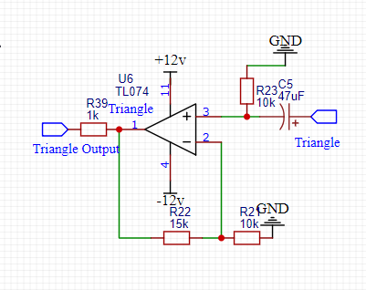

10v=4v(1+15/10)

10v=4v(2.5)

10v=10v

So here are the expected values now to simulate and try it out.

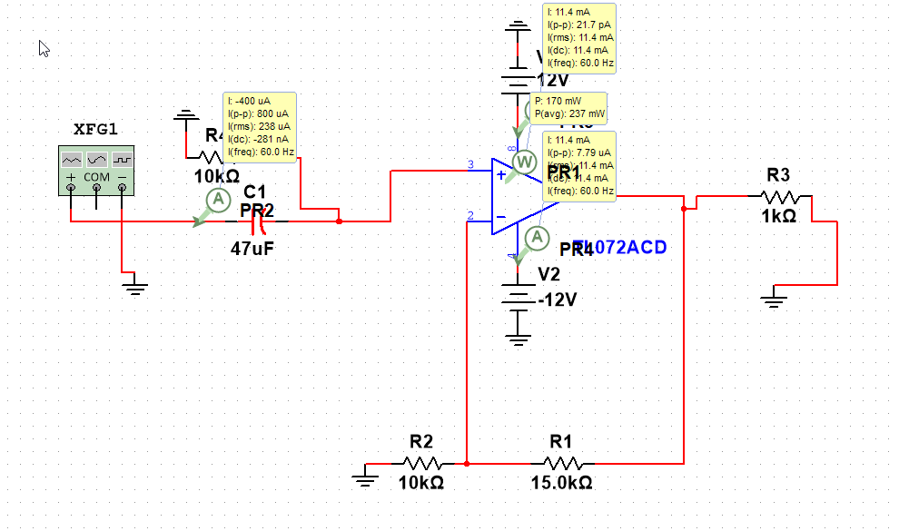

Simulating in multisim and setting a function generator to a 4v pk to pk as an input.

We run a transient analysis at the voltage over R3.

Then

This is the schematic I came up with some help from students, faculty ,books. Oh my god the list goes on

This is a simple voltage follower with a load at R3.

And a capacitor and resistor are used to ease up the dominant pole response. How I know this is through books. I do not really know how it works but without the capacitor and dual resistors the output comes out like that with transient over voltages.

Output measured across the load at R3

This is remedied with those capacitors.

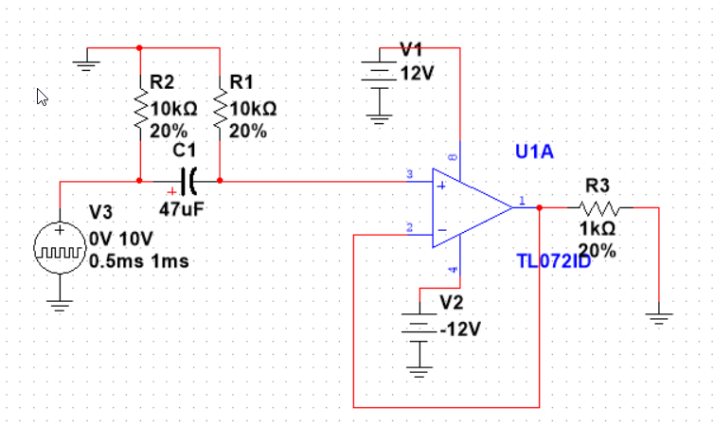

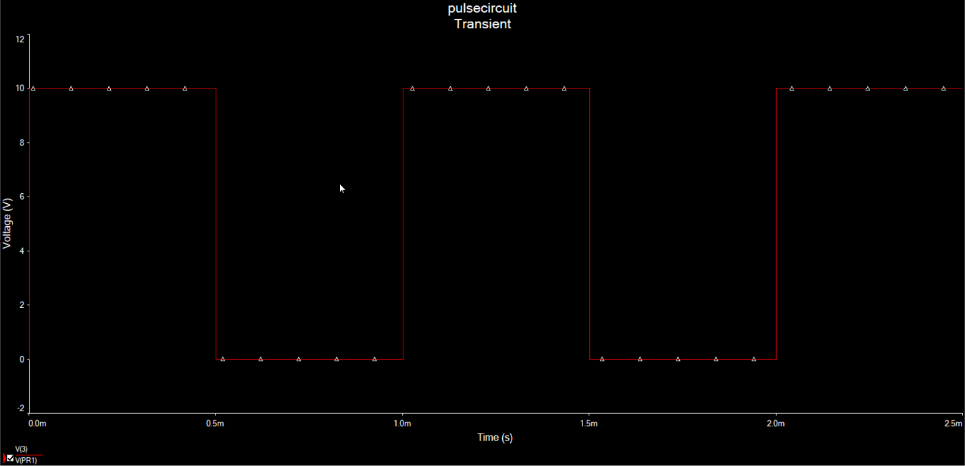

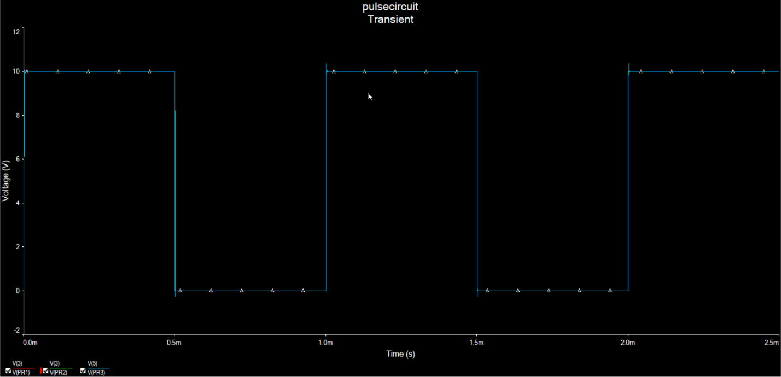

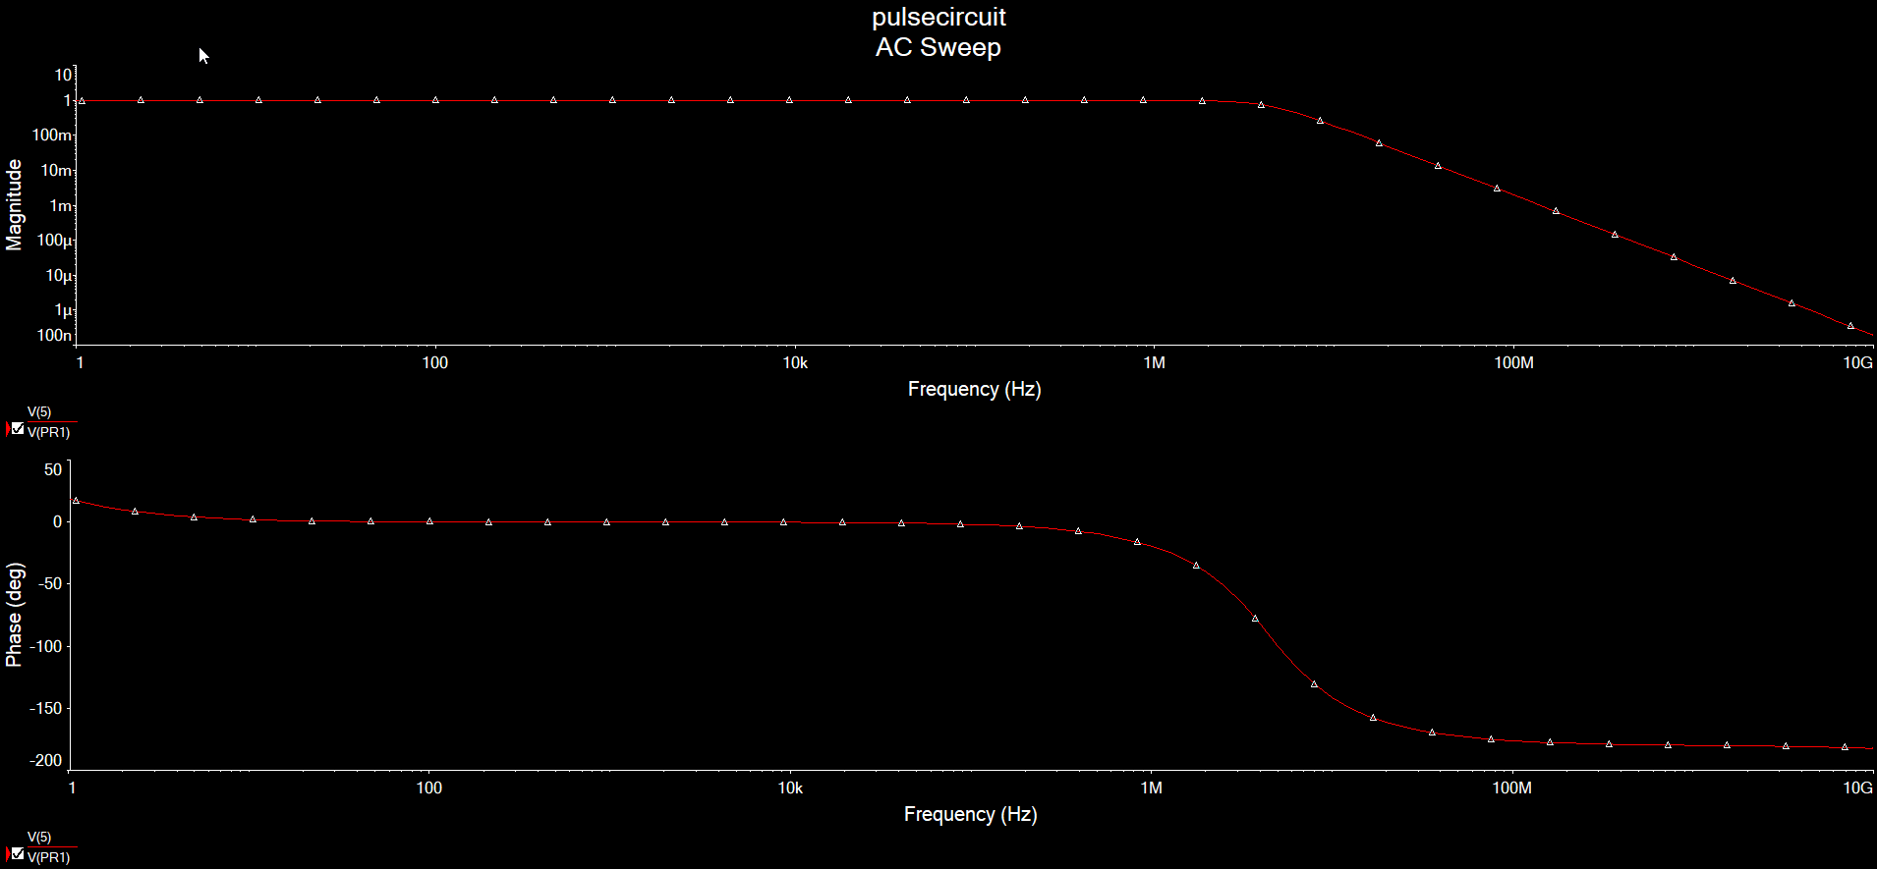

#### Eng. Analysis and Materials Selection Details for SS1-P3 – PWM

**EE Rafael A Alvarez-Santiago**

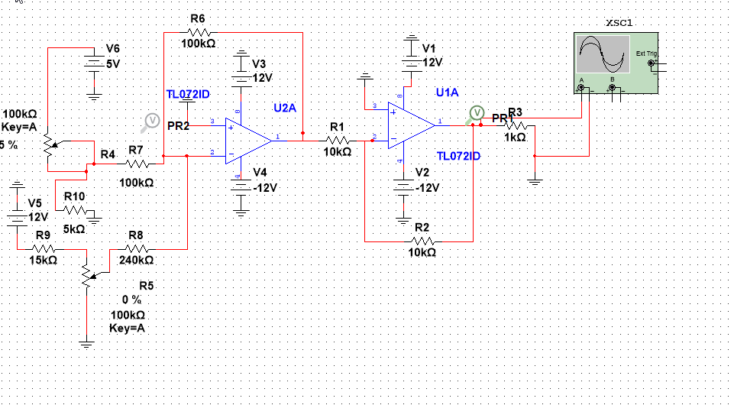

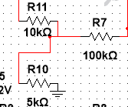

So how this circuit works.

Is that at the V6 at the left of the main circuit sends an input through a potentiometer that the user is free to turn to get values from 0 –100kohm.

The op-amps take the input invert it and preserve the value with minimal noise.

So, the bottom potentiometer does little to assist think of it as a tuner for potentiometers with low tolerances.

So, for the analysis of the circuit, we just did a transient analysis across r3 at pr1.

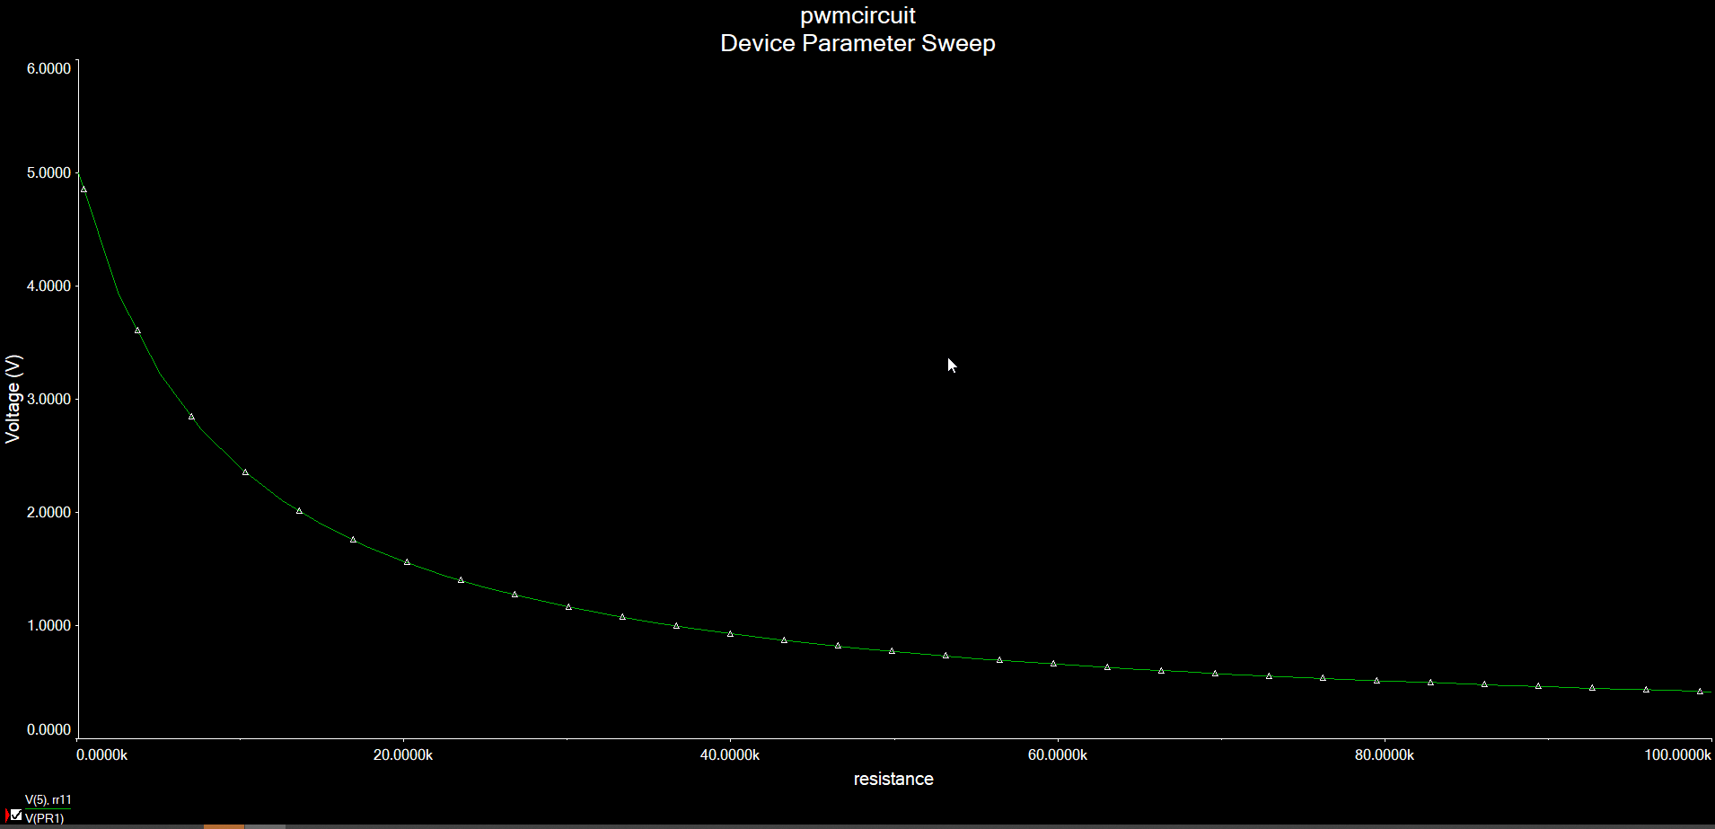

And it shows that the output goes in a beautiful exponential decay from 5-0v

Outcome: The outputs are a steady decay from 5v to 0v satisfying the datasheet.

#### Eng. Analysis and Materials Selection Details for SS1-P3 – PWM Actual

**EE Rafael A Alvarez-Santiago**

Test Goal

VCO needs to output 3 waveforms.

Project Relevance

These waveforms are pivotal in musical generation and interaction with the system

Method

Testing will be done by measuring the outputs and taking readings at the terminals

Testing Apparatus

VCO, Multimeter, Oscilloscope.

Steps Taken in Procedure

1st I made some changes to the pcb design that included some movement of potentiometers and rewiring of the board. Once the changes were made, we began to test the new outcomes.

2nd We plugged in output jacks into the VCO

3rd We powered the VCO

4th we hooked up the oscilloscope to the output jacks

5th we played with the potentiometers to see if we can have a reading.

6th We got a reading on the pulse and the triangle and ramp waveforms

7th I recorded the results below and will begin to discuss them below.

Sources of Error

There are still errors they are not outputting even close to the expected results this could be from a bypassed opamp and not getting amplified will need to check the board and retest it.

Expected Results

We expected 3 waveforms ranging close to 10Vs

But I got 3 waveforms outputting at 3-4vs expected.

To get maximum power transfer they need to be higher than that to satisfy the proper audio levels.

My results at the bottom.

Triangle, Pulse at different duty cycle so the PWM works, and the frequency knob works.

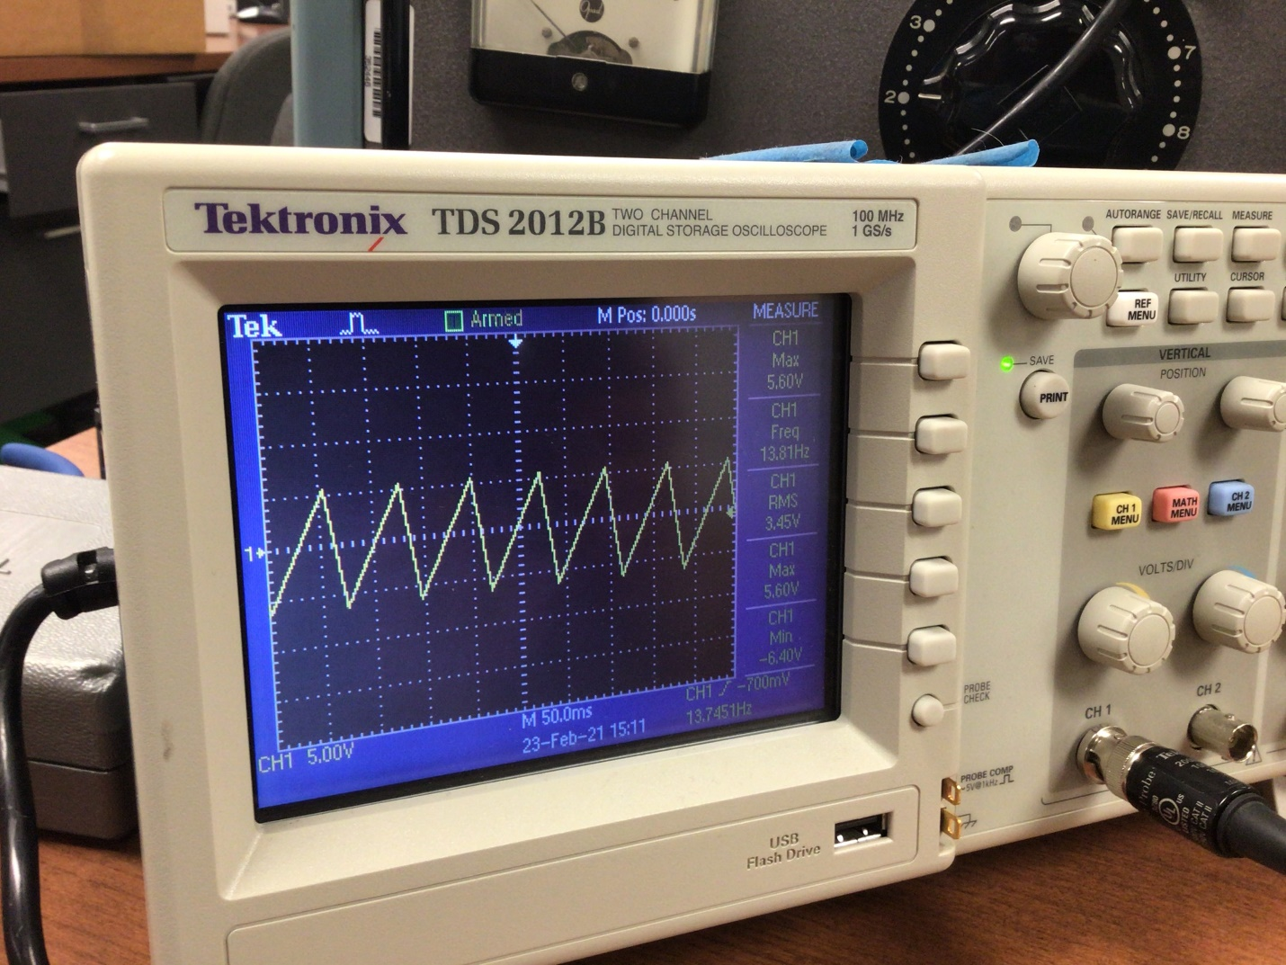

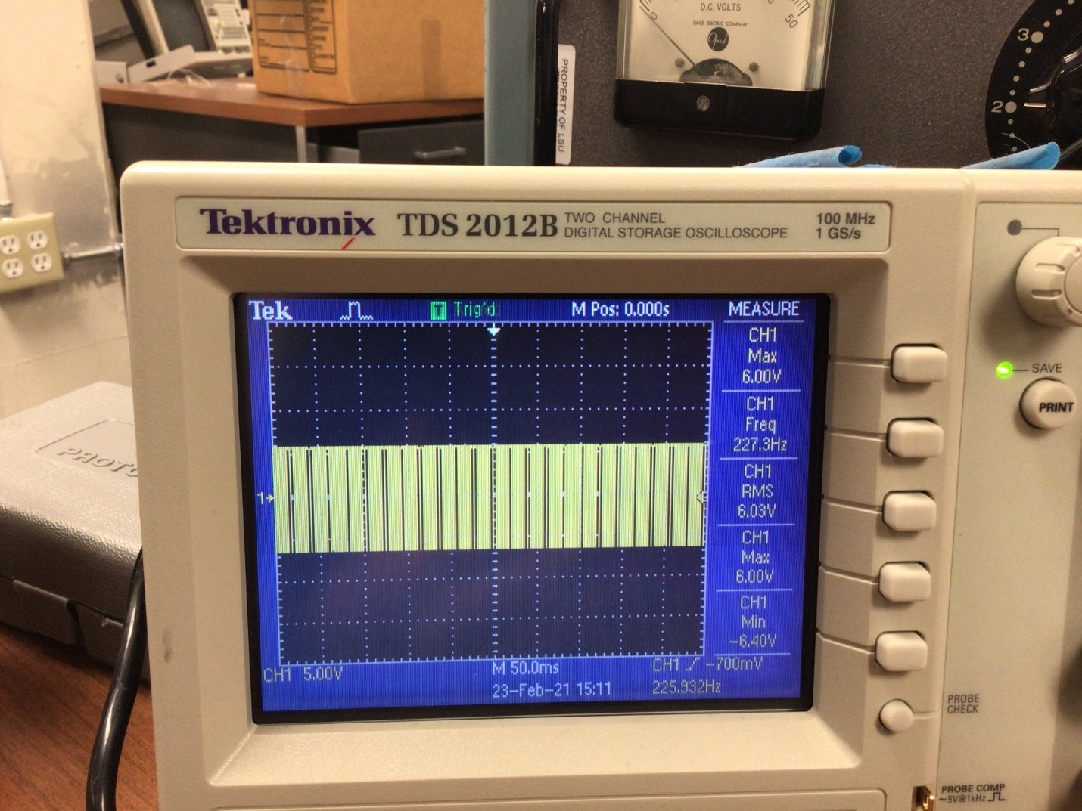

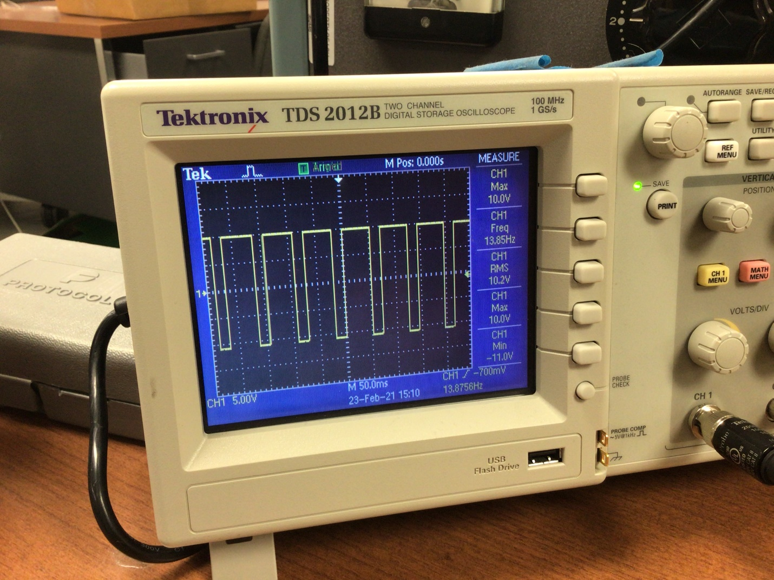

#### Eng. Analysis and Materials Selection Details for SS1-P4 – TempratureAnalysis and Materials Selection Details for SS1-P4 – Temperature

Test Goal

Begin Gathering Data for heat testing

Project Relevance

I need to see if my module generates enough heat to worry about.

Method

Testing will be done by running the module for an hour.

Then taking a reading. Then repeating 5 times.

Testing Apparatus

VCO, Temperature gun

1st VCO Powered

2nd Left running under max load with a high frequency waveform for 30mins

3rd Then reading was taken with heat gun pointed at the IC.

4th we repeated five times.

Sources of Error

I think my solder points are not done well or the resistor values are not right.

We check the power supply for errors, and it seemed to be fine.

Also, the vco could just be a flimsy design.

Expected Results

We got operating temps on the data like this.

76F

77F

79F

80F

80F

Each taken with 5mins gaps.

The IC was touched by finger and found no significant warmth.

This is to be expected from a buffer opamp circuit.

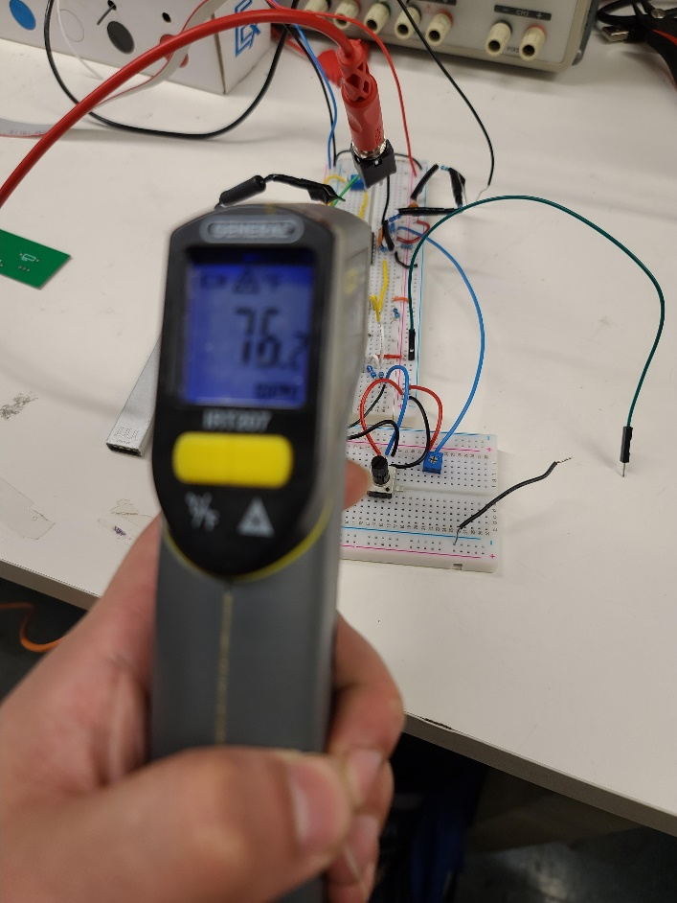

### Eng. Analysis Details for SS2- Voltage Controlled Filter

#### Eng. Analysis and Materials Selection Details for SS#-P# - Part Name

Click or tap here to enter text.

(1)

Force

Accewhy leration

Mass

### Eng. Analysis Details for SS3- Digital Multi-Effects

#### Eng. Analysis and Materials Selection Details for SS3-P1 – DSP Microcontroller

Kyle Sellers (EEC)

#### Eng. Analysis and Materials Selection Details for SS3-P1 – DSP Microcontroller

Kyle Sellers (EEC)

DSP Microcontroller Decision Matrix:

|  |  |  |  |  |  |  |  |
| --- | --- | --- | --- | --- | --- | --- | --- |
|  | Weight |  | Daisy | FV-1 |  | Weighted Daisy | Weighted FV-1 |
| Cost | 0.2687 |  | 0.3280 | 0.6720 |  | 0.0881 | 0.1805 |
| Ease of Programming | 0.4463 |  | 0.7692 | 0.2308 |  | 0.3433 | 0.1030 |
| Size | 0.0343 |  | 0.8327 | 0.1673 |  | 0.0285 | 0.0057 |
| Fidelity | 0.0602 |  | 0.8000 | 0.2000 |  | 0.0482 | 0.0120 |
| I/O | 0.0754 |  | 0.9118 | 0.0882 |  | 0.0688 | 0.0067 |
| Memory | 0.1151 |  | 0.9995 | 0.0005 |  | 0.1150 | 0.0001 |
|  |  |  |  |  |  |  |  |
| Total |  |  | 0.6920 | 0.3080 |  |  |  |

Pairwise Comparison Matrix:

|  |  |  |  |  |  |  |  |  |  |
| --- | --- | --- | --- | --- | --- | --- | --- | --- | --- |
|  | Cost | Ease of Programming | Size | Fidelity | I/O | Memory |  | Geo Mean | Normalized |
| Cost | 1 | 1/5 | 7 | 5 | 5 | 5 |  | 2.36505 | 0.26868 |
| Ease of Programming | 5 | 1 | 3 | 7 | 7 | 5 |  | 3.92834 | 0.44628 |
| Size | 1/7 | 1/3 | 1 | 1/7 | 1/3 | 1/3 |  | 0.30181 | 0.03429 |
| Fidelity | 1/5 | 1/7 | 7 | 1 | 1/3 | 1/3 |  | 0.53023 | 0.06024 |
| I/O | 1/5 | 1/7 | 3 | 3 | 1 | 1/3 |  | 0.66401 | 0.07544 |
| Memory | 1/5 | 1/5 | 3 | 3 | 3 | 1 |  | 1.01291 | 0.11507 |

Cost Matrix:

|  |  |  |  |
| --- | --- | --- | --- |
| DSP Chip | Cost | Min Cost / Cost | Normalized |
| Daisy | 29.95 | 0.488146912 | 0.328023334 |
| FV-1 | 14.62 | 1 | 0.671976666 |

Ease of Programming Matrix:

|  |  |  |  |
| --- | --- | --- | --- |
| DSP Chip | Relative Ease | RE / Max RE | Normalized |
| Daisy | 10 | 1 | 0.769230769 |
| FV-1 | 3 | 0.3 | 0.230769231 |

Size Matrix:

|  |  |  |  |
| --- | --- | --- | --- |
| DSP Chip | Size ( mm^2) | Min Variation / Variation | Normalized |
| Daisy | 184.5 | 1.0000 | 0.8327 |
| FV-1 | 918 | 0.2010 | 0.1673 |

Fidelity Matrix:

|  |  |  |  |
| --- | --- | --- | --- |
| DSP Chip | Max Sample Rate | MSR / Max MSR | Normalized |
| Daisy | 192000 | 1 | 0.8 |
| FV-1 | 48000 | 0.25 | 0.2 |

I/O Matrix:

|  |  |  |  |
| --- | --- | --- | --- |
| DSP Chip | I/O | I/O / Max I/O | Normalized |
| Daisy | 31 | 1 | 0.9117647 |
| FV-1 | 3 | 0.096774194 | 0.0882353 |

Memory Matrix:

|  |  |  |  |
| --- | --- | --- | --- |
| DSP Chip | RAM | Mem/Max Mem | Normalized |
| Daisy | 64,000 | 1 | 0.9995 |
| FV-1 | 32 | 0.0005 | 0.0005 |

#### Eng. Analysis and Materials Selection Details for SS3-P2– Audio Input Attenuator / Filter

Kyle Sellers (EEC)

The SPICE circuit in which tests were run is shown below. Note this is for both the Audio Input and output since both were needed in the same circuit to test cascading the sub circuits.

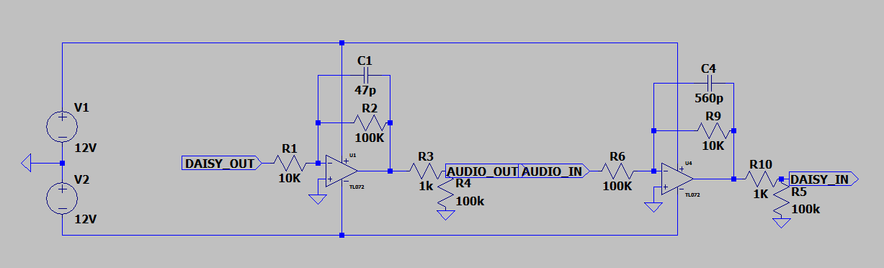

Both the input and output are of the form of an inverting active low-pass filter, shown below:

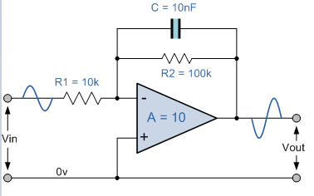

As stated above, this configuration is inverting, so a second op-amp is used to re invert the signal, placing it in phase with the input.

DC gain for this configuration is -R2/R1, and the -3dB cutoff frequency is 1/(2*pi*R2*C).

Using these equations, the gain and cutoff frequencies for the above op amps are as follows:

Op-Amp Gain Cutoff Freq

Input 10 28481

Output 0.1 33863

DC Sweep:

With an input ranging from -10V to 10V, an output voltage of 1V to -1V is expected for sending to the Electrosmith Daisy DSP Microcontroller, since the gain is – (10k / 100k) = -0.1

Below shows the results of this SPICE simulation

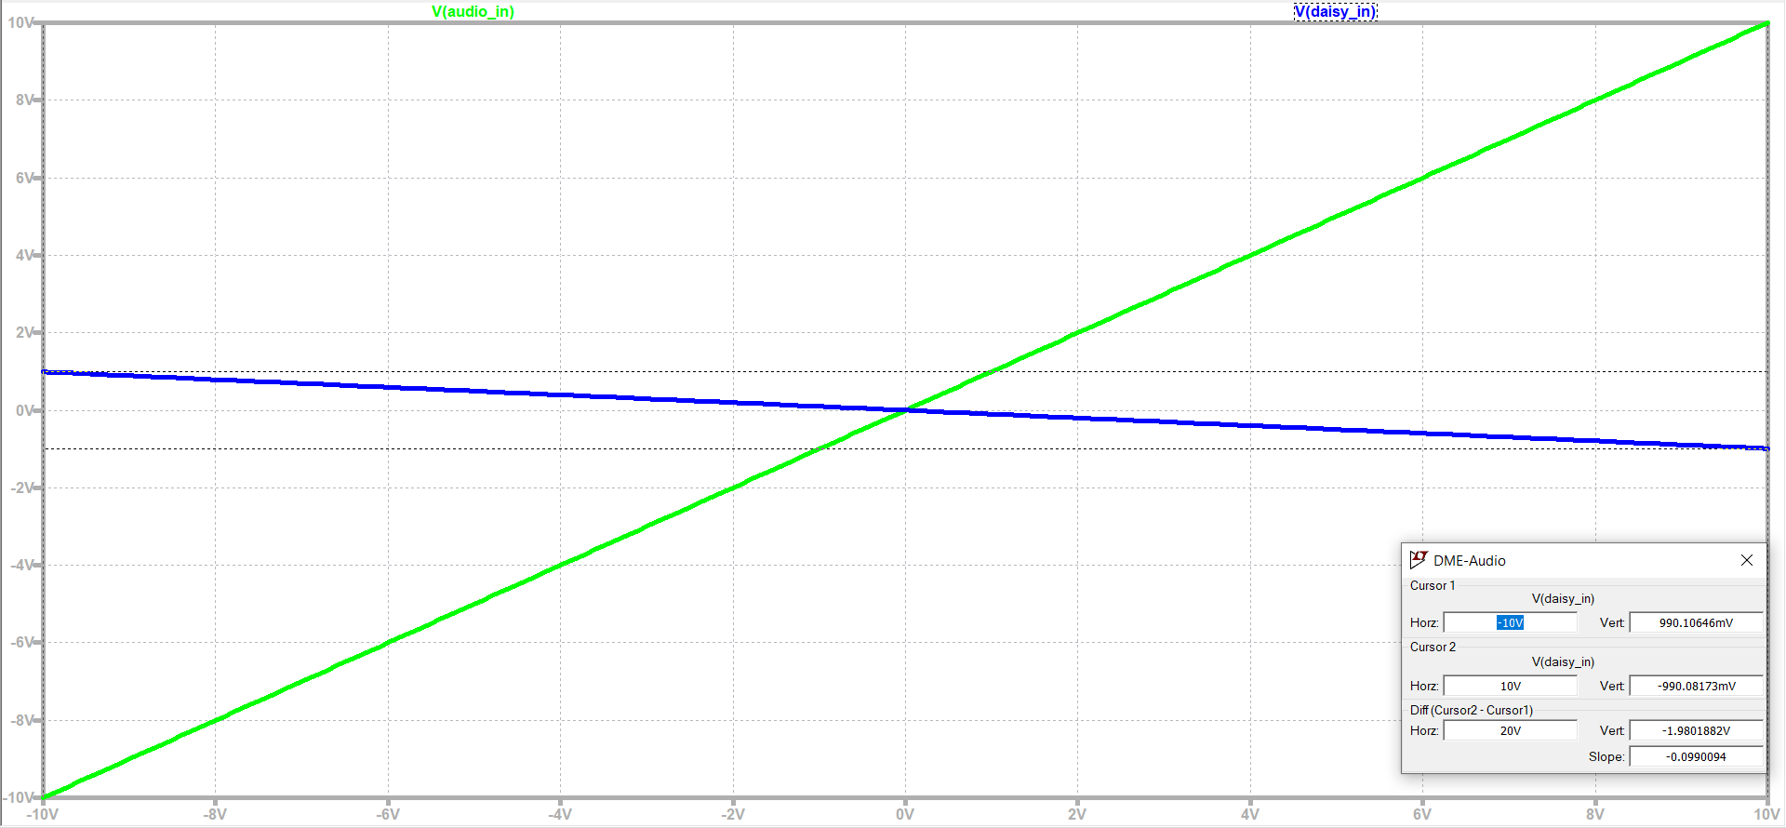

Results indicate an actual output range of 990 mV to -990 mV, or 99% of expected values.

AC Analysis:

The anticipated -3dB cutoff frequency is calculated as 1/(2*pi*10k*560p) = 28.5 kHz.

Results of SPICE analysis are show below

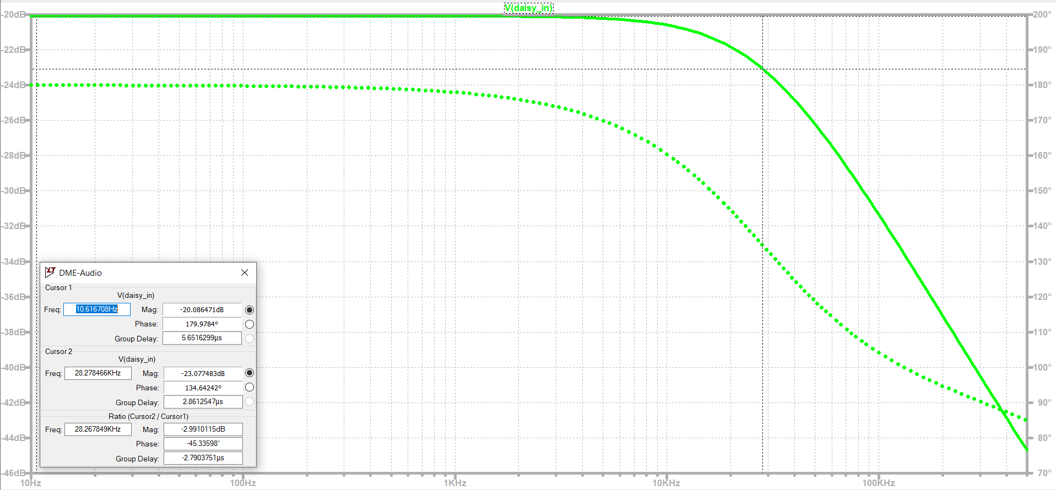

The simulated -3 dB cutoff frequency is 28.3 kHz, which is close enough to calculated values.

Transient Analysis:

The RC time constant for the audio input is 10k * 560p = 5.6 us. From what we learned in our Circuits I course, it takes an RC circuit 5-time constants to reach a target value, so 5 * 5.6 = 28us.

The highest frequency that can be produced by the VCO is 7kHz, making the fasted half period 71.4 us long. The 5 * time constant needs to be faster than this to ensure proper functionality.

Looking at transient analysis in SPICE, our simulated time constant (61% of signal strength) is 6.8 us, making the 5*TC = 34 us, still well under 71.4 us.

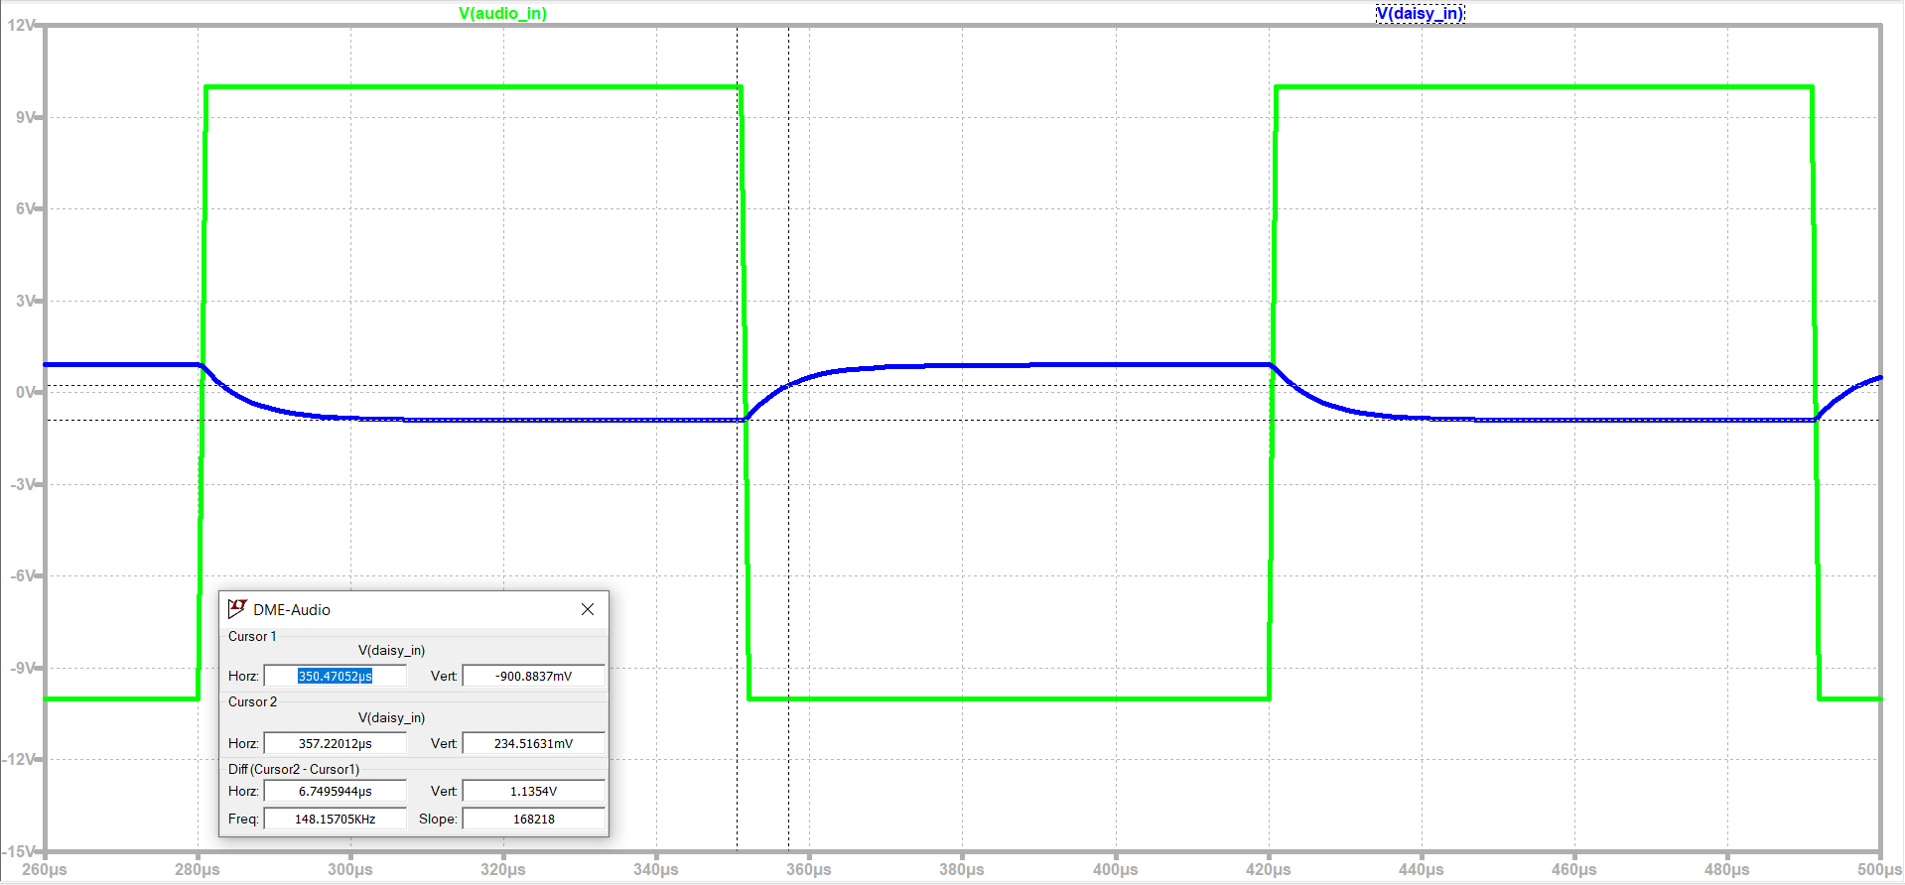

Looking at transient analysis in SPICE, our simulated time constant (61% of signal strength) is 6.8 us, making the 5*TC = 34 us, still well under 71.4 us.

Sensitivity Analysis:

Below shows the sensitivity analysis ran on the combined audio input and output subcircuits.

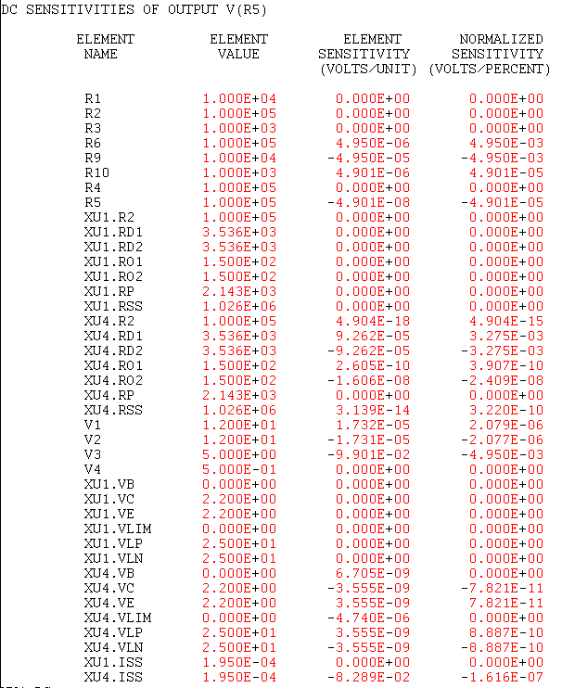

Results indicate the output value changes by 0.25% (5mv / 2V) for every 1% change to audio input level and the input and feedback resistors.

Temperature Analysis:

Temperature analysis was run from 0 C to 120 C, as this is the lowest expected external temperature and highest expected internal temperature of the circuit

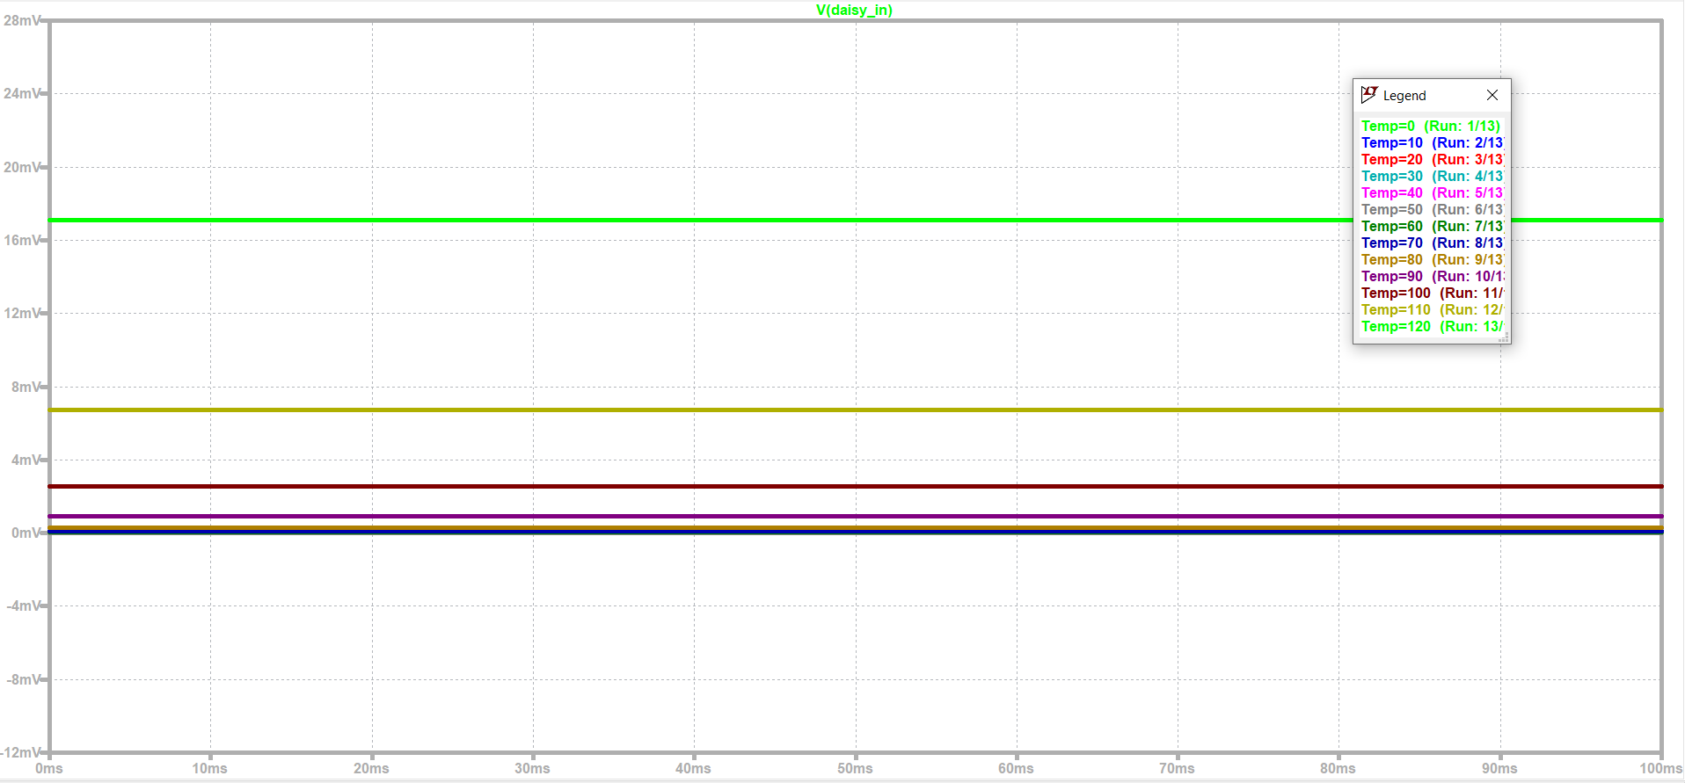

. Results indicate a 17-mV swing in output voltages over this temperature range, or 0.85% (17mV / 2V) of the output voltage range. When looking at a more realistic temperature range of 25 C to 80 C, this variance reduces to 7 mV, or 0.35% of the output voltage range.

Power Analysis:

Power Analysis was conducted on the audio input and output stages together.

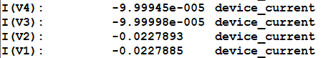

Power draw is dominated by power draw from V1 and V2. This comes out to (12 * 0.0228) + (12 * 0.0228) = 0.5472 W total, half that of the original design.

The total current draw is 22.8 mA per rail for the combined input & output, or 45.6 mA total.

#### Eng. Analysis and Materials Selection Details for SS3-P3– Audio Output Amplifier/ Filter

Kyle Sellers (EEC)

Refer to the top of the above section for a description of the circuit.

DC Sweep:

With an input ranging from -1V to 1V, an output voltage of 10V to -10V is expected for sending to the Electrosmith Daisy DSP Microcontroller, since the gain is – (100k / 10k) = -10

Below shows the results of this SPICE simulation

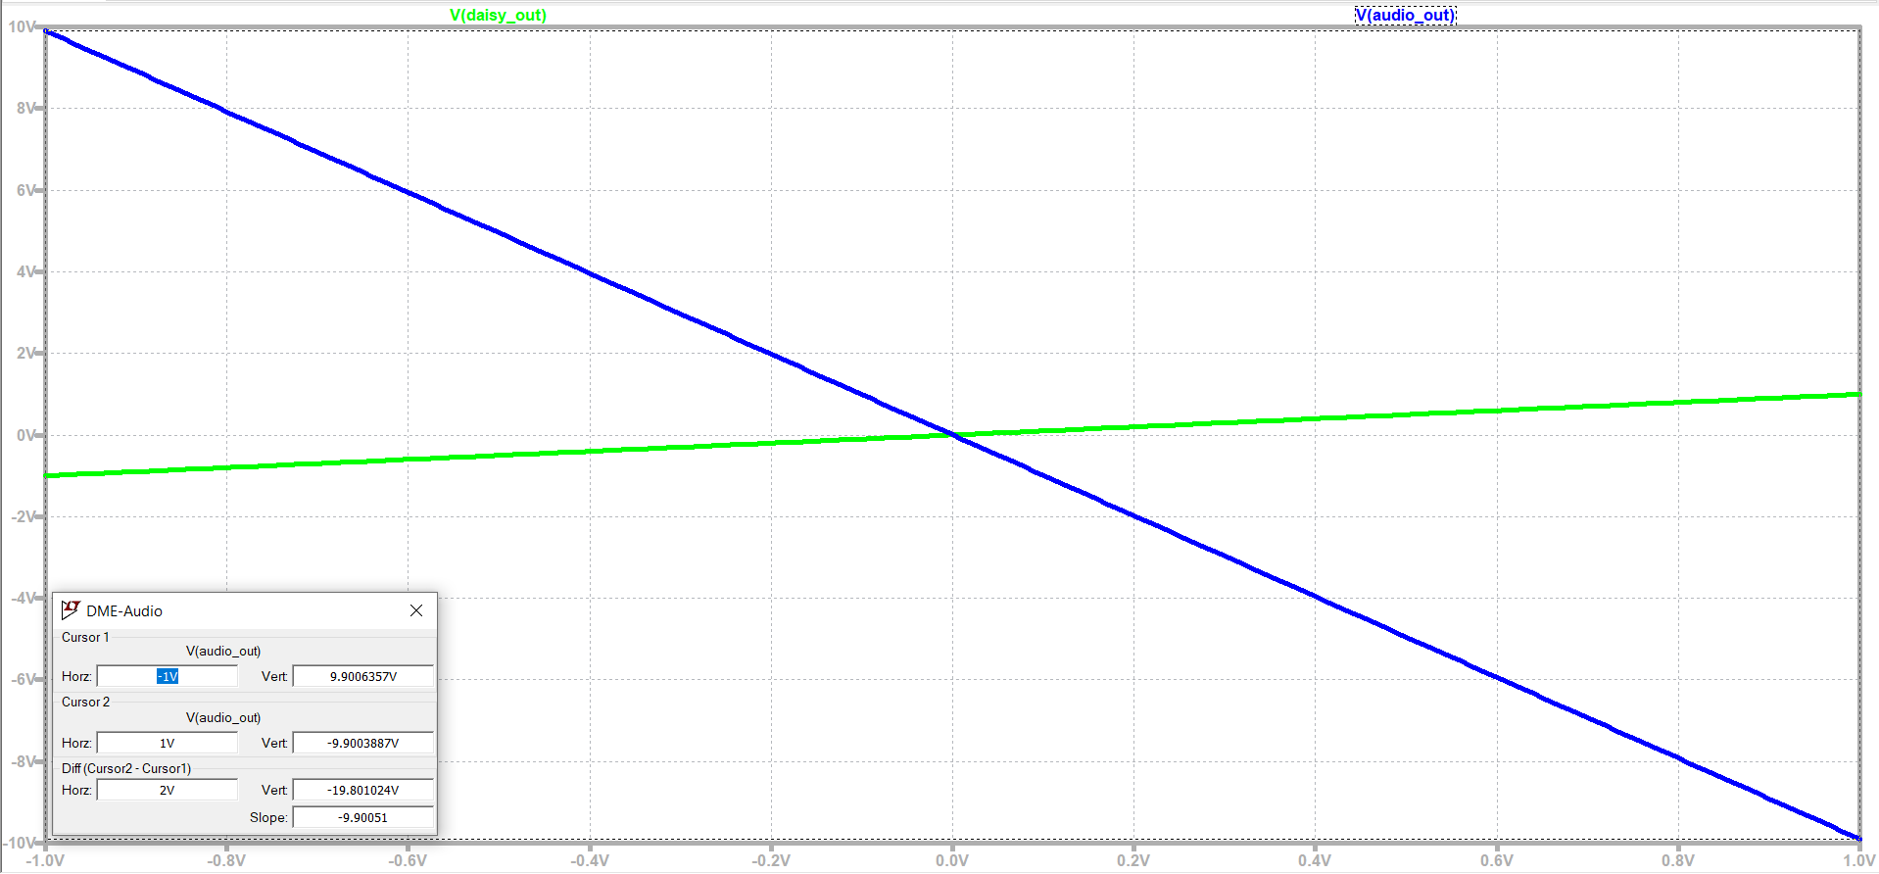

Results indicate an actual output range of 9.9 V to -9.9V, or 99% of expected values.

AC Analysis:

Output:

The anticipated -3dB cutoff frequency is calculated as 1/(2*pi*100k*47p) = 33.8kHz.

Results of SPICE analysis are show below

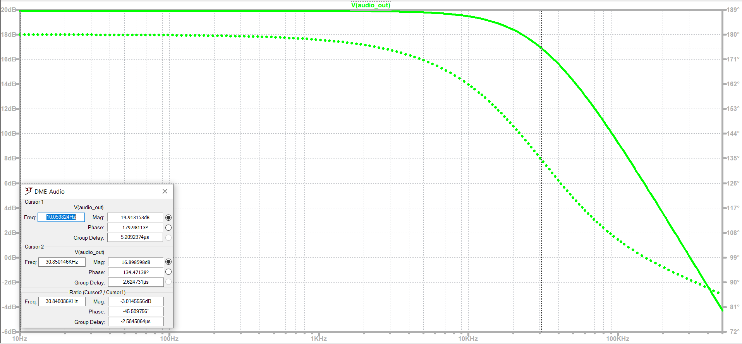

The simulated -3 dB cutoff frequency is 30.8 kHz, which is lower than calculated values, but close enough.

Cascaded:

The AC response was tested for cascading the input and output by connecting the output of the input amplifier to the input of the output amplifier. Results are shown below

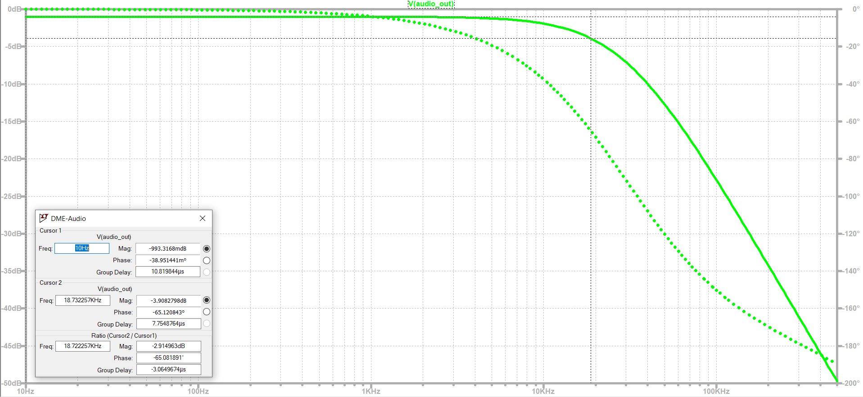

The -6dB frequency is 18.7 kHz, which while under 22kHz, is above the highest frequency that most humans can hear.

Transient Analysis:

Output:

The RC time constant for the audio input is 100k * 47p = 4.7 us. From what we learned in our Circuits I course, it takes an RC circuit 5-time constants to reach a target value, so 5 * 4.7 = 23.5us.

The highest frequency that can be produced by the VCO is 7kHz, making the fasted half period 71.4 us long. The 5 * time constant needs to be faster than this to ensure proper functionality.

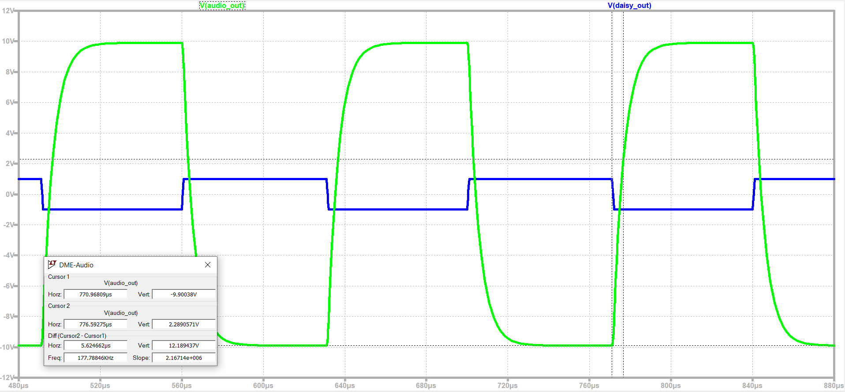

Looking at transient analysis in SPICE, our simulated time constant (61% of signal strength) is 6.6 us, making the 5*TC = 33 us, still well under 71.4 us.

Cascaded:

Cascading the modules, we expect a TC = 5.6+4.7 = 10.3 us, making 5 * TC = 51.5 us, still under 71.4 us.

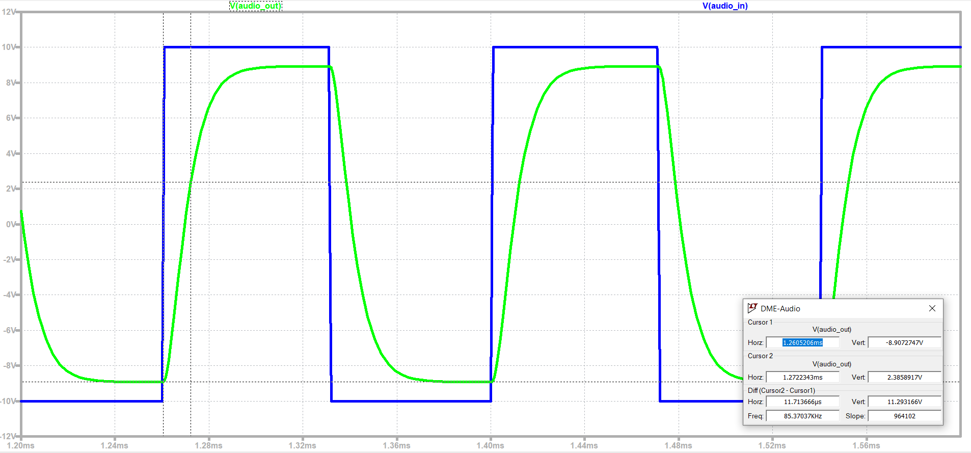

SPICE analysis shows a simulated TC = 11.7 us, yielding a 5 * TC value of 58.5, still under 71.4 us.

Sensitivity Analysis:

Below shows the sensitivity analysis ran on the combined audio input and output subcircuits.

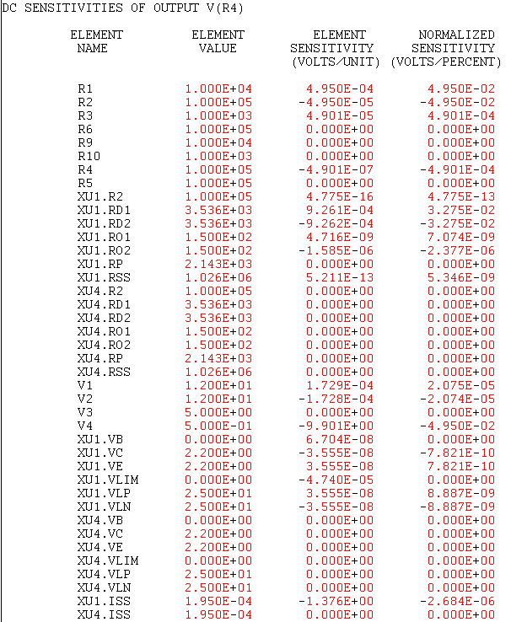

Results indicate the output value changes by 0.25% (50mv / 20V) for every 1% change to microcontroller audio output level and the input and feedback resistors.

Temperature Analysis:

Temperature analysis was run from 0 C to 120 C, as this is the lowest expected external temperature and highest expected internal temperature of the circuit.

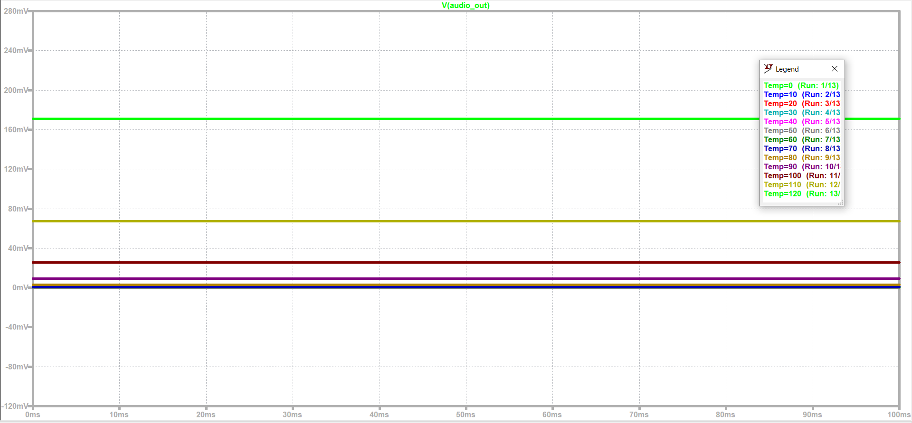

Results indicate a 170-mV swing in output voltages over this temperature range, or 0.85% (170mV/2V) of the output voltage range . When looking at a more realistic temperature range of 25 C to 80 C, this variance reduces to 70 mV, or 0.35% of the output voltage range.

Power Analysis:

Refer to above section for power analysis.

#### Eng. Analysis and Materials Selection Details for SS3-P4– CV/Knob Sum

Kyle Sellers (EEC)

The design being analyzed is pictured below. All analyses are run in LTSPICE.

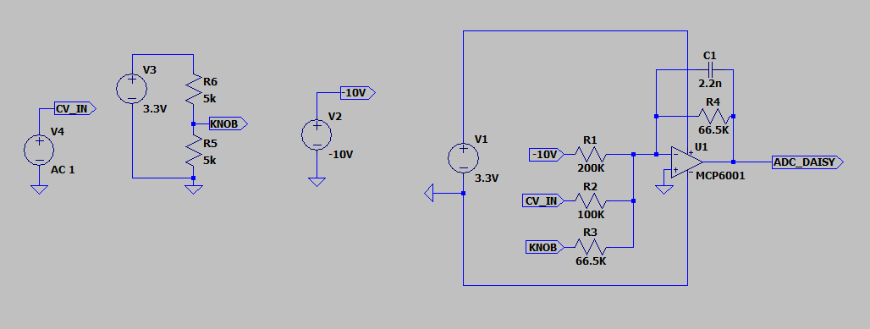

The circuit is of a summing, inverting opamp configuration. This configuration is shown below.

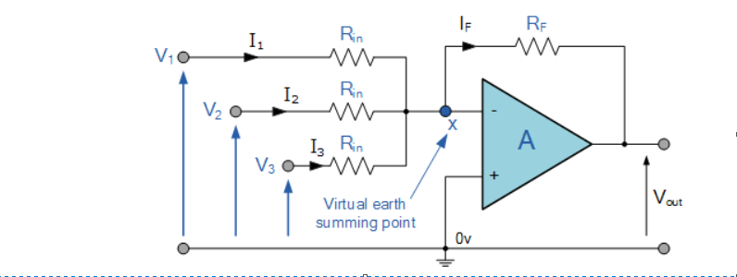

With gain equation:

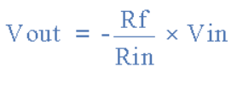

Source: https://www.electronics-tutorials.ws/opamp/opamp_4.html

Using this, we can calculate the gain of each input:

-10V = -66.5 / 200 = -0.3325

CV_IN = -66.5 / 100 =- 0.665

KNOB = -66.5 / 66.5 = -1

-10V is constant at the input, so it will always be contributing +3.3V to the input

CV_IN can range from -5V to +5V, so it will be contributing +3.3V to -3.3V to the signal.

KNOB can range from 0 to 3.3 V, so it will be contributing -3.3V to 0V to the signal.

Since the configuration is an inverting op-amp, we will be treating 3.3V as logical 0 and 0V as logical 1 in the software. The -10V input is used to bias the circuit to 3.3V when both CV_IN and KNOB are at 0V, Serving as a logical 0 point.

We are using the MCP6001 Op-Amp, which provides rail to rail output voltage (in our case, 0 to 3.3V). That means no matter how high or low our input voltage gets, the min value it can put out is 0V and max is 3.3V.

Since knob can contribute min 0 V and max -3.3V to the signal, even with CV_IN at 0V, we can still get the full input range by only adjusting the knob.

Since CV_Ins contribution can range from -3.3V to +3.3V, we can get any range of output no matter what knob is set to:

When knob is min, vout = 3.3V, we can vary V_IN between 0 and -3.3V to get full range.

When knob is max, vout is 0V, we can vary CV_IN between 0 and 3.3V to get full range.

The circuit is designed so that no matter what, either knob input and/or CV_IN can be varied to get full 0-3.3V output range.

In addition to this, a filtering capacitor is added to the configuration to filter out High frequency noise. The RC cutoff frequency is 1 / (2 * pi * R * C) = 1kHz. This is plenty high enough for a low pass filter

For purposes of testing, ideal power sources are used.

DC Sweep:

Output voltage into the Daisy Seed should never exceed a 0-3.3V range. This should not be a problem, as the MCP6004 is only powered by 3.3V and 0 V rails, and it only has rail to rail output.

Ideally, both knob and CV in should be able to recreate this 0 to 3.3V range. Multiple tests are run to verify this

First, CV_IN is held at 0V, and the potentiometer for KNOB is swept from 0 to 10k. Results are shown below.

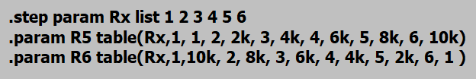

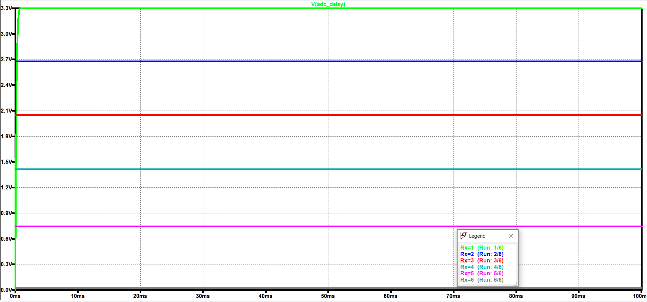

Steps tested are 0, 2k, 4k, 6k, 8k, and 10k. As seen, this splits the output voltage into 5 even splits spanning 3.3V to 0V, as expected. Also, note that 3.3V corresponds to a pot value of 0, and 23.5 mV corresponds to a pot value of 10k.

Now that we know the potentiometer linearly splits the output between 0 and 3.3V buy itself, we will sweep CV_IN and measure the circuit response. This will be done at 3 KNOB values, 0 ohms, 5kohm, and 10kohm.

For the 0-position case, ADC_DAISY should be 3.3V. Due to this, and based on the gain calculations above, ADC_DAISY should only vary in the +5 to 0V range of CV_IN, with the output staying at 3.3V in the 0V to -5V range.

Results of this test are shown below, sweeping CV_IN from -5V to 5V, and reading the output at ADC_DAISY.

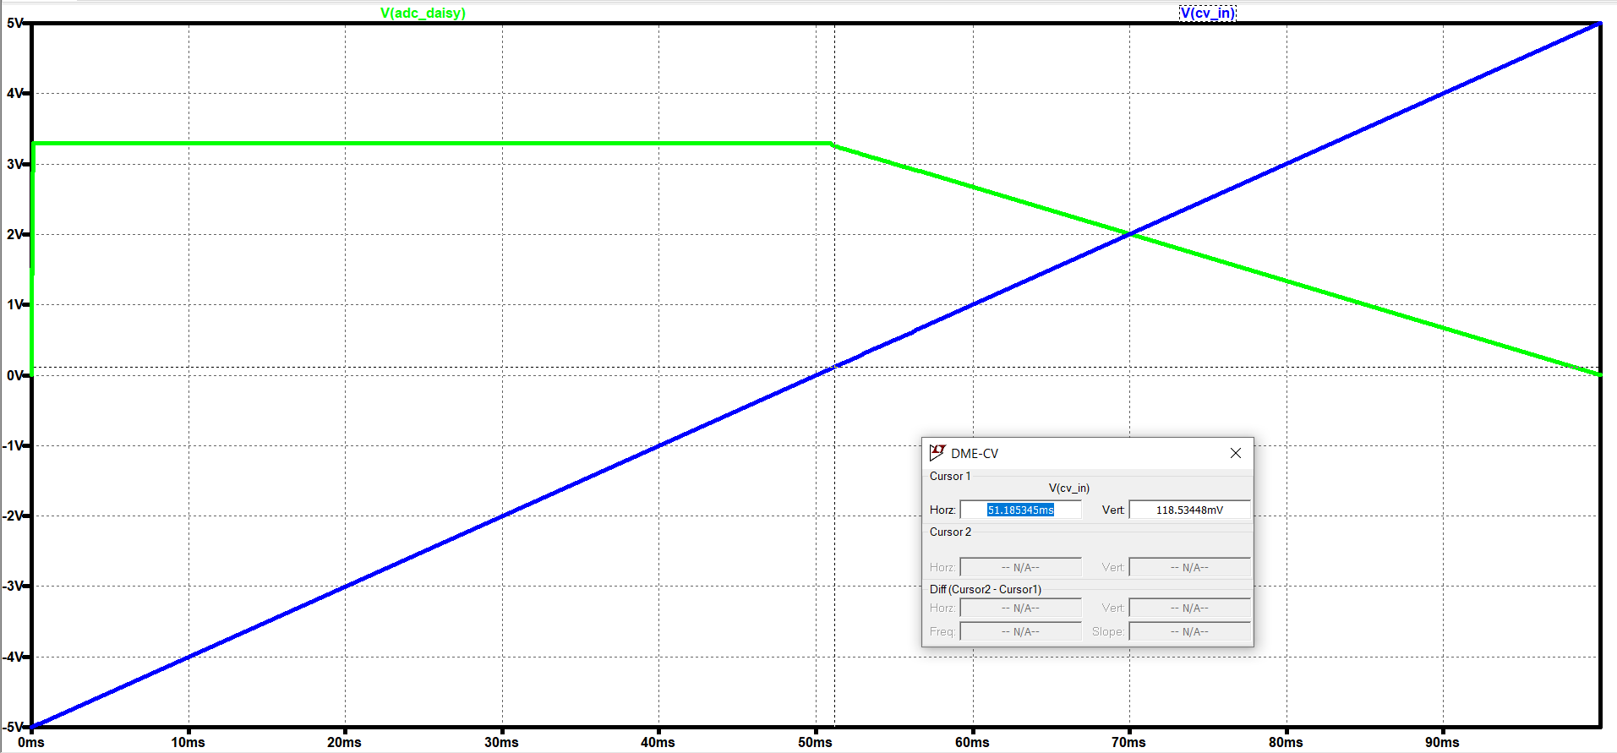

As seen above, the output remains at 3.3V from -5V to about 120 mV. Then, it sweeps linearly from 3.3V to 8 mV (essentially 0) when CV_IN is 5V.

For the 10k position case, ADC_DAISY should be 0V (well, 23.5 mV, but close enough). Due to this, and based on the gain calculations above, ADC_DAISY should only vary in the -5 to 0V range of CV_IN, with the output staying at 0V in the 0V to +5V range.

Results of this test are shown below, sweeping CV_IN from -5V to 5V, and reading the output at ADC_DAISY.

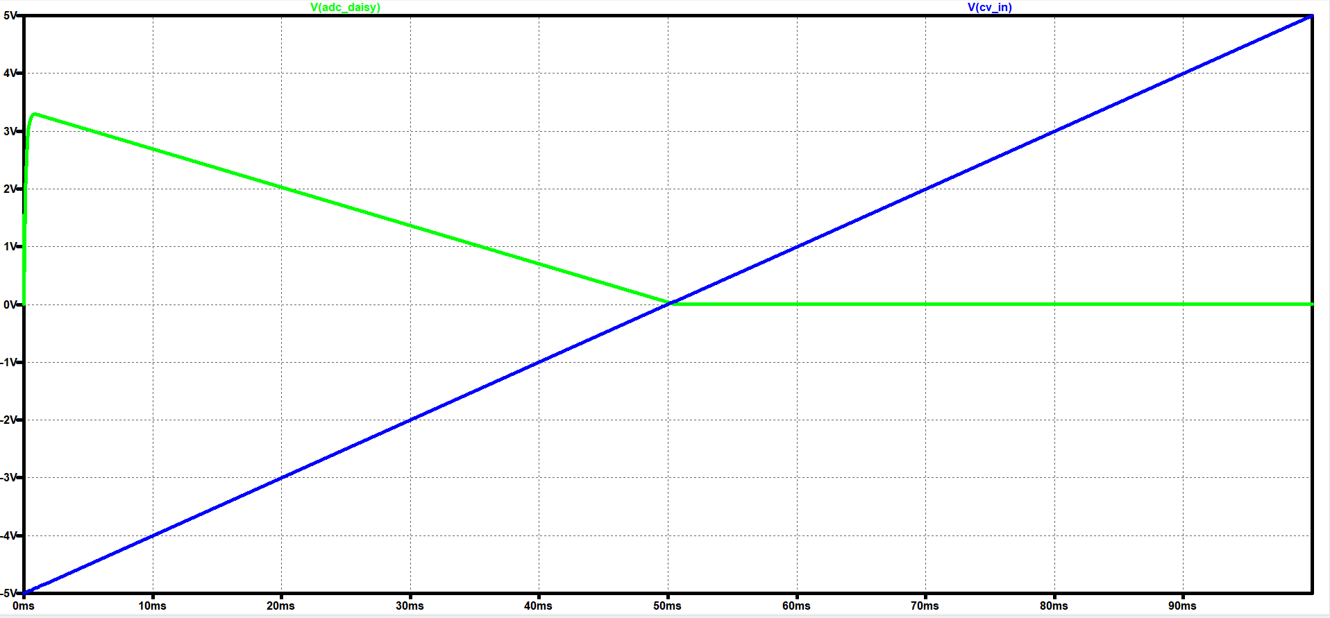

Results correspond with our calculated values.

For the 5k position case, ADC_DAISY should be about 1.67V. Due to this, and based on the gain calculations above, ADC_DAISY should only vary in the -2.5 to 2.5V range of CV_IN, with the output staying at 3.3V in the -5 to -2.5 range, and 0V in the 2.5V to +5V range.

Results of this test are shown below, sweeping CV_IN from -5V to 5V, and reading the output at ADC_DAISY.

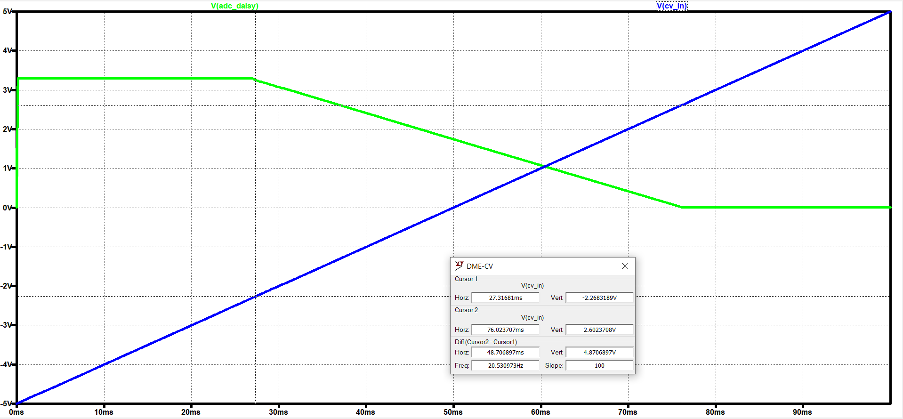

As seen above, the output only varies in the -2.26V to 2.6 V range. This is not the exact save as calculated values but is close enough for our uses.

In all, we see that this circuit behaves as expected with varying KNOB and CV_IN values.

AC Analysis:

This Op-Amp configuration does serve as a first order low pass filter, with cutoff frequency calculated to be about 1 kHz. This is for reasons stated in the WCM amplifier circuit, where we need to be able to produce and intake LFO square waves at about 100 Hz, so 1000 Hz contains up to its 9th harmonic without attenuation.

AC analysis is run with CV in as the input, with output read at ADC_DAISY, from 0.01 Hz to 10kHz. The bode plot is shown below.

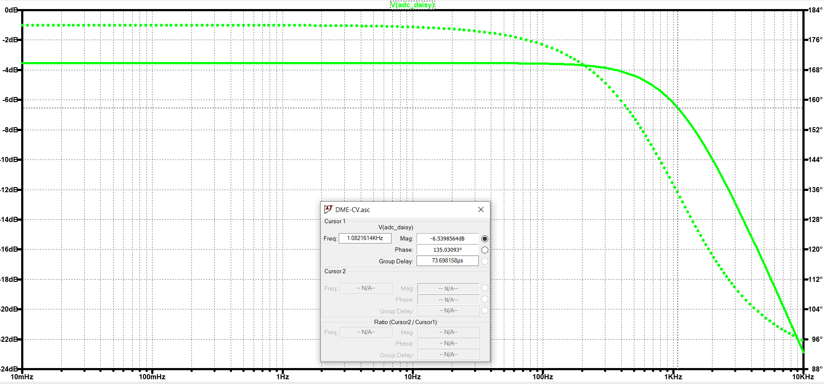

As seen above, just as we calculated, the -6 dB frequency is around 1 kHz

Transient Analysis:

Since we are using an RC low pass filter, we have an RC time constant associated with it. With a 100Hz Signal, the circuit has 5 ms to respond to changes in input voltages. This is an eternity compared to the slew rate of the MCP6001 ( 0.6 V/us) , so this is not an issue.

Source for datasheet: https://ww1.microchip.com/downloads/en/DeviceDoc/MCP6001-1R-1U-2-4-1-MHz-Low-Power-Op-Amp-DS20001733L.pdf

The RC time constant is 66.5k * 2.2n = .15 ms. 5-time constants are 0.75 ms. This over 6x faster than the 5ms max we would need, so this should be fine.

A transient analysis is run on CV_IN from 0 to 5V, this knob set to 0 position (0V). The output is taken at ADC_DAISY

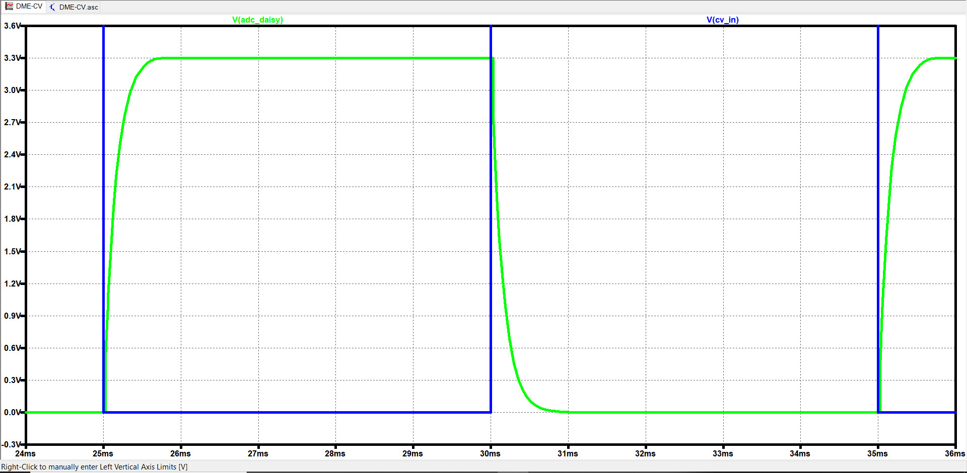

As calculated, it takes about 0.75 ms to reach the target value.

Total power = (3.3 * .11e-3) + (10 * 5.3e-5) + (3.3 * .34e-3) + (5 * 4.4e-5) = 0.0022 W

Total current = .13e-3 + 5e-5 + .34e-3 + 4.4e-5 = 0.0006 = 0.6 mA

Power Analysis:

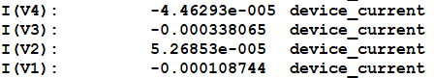

Total power = (3.3 * .11e-3) + (10 * 5.3e-5) + (3.3 * .34e-3) + (5 * 4.4e-5) = 0.0022 W

Total current = .13e-3 + 5e-5 + .34e-3 + 4.4e-5 = 0.0006 = 0.6 mA

at about 2.2 mW power dissipation, and 0.6 mA power draw per CV input.

Our system will have 4 CV inputs, so power dissipation for this full subcircuit will be 8.8 mW and 2.4 mA power draw.

Temperature Analysis:

Temperature analysis is run from 0 *C to 150 * C with KNOB input being half (5k) and CV_IN being 1 V. The variation in output is shown below.

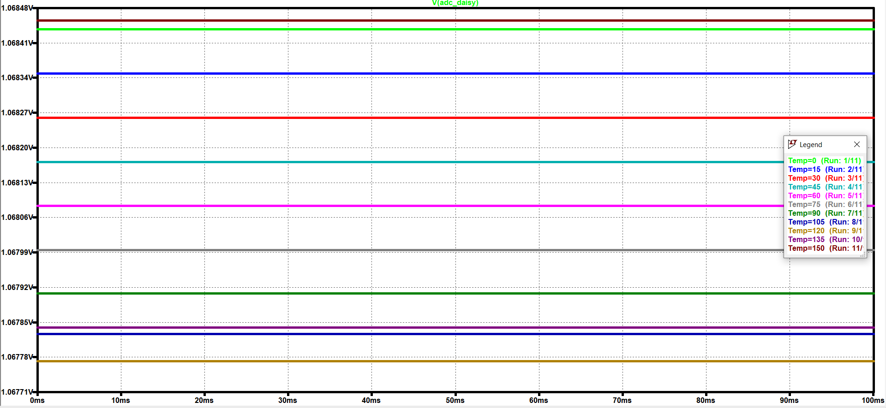

Variation at the output only spans 6.9 mV over this extreme temperature range, which will not be a problem in the real system.

#### Eng. Analysis and Materials Selection Details for SS3-P5– LCD Display

Kyle Sellers (EEC)

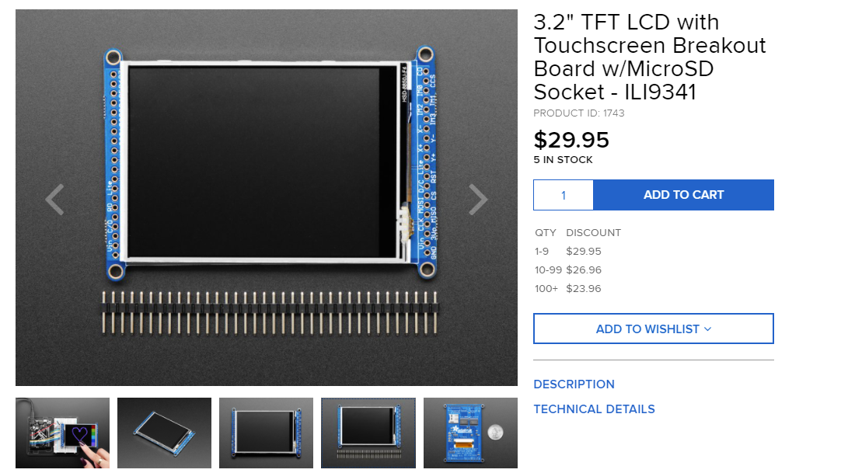

Below is an example of the display working.

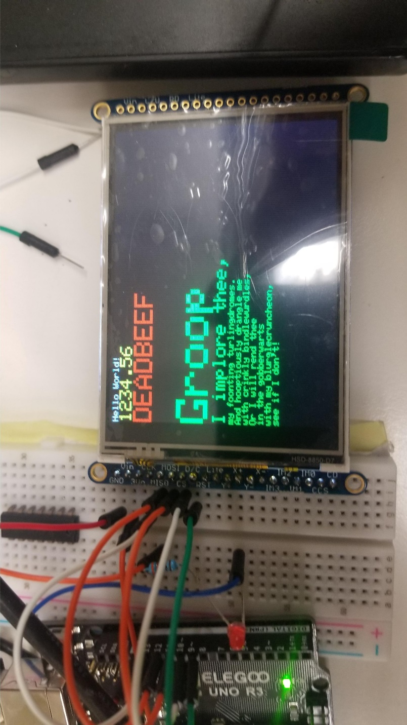

#### Eng. Analysis and Materials Selection Details for SS3-P6– Power Regulator

Kyle Sellers (EEC)

+/- 12V Power Filtering:

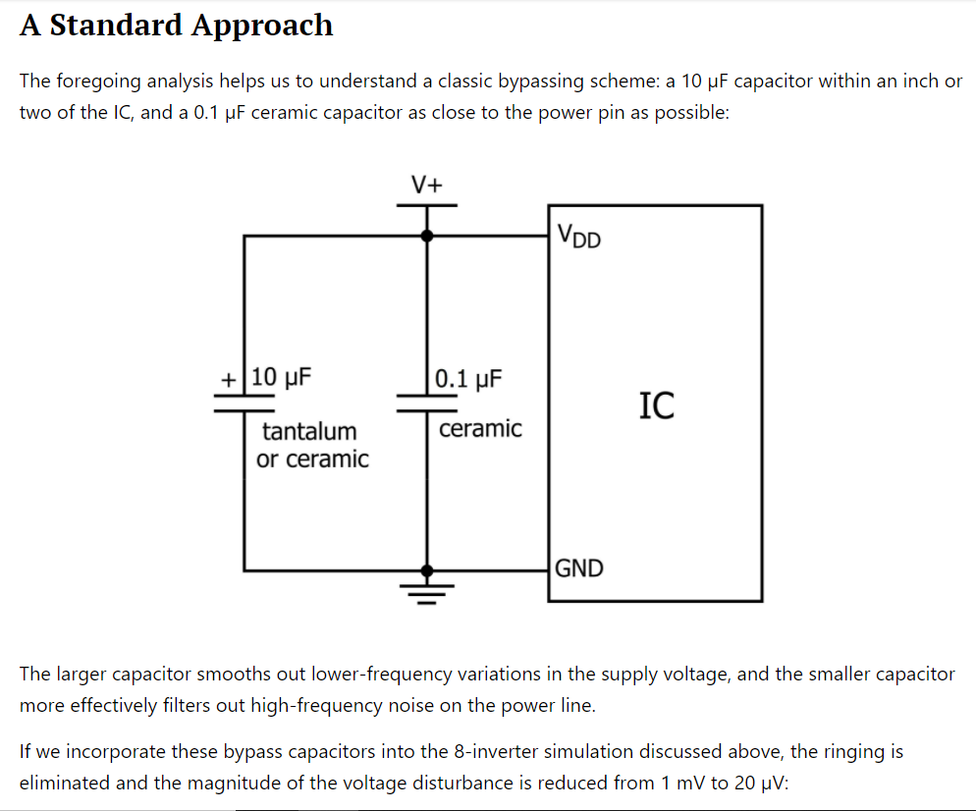

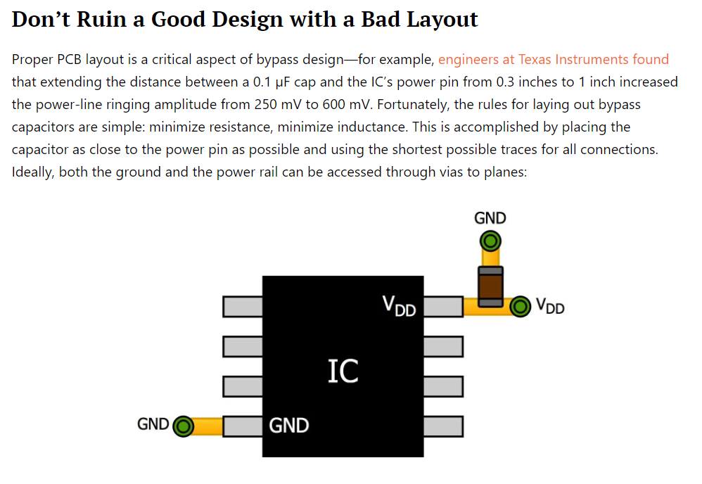

LM7805 Specs:

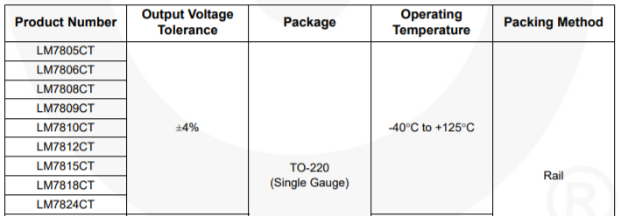

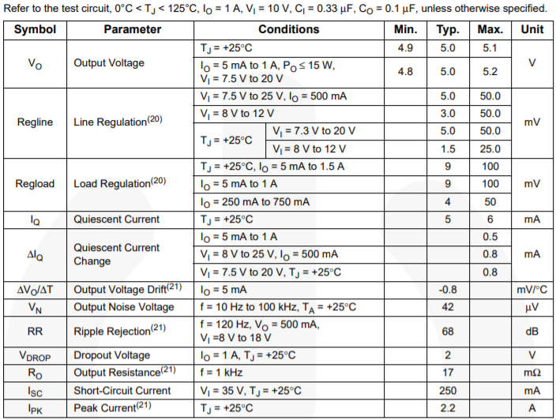

LM4040 Specs:

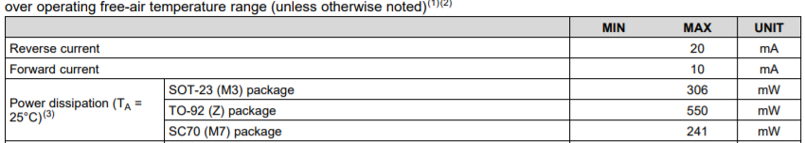

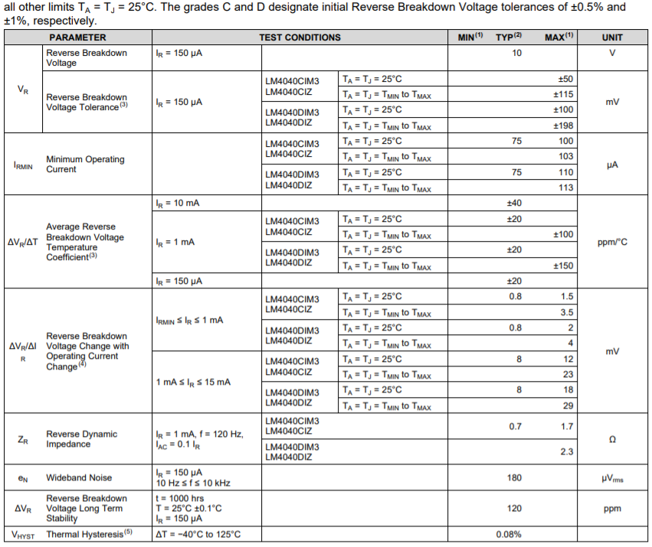

### Eng. Analysis Details for SS4- Level Control Module

#### Eng. Analysis and Materials Selection Details for SS#-P# - Part Name

Click or tap here to enter text.

(1)

Force

Acceleration

Mass

### Eng. Analysis Details for SS5- Sequencer

#### Eng. Analysis and Materials Selection Details for SS#-P# - Part Name

Click or tap here to enter text.

(1)

Force

Acceleration

Mass

### Eng. Analysis Details for SS6- Envelope Generator

#### Eng. Analysis and Materials Selection Details for SS#-P# - Part Name

Keri Grevemberg (EE)

Fall Semester Analysis:

the timing of the attack, decay, and release parameters on the Envelope Generator are based off of U10 and C1. This means my output timing when the potentiometers are turned at maximum is T=1.1xRxC.

The capacitor I am using currently is 4.7u.

The potentiometers (U10 and U11) are 1M ohms.

That is T= 1.1 x 1M x 4.7u = 5.17s.

Using the oscilloscope, we should expect this timing interval because the envelope has been troubleshot and works perfectly.

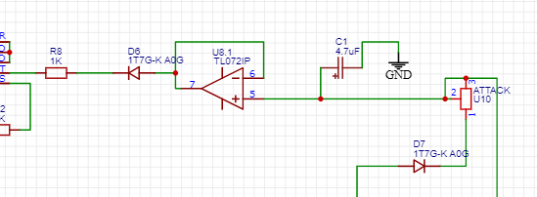

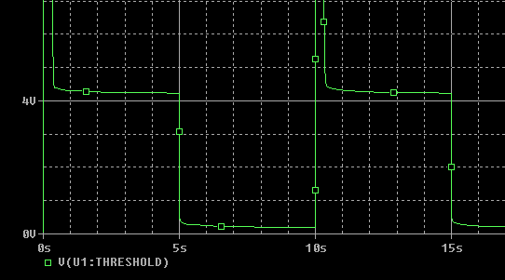

Above shows a sustain of about 4.2 Volts. Maximum should be 5V.

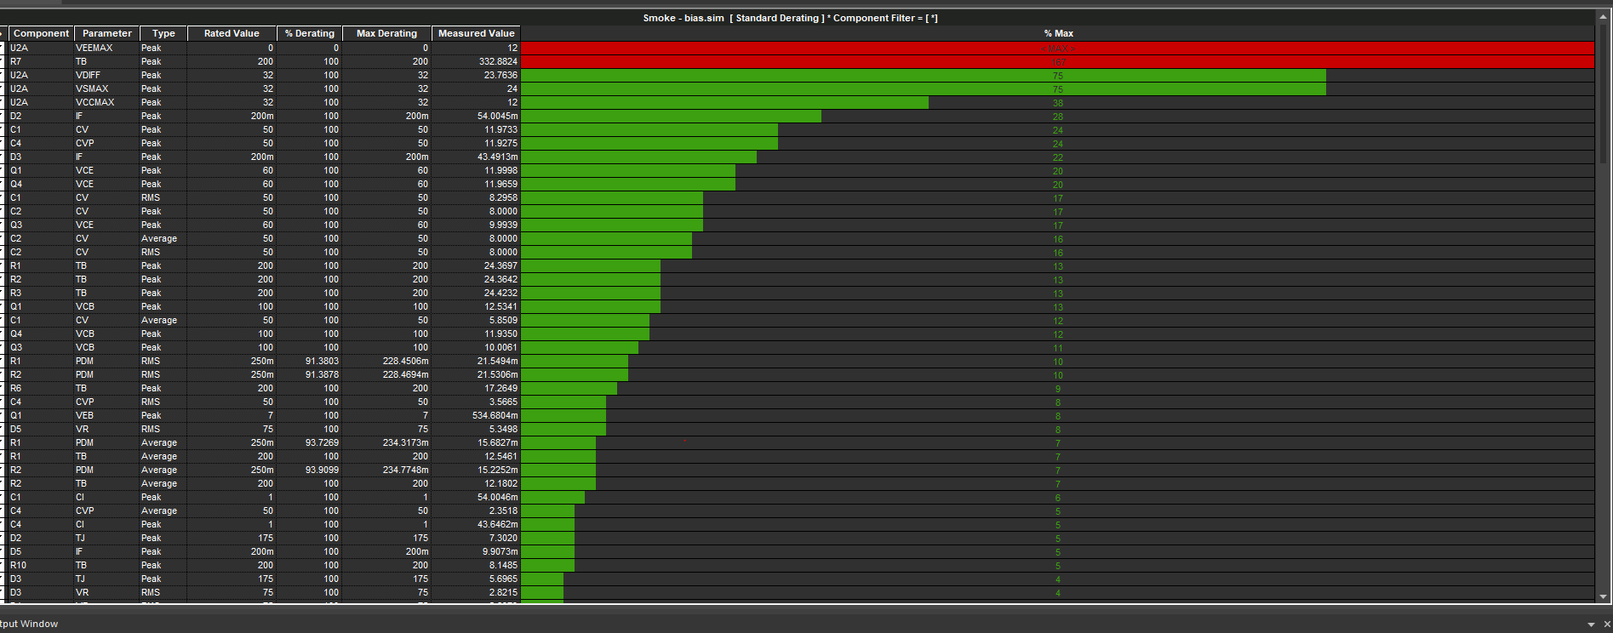

Smoke Test

ICs without heat sinks providing the most stress on the circuit.

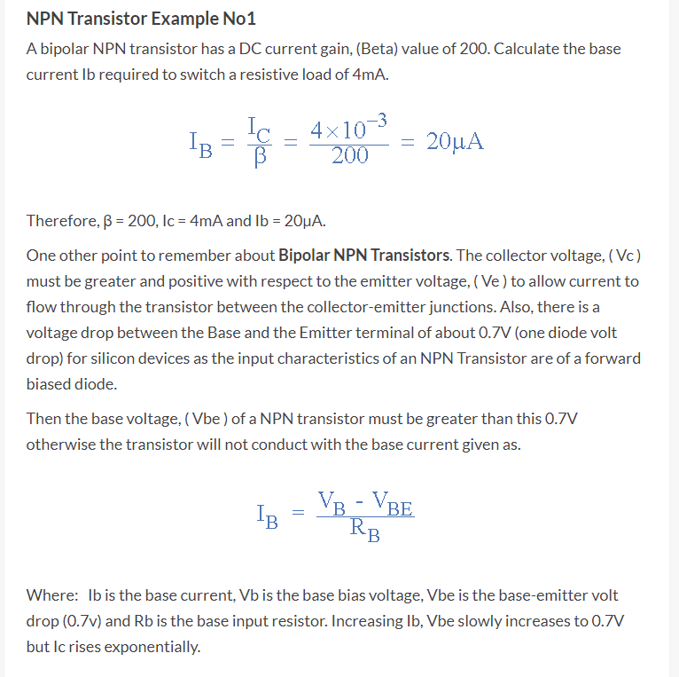

### Eng. Analysis Details for SS7- Wireless Control Module

#### Eng. Analysis and Materials Selection Details for SS7-P1- Wireless Microcontroller

Kyle Sellers (EEC)

Wireless Technology Decision Matrix:

|  |  |  |  |  |  |  |  |  |  |
| --- | --- | --- | --- | --- | --- | --- | --- | --- | --- |
|  | Weight |  | Bluetooth | Wi-Fi | Zigbee |  | Weighted Bluetooth | Weighted Wi-Fi | Weighted Zigbee |
| Multiple Device Support | 0.0436 |  | 0.1739 | 0.3913 | 0.4348 |  | 0.0076 | 0.0171 | 0.0190 |
| Latency | 0.3231 |  | 0.2000 | 0.4000 | 0.4000 |  | 0.0646 | 0.1293 | 0.1293 |
| Documentation | 0.2691 |  | 0.2353 | 0.5882 | 0.1765 |  | 0.0633 | 0.1583 | 0.0475 |
| Range | 0.1123 |  | 0.6250 | 0.3125 | 0.0625 |  | 0.0702 | 0.0351 | 0.0070 |
| Power Consumption | 0.0401 |  | 0.3373 | 0.2410 | 0.4217 |  | 0.0135 | 0.0097 | 0.0169 |
| Security | 0.2118 |  | 0.4762 | 0.2857 | 0.2381 |  | 0.1009 | 0.0605 | 0.0504 |
|  |  |  |  |  |  |  |  |  |  |
| Total |  |  | 0.3201 | 0.4099 | 0.2700 |  |  |  |  |

Pairwise Decision Matrix:

|  |  |  |  |  |  |  |  |  |  |
| --- | --- | --- | --- | --- | --- | --- | --- | --- | --- |
|  | Device Support | Latency | Documentation | Range | Power Consumption | Security |  | Geo Mean | Normalized |
| Device Support | 1 | 1/7 | 1/5 | 1/3 | 1 | 1/5 |  | 0.35208 | 0.04361 |
| Latency | 7 | 1 | 3 | 3 | 5 | 1 |  | 2.60847 | 0.32313 |
| Documentation | 5 | 1/3 | 1 | 3 | 7 | 3 |  | 2.17203 | 0.26906 |
| Range | 3 | 1/3 | 1/3 | 1 | 5 | 1/3 |  | 0.90668 | 0.11232 |
| Power Consumption | 1 | 1/5 | 1/7 | 1/5 | 1 | 1/5 |  | 0.32334 | 0.04005 |
| Security | 5 | 1 | 1/3 | 3 | 5 | 1 |  | 1.70998 | 0.21183 |

Device Support Matrix:

|  |  |  |  |
| --- | --- | --- | --- |
| Technology | Device Support | DS / Max DS | Normalized |
| Bluetooth | 4 | 0.4 | 0.173913043 |
| Wi-Fi | 9 | 0.9 | 0.391304348 |
| Zigbee | 10 | 1 | 0.434782609 |

Latency Matrix:

|  |  |  |  |
| --- | --- | --- | --- |
| Technology | Latency | Min Latency / Latency | Normalized |
| Bluetooth | 100 | 0.5 | 0.2 |
| Wi-Fi | 50 | 1 | 0.4 |
| Zigbee | 50 | 1 | 0.4 |

Documentation Matrix:

|  |  |  |  |
| --- | --- | --- | --- |
| Technology | Documentation | Doc / Max Doc | Normalized |
| Bluetooth | 4 | 0.4 | 0.235294118 |
| Wi-Fi | 10 | 1 | 0.588235294 |
| Zigbee | 3 | 0.3 | 0.176470588 |

Range Matrix:

|  |  |  |  |
| --- | --- | --- | --- |
| Technology | Range | Range / Max Range | Normalized |
| Bluetooth | 10 | 1 | 0.625 |
| Wi-Fi | 5 | 0.5 | 0.3125 |
| Zigbee | 1 | 0.1 | 0.0625 |

Power Consumption Matrix:

|  |  |  |  |
| --- | --- | --- | --- |
| Technology | Power Consumption | Min PC / PC | Normalized |
| Bluetooth | 50 | 0.8 | 0.3373494 |
| Wi-Fi | 70 | 0.571428571 | 0.2409639 |
| Zigbee | 40 | 1 | 0.4216867 |

Security Matrix:

|  |  |  |  |
| --- | --- | --- | --- |
| Technology | Cost | Min Cost / Cost | Normalized |
| Bluetooth | 10 | 1 | 0.47619 |
| Wi-Fi | 6 | 0.6 | 0.285714 |
| Zigbee | 5 | 0.5 | 0.238095 |

#### Eng. Analysis and Materials Selection Details for SS7-P2- DAC

Kyle Sellers (EEC)

The outputs of the Wireless control module need about 10-bits of resolution (10V / 1024 = 10 mV resolution). This divides each octave into 100 values, which should be sufficient for use in a 1V / octave VCO.

For our purposes of testing, I will be using 50kHz PWM signal with a 50% duty cycle, which has the most ripple. With the analog voltage out of the analog pins being 3.3V, this gives a target voltage of 1.67 V.

From frequency constraints stated in the EATB found here (), the WCM should be able to produce frequencies of up to 1kHz.

Due to this, we select the cutoff frequency to be 1kHz. Selecting a 10nF capacitor, this gives a resistor value of about 16kOhms.

Below is the configuration in LTSPICE

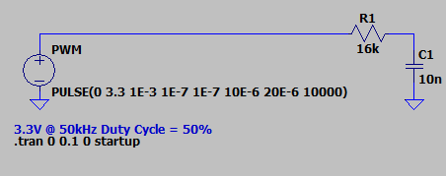

Running the transient simulation, we get the following result.

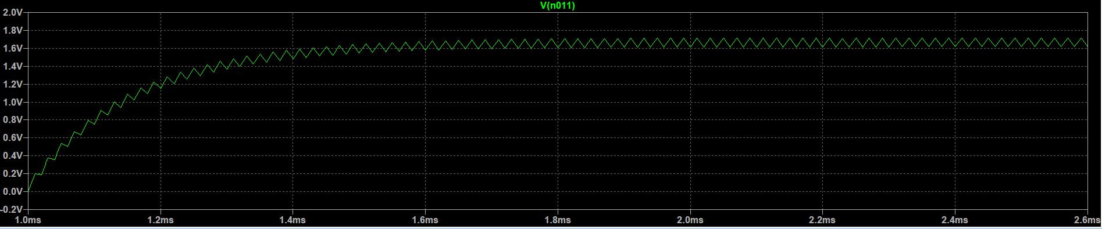

This circuit takes 0.8 ms to get up to the appropriate voltage, which is much less than the required 5 ms. However, there is a problem with ripple:

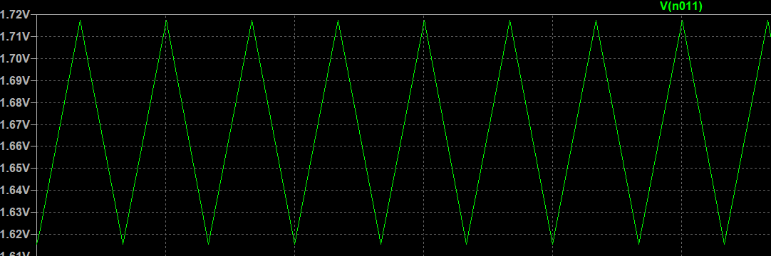

As can be seen, there is about 100 mV of ripple, which is not at all acceptable. This is amplified to 300 mV after the amplification stage, which translates to 1 / 3 of a volt. Using the 1V per octave VCO parameter, this gives us about 4 notes of frequency sway, which is very much noticeable and causes the waveform frequency to be very unstable.

To fix this, we could lower the cutoff frequency. For every factor of n, we divide the cutoff frequency by, the ripple is divided by a factor of n. However, the slew rate is multiplied by a factor of n.

Reducing the cutoff frequency to 200 Hz would put it at a slew rate of 4 ms (still acceptable) and reduce the ripple to around 75 mV. This would create only about +/- note worth of ripple, which is still very audible, and not acceptable

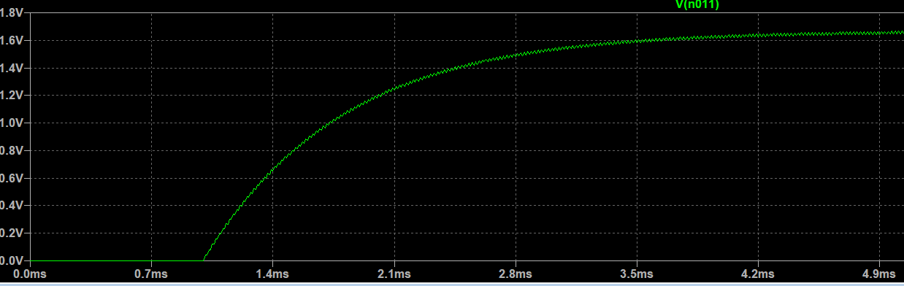

A critically damped RLC circuit also can be used as an integrator, with comparable Delay and Less ripple. However, the drawback to this is that we have to include inductors, which can cause magnetic interference with other inductors and other components on a PCB. Since we will have 6-12 outputs, this is a real issue.

Using this tool http://sim.okawa-denshi.jp/en/RLClowkeisan.htm to calculate RL values based on a critically damped RLC circuit with cutoff frequency 1kHz and C values of 10uF, we get a R value of 30 ohms and L value of 2.2mH. This is a very large inductor, but for simulation's sake, we will use it.

Below is the circuit simulated.

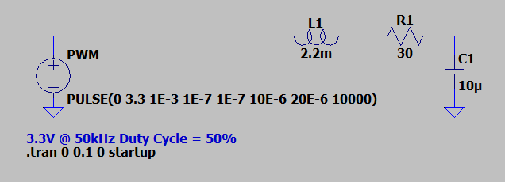

Which gives the following results.

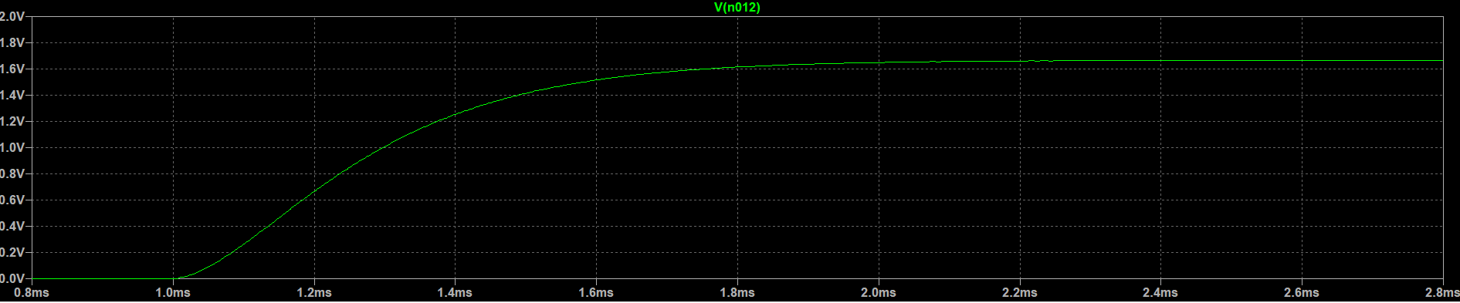

The slew rate is about 1 ms

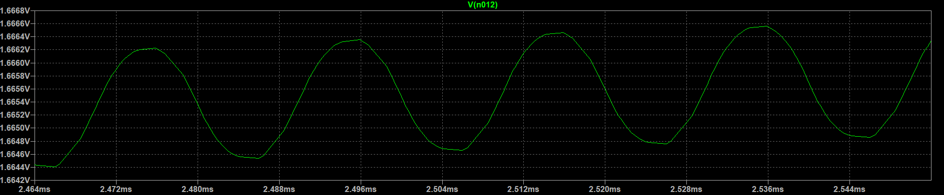

And the ripple is only 1.8 mV, which gets amplified to 5.4 mV. This is a giant improvement over the RC circuit. This is only +/-3 Cents of ripple, or 1 / 33rd of a note. This is absolutely acceptable.

An RC circuit has too much ripple to be considered as a solution as an integrator. The RLC circuit is very attractive, however, is not very practical due to requiring multiple large inductors.

#### Eng. Analysis and Materials Selection Details for SS7-P3- Output Amplifier / Voltage Shift

Kyle Sellers (EEC)

The circuit simulated is shown below:

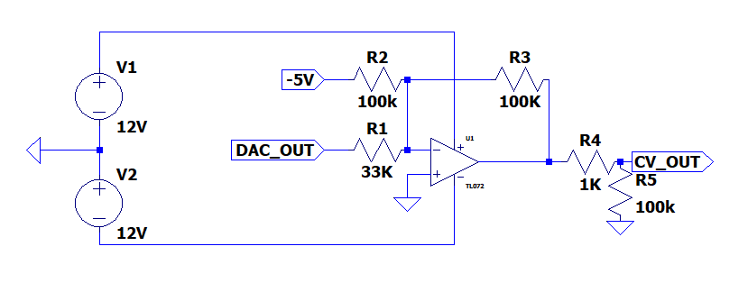

The circuit is of a summing, inverting opamp configuration. This configuration is shown below.



With gain equation:



Source: https://www.electronics-tutorials.ws/opamp/opamp_4.html

Using this, we can calculate the gain of each input:

-5V = -(100 / 100) = -1

DAC_OUT = -(33/100) =- 0.33

DC Sweep:

With calculated gains, we expect a 0 to 3.3V input to translate to a +5V to -5V output, respectively.

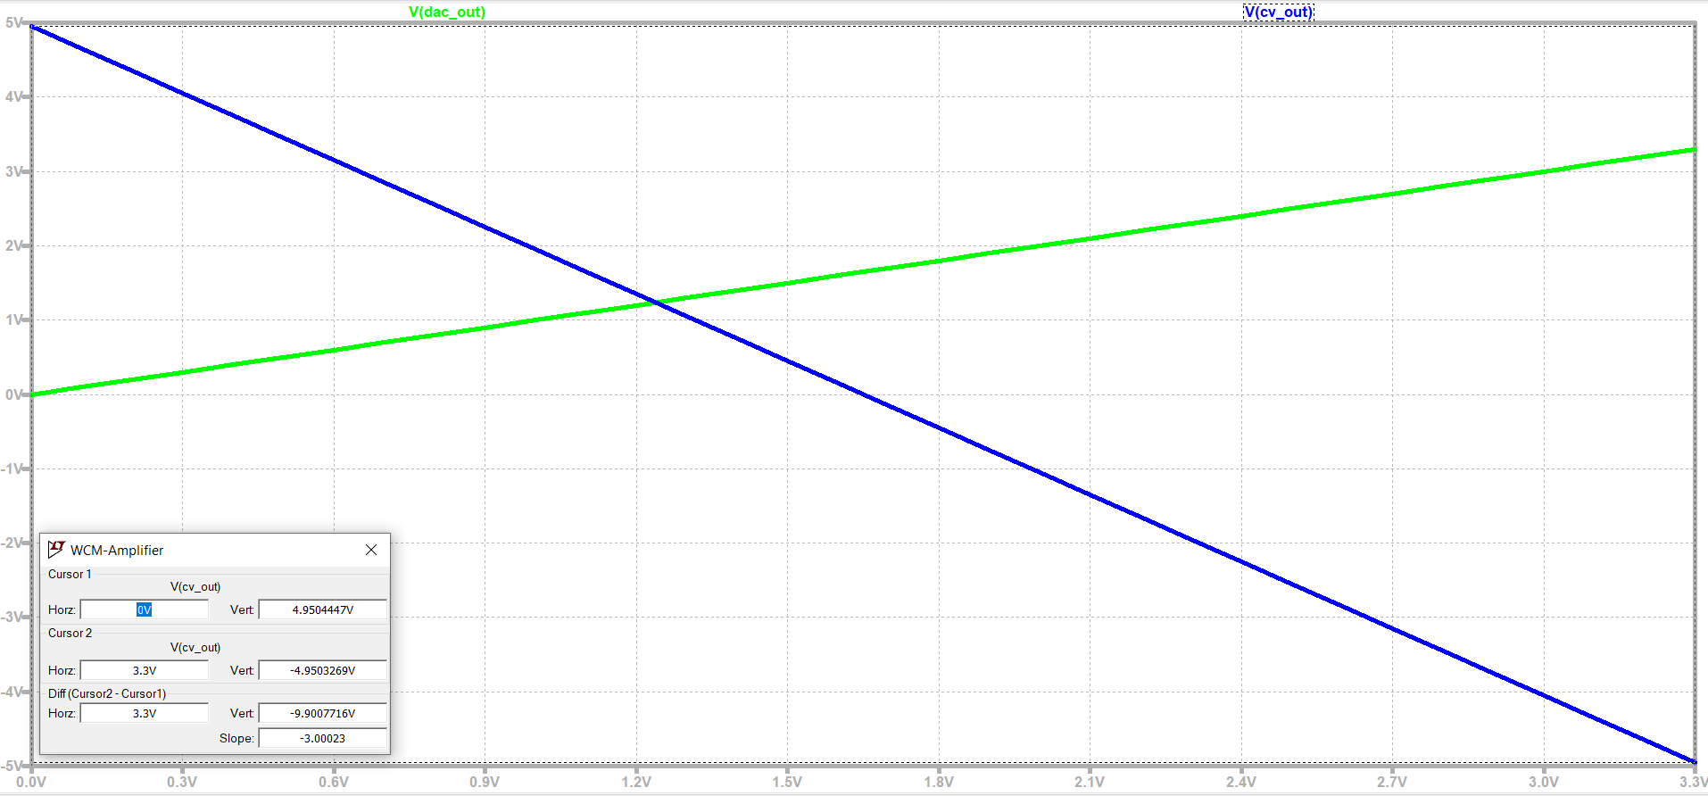

0V translates to +4.95V, and 3.3V translates to -4.85V, with linear transition in between. This is 99% of expected values, which is acceptable.

Sensitivity Analysis:

Sensitivity analysis was run to identify the most critical resistors and voltage inputs for this subcircuit.

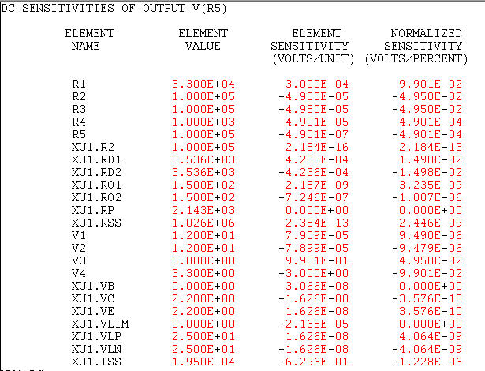



Results indicate the output value changes by 1%(100mV/10V) for every 1% change to the DAC voltage and resistance value, and(50mV/10V) 0.5% for every 1% change to the -5V reference voltage, input resistor, and internal resistor . Due to this 1% tolerance resistors are selected for this circuit for optimal performance.

Temperature Analysis:

Temperature analysis was run from 0 C to 120 C, as this is the lowest expected external temperature and highest expected internal temperature of the circuit

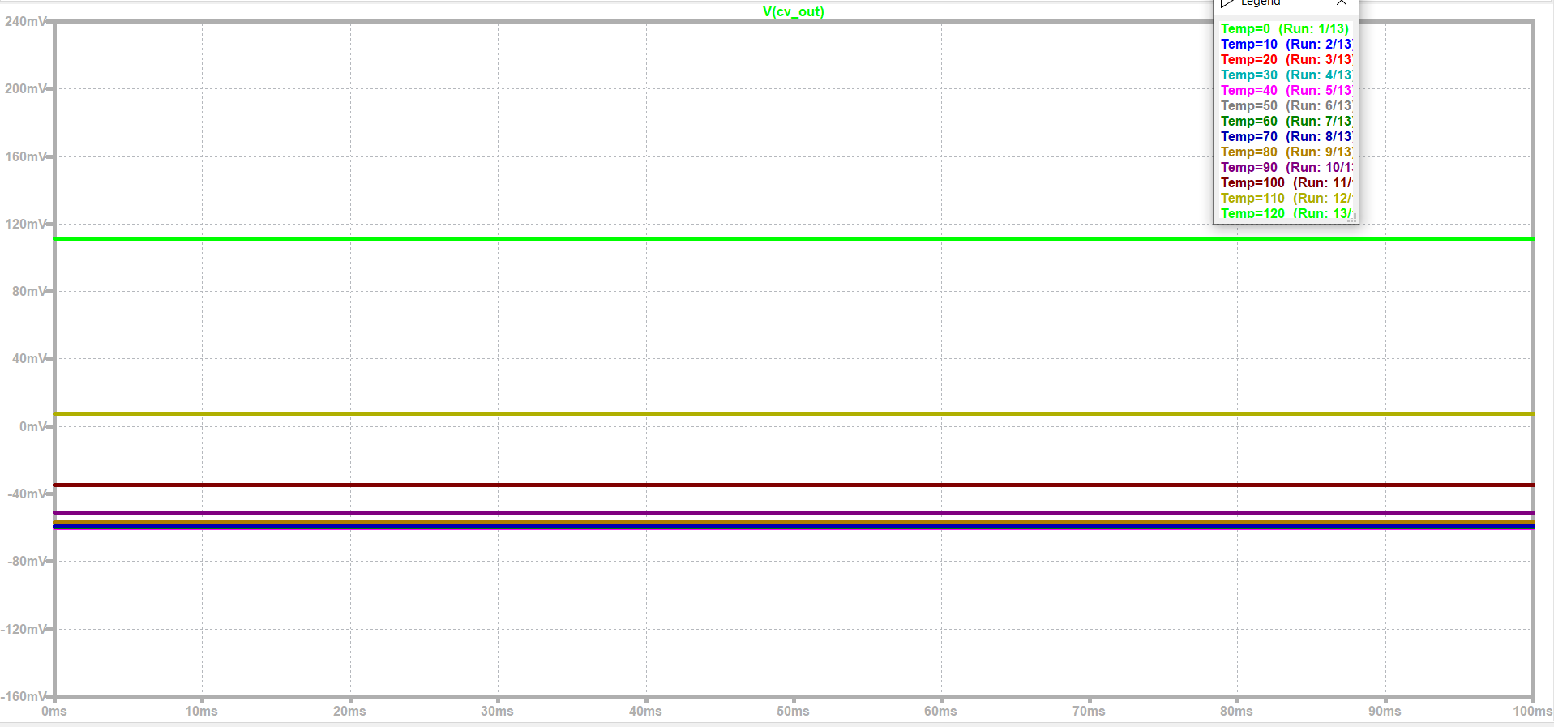

Results indicate a 170-mV swing in output voltages over this temperature range, or 1.7% of the output voltage range. When looking at a more realistic temperature range of 25 C to 80 C, this variance reduces to 70 mV, or 0.7% of the output voltage range.

Power Analysis:

Expected power from datasheet:



Actual Power Draw:

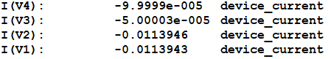

SPICE simulations of the circuit yielded much higher current draw than values shown on the data sheet. Consulting the DIY Pedals Discord Server / Forum, members stated this is likely due to a bad SPICE model provided by TI, and that actual values will likely reflect those from the datasheet. Regardless, these larger values are used for total power draw considerations, just in case.

AC Analysis:

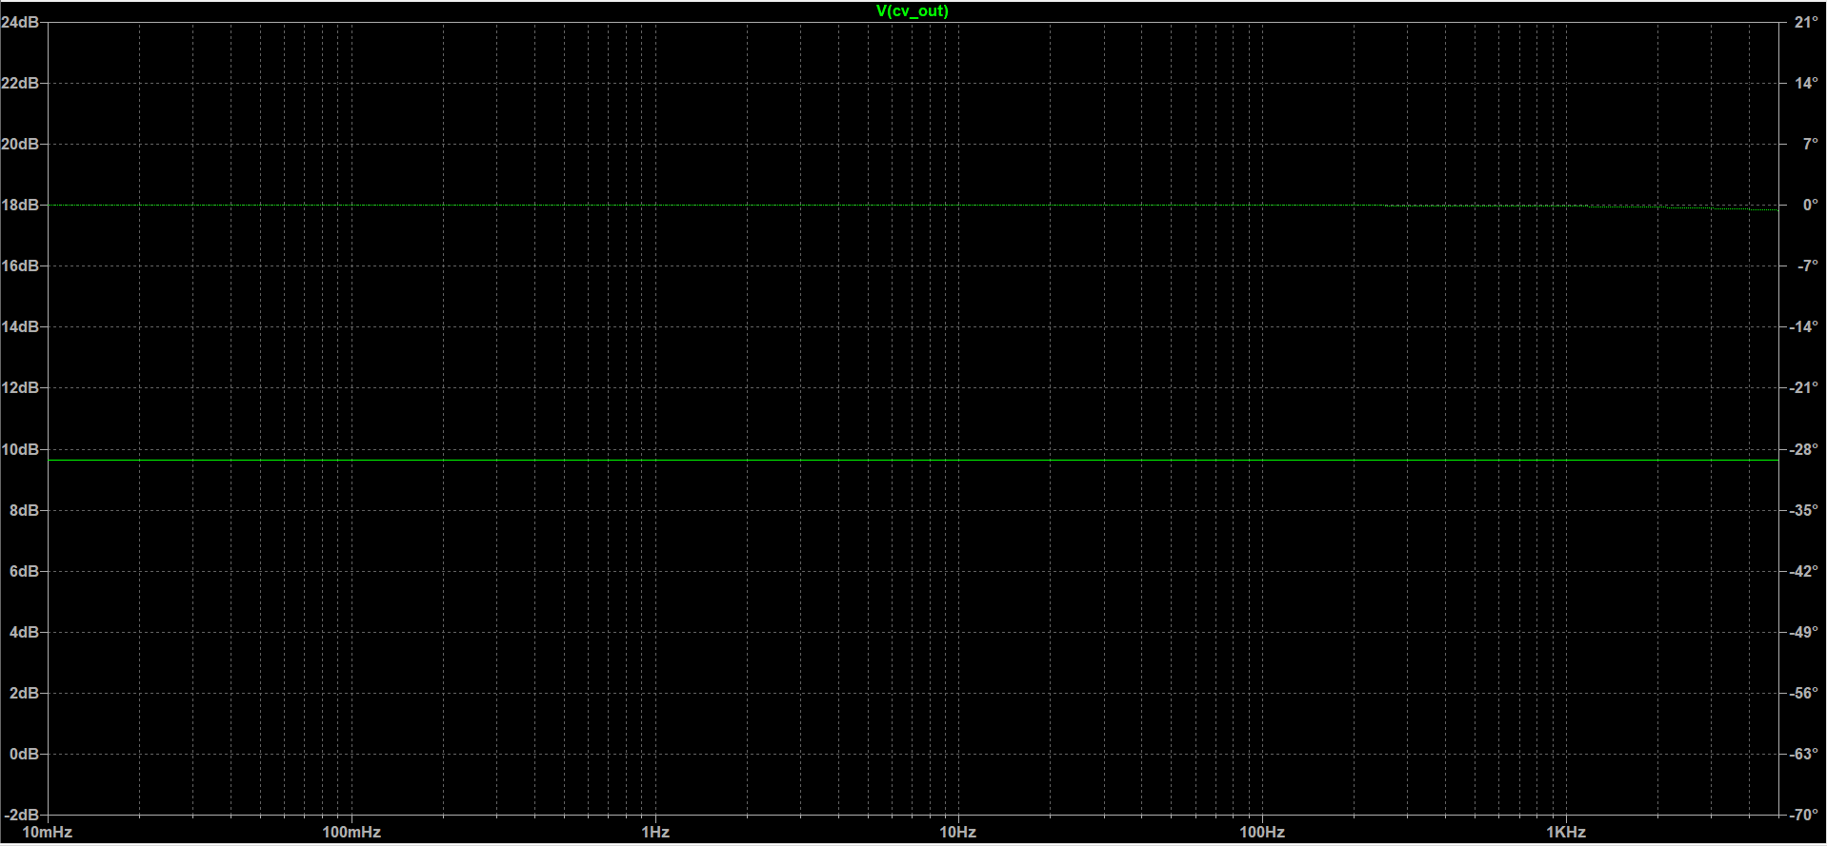

Gain = 10dB

No attenuation at target frequencies (0.01 Hz to 100 Hz)

Transient Analysis:



Slew ~ 1us, which is much faster than fastest half period of 5ms @ 100 Hz.

#### Eng. Analysis and Materials Selection Details for SS7-P4- Power Regulator

Kyle Sellers (EEC)

+/- 12V Power Filtering:





LM7805 Specs:





LM4040 Specs:



### Eng. Analysis Details for SS8- Power Supply

#### Eng. Analysis and Materials Selection Details for SS#-P# - Part Name

Click or tap here to enter text.

$\vec{F}=m\vec{a}$ (1)

$\vec{F:}$ Force

$\vec{a:}$ Acceleration

$m:$ Mass

#### Eng. Analysis and Materials Selection Details for SS1-P2– Outputs

Click or tap here to enter text.

**Outputs on simulation of the frequency response of the waveforms and their schematics.** So, I ran a sawtooth wave through the circuit shown below at 8v. And took the magnitude response of the circuit.

We need the frequency response to have no loss in amplitude and low phase noise to make sure our audio is close to 1:1.

So, as you can see on the left. For the frequencies of 100-22khz normal human hearing the bode is flat for the voltage being output.

The current draw for the circuit was done interactively and shown to be negligible at the input and tremendous at the opamp supply voltages being 11mA. This will need to be recorded so that we will know the total draw of the system.

Outcome: Frequency response was stable and current draw was only 22mA.





#### 15 10 -10 -15 0.0 VIPRII 0.2 triagnlewaveout input Waveform 04 0.6 08 1.0





10v=4v(1+15/10)

10v=4v(2.5)

10v=10v

So here are the expected values now to simulate and try it out.



Simulating in multisim and setting a function generator to a 4v pk to pk as an input.

We run a transient analysis at the voltage over R3.

Then

This is the schematic I came up with some help from students, faculty ,books. Oh my god the list goes on

This is a simple voltage follower with a load at R3.

And a capacitor and resistor are used to ease up the dominant pole response. How I know this is through books. I don’t really know how it works but without the capacitor and dual resistors the output comes out like that with transient over voltages.

Output measured across the load at R3

This is remedied with those capacitors.









#### Eng. Analysis and Materials Selection Details for SS1-P3 – PWM

Click or tap here to enter text.





So how this circuit works.

Is that at the V6 at the left of the main circuit sends an input through a potentiometer that the user is free to turn to get values from 0 –100kohm.

The op-amps take the input invert it and preserve the value with minimal noise.

So, the bottom potentiometer does little to assist think of it as a tuner for potentiometers with low tolerances.

So for the analysis of the circuit, we just did a transient analysis across r3 at pr1.



And it shows that the output goes in a beautiful exponential decay from 5-0v

Outcome: The outputs are a steady decay from 5v to 0v satisfying the datasheet.

#### Eng. Analysis and Materials Selection Details for SS1-P3 – PWM Actual

Click or tap here to enter text.

Test Goal

VCO needs to output 3 waveforms.

Project Relevance

These waveforms are pivotal in musical generation and interaction with the system

Method

Testing will be done by measuring the outputs and taking readings at the terminals

Testing Apparatus

VCO, Multimeter, Oscilloscope.

Steps Taken in Procedure

1st I made some changes to the pcb design that included some movement of potentiometers and rewiring of the board. Once the changes were made we began to test the new outcomes.

2nd We plugged in output jacks into the VCO

3rd We powered the VCO

4th we hooked up the oscilloscope to the output jacks

5th we played with the potentiometers to see if we can have a reading.

6th We got a reading on the pulse and the triangle and ramp waveforms

7th I recorded the results below and will begin to discuss them below.

Sources of Error

There is still errors they are not outputting even close to the expected results this could be from a bypassed opamp and not getting amplified will need to check the board and retest it.

Expected Results

We expected 3 waveforms ranging close to 10Vs

But I got 3 waveforms outputting at 3-4vs expected.

To get maximum power transfer they need to be higher than that to satisfy the proper audio levels.

My results at the bottom.

Triangle, Pulse at different duty cycle so the PWM works and the frequency knob works.







### Eng. Analysis Details for SS2- Voltage Controlled Filter

#### Eng. Analysis and Materials Selection Details for SS#-P# - Part Name

Click or tap here to enter text.

(1)

Force

Accewhy leration

Mass

### Eng. Analysis Details for SS3- Digital Multi-Effects

#### Eng. Analysis and Materials Selection Details for SS3-P1 – DSP Microcontroller

Click or tap here to enter text.

#### Eng. Analysis and Materials Selection Details for SS3-P6– Power Regulator

Click or tap here to enter text.

+/- 12V Power Filtering:





LM7805 Specs:





LM4040 Specs:





### Eng. Analysis Details for SS4- Level Control Module

#### Eng. Analysis and Materials Selection Details for SS#-P# - Part Name

Click or tap here to enter text.

(1)

Force

Acceleration

Mass

### Eng. Analysis Details for SS5- Sequencer

#### Eng. Analysis and Materials Selection Details for SS#-P# - Part Name

Click or tap here to enter text.

(1)

Force

Acceleration

Mass

### Eng. Analysis Details for SS6- Envelope Generator

#### Eng. Analysis and Materials Selection Details for SS#-P# - Part Name

Click or tap here to enter text.

Fall Semester Analysis:

the timing of the attack, decay, and release parameters on the Envelope Generator are based off of U10 and C1. This means my output timing when the potentiometers are turned at maximum is T=1.1xRxC.

The capacitor I am using currently is 4.7u.

The potentiometers (U10 and U11) are 1M ohms.

That is T= 1.1 x 1M x 4.7u = 5.17s.

Using the oscilloscope, we should expect this timing interval because the envelope has been troubleshot and works perfectly.





Above shows a sustain of about 4.2 Volts. Maximum should be 5V.



Smoke Test

ICs without heat sinks providing the most stress on the circuit.



### Eng. Analysis Details for SS7- Wireless Control Module

#### Eng. Analysis and Materials Selection Details for SS7-P1- Wireless Microcontroller

Click or tap here to enter text.

Wireless Technology Decision Matrix:

|  |  |  |  |  |  |  |  |  |  |
| --- | --- | --- | --- | --- | --- | --- | --- | --- | --- |
|  | Weight |  | Bluetooth | Wi-Fi | Zigbee |  | Weighted Bluetooth | Weighted Wi-Fi | Weighted Zigbee |
| Multiple Device Support | 0.0436 |  | 0.1739 | 0.3913 | 0.4348 |  | 0.0076 | 0.0171 | 0.0190 |
| Latency | 0.3231 |  | 0.2000 | 0.4000 | 0.4000 |  | 0.0646 | 0.1293 | 0.1293 |
| Documentation | 0.2691 |  | 0.2353 | 0.5882 | 0.1765 |  | 0.0633 | 0.1583 | 0.0475 |
| Range | 0.1123 |  | 0.6250 | 0.3125 | 0.0625 |  | 0.0702 | 0.0351 | 0.0070 |
| Power Consumption | 0.0401 |  | 0.3373 | 0.2410 | 0.4217 |  | 0.0135 | 0.0097 | 0.0169 |
| Security | 0.2118 |  | 0.4762 | 0.2857 | 0.2381 |  | 0.1009 | 0.0605 | 0.0504 |
|  |  |  |  |  |  |  |  |  |  |
| Total |  |  | 0.3201 | 0.4099 | 0.2700 |  |  |  |  |

Pairwise Decision Matrix:

|  |  |  |  |  |  |  |  |  |  |
| --- | --- | --- | --- | --- | --- | --- | --- | --- | --- |
|  | Device Support | Latency | Documentation | Range | Power Consumption | Security |  | Geo Mean | Normalized |
| Device Support | 1 | 1/7 | 1/5 | 1/3 | 1 | 1/5 |  | 0.35208 | 0.04361 |
| Latency | 7 | 1 | 3 | 3 | 5 | 1 |  | 2.60847 | 0.32313 |
| Documentation | 5 | 1/3 | 1 | 3 | 7 | 3 |  | 2.17203 | 0.26906 |
| Range | 3 | 1/3 | 1/3 | 1 | 5 | 1/3 |  | 0.90668 | 0.11232 |
| Power Consumption | 1 | 1/5 | 1/7 | 1/5 | 1 | 1/5 |  | 0.32334 | 0.04005 |
| Security | 5 | 1 | 1/3 | 3 | 5 | 1 |  | 1.70998 | 0.21183 |

Device Support Matrix:

|  |  |  |  |
| --- | --- | --- | --- |
| Technology | Device Support | DS / Max DS | Normalized |
| Bluetooth | 4 | 0.4 | 0.173913043 |
| Wi-Fi | 9 | 0.9 | 0.391304348 |
| Zigbee | 10 | 1 | 0.434782609 |

Latency Matrix:

|  |  |  |  |
| --- | --- | --- | --- |
| Technology | Latency | Min Latency / Latency | Normalized |
| Bluetooth | 100 | 0.5 | 0.2 |
| Wi-Fi | 50 | 1 | 0.4 |
| Zigbee | 50 | 1 | 0.4 |

Documentation Matrix:

|  |  |  |  |
| --- | --- | --- | --- |
| Technology | Documentation | Doc / Max Doc | Normalized |
| Bluetooth | 4 | 0.4 | 0.235294118 |
| Wi-Fi | 10 | 1 | 0.588235294 |
| Zigbee | 3 | 0.3 | 0.176470588 |

Range Matrix:

|  |  |  |  |
| --- | --- | --- | --- |
| Technology | Range | Range / Max Range | Normalized |
| Bluetooth | 10 | 1 | 0.625 |
| Wi-Fi | 5 | 0.5 | 0.3125 |
| Zigbee | 1 | 0.1 | 0.0625 |

Power Consumption Matrix:

|  |  |  |  |
| --- | --- | --- | --- |
| Technology | Power Consumption | Min PC / PC | Normalized |
| Bluetooth | 50 | 0.8 | 0.3373494 |
| Wi-Fi | 70 | 0.571428571 | 0.2409639 |
| Zigbee | 40 | 1 | 0.4216867 |

Security Matrix:

|  |  |  |  |
| --- | --- | --- | --- |
| Technology | Cost | Min Cost / Cost | Normalized |
| Bluetooth | 10 | 1 | 0.47619 |
| Wi-Fi | 6 | 0.6 | 0.285714 |
| Zigbee | 5 | 0.5 | 0.238095 |

#### Eng. Analysis and Materials Selection Details for SS7-P4- Power Regulator

Click or tap here to enter text.

+/- 12V Power Filtering:





LM7805 Specs:





LM4040 Specs:



### Eng. Analysis Details for SS8- Power Supply

#### Eng. Analysis and Materials Selection Details for SS#-P# - Part Name

Click or tap here to enter text.

$\vec{F}=m\vec{a}$ (1)

$\vec{F:}$ Force

$\vec{a:}$ Acceleration

$m:$ Mass

### Eng. Analysis Details for SS2- Voltage Controlled Filter

#### Eng. Analysis and Materials Selection Details for SS#-P# - Part Name

Click or tap here to enter text.

(1)

Force

Accewhy leration

Mass

### Eng. Analysis Details for SS3- Digital Multi-Effects

#### Eng. Analysis and Materials Selection Details for SS3-P1 – DSP Microcontroller

Kyle Sellers (EEC)

#### Eng. Analysis and Materials Selection Details for SS3-P1 – DSP Microcontroller

Kyle Sellers (EEC)

DSP Microcontroller Decision Matrix:

|  |  |  |  |  |  |  |  |
| --- | --- | --- | --- | --- | --- | --- | --- |
|  | Weight |  | Daisy | FV-1 |  | Weighted Daisy | Weighted FV-1 |
| Cost | 0.2687 |  | 0.3280 | 0.6720 |  | 0.0881 | 0.1805 |
| Ease of Programming | 0.4463 |  | 0.7692 | 0.2308 |  | 0.3433 | 0.1030 |
| Size | 0.0343 |  | 0.8327 | 0.1673 |  | 0.0285 | 0.0057 |
| Fidelity | 0.0602 |  | 0.8000 | 0.2000 |  | 0.0482 | 0.0120 |
| I/O | 0.0754 |  | 0.9118 | 0.0882 |  | 0.0688 | 0.0067 |
| Memory | 0.1151 |  | 0.9995 | 0.0005 |  | 0.1150 | 0.0001 |
|  |  |  |  |  |  |  |  |
| Total |  |  | 0.6920 | 0.3080 |  |  |  |

Pairwise Comparison Matrix:

|  |  |  |  |  |  |  |  |  |  |
| --- | --- | --- | --- | --- | --- | --- | --- | --- | --- |
|  | Cost | Ease of Programming | Size | Fidelity | I/O | Memory |  | Geo Mean | Normalized |
| Cost | 1 | 1/5 | 7 | 5 | 5 | 5 |  | 2.36505 | 0.26868 |
| Ease of Programming | 5 | 1 | 3 | 7 | 7 | 5 |  | 3.92834 | 0.44628 |
| Size | 1/7 | 1/3 | 1 | 1/7 | 1/3 | 1/3 |  | 0.30181 | 0.03429 |
| Fidelity | 1/5 | 1/7 | 7 | 1 | 1/3 | 1/3 |  | 0.53023 | 0.06024 |
| I/O | 1/5 | 1/7 | 3 | 3 | 1 | 1/3 |  | 0.66401 | 0.07544 |
| Memory | 1/5 | 1/5 | 3 | 3 | 3 | 1 |  | 1.01291 | 0.11507 |

Cost Matrix:

|  |  |  |  |
| --- | --- | --- | --- |
| DSP Chip | Cost | Min Cost / Cost | Normalized |
| Daisy | 29.95 | 0.488146912 | 0.328023334 |
| FV-1 | 14.62 | 1 | 0.671976666 |

Ease of Programming Matrix:

|  |  |  |  |
| --- | --- | --- | --- |
| DSP Chip | Relative Ease | RE / Max RE | Normalized |
| Daisy | 10 | 1 | 0.769230769 |
| FV-1 | 3 | 0.3 | 0.230769231 |

Size Matrix:

|  |  |  |  |
| --- | --- | --- | --- |
| DSP Chip | Size ( mm^2) | Min Variation / Variation | Normalized |
| Daisy | 184.5 | 1.0000 | 0.8327 |
| FV-1 | 918 | 0.2010 | 0.1673 |

Fidelity Matrix:

|  |  |  |  |
| --- | --- | --- | --- |
| DSP Chip | Max Sample Rate | MSR / Max MSR | Normalized |
| Daisy | 192000 | 1 | 0.8 |
| FV-1 | 48000 | 0.25 | 0.2 |

I/O Matrix:

|  |  |  |  |
| --- | --- | --- | --- |
| DSP Chip | I/O | I/O / Max I/O | Normalized |
| Daisy | 31 | 1 | 0.9117647 |
| FV-1 | 3 | 0.096774194 | 0.0882353 |

Memory Matrix:

|  |  |  |  |
| --- | --- | --- | --- |
| DSP Chip | RAM | Mem/Max Mem | Normalized |
| Daisy | 64,000 | 1 | 0.9995 |
| FV-1 | 32 | 0.0005 | 0.0005 |

#### Eng. Analysis and Materials Selection Details for SS3-P2– Audio Input Attenuator / Filter

Kyle Sellers (EEC)

The SPICE circuit in which tests were run is shown below. Note this is for both the Audio Input and output since both were needed in the same circuit to test cascading the sub circuits.

Both the input and output are of the form of an inverting active low-pass filter, shown below:

As stated above, this configuration is inverting, so a second op-amp is used to re invert the signal, placing it in phase with the input.

DC gain for this configuration is -R2/R1, and the -3dB cutoff frequency is 1/(2*pi*R2*C).

Using these equations, the gain and cutoff frequencies for the above op amps are as follows:

Op-Amp Gain Cutoff Freq

Input 10 28481

Output 0.1 33863

DC Sweep:

With an input ranging from -10V to 10V, an output voltage of 1V to -1V is expected for sending to the Electrosmith Daisy DSP Microcontroller, since the gain is – (10k / 100k) = -0.1

Below shows the results of this SPICE simulation

Results indicate an actual output range of 990 mV to -990 mV, or 99% of expected values.

AC Analysis:

The anticipated -3dB cutoff frequency is calculated as 1/(2*pi*10k*560p) = 28.5 kHz.

Results of SPICE analysis are show below

The simulated -3 dB cutoff frequency is 28.3 kHz, which is close enough to calculated values.

Transient Analysis:

The RC time constant for the audio input is 10k * 560p = 5.6 us. From what we learned in our Circuits I course, it takes an RC circuit 5 time constants to reach a target value, so 5 * 5.6 = 28us.

The highest frequency that can be produced by the VCO is 7kHz, making the fasted half period 71.4 us long. The 5 * time constant needs to be faster than this to ensure proper functionality.

Looking at transient analysis in SPICE, our simulated time constant (61% of signal strength) is 6.8 us, making the 5*TC = 34 us, still well under 71.4 us.

Looking at transient analysis in SPICE, our simulated time constant (61% of signal strength) is 6.8 us, making the 5*TC = 34 us, still well under 71.4 us.

Sensitivity Analysis:

Below shows the sensitivity analysis ran on the combined audio input and output subcircuits.

Results indicate the output value changes by 0.25% (5mv / 2V) for every 1% change to audio input level and the input and feedback resistors.

Temperature Analysis:

Temperature analysis was run from 0 C to 120 C, as this is the lowest expected external temperature and highest expected internal temperature of the circuit

. Results indicate a 17-mV swing in output voltages over this temperature range, or 0.85% (17mV / 2V) of the output voltage range. When looking at a more realistic temperature range of 25 C to 80 C, this variance reduces to 7 mV, or 0.35% of the output voltage range.

Power Analysis:

Power Analysis was conducted on the audio input and output stages together.

Power draw is dominated by power draw from V1 and V2. This comes out to (12 * 0.0228) + (12 * 0.0228) = 0.5472 W total, half that of the original design.

The total current draw is 22.8 mA per rail for the combined input & output, or 45.6 mA total.

#### Eng. Analysis and Materials Selection Details for SS3-P3– Audio Output Amplifier/ Filter

Kyle Sellers (EEC)

Refer to the top of the above section for a description of the circuit.

DC Sweep:

With an input ranging from -1V to 1V, an output voltage of 10V to -10V is expected for sending to the Electrosmith Daisy DSP Microcontroller, since the gain is – (100k / 10k) = -10

Below shows the results of this SPICE simulation

Results indicate an actual output range of 9.9 V to -9.9V, or 99% of expected values.

AC Analysis:

Output:

The anticipated -3dB cutoff frequency is calculated as 1/(2*pi*100k*47p) = 33.8kHz.

Results of SPICE analysis are show below

The simulated -3 dB cutoff frequency is 30.8 kHz, which is lower than calculated values, but close enough.

Cascaded:

The AC response was tested for cascading the input and output by connecting the output of the input amplifier to the input of the output amplifier. Results are shown below

The -6dB frequency is 18.7 kHz, which while under 22kHz, is above the highest frequency that most humans can hear.

Transient Analysis:

Output:

The RC time constant for the audio input is 100k * 47p = 4.7 us. From what we learned in our Circuits I courses, it takes an RC circuit 5 time constants to reach a target value, so 5 * 4.7 = 23.5us.

The highest frequency that can be produced by the VCO is 7kHz, making the fasted half period 71.4 us long. The 5 * time constant needs to be faster than this to ensure proper functionality.

Looking at transient analysis in SPICE, our simulated time constant (61% of signal strength) is 6.6 us, making the 5*TC = 33 us, still well under 71.4 us.

Cascaded:

Cascading the modules, we expect a TC = 5.6+4.7 = 10.3 us, making 5 * TC = 51.5 us, still under 71.4 us.

SPICE analysis shows a simulated TC = 11.7 us, yielding a 5 * TC value of 58.5, still under 71.4 us.

Sensitivity Analysis:

Below shows the sensitivity analysis ran on the combined audio input and output subcircuits.

Results indicate the output value changes by 0.25% (50mv / 20V) for every 1% change to microcontroller audio output level and the input and feedback resistors.

Temperature Analysis:

Temperature analysis was run from 0 C to 120 C, as this is the lowest expected external temperature and highest expected internal temperature of the circuit.

Results indicate a 170 mV swing in output voltages over this temperature range, or 0.85% (170mV/2V) of the output voltage range . When looking at a more realistic temperature range of 25 C to 80 C, this variance reduces to 70 mV, or 0.35% of the output voltage range.

Power Analysis:

Refer to above section for power analysis.

#### Eng. Analysis and Materials Selection Details for SS3-P4– CV/Knob Sum

Kyle Sellers (EEC)

The design being analyzed is pictured below. All analyses are run in LTSPICE.

The circuit is of a summing, inverting opamp configuration. This configuration is shown below.

With gain equation:

Source: https://www.electronics-tutorials.ws/opamp/opamp_4.html

Using this, we can calculate the gain of each input:

-10V = -66.5 / 200 = -0.3325

CV_IN = -66.5 / 100 =- 0.665

KNOB = -66.5 / 66.5 = -1

-10V is constant at the input, so it will always be contributing +3.3V to the input

CV_IN can range from -5V to +5V, so it will be contribuiting +3.3V to -3.3V to the signal.

KNOB can range from 0 to 3.3 V, so it will be contributing -3.3V to 0V to the signal.

Since the configuration is an inverting op-amp, we will be treating 3.3V as logical 0 and 0V as logical 1 in the software. The -10V input is used to bias the circuit to 3.3V when both CV_IN and KNOB are at 0V, Serving as a logical 0 point.

We are using the MCP6001 Op-Amp, which provides rail to rail output voltage (in our case, 0 to 3.3V). That means no matter how high or low our input voltage gets, the min value it can put out is 0V and max is 3.3V.

Since knob can contribute min 0 V and max -3.3V to the signal, even with CV_IN at 0V, we can still get the full input range by only adjusting the knob.

Since CV_Ins contribution can range from -3.3V to +3.3V, we can get any range of output no matter what knob is set to:

When knob is min, vout = 3.3V, we can vary V_IN between 0 and -3.3V to get full range.

When knob is max, vout is 0V, we can vary CV_IN between 0 and 3.3V to get full range.

The circuit is designed so that no matter what, either knob input and/or CV_IN can be varied to get full 0-3.3V output range.

In addition to this, a filtering capacitor is added to the configuration to filter out High frequency noise. The RC cutoff frequency is 1 / (2 * pi * R * C) = 1kHz. This is plenty high enough for a low pass filter

For purposes of testing, ideal power sources are used.

DC Sweep:

Output voltage into the Daisy Seed should never exceed a 0-3.3V range. This should not be a problem, as the MCP6004 is only powered by 3.3V and 0 V rails, and it only has rail to rail output.

Ideally, both knob and CV in should be able to recreate this 0 to 3.3V range. Multiple tests are run to verify this

First, CV_IN is held at 0V, and the potentiometer for KNOB is swept from 0 to 10k. Results are shown below.

Steps tested are 0, 2k, 4k, 6k, 8k, and 10k. As seen, this splits the output voltage into 5 even splits spanning 3.3V to 0V, as expected. Also, note that 3.3V corresponds to a pot value of 0, and 23.5 mV corresponds to a pot value of 10k.

Now that we know the potentiometer linearly splits the output between 0 and 3.3V buy itself, we will sweep CV_IN and measure the circuit response. This will be done at 3 KNOB values, 0 ohms, 5kohm, and 10kohm.

For the 0 position case, ADC_DAISY should be 3.3V. Due to this, and based on the gain calculations above, ADC_DAISY should only vary in the +5 to 0V range of CV_IN, with the output staying at 3.3V in the 0V to -5V range.

Results of this test are shown below, sweeping CV_IN from -5V to 5V, and reading the output at ADC_DAISY.

As seen above, the output remains at 3.3V from -5V to about 120 mV. Then, it sweeps linearly from 3.3V to 8 mV (essentially 0) when CV_IN is 5V.

For the 10k position case, ADC_DAISY should be 0V (well, actually 23.5 mV, but close enough). Due to this, and based on the gain calculations above, ADC_DAISY should only vary in the -5 to 0V range of CV_IN, with the output staying at 0V in the 0V to +5V range.

Results of this test are shown below, sweeping CV_IN from -5V to 5V, and reading the output at ADC_DAISY.

Results correspond with our calculated values.

For the 5k position case, ADC_DAISY should be about 1.67V. Due to this, and based on the gain calculations above, ADC_DAISY should only vary in the -2.5 to 2.5V range of CV_IN, with the output staying at 3.3V in the -5 to -2.5 range, and 0V in the 2.5V to +5V range.

Results of this test are shown below, sweeping CV_IN from -5V to 5V, and reading the output at ADC_DAISY.

As seen above, the output actually only varies in the -2.26V to 2.6 V range. This is not the exact save as calculated values, but is close enough for our uses.

In all, we see that this circuit behaves as expected with varying KNOB and CV_IN values.

AC Analysis:

This Op-Amp configuration does serve as a first order low pass filter, with cutoff frequency calculated to be about 1 kHz. This is for reasons stated in the WCM amplifier circuit, where we need to be able to produce and intake LFO square waves at about 100 Hz, so 1000 Hz contains up to its 9th harmonic without attenuation.

AC analysis is run with CV in as the input, with output read at ADC_DAISY, from 0.01 Hz to 10kHz. The bode plot is shown below.

As seen above, just as we calculated, the -6 dB frequency is around 1 kHz

Transient Analysis:

Since we are using an RC low pass filter, we have an RC time constant associated with it. With a 100Hz Signal, the circuit has 5 ms to respond to changes in input voltages. This is an eternity compared to the slew rate of the MCP6001 ( 0.6 V/us) , so this is not an issue.

Source for datasheet: https://ww1.microchip.com/downloads/en/DeviceDoc/MCP6001-1R-1U-2-4-1-MHz-Low-Power-Op-Amp-DS20001733L.pdf

The RC time constant is 66.5k * 2.2n = .15 ms. 5 time constants is 0.75 ms. This over 6x faster than the 5ms max we would need, so this should be fine.

A transient analysis is run on CV_IN from 0 to 5V, this knob set to 0 position (0V). The output is taken at ADC_DAISY

As calculated, it takes about 0.75 ms to reach the target value.

Total power = (3.3 * .11e-3) + (10 * 5.3e-5) + (3.3 * .34e-3) + (5 * 4.4e-5) = 0.0022 W

Total current = .13e-3 + 5e-5 + .34e-3 + 4.4e-5 = 0.0006 = 0.6 mA

Power Analysis:

Total power = (3.3 * .11e-3) + (10 * 5.3e-5) + (3.3 * .34e-3) + (5 * 4.4e-5) = 0.0022 W

Total current = .13e-3 + 5e-5 + .34e-3 + 4.4e-5 = 0.0006 = 0.6 mA

at about 2.2 mW power dissipation, and 0.6 mA power draw per CV input.

Our system will have 4 CV inputs, so power dissipation for this full subcircuit will be 8.8 mW and 2.4 mA power draw.

Temperature Analysis:

Temperature analysis is run from 0 *C to 150 * C with KNOB input being half (5k) and CV_IN being 1 V. The variation in output is shown below.

Variation at the output only spans 6.9 mV over this extreme temperature range, which will not be a problem in the real system.

#### Eng. Analysis and Materials Selection Details for SS3-P5– LCD Display

Kyle Sellers (EEC)

Below is an example of the display working.

#### Eng. Analysis and Materials Selection Details for SS3-P6– Power Regulator

Kyle Sellers (EEC)

+/- 12V Power Filtering:

LM7805 Specs:

LM4040 Specs:

### Eng. Analysis Details for SS4- Level Control Module

#### Eng. Analysis and Materials Selection Details for SS4-P# - Part Name

Taylor LeBlanc (EE)

### Eng. Analysis Details for SS5- Sequencer

#### Eng. Analysis and Materials Selection Details for SS#-P# - Part Name

Taylor LeBlanc (EE)

### Eng. Analysis Details for SS6- Envelope Generator

#### Eng. Analysis and Materials Selection Details for SS#-P# - Part Name

Keri Grevemberg (EE)

Fall Semester Analysis:

the timing of the attack, decay, and release parameters on the Envelope Generator are based off of U10 and C1. This means my output timing when the potentiometers are turned at maximum is T=1.1xRxC.

The capacitor I am using currently is 4.7u.

The potentiometers (U10 and U11) are 1M ohms.

That is T= 1.1 x 1M x 4.7u = 5.17s.

Using the oscilliscope, we should expect this timing interval because the envelope has been troubleshot and works perfectly.

Above shows a sustain of about 4.2 Volts. Maximum should be 5V.

Smoke Test

ICs without heat sinks providing the most stress on the circuit.

### Eng. Analysis Details for SS7- Wireless Control Module

#### Eng. Analysis and Materials Selection Details for SS7-P1- Wireless Microcontroller

Kyle Sellers (EEC)

Wireless Technology Decision Matrix:

|  |  |  |  |  |  |  |  |  |  |
| --- | --- | --- | --- | --- | --- | --- | --- | --- | --- |
|  | Weight |  | Bluetooth | Wi-Fi | Zigbee |  | Weighted Bluetooth | Weighted Wi-Fi | Weighted Zigbee |
| Multiple Device Support | 0.0436 |  | 0.1739 | 0.3913 | 0.4348 |  | 0.0076 | 0.0171 | 0.0190 |
| Latency | 0.3231 |  | 0.2000 | 0.4000 | 0.4000 |  | 0.0646 | 0.1293 | 0.1293 |
| Documentation | 0.2691 |  | 0.2353 | 0.5882 | 0.1765 |  | 0.0633 | 0.1583 | 0.0475 |
| Range | 0.1123 |  | 0.6250 | 0.3125 | 0.0625 |  | 0.0702 | 0.0351 | 0.0070 |
| Power Consumption | 0.0401 |  | 0.3373 | 0.2410 | 0.4217 |  | 0.0135 | 0.0097 | 0.0169 |
| Security | 0.2118 |  | 0.4762 | 0.2857 | 0.2381 |  | 0.1009 | 0.0605 | 0.0504 |
|  |  |  |  |  |  |  |  |  |  |
| Total |  |  | 0.3201 | 0.4099 | 0.2700 |  |  |  |  |

Pairwise Decision Matrix:

|  |  |  |  |  |  |  |  |  |  |
| --- | --- | --- | --- | --- | --- | --- | --- | --- | --- |
|  | Device Support | Latency | Documentation | Range | Power Consumption | Security |  | Geo Mean | Normalized |
| Device Support | 1 | 1/7 | 1/5 | 1/3 | 1 | 1/5 |  | 0.35208 | 0.04361 |
| Latency | 7 | 1 | 3 | 3 | 5 | 1 |  | 2.60847 | 0.32313 |
| Documentation | 5 | 1/3 | 1 | 3 | 7 | 3 |  | 2.17203 | 0.26906 |
| Range | 3 | 1/3 | 1/3 | 1 | 5 | 1/3 |  | 0.90668 | 0.11232 |
| Power Consumption | 1 | 1/5 | 1/7 | 1/5 | 1 | 1/5 |  | 0.32334 | 0.04005 |
| Security | 5 | 1 | 1/3 | 3 | 5 | 1 |  | 1.70998 | 0.21183 |

Device Support Matrix:

|  |  |  |  |
| --- | --- | --- | --- |
| Technology | Device Support | DS / Max DS | Normalized |
| Bluetooth | 4 | 0.4 | 0.173913043 |
| Wi-Fi | 9 | 0.9 | 0.391304348 |
| Zigbee | 10 | 1 | 0.434782609 |

Latency Matrix:

|  |  |  |  |
| --- | --- | --- | --- |
| Technology | Latency | Min Latency / Latency | Normalized |
| Bluetooth | 100 | 0.5 | 0.2 |
| Wi-Fi | 50 | 1 | 0.4 |
| Zigbee | 50 | 1 | 0.4 |

Documentation Matrix:

|  |  |  |  |
| --- | --- | --- | --- |
| Technology | Documentation | Doc / Max Doc | Normalized |
| Bluetooth | 4 | 0.4 | 0.235294118 |
| Wi-Fi | 10 | 1 | 0.588235294 |
| Zigbee | 3 | 0.3 | 0.176470588 |

Range Matrix:

|  |  |  |  |
| --- | --- | --- | --- |
| Technology | Range | Range / Max Range | Normalized |
| Bluetooth | 10 | 1 | 0.625 |
| Wi-Fi | 5 | 0.5 | 0.3125 |
| Zigbee | 1 | 0.1 | 0.0625 |

Power Consumption Matrix:

|  |  |  |  |
| --- | --- | --- | --- |
| Technology | Power Consumption | Min PC / PC | Normalized |
| Bluetooth | 50 | 0.8 | 0.3373494 |
| Wi-Fi | 70 | 0.571428571 | 0.2409639 |
| Zigbee | 40 | 1 | 0.4216867 |

Security Matrix:

|  |  |  |  |
| --- | --- | --- | --- |
| Technology | Cost | Min Cost / Cost | Normalized |
| Bluetooth | 10 | 1 | 0.47619 |
| Wi-Fi | 6 | 0.6 | 0.285714 |
| Zigbee | 5 | 0.5 | 0.238095 |

#### Eng. Analysis and Materials Selection Details for SS7-P2- DAC

Kyle Sellers (EEC)

The outputs of the Wireless control module needs about 10-bits of resolution (10V / 1024 = 10 mV resolution). This divides each octave into 100 values, which should be sufficient for use in a 1V / octave VCO.

For our purposes of testing, I will be using 50kHz PWM signal with a 50% duty cycle, which has the most ripple. With the analog voltage out of the analog pins being 3.3V, this gives a target voltage of 1.67 V.

From frequency constraints stated in the EATB found here (), the WCM should be able to produce frequencies of up to 1kHz.

Due to this, we select the cutoff frequency to be 1kHz. Selecting a 10nF capacitor, this gives a resistor value of about 16kOhms.

Below is the configuration in LTSPICE

Running the transient simulation, we get the following result.

This circuit takes 0.8 ms to get up to the appropriate voltage, which is much less than the required 5 ms. However, there is a problem with ripple:

As can be seen, there is about 100 mV of ripple, which is not at all acceptable. This is amplified to 300 mV after the amplification stage, which translates to 1 / 3 of a volt. Using the 1V per octave VCO parameter, this gives us about 4 notes of frequency sway, which is very much noticeable and causes the waveform frequency to be very unstable.

To fix this, we could lower the cutoff frequency. For every factor of n we divide the cutoff frequency by, the ripple is divided by a factor of n. However, the slew rate is multiplied by a factor of n.

Reducing the cutoff frequency to 200 Hz would put it at a slew rate of 4 ms (still acceptable) and reduce the ripple to around 75 mV. This would create only about +/- note worth of ripple, which is still very audible, and not acceptable

A critically damped RLC circuit also can be used as an integrator, with comparable Delay and Less ripple. However, the drawback to this is that we have to include inductors, which can cause magnetic interference with other inductors and other components on a PCB. Since we will have 6-12 outputs, this is a real issue.

Using this tool http://sim.okawa-denshi.jp/en/RLClowkeisan.htm to calculate RL values based on a critically damped RLC circuit with cutoff frequency 1kHz and C values of 10uF, we get a R value of 30 ohms and L value of 2.2mH. This is a very large inductor, but for simulation's sake, we will use it.

Below is the circuit simulated.

Which gives the following results.

The slew rate is about 1 ms

And the ripple is only 1.8 mV, which gets amplified to 5.4 mV. This is a giant improvement over the RC circuit. This is only +/-3 Cents of ripple, or 1 / 33rd of a note. This is absolutely acceptable.

An RC circuit has too much ripple to be considered as a solution as an integrator. The RLC circuit is very attractive, however, is not very practical due to requiring multiple large inductors.

#### Eng. Analysis and Materials Selection Details for SS7-P3- Output Amplifier / Voltage Shift

Kyle Sellers (EEC)

The circuit simulated is shown below:

The circuit is of a summing, inverting opamp configuration. This configuration is shown below.

With gain equation:

Source: https://www.electronics-tutorials.ws/opamp/opamp_4.html

Using this, we can calculate the gain of each input:

-5V = -(100 / 100) = -1

DAC_OUT = -(33/100) =- 0.33

DC Sweep:

With calculated gains, we expect a 0 to 3.3V input to translate to a +5V to -5V output respectively.

0V translates to +4.95V, and 3.3V translates to -4.85V, with linear transition in between. This is 99% of expected values, which is acceptable.

Sensitivity Analysis:

Sensitivity analysis was run to identify the most critical resistors and voltage inputs for this subcircuit.

Results indicate the output value changes by 1%(100mV/10V) for every 1% change to the DAC voltage and resistance value, and(50mV/10V) 0.5% for every 1% change to the -5V reference voltage, input resistor, and internal resistor . Due to this 1% tolerance resistors are selected for this circuit for optimal performance.

Temperature Analysis:

Temperature analysis was run from 0 C to 120 C, as this is the lowest expected external temperature and highest expected internal temperature of the circuit

Results indicate a 170 mV swing in output voltages over this temperature range, or 1.7% of the output voltage range. When looking at a more realistic temperature range of 25 C to 80 C, this variance reduces to 70 mV, or 0.7% of the output voltage range.

Power Analysis:

Expected power from datasheet:

Actual Power Draw:

SPICE simulations of the circuit yielded much higher current draw than values shown on the data sheet. Consulting the DIY Pedals Discord Server / Forum, members stated this is likely due to a bad SPICE model provided by TI, and that actual values will likely reflect those from the datasheet. Regardless, these larger values are used for total power draw considerations, just in case.

AC Analysis:

Gain = 10dB

No attenuation at target frequencies (0.01 Hz to 100 Hz)

Transient Analysis:

Slew ~ 1us, which is much faster than fastest half period of 5ms @ 100 Hz.

#### Eng. Analysis and Materials Selection Details for SS7-P4- Power Regulator

Kyle Sellers (EEC)

+/- 12V Power Filtering:

LM7805 Specs:

LM4040 Specs:

### Eng. Analysis Details for SS8- Power Supply

#### Eng. Analysis and Materials Selection Details for SS#-P# - Part Name

Click or tap here to enter text.

$\vec{F}=m\vec{a}$ (1)

$\vec{F:}$ Force

$\vec{a:}$ Acceleration

$m:$ Mass

## Manufacturing & Assembly Supplement

### Manufacturing Processes

Table XIII‑2: Manufacturing Processes for Parts of Sub-System SS#

| **Part #** | **Manufacturing Process** |
| --- | --- |
| SS1-P1 | PCB designed and Gerber File Sent to Mill House |
| SS1-P2 | Face Plate Milled at millhouse with help from easyeda software that helped with design |
| SS2-P1 | PCB designed and Gerber File Sent to Mill House |
| SS2-P2 | Face Plate Milled at millhouse with help from easyeda software that helped with design |
| SS3-P1 | PCB designed and Gerber File Sent to Mill House |
| SS3-P2 | Face Plate Milled at millhouse with help from easyeda software that helped with design |
| SS4-P1 | PCB designed and Gerber File Sent to Mill House |
| SS4-P2 | Face Plate Milled at millhouse with help from easyeda software that helped with design |
| SS5-P1 | PCB designed and Gerber File Sent to Mill House |
| SS5-P2 | Face Plate Milled at millhouse with help from easyeda software that helped with design |
| SS6-P1 | PCB designed and Gerber File Sent to Mill House |
| SS6-P2 | Face Plate Milled at millhouse with help from easyeda software that helped with design |
| SS7-P1 | PCB designed and Gerber File Sent to Mill House |
| SS7-P2 | Face Plate Milled at millhouse with help from easyeda software that helped with design |
| SS8-P1 | This module was bought from frequency control and assembled and tested in the errad like all pcbs before |
| SS9-P1 | Case was assembled at Raf’s House, Taylor’s House, and the Erad laboratory |

### Assembly Processes

#### Assembly Process for Sub-System SS1 – Voltage Controlled Oscillator

#### – Voltage Controlled Oscillator

PCB was components bought PCB in hand. Then with Schematic as reference place the appropriate components according to the silkscreen of the board files. Then once mounted we pushed the components through and soldered them at the erad.

For the faceplates we need to make sure there were clearances for knobs and phone jacks with also some artistic liberty to help with educational labeling. By labeling what part did what input our output.

The holes were 9mm diameter for phone jacks and 6.1mm for knobs, 3mm for standoff holes and they are 7.5mm from their side and 3mm from the top or bottom edge of the faceplate.

#### Assembly Process for Sub-System SS2 – Voltage Controlled Filter

PCB was components bought PCB in hand. Then with Schematic as reference place the appropriate components according to the silkscreen of the board files. Then once mounted we pushed the components through and soldered them at the erad.

For the faceplates we need to make sure there were clearances for knobs and phone jacks with also some artistic liberty to help with educational labeling. By labeling what part did what input our output.

The holes were 9mm diameter for phone jacks and 6.1mm for knobs, 3mm for standoff holes and they are 7.5mm from their side and 3mm from the top or bottom edge of the faceplate

#### Assembly Process for Sub-System SS3- Digital Multieffects

PCB was components bought PCB in hand. Then with Schematic as reference place the appropriate components according to the silkscreen of the board files. Then once mounted we pushed the components through and soldered them at the erad.

For the faceplates we need to make sure there were clearances for knobs and phone jacks with also some artistic liberty to help with educational labeling. By labeling what part did what input our output.

The holes were 9mm diameter for phone jacks and 6.1mm for knobs, 3mm for standoff holes and they are 7.5mm from their side and 3mm from the top or bottom edge of the faceplate

#### Assembly Process for Sub-System SS4 – Level Control Module

PCB was components bought PCB in hand. Then with Schematic as reference place the appropriate components according to the silkscreen of the board files. Then once mounted we pushed the components through and soldered them at the erad.

For the faceplates we need to make sure there were clearances for knobs and phone jacks with also some artistic liberty to help with educational labeling. By labeling what part did what input our output.

The holes were 9mm diameter for phone jacks and 6.1mm for knobs, 3mm for standoff holes and they are 7.5mm from their side and 3mm from the top or bottom edge of the faceplate

#### Assembly Process for Sub-System SS5 - Sequencer

PCB was components bought PCB in hand. Then with Schematic as reference place the appropriate components according to the silkscreen of the board files. Then once mounted we pushed the components through and soldered them at the erad.

For the faceplates we need to make sure there were clearances for knobs and phone jacks with also some artistic liberty to help with educational labeling. By labeling what part did what input our output.

The holes were 9mm diameter for phone jacks and 6.1mm for knobs, 3mm for standoff holes and they are 7.5mm from their side and 3mm from the top or bottom edge of the faceplate

#### Assembly Process for Sub-System SS6 – Envelop Generator

PCB was components bought PCB in hand. Then with Schematic as reference place the appropriate components according to the silkscreen of the board files. Then once mounted we pushed the components through and soldered them at the erad.

For the faceplates we need to make sure there were clearances for knobs and phone jacks with also some artistic liberty to help with educational labeling. By labeling what part did what input our output.

The holes were 9mm diameter for phone jacks and 6.1mm for knobs, 3mm for standoff holes and they are 7.5mm from their side and 3mm from the top or bottom edge of the faceplate

#### Assembly Process for Sub-System SS7 – Wireless Control Module

PCB was components bought PCB in hand. Then with Schematic as reference place the appropriate components according to the silkscreen of the board files. Then once mounted we pushed the components through and soldered them at the erad.

For the faceplates we need to make sure there were clearances for knobs and phone jacks with also some artistic liberty to help with educational labeling. By labeling what part did what input our output.

The holes were 9mm diameter for phone jacks and 6.1mm for knobs, 3mm for standoff holes and they are 7.5mm from their side and 3mm from the top or bottom edge of the faceplate

#### Assembly Process for Sub-System SS8 – Power Supply

Bought from an online supplier and assembled the same as the previously mentioned pcbs.

#### Assembly Process for Sub-System SS9 - Case

The case was assembled all over the place. First once material was gathered in the workspace, we drilled pilot holes into the sides of the case so that they can mate without having breaks or splintering. Once assembled with sandpaper there was a level and carpenter square to make sure corners were 90degrees and the case was level. Once the sides were mated, we need to cut rails according to the tolerances of the pcbs and then we screw the rails the case same as the sides. The distances are Eurorack standards with clearance in the case being shown below on the figure.

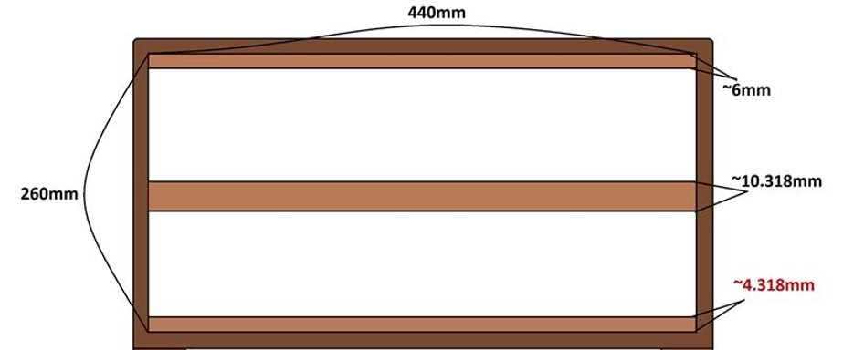

The material thickness in this case was around 3/4 “ with a depth to the back wall of around 6inches this was used to give us the maximum clearance for the pcb, depth , faceplate and power supply.

What is not shown is that after the case was assembled is that we took a router to the case corners with a router bit and de cornered the case. Then drilled holes smartly spaced for aesthetics on the bottom side and the back top side of the case for ventilation shown in picture below

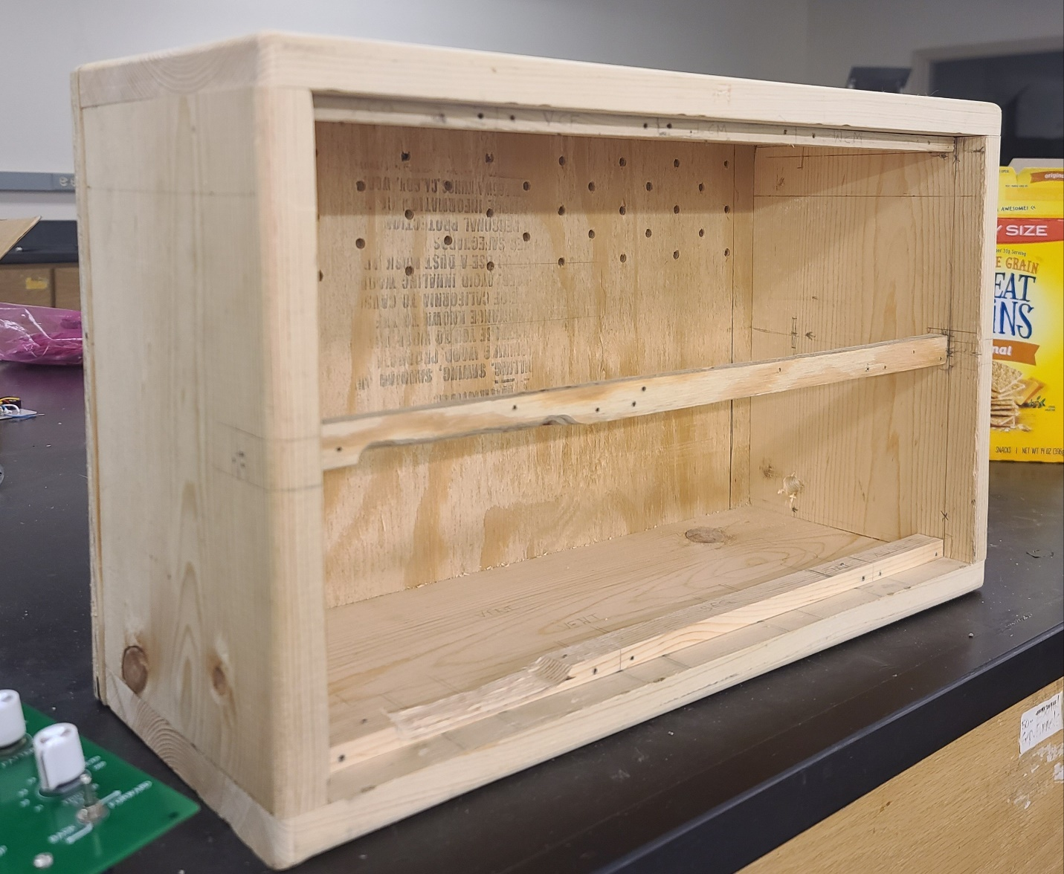

## Design Phase Testing Supplement

Click or tap here to enter text.

### Design Phase Testing Methods and Details

**Voltage Controlled Oscillator:**

To find a working value, our sponsor Taylor LeBlanc tested the maximum frequency on the prototype’s VCO. This was done by turning the frequency control knob to its maximum position, routing audio to a speaker, then measuring the fundamental frequency using a spectrum analyzer smart phone application.

**Digital Multi-Effects:**

Testing included setting up the development environment and writing a simple program to test passing audio through the microcontroller. This test was performed by routing one ¼” TS jack to the input with a guitar audio signal coming in, and routing another ¼” TS jack to the output which connected to an active amplifier.

Testing configuration is shown below

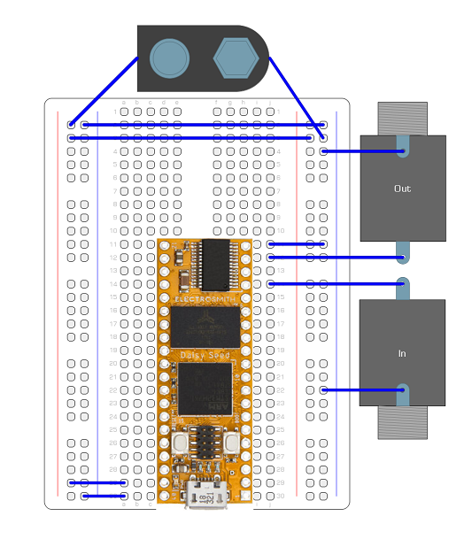

**Sequencer:**

**Wireless Control Module:**

After selecting the ESP32 as our wireless microcontroller, the team wanted to verify that connectivity to mobile phones was possible.

To test this, our sponsor Kyle Sellers ordered one to test connection via Bluetooth. To do so, the Bluetooth connectivity test example program was uploaded to the microcontroller, and connected to an Android phone via the LightBlue application.

Connectivity, reading packets, and writing packets to the phone application were successfully verified, which validates the ESP32 as an appropriate microcontroller.

### Design Phase Testing Results

**Voltage Controlled Oscillator:**

The highest fundamental frequency found was 7kHz. This is acceptable, as the highest fundamental frequency on a grand piano is C8, or 4168 Hz, so our system can produce about an octave above this. 7kHz is used as the highest frequency in transient analyses of other modules.

**Wireless Control Module:**

Link to example used:

https://github.com/espressif/esp-idf/tree/master/examples/bluetooth/bluedroid/ble/ble_compatibility_test

Test Case:

https://github.com/espressif/esp-idf/blob/master/examples/bluetooth/bluedroid/ble/ble_compatibility_test/ble_compatibility_test_case.md

This test uses the lightblue app on smartphone for testing connectivity.

Initialization of esp32 and phone are as follows

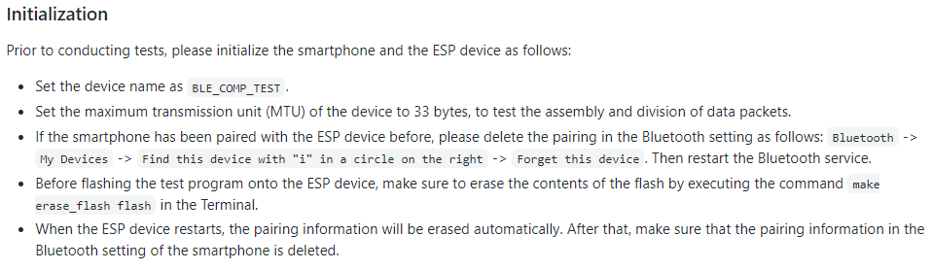

For setup in VSCode, create a blank folder, press F1, and type "ESP-IDF: Show ESP-IDF Examples Projects" and select bluetooth -> ble-compatibility-test

Connect the ESP32, then run ""ESP-IDF: Show ESP-IDF Examples Projects ">ESP-IDF: Build, Flash and start a monitor on your device"

After running this, the following tests were run with results following:

Test1:

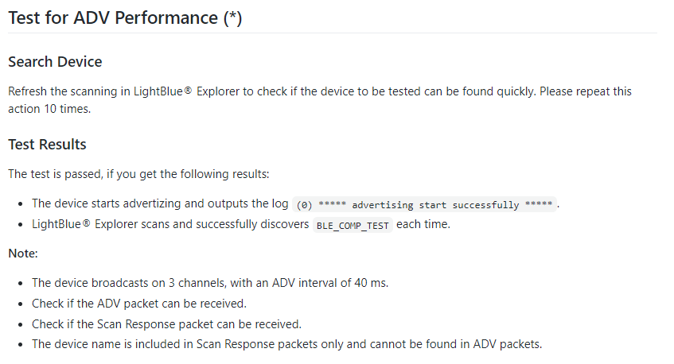



Results1:



Test2:

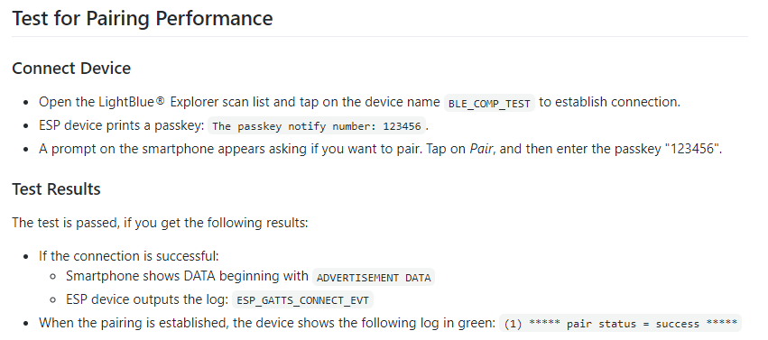

Results2:

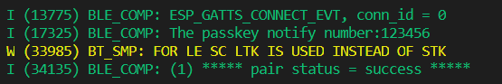

Test3:

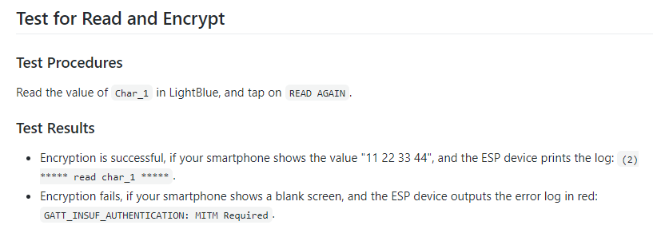

Results3:



Test4:

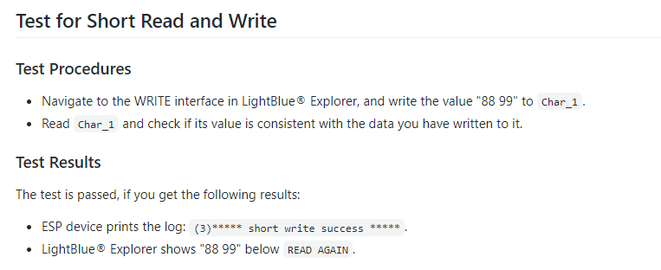

Results4:



Test5:

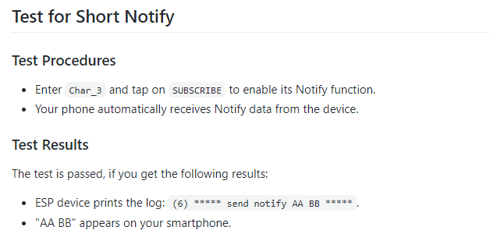

Results5:



## Testing & Validation Supplement

### Testing & Validation of Function F1 – Assist Course Syllabi

Click or tap here to enter text.

#### Test Protocol Description – F1

Questioned Dr.Wei and he gave commentary and recommendations on our labs.

#### Equipment and Instrumentation – F1

n/a

#### Data Acquisition & Analysis – F1

n/a

#### Results Details – F1

n/a

Table XIII‑4: Test Result Data Table

|  |  |  |  |  |
| --- | --- | --- | --- | --- |
| Column 1 Title | Column 2 Title |  |  |  |
|  |  |  |  |  |
|  |  |  |  |  |



Figure XIII‑6: Test Results

### Testing & Validation of Function F2 – Generate Audio Signals

Click or tap here to enter text.

#### Test Protocol Description – F2

#### Equipment and Instrumentation – F2

#### Data Acquisition & Analysis – F2

#### Results Details – F2

Table XIII‑5: Test Result Data Table

|  |  |  |  |  |
| --- | --- | --- | --- | --- |
| Column 1 Title | Column 2 Title |  |  |  |
|  |  |  |  |  |
|  |  |  |  |  |

Figure XIII‑7: Test Results

### Testing & Validation of Function F3 – Output Audio Signals

Click or tap here to enter text.

#### Test Protocol Description – F3

#### Equipment and Instrumentation – F3

#### Data Acquisition & Analysis – F3

#### Results Details – F3

Table XIII‑5: Test Result Data Table

|  |  |  |  |  |
| --- | --- | --- | --- | --- |
| Column 1 Title | Column 2 Title |  |  |  |
|  |  |  |  |  |
|  |  |  |  |  |



Figure XIII‑7: Test Results

### Testing & Validation of Function F4 – Generate Control Voltages

Click or tap here to enter text.

#### Test Protocol Description – F4

#### Equipment and Instrumentation – F4

#### Data Acquisition & Analysis – F4

#### Results Details – F4

Table XIII‑5: Test Result Data Table

|  |  |  |  |  |
| --- | --- | --- | --- | --- |
| Column 1 Title | Column 2 Title |  |  |  |
|  |  |  |  |  |
|  |  |  |  |  |



Figure XIII‑7: Test Results

### Testing & Validation of Function F5 – Manipulate Signal Frequency

Click or tap here to enter text.

#### Test Protocol Description – F5

#### Equipment and Instrumentation – F5

#### Data Acquisition & Analysis – F5

#### Results Details – F5

Table XIII‑5: Test Result Data Table

|  |  |  |  |  |
| --- | --- | --- | --- | --- |
| Column 1 Title | Column 2 Title |  |  |  |
|  |  |  |  |  |
|  |  |  |  |  |



Figure XIII‑7: Test Results

### Testing & Validation of Function F6 – Manipulate Signal Amplitude

Click or tap here to enter text.

#### Test Protocol Description – F6

#### Equipment and Instrumentation – F6

#### Data Acquisition & Analysis – F6

#### Results Details – F6

Table XIII‑5: Test Result Data Table

|  |  |  |  |  |
| --- | --- | --- | --- | --- |
| Column 1 Title | Column 2 Title |  |  |  |
|  |  |  |  |  |
|  |  |  |  |  |



Figure XIII‑7: Test Results

### Testing & Validation of Function F7 – Process Signals Digitally

Kyle Sellers (EEC)

#### Test Protocol Description – F7

Digital Effects from the Digital Multi-Effects module were tested one of two ways:

1. Monitorting the signal through an oscilloscope
2. Listening to the effect over speakers.

Method 1 was used for testing the Distortion and Bitcrusher, while method 2 was used for delay and reverb, as these are time based effects.

#### Equipment and Instrumentation – F7

The oscilloscope used was the Tektronix TDS 2022. Active speakers were used to listen to time based effects.

#### Results Details – F7

All effects behaved as expected. Delay was able to go up to a max delay of 0.5 s, due to memory constraints. Reverb was implemented with the ability to have infinite reverb at max values.

#### Algorithms

Below are details on each effect included in the Digital Multi-Effects. Code used in the Digital Multi-Effects can be found in Team 80s shared folder labelled DME. All algorithms used execute in O(n) time, where n is the audio buffer size (48 in our case). Distortion and Bitcrusher require no memory, while Delay and Reverb require a large amount, proportional to their ring buffer size. This is calculated proportional to their max delay or reverb time.

Memory needed = Time * Sample Rate * size of float

= time * 48000 * 4 bytes

= 192 kB / s or 192 B / ms

#### Distortion

The distortion effect is simple. It first multiplies incoming samples by a gain factor, then passes that through an arctangeant function (a non linear function). This value is then normalized, and multiplied by a volume level (linear function).

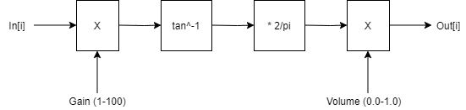

Figure XIV‑7: Distortion Dataflow

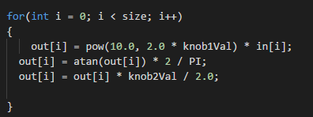

Figure XIV‑7: Distortion Code

#### Bitcrusher

The bitcrusher serves 3 functions: adding noise, reducing bitdepth, and reducting sample rate with sample and hold. These topics are covered in chapters 1 and 6 of the DSP textbook.

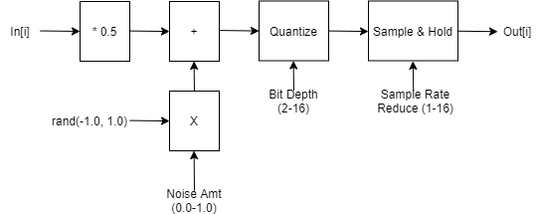

Figure XIV‑7: Bitcrusher Dataflow

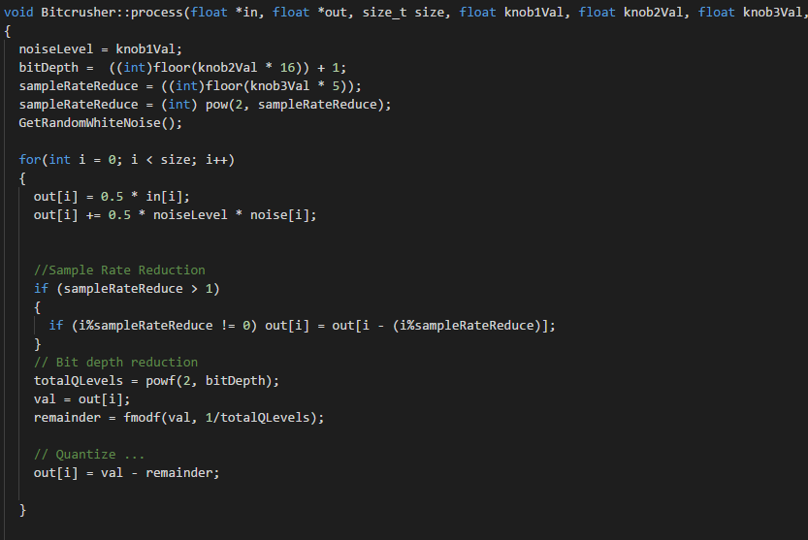

Figure XIV‑7: Bitcrusher Code

#### Delay

Delay is an IIR implementation that has a max length of 500 ms.

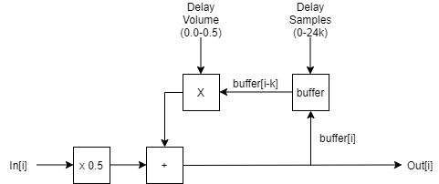

Figure XIV‑7: Delay Dataflow

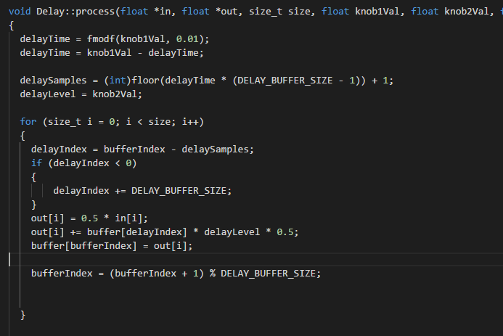

Figure XIV‑7: Delay Code

#### Reverb

The reverb used is a Schroeder Reverb, with algorithm inspired from here: <https://ccrma.stanford.edu/~jos/pasp/Schroeder_Reverberators.html>

Figures taken from here: <https://medium.com/the-seekers-project/coding-a-basic-reverb-algorithm-part-2-an-introduction-to-audio-programming-4db79dd4e325>

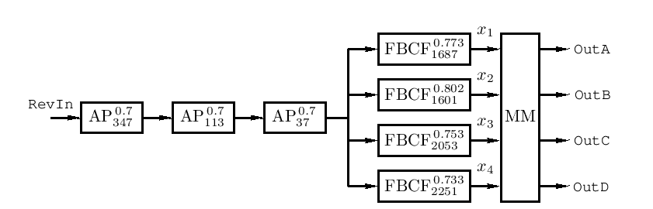

Figure XIV‑7: Reverb Diagram

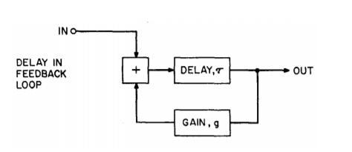

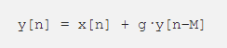

Figure XIV‑7: Feedback Comb Filter Diagram

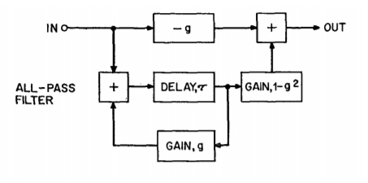



Figure XIV‑7: Allpass Filter Diagram

### Testing & Validation of Function F8 –Regulate Operating Temperature

#### Test Protocol Description – F7

The full system was assembled and interconnected via patch cables. Module parameters where set in such a way that we anticipated max power draw (for example, max voltage sent from wireless control module, reverb algorithm selected on Digital Multi-Effects for maximum processing.

The system was set up in the IEEE lab in the ERAD and allowed to run for 2 hours, the max time we expect a lab to take on the system.

#### Equipment and Instrumentation – F7

The heat gun used is the FLIR TG165, shown below.

#### Results Details – F7

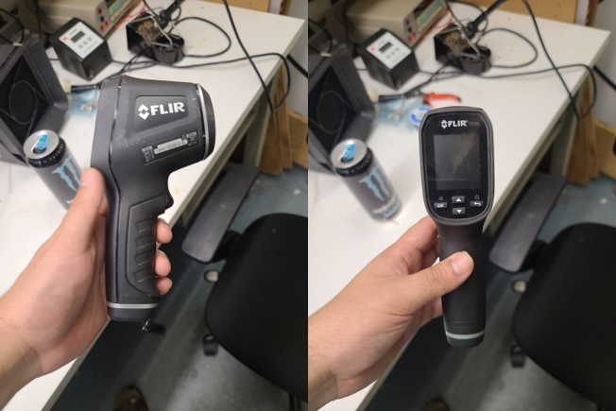

Figure XIV‑7: Heat Gun for Temperature Measurements

### Testing & Validation of Function F9 –Click or tap here to enter text.

#### Test Protocol Description – F7

#### Equipment and Instrumentation – F7

#### Results Details – F7

### Testing & Validation of Function F10 –

Click or tap here to enter text.

#### Test Protocol Description – F7

#### Equipment and Instrumentation – F7

#### Results Details – F7

### Enter any content that you want to repeat, including other content controls. You can also insert this control around table rows in order to repeat parts of a table.

### Testing & Validation of Qualitative Constraint Q1 - Customizable

Click or tap here to enter text.

#### Test Protocol Description – Q1

#### Equipment and Instrumentation – Q1

#### Data Acquisition & Analysis – Q1

#### Results Details – Q1

Table XIII‑6: Test Result Data Table

|  |  |  |  |  |
| --- | --- | --- | --- | --- |
| Column 1 Title | Column 2 Title |  |  |  |
|  |  |  |  |  |
|  |  |  |  |  |



Figure XIII‑8: Test Results

### Testing & Validation of Qualitative Constraint Q2 – Engaging / Fun to Us

Click or tap here to enter text.

#### Test Protocol Description – Q2

#### Equipment and Instrumentation – Q2

#### Data Acquisition & Analysis – Q2

#### Results Details – Q2

Table XIII‑7: Test Result Data Table

|  |  |  |  |  |
| --- | --- | --- | --- | --- |
| Column 1 Title | Column 2 Title |  |  |  |
|  |  |  |  |  |
|  |  |  |  |  |



Figure XIII‑9: Test Results

### Testing & Validation of Qualitative Constraint Q3 – Good Sound Quality

Click or tap here to enter text.

#### Test Protocol Description – Q3

#### Equipment and Instrumentation – Q3

#### Data Acquisition & Analysis – Q3

#### Results Details – Q3

Table XIII‑7: Test Result Data Table

|  |  |  |  |  |
| --- | --- | --- | --- | --- |
| Column 1 Title | Column 2 Title |  |  |  |
|  |  |  |  |  |
|  |  |  |  |  |



Figure XIII‑9: Test Results

### Testing & Validation of Qualitative Constraint Q4 – Easy to DIY

Click or tap here to enter text.

#### Test Protocol Description – Q4

#### Equipment and Instrumentation – Q4

#### Data Acquisition & Analysis – Q4

#### Results Details – Q4

Table XIII‑7: Test Result Data Table

|  |  |  |  |  |
| --- | --- | --- | --- | --- |
| Column 1 Title | Column 2 Title |  |  |  |
|  |  |  |  |  |
|  |  |  |  |  |



Figure XIII‑9: Test Results

### Testing & Validation of Qualitative Constraint Q5 – Easy to Use

Click or tap here to enter text.

#### Test Protocol Description – Q5

#### Equipment and Instrumentation – Q5

#### Data Acquisition & Analysis – Q5

#### Results Details – Q5

Table XIII‑7: Test Result Data Table

|  |  |  |  |  |
| --- | --- | --- | --- | --- |
| Column 1 Title | Column 2 Title |  |  |  |
|  |  |  |  |  |
|  |  |  |  |  |



Figure XIII‑9: Test Results

### Testing & Validation of Qualitative Constraint Q6 – Stable Waveform

Click or tap here to enter text.

#### Test Protocol Description – Q6

#### Equipment and Instrumentation – Q6

#### Data Acquisition & Analysis – Q6

#### Results Details – Q6

Table XIII‑7: Test Result Data Table

|  |  |  |  |  |
| --- | --- | --- | --- | --- |
| Column 1 Title | Column 2 Title |  |  |  |
|  |  |  |  |  |
|  |  |  |  |  |



Figure XIII‑9: Test Results

### Testing & Validation of Quantitative Constraint M1 - Cost

Click or tap here to enter text.

#### Test Protocol Description – M1

#### Equipment and Instrumentation – M1

#### Data Acquisition & Analysis – M1

#### Results Details – M1

Table XIII‑8: Test Result Data Table

|  |  |  |  |  |
| --- | --- | --- | --- | --- |
| Column 1 Title | Column 2 Title |  |  |  |
|  |  |  |  |  |
|  |  |  |  |  |



Figure XIII‑10: Test Results

### Testing & Validation of Quantitative Constraint M2 – Size of Case

Click or tap here to enter text.

#### Test Protocol Description – M2

#### Equipment and Instrumentation – M2

#### Data Acquisition & Analysis – M2

#### Results Details – M2

Table XIII‑9: Test Result Data Table

|  |  |  |  |  |
| --- | --- | --- | --- | --- |
| Column 1 Title | Column 2 Title |  |  |  |
|  |  |  |  |  |
|  |  |  |  |  |



Figure XIII‑11: Test Results

### Testing & Validation of Quantitative Constraint M3 – Weight

Kyle Sellers (EEC)

#### Test Protocol Description – M3

Weight was measured using a typical bathroom scale, seen below.

The scale has a resolution of 0.2 lb intervals. This was precise enough for our application.

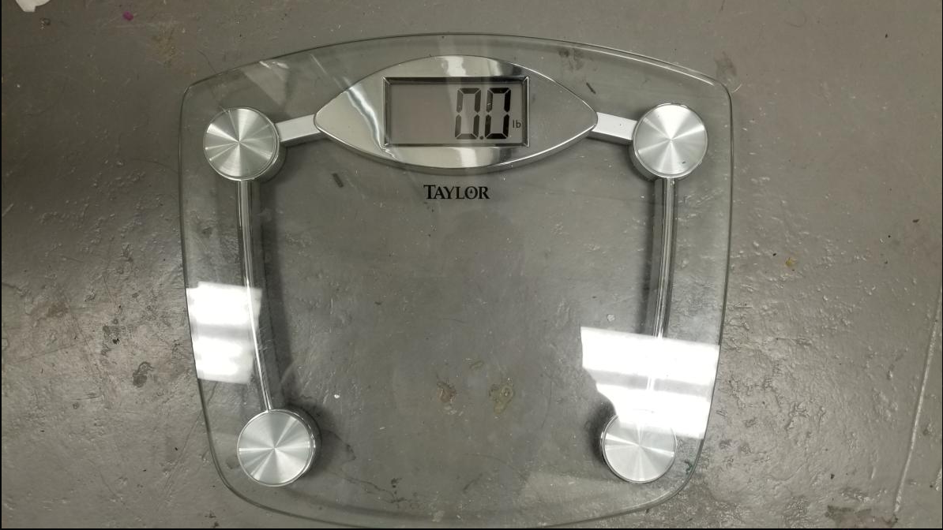

Figure XIII‑11: Scale for Testing Weight

Figure XIII‑11: Test Results

### Testing & Validation of Quantitative Constraint M4 – Power Consumption

Click or tap here to enter text.

#### Test Protocol Description – M3

#### Equipment and Instrumentation – M3

#### Data Acquisition & Analysis – M2

#### Results Details – M2

Table XIII‑9: Test Result Data Table

|  |  |  |  |  |
| --- | --- | --- | --- | --- |
| Column 1 Title | Column 2 Title |  |  |  |
|  |  |  |  |  |
|  |  |  |  |  |



Figure XIII‑11: Test Results

### Testing & Validation of Quantitative Constraint M5 – Bandwidth

Click or tap here to enter text.

#### Test Protocol Description – M3

#### Equipment and Instrumentation – M3

#### Data Acquisition & Analysis – M2

#### Results Details – M2

Table XIII‑9: Test Result Data Table

|  |  |  |  |  |
| --- | --- | --- | --- | --- |
| Column 1 Title | Column 2 Title |  |  |  |
|  |  |  |  |  |
|  |  |  |  |  |



Figure XIII‑11: Test Results

### Testing & Validation of Quantitative Constraint M6 – Signal to Noise Ratio

Kyle Sellers (EEC)

See corresponding main body section.

### Testing & Validation of Quantitative Constraint M7 – Operating Temperature

Taylor LeBlanc (EE) & Kyle Sellers (EEC)

**See Section XIII.G.8 F8 – Regulate Operating Temperature**

### Testing & Validation of Quantitative Constraint M8 – Latency of Wireless Control

Kyle Sellers (EEC)

#### Test Protocol Description – M3

Wireless control latency was tested by placing a phone in the room with the system and a user. The Wireless Control Module was attached to the frequency control of the VCO. I would clap at the same time that I changed a parameter on the mobile application, which would trigger a change in frequency on the system output. The time difference between the transient of the clap and the change In frequency was recorded.

#### Equipment and Instrumentation – M3

Data was acquired using a smart phonme microphone and analyzed in Studio One 4 audio software

#### Results Details – M2

Results are shown in the main body.

### Testing & Validation of Quantitative Constraint M9 – Range of Wireless Control

Kyle Sellers (EEC)

All relevant information on this test was provided in the main body.

### Testing & Validation of Quantitative Constraint M10 – Latency of Digital Module

Kye Sellers (EEC)

#### Equipment and Instrumentation – M3

This test was performed using 2 Electrosmith Daisy Seeds. One of them generated white noise every n buffers, with n varied to verify that the latency was accurate. The other was configured as an audio buffer.

The output of both Daisy Seed were passed into an oscilloscope, and the time difference between when each noise section started was measured.

Below shows the code used for the noise generator, with numCycles varied (n).

const int bufferSize = 48;

int counter = 0;

int numCycles = 22;

float HI = 1.0;

float LO = -1.0;

float newIn[bufferSize] = {};

float newOut[bufferSize] = {};

void MyAudioCallback(float *in, float *out, size_t size)

{

if (counter % numCycles == 0)

{

for(size_t i = 0; i < size; i++)

{

float random = ((float) rand()) / (float) RAND_MAX;

out[i] = (random * 2.0) - 1.0;

}

}

else

{

for(size_t i = 0; i < size; i++)

{

out[i] = 0.0;

}

}

counter++;

counter = counter % numCycles;

}

### Testing & Validation of Quantitative Constraint M11 – Sample Rate

Kyle Sellers (EEC)

All relevant information on this test provided in the main body.

### Testing & Validation of Quantitative Constraint M12 – Instructional Material

Click or tap here to enter text.

#### Test Protocol Description – M3

#### Equipment and Instrumentation – M3

#### Data Acquisition & Analysis – M2

#### Results Details – M2

Table XIII‑9: Test Result Data Table

|  |  |  |  |  |
| --- | --- | --- | --- | --- |
| Column 1 Title | Column 2 Title |  |  |  |
|  |  |  |  |  |
|  |  |  |  |  |



Figure XIII‑11: Test Results

### Testing & Validation of Quantitative Constraint M13 – Degree of Loudness

Click or tap here to enter text.

#### Test Protocol Description – M3

#### Equipment and Instrumentation – M3

#### Data Acquisition & Analysis – M2

#### Results Details – M2

Table XIII‑9: Test Result Data Table

|  |  |  |  |  |
| --- | --- | --- | --- | --- |
| Column 1 Title | Column 2 Title |  |  |  |
|  |  |  |  |  |
|  |  |  |  |  |



Figure XIII‑11: Test Results

## Project Management Supplement

### Schedule and Milestones Details

Procurement Phase

BOM Started Jan 11 and turned in the 22nd

Parts and PCB ordered Jan 22nd

These are huge bottlenecks that if not met will set us behind because the next part is testing and manufacturing

Roadblocks: BOM for budget and ordering, and PCB and Component ordering

Actual not much changed we had a pretty good start to the semester so no major differences.

Manufacturing Phase

Board testing to start in Jan 25 and finish Feb 1

PCB redesign also to start alongside testing Feb 1 and end Feb 9th

Roadblocks if boards do not arrive, we won’t be able to assemble or test them.

Actual: Took the most amount of time and differed much from what we predicted. We projected to be done by February but in actuality we finished around March 28th. This occurred because of issues with soldering, parts being dead on arrival or missing, and the fact that we had 7 modules to assemble and test.

Assembly Phase

PCB V2 to be ordered at the end of march the 5th

And case design to start while we wait for pcbs to arrive.

Major roadblocks are the pcb redesign to finish by Feb 17th

Main Testing Phase

This phase will cover the majority of the testing of the project but most testing will occur throughout the semester, but we find that this testing is the most impactful for our qualitative and quantitative constraints. Once 2nd PCB round shows up we assemble and test to see if our results change or are consistent and then with case assembled integration testing and temperature testing to be done the on March 19th and March 15th respectively.

While research of educational material and mock labs to be done over the course of the semester.

Critical path. Bill of materials > Parts ordered , Boards ordered> Receive Parts and boards> Board testing and pcb redesign> PCB v2> final testing and adjustments> Case built> full assembly.



Figure XIII‑12: Gantt Chart with Detailed Project Time-Line



Figure XIII13: Gantt Chart with Detailed Project Time-Line

### Budget Details

|  |  |  |  |
| --- | --- | --- | --- |
| Expense Type​ | Ideal Budget ​ | Final Spent​ | Per System Cost ​ |
| Circuit Components​ | $400.00​ | $647.96​ | $414.09​  ​ |
| PCBs​ | $75.00​ | $91.46​ | $13.07​ |
| Faceplates​ | $75.00​ | $124.91​ | $17.85​ |
| Case Material​ | $50.00​ | $35.00​ | $35.00​ |
| **TOTAL**​ | $600​ | $899.33​ | $479.85​ |

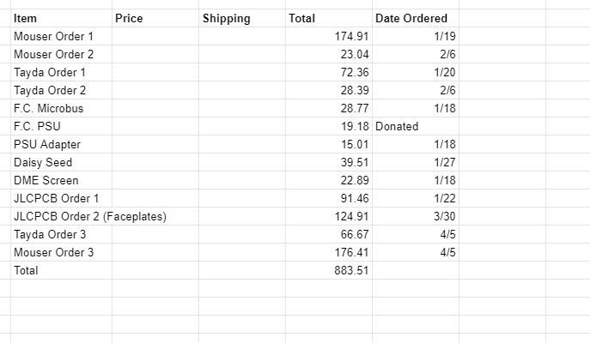

Table XIII‑10: Bill of Materials/Parts

|  |  |  |  |  |  |
| --- | --- | --- | --- | --- | --- |
| Part No. (SS#-P#) | Part Name | Quantity | Price (per unit) | Cost Tota  (no shipping) | Vendor and Ordering Info. |
| SS1-P1 | Stepper Motor | 3 | $60.39 | $181.17 | Grainger: <https://www.grainger.com/product/AUTONICS-2-Phase-5PFF1> |
| SS1-P2 | Motor Bracket (Material) | 1 | $67.00 | $67.00 | Grainger: <https://www.grainger.com/product/GRAINGER-APPROVED-Aluminum-Plate-Stock-2AVE2> |
| SS1-P2 | Motor Bracket (Manufacturing) | 1 | $300.00 | $300.00 | Precision Machining Works LLC |
|  |  |  |  |  |  |
|  |  |  |  |  |  |
|  |  |  |  |  |  |
|  |  |  |  |  |  |
|  |  |  |  |  |  |
|  |  |  |  |  |  |
|  |  |  |  |  |  |
|  |  |  |  |  |  |
|  |  |  |  |  |  |
|  |  |  |  |  |  |
|  |  |  |  |  |  |
|  |  |  |  |  |  |
|  |  |  |  |  |  |
|  |  |  |  |  |  |
|  |  |  |  |  |  |
|  |  |  |  |  |  |
|  |  |  |  |  |  |

## Reference Materials

### Codes and Standards

### References and Bibliography